#1.1-1.3

x <- 7

x

print(x)

y <- 11

y

ls()

#ls is a command to show what is stored in the R **workspace memory**.

#1.5

Save the data as “.txt”or a “.csv” file.

data1 <- read.csv(file.choose(),header=T)

#header=T tells R that the first row contains the names of the columns of the table.

#?Why sep=","--> csv 本來就是"separated by comma的簡寫。"

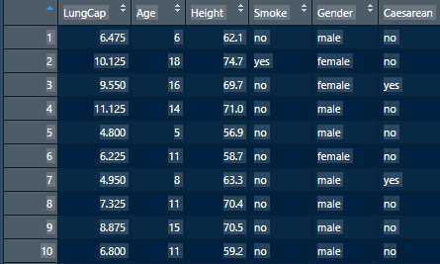

data1

data2 <- read.table(file.choose(), header = T, sep=",")



data3 <- read.delim(file.choose(), header=T)



*************************************************************************************

#1-1.4

#Q1 build a sequence that starts by 2,4,6.....to 12

#wrong: seq(from 2 to 12 by 2) lack the "="

seq(from=2, to=12, by=2)

rep(1, times=100)

rep("cc",times=12)

x <- seq(from=1, to=34 ,by=1/3)

x+0.3

y <- rep(1, time=102)

x+y

xx <- c(1,3,5)

yy <- 1:3

xx+yy

y[3]

y[-3]

#all elements except.

y[c(1,5)]

y[1:3]

y <- rep(1, time=102)

y[y<0.5]

mat <- matrix(1:9, nrow = 3, byrow=T)

#W: matrix(1:9, byrow = 3, byrow=T)

matrix(c(1,2,3,4,5,6,7,8,9), nrow=2)

mat[1,2]

mat[c(1,2),3]

#get, mat[1,3],mat[2,3]

mat*10

mat[1,]

Read.delim (file=choose(), header=T)

Read.table(file=choose(), header=T)

Read.csv(file=choose(), header=T, sep=”,”)

library(readxl)

LungCapData2 <- read_excel("C:/Users/maste/Downloads/LungCapData.xls",

na = "***")

View(LungCapData2)

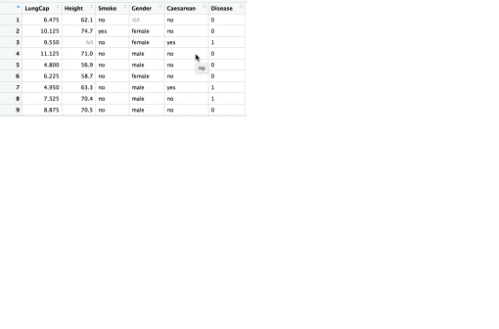

data1 <- read.csv(file.choose(), header=T)

data2 <- read.table(file.choose(), header=T, sep=" ")

data3 <- read.delim(file.choose(),header = T)

#header=T tells R that the first row contains the names of the columns of the table.

read.table(file.choose(), row.names = F,header=T )

write.table(,file = "", row.names = F, sep = ",")

write.table(D, file = , row.names = F, sep="\t")

rm(data1)

rm(data2)

data1 <- read.csv(file.choose(),header=T)

#make R know that the first row of our dataset are variable names or headers.

#header=T tells R that the first row contains the names of the columns of the table.

#?Why sep=","--> csv is an abbreviation of "separated by comma。"

data1

data2 <- read.table(file.choose(), header = T, sep=",")

data3 <- read.delim(file.choose(), header=T)

*************************************************************************************

#1.6

write.table(DataToExport, file="ExportedFileName.csv",row.names=F, sep = "," )

write.csv(DataToExport, file="ExportedFileName.csv",row.names=F)

# save the file in our current working directory, name it

# "ExportedFileName", and save as a .CSV file format

?write.table()

getwd()

write.table(DDD, file = , row.names = F, sep=",")

write.table(DataToExport, file = "", row.names=F, sep= ",")

###################################################################

library(readxl)

LungCapData2 <- read_excel("C:/Users/maste/Downloads/LungCapData.xls",

na = "***")

View(LungCapData2)

data1 <- read.csv(file.choose(), header=T)

data2 <- read.table(file.choose(), header=T, sep=" ")

#we would see

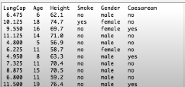

data3 <- read.delim(file.choose(),header = T)

#header=T tells R that the first row contains the names of the columns of the table.

read.table(file.choose(), row.names = F,header=T )

write.table(,file = "", row.names = F, sep = ",")

write.table(D, file = , row.names = F, sep="\t")

rm(data1)

rm(data2)

#rm(data1, data2)

length()

dim()

#know the number of columns and rows.

head()

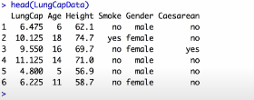

tail()

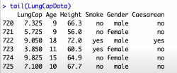

LungCapData[c(5,6,7,8,9), ]

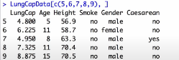

LungCapData[-(4:722), ]

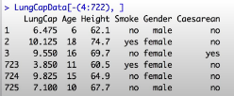

#"-"means that data except 4:722 will be showed on screen.

write.table(DataToExport,file="", sep=",")

names(Lung...)

#check the variable names in every row.

mean(LungCapData$Age)

# XX: age, Capital letters

#extract the column”Age” from the data.

LungCapData$Age

attach(LungCapData)

Mean(Age)

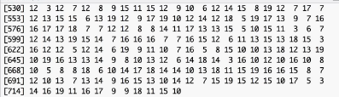

#it will show every Age column in the row.

Age

detach(LungCapData)

Age

Error: Age not found

# since we detach the LungCapData, R could not find the coulum Age in the working space.

attach(LungCapData)

names(LungCapData)



#It will show every column name.

class(Age)

levels(Smoke)

#Shows the sign in the level, by “Yes / No”,



summary(LungCapData)

# briefly capture the points in the column.

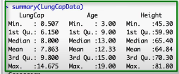

x <- c(1,0,1,0)

x <- as.factor(x)

class(x)

[1] "factor"

summary(x)



#reports frequencies

*************************************************************************************

#1-7~1-10

mean(Age[Gender=="female"])

# == subsetting the mean of the female==



#XXX mean[Age(Gender=="male") ]

mean(Age[Gender=="female"])



MaleData <- LungCapData[Gender=="female"]

# X MaleData <- Age[Gender=="female"] Age

dim(MaleData)

dim(FemData)

summary(Gender)

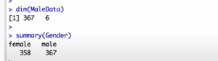

FemData[1:4, ]

MaleOver15 <- LungCapData[Gender=="Male"&Age>15, ]

#X male "male"

#X MaleOver15 <- LungCapData[Gender=="Male"&Age>15]

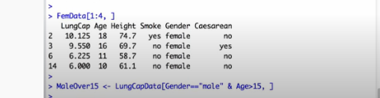

dim(MaleOver15)

MaleOver15[1:4, ]

LungCapData <- read.table(file.choose(),header=T, sep="\t")

attach(LungCapData)

names(LungCapData)

head(LungCapData)

temp <- Age>50

temp[1:5]

temp2 <- as.numeric(Age>15)

temp2[1:4]

FemSmoke <- Gender=="Female"&Smoke=="Yes"

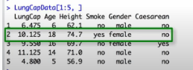

#X FemSmoke <- Age(Gender=="Female")&Smoking="Yes" Age

MoreData <- cbind(LungCapData, FemSmoke)

#cbind(LungCapData&FemSmoke)

#use the cbind and attach the FemSmoke to the entire dataset.

rm(list=ls())

*************************************************************************************

#1.11-1.12

setwd(C:Users/maste/Documents/R/管數)

setwd("Users/maste/Documents/R/管數")

setwd("~/Documents/R/管數")

projectWD <-setwd(C:Users/maste/Documents/R/管數)

setwd(projectWD)

#set the working directory by R sessions.

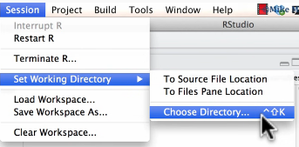

rm(lst=ls())

q()

ls()

setwd("~/Documents/R/管數")

getwd()

load("FirstProject.RData")

x <- c(1,2,3,4,5)

y <- 14

z =summary(LungCapData)

save.image(“”)



Or select clear workspace in session

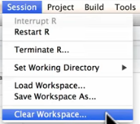

*************************************************************************************

#1.13