Caffe2 Basics

Glossary of basic functions
Import caffe2

from caffe2.python import core, workspace
from caffe2.proto import caffe2_pb2

Workspaces
workspace.Blobs()- Prints out all existing blobs in the workspace.

workspace.HasBlob("X") - Queries if a blob exists in the workspace. As of now, we don't have any.

workspace.FeedBlob("X", X) - Feed blobs into the workspace.

workspace.FetchBlob("X") - Obtain data in blob. Returns error if blob does not exist.

workspace.SwitchWorkspace("gutentag", True)- Switch to new workspace

ResetWorkspace() - Clears anything that is in the current workspace.

Operators
The interface of operators is defined in caffe2/proto/caffe2.proto
Create an operator:
op = core.CreateOperator(
"Relu", # The type of operator that we want to run
["X"], # A list of input blobs by their names
["Y"], # A list of output blobs by their names
)

workspace.RunOperatorOnce(operator) – The simplest way to run an operator
For example:
workspace.FeedBlob("X", np.random.randn(2, 3).astype(np.float32))
workspace.RunOperatorOnce(op)

Nets
Nets are essentially computation graphs
net = core.Net("my_first_net") – Create a network. Upon creation this network’s underlying protocol buffer is essentially empty.

Create a blob called X, and use GaussianFill to fill it with some random data:
X = net.GaussianFill([],
["X"],
mean=0.0,
std=1.0,
shape=[2, 3],
run_once=0)

We could also have created the operator with the command:
op = core.CreateOperator(“someOp”, …)
net.Proto().op.append(op)
But using the initial method is much simpler way to add an operator to the network.

When adding operators to a network, we can create operators from a BlobReference. For instance, using the blob X as the BlobReference:
Y = X.FC([W, b], ["Y"])
This is equivalent to calling:
Y = net.FC([X, W, b], ["Y"])

Visualize a network
We will use the minimal graph visualization tool that comes with caffe2 by calling the following:
from caffe2.python import net_drawer
from IPython import display
graph = net_drawer.GetPydotGraph(net, rankdir="LR")
The result is this figure
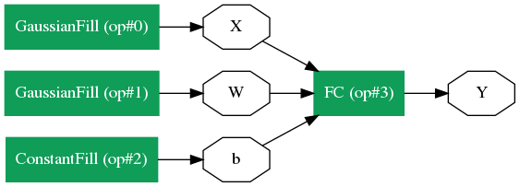

Executing the Net
Before we do anything, we should clear any earlier workspace variables with ResetWorkspace()
Then there are two ways to run a net from Python. We will do the first option in the example below.
- Call workspace.RunNetOnce(), which instantiates, runs and immediately destructs the network
- Call workspace.CreateNet() to create the C++ net object owned by the workspace, then call workspace.RunNet(), passing the name of the network to it
The preferred method will be method 2, because the network is instantiated and remains open, as opposed to method 1 where the network is run and then killed as soon as the run is complete.
This would be the commands to run a network:
workspace.ResetWorkspace()
workspace.CreateNet(net)
workspace.RunNet(net.Proto().name)

