Drive already mounted at /content/drive; to attempt to forcibly remount, call drive.mount("/content/drive", force_remount=True).
📦 Installing dependencies...
━━━━━━━━━━━━━━━━━━━━━━━━━━━━━━━━━━━━━━━━ 129.1/129.1 kB 4.0 MB/s eta 0:00:00
📁 Results will be saved to: /content/drive/MyDrive/AllergenAI-new/results

📊 Loading ESM-2 embedding data...
✅ Training set: 16120 samples (8060 positive)
✅ Test set: 4030 samples (2015 positive)
✅ Feature dimension: 1280
✅ Class balance - Train: 0.500, Test: 0.500

============================================================
📊 BASELINE: DUMMY CLASSIFIER
============================================================

Dummy Classifier (Stratified) - 5-Fold CV Results:

==================================================
Average Dummy Metrics
==================================================
Accuracy: 0.4991
Sensitivity: 0.4950
Specificity: 0.5031
Precision: 0.4991
F1-Score: 0.4970
MCC: -0.0019
AUC-ROC: 0.4991
==================================================

Dummy Classifier - Test Set Results:

==================================================
Test Set Dummy Metrics
==================================================
Accuracy: 0.4950
Sensitivity: 0.4948
Specificity: 0.4953
Precision: 0.4950
F1-Score: 0.4949
MCC: -0.0099
AUC-ROC: 0.4950
==================================================

============================================================
🔀 Y-SCRAMBLING NEGATIVE CONTROL
============================================================

============================================================
📊 EVALUATING: CNN
============================================================

Fold 1/5:
101/101 ━━━━━━━━━━━━━━━━━━━━ 1s 4ms/step
Accuracy: 0.7714, AUC: 0.8506, MCC: 0.5428

Fold 2/5:
101/101 ━━━━━━━━━━━━━━━━━━━━ 1s 3ms/step
Accuracy: 0.7764, AUC: 0.8671, MCC: 0.5559

Fold 3/5:
101/101 ━━━━━━━━━━━━━━━━━━━━ 0s 3ms/step
Accuracy: 0.7723, AUC: 0.8565, MCC: 0.5448

Fold 4/5:
101/101 ━━━━━━━━━━━━━━━━━━━━ 0s 3ms/step
Accuracy: 0.7255, AUC: 0.8260, MCC: 0.4558

Fold 5/5:
101/101 ━━━━━━━━━━━━━━━━━━━━ 0s 3ms/step
Accuracy: 0.7053, AUC: 0.8130, MCC: 0.4159

CNN - 5-Fold CV Summary:

==================================================
CNN Average Metrics
==================================================
Accuracy: 0.7502
Sensitivity: 0.7922
Specificity: 0.7082
Precision: 0.7330
F1-Score: 0.7607
MCC: 0.5030
AUC-ROC: 0.8426
==================================================

🔀 Y-Scrambling Test for CNN:
101/101 ━━━━━━━━━━━━━━━━━━━━ 0s 3ms/step
101/101 ━━━━━━━━━━━━━━━━━━━━ 0s 3ms/step
101/101 ━━━━━━━━━━━━━━━━━━━━ 0s 3ms/step
Y-Scrambled AUC: 0.4957 ± 0.0118
Y-Scrambled MCC: 0.0000 ± 0.0000

============================================================
📊 EVALUATING: MLP
============================================================

Fold 1/5:
101/101 ━━━━━━━━━━━━━━━━━━━━ 1s 4ms/step
Accuracy: 0.9708, AUC: 0.9926, MCC: 0.9419

Fold 2/5:
101/101 ━━━━━━━━━━━━━━━━━━━━ 0s 3ms/step
Accuracy: 0.9733, AUC: 0.9943, MCC: 0.9467

Fold 3/5:
101/101 ━━━━━━━━━━━━━━━━━━━━ 0s 3ms/step
Accuracy: 0.9764, AUC: 0.9954, MCC: 0.9529

Fold 4/5:
101/101 ━━━━━━━━━━━━━━━━━━━━ 0s 3ms/step
Accuracy: 0.9814, AUC: 0.9961, MCC: 0.9628

Fold 5/5:
101/101 ━━━━━━━━━━━━━━━━━━━━ 0s 3ms/step
Accuracy: 0.9628, AUC: 0.9910, MCC: 0.9259

MLP - 5-Fold CV Summary:

==================================================
MLP Average Metrics
==================================================
Accuracy: 0.9730
Sensitivity: 0.9770
Specificity: 0.9689
Precision: 0.9693
F1-Score: 0.9731
MCC: 0.9460
AUC-ROC: 0.9939
==================================================

🔀 Y-Scrambling Test for MLP:
101/101 ━━━━━━━━━━━━━━━━━━━━ 0s 3ms/step
101/101 ━━━━━━━━━━━━━━━━━━━━ 0s 3ms/step
101/101 ━━━━━━━━━━━━━━━━━━━━ 0s 3ms/step
Y-Scrambled AUC: 0.5015 ± 0.0039
Y-Scrambled MCC: 0.0065 ± 0.0185

============================================================
📊 EVALUATING: XGBoost
============================================================

Fold 1/5:
Accuracy: 0.9870, AUC: 0.9972, MCC: 0.9740

Fold 2/5:
Accuracy: 0.9848, AUC: 0.9983, MCC: 0.9696

Fold 3/5:
Accuracy: 0.9870, AUC: 0.9988, MCC: 0.9740

Fold 4/5:
Accuracy: 0.9851, AUC: 0.9983, MCC: 0.9702

Fold 5/5:
Accuracy: 0.9876, AUC: 0.9987, MCC: 0.9752

XGBoost - 5-Fold CV Summary:

==================================================
XGBoost Average Metrics
==================================================
Accuracy: 0.9863
Sensitivity: 0.9885
Specificity: 0.9841
Precision: 0.9842
F1-Score: 0.9863
MCC: 0.9726
AUC-ROC: 0.9983
==================================================

🔀 Y-Scrambling Test for XGBoost:
Y-Scrambled AUC: 0.5058 ± 0.0124
Y-Scrambled MCC: 0.0062 ± 0.0226

============================================================
🔧 HYPERPARAMETER TUNING: XGBoost
============================================================
Searching for best hyperparameters...
Fitting 3 folds for each of 50 candidates, totalling 150 fits

Best parameters found:
subsample: 0.9
n_estimators: 400
min_child_weight: 1
max_depth: 6
learning_rate: 0.05
gamma: 0.1
colsample_bytree: 1.0
Best CV score: 0.9943

============================================================
🎯 FINAL MODEL TRAINING AND TEST SET EVALUATION
============================================================

1️⃣ Training final CNN model...
Epoch 1/100
403/403 ━━━━━━━━━━━━━━━━━━━━ 6s 7ms/step - accuracy: 0.5875 - loss: 0.6884 - val_accuracy: 0.0000e+00 - val_loss: 0.9443
Epoch 2/100
403/403 ━━━━━━━━━━━━━━━━━━━━ 2s 6ms/step - accuracy: 0.6201 - loss: 0.6648 - val_accuracy: 0.0828 - val_loss: 0.8775
Epoch 3/100
403/403 ━━━━━━━━━━━━━━━━━━━━ 2s 6ms/step - accuracy: 0.6388 - loss: 0.6476 - val_accuracy: 0.2646 - val_loss: 0.7979
Epoch 4/100
403/403 ━━━━━━━━━━━━━━━━━━━━ 3s 6ms/step - accuracy: 0.6688 - loss: 0.6138 - val_accuracy: 0.3756 - val_loss: 0.7555
Epoch 5/100
403/403 ━━━━━━━━━━━━━━━━━━━━ 3s 7ms/step - accuracy: 0.6841 - loss: 0.5921 - val_accuracy: 0.4755 - val_loss: 0.6998
Epoch 6/100
403/403 ━━━━━━━━━━━━━━━━━━━━ 2s 6ms/step - accuracy: 0.6991 - loss: 0.5677 - val_accuracy: 0.5282 - val_loss: 0.6837
Epoch 7/100
403/403 ━━━━━━━━━━━━━━━━━━━━ 2s 6ms/step - accuracy: 0.7115 - loss: 0.5463 - val_accuracy: 0.6520 - val_loss: 0.6250
Epoch 8/100
403/403 ━━━━━━━━━━━━━━━━━━━━ 2s 6ms/step - accuracy: 0.7253 - loss: 0.5325 - val_accuracy: 0.6607 - val_loss: 0.6335
Epoch 9/100
403/403 ━━━━━━━━━━━━━━━━━━━━ 3s 6ms/step - accuracy: 0.7300 - loss: 0.5182 - val_accuracy: 0.6411 - val_loss: 0.6678
Epoch 10/100
403/403 ━━━━━━━━━━━━━━━━━━━━ 3s 6ms/step - accuracy: 0.7384 - loss: 0.5104 - val_accuracy: 0.7162 - val_loss: 0.6019
Epoch 11/100
403/403 ━━━━━━━━━━━━━━━━━━━━ 5s 6ms/step - accuracy: 0.7482 - loss: 0.5037 - val_accuracy: 0.7736 - val_loss: 0.5507
Epoch 12/100
403/403 ━━━━━━━━━━━━━━━━━━━━ 2s 6ms/step - accuracy: 0.7495 - loss: 0.5033 - val_accuracy: 0.7280 - val_loss: 0.6012
Epoch 13/100
403/403 ━━━━━━━━━━━━━━━━━━━━ 3s 6ms/step - accuracy: 0.7632 - loss: 0.4910 - val_accuracy: 0.6858 - val_loss: 0.6435
Epoch 14/100
403/403 ━━━━━━━━━━━━━━━━━━━━ 3s 6ms/step - accuracy: 0.7619 - loss: 0.4853 - val_accuracy: 0.7438 - val_loss: 0.5756
Epoch 15/100
403/403 ━━━━━━━━━━━━━━━━━━━━ 5s 6ms/step - accuracy: 0.7632 - loss: 0.4813 - val_accuracy: 0.7075 - val_loss: 0.6251
Epoch 16/100
403/403 ━━━━━━━━━━━━━━━━━━━━ 2s 5ms/step - accuracy: 0.7712 - loss: 0.4720 - val_accuracy: 0.7208 - val_loss: 0.6055
Epoch 17/100
403/403 ━━━━━━━━━━━━━━━━━━━━ 3s 5ms/step - accuracy: 0.7674 - loss: 0.4746 - val_accuracy: 0.6917 - val_loss: 0.6225
Epoch 18/100
403/403 ━━━━━━━━━━━━━━━━━━━━ 2s 6ms/step - accuracy: 0.7717 - loss: 0.4706 - val_accuracy: 0.7516 - val_loss: 0.5674
Epoch 19/100
403/403 ━━━━━━━━━━━━━━━━━━━━ 3s 7ms/step - accuracy: 0.7718 - loss: 0.4634 - val_accuracy: 0.7134 - val_loss: 0.6026
Epoch 20/100
403/403 ━━━━━━━━━━━━━━━━━━━━ 5s 6ms/step - accuracy: 0.7743 - loss: 0.4676 - val_accuracy: 0.6951 - val_loss: 0.6279
Epoch 21/100
403/403 ━━━━━━━━━━━━━━━━━━━━ 2s 5ms/step - accuracy: 0.7697 - loss: 0.4689 - val_accuracy: 0.7320 - val_loss: 0.5799
126/126 ━━━━━━━━━━━━━━━━━━━━ 1s 3ms/step

2️⃣ Training final MLP model...
Epoch 1/100
403/403 ━━━━━━━━━━━━━━━━━━━━ 6s 5ms/step - accuracy: 0.8730 - loss: 0.2782 - val_accuracy: 0.9736 - val_loss: 0.0941
Epoch 2/100
403/403 ━━━━━━━━━━━━━━━━━━━━ 2s 3ms/step - accuracy: 0.9642 - loss: 0.1100 - val_accuracy: 0.9746 - val_loss: 0.0866
Epoch 3/100
403/403 ━━━━━━━━━━━━━━━━━━━━ 1s 3ms/step - accuracy: 0.9704 - loss: 0.0917 - val_accuracy: 0.9780 - val_loss: 0.0708
Epoch 4/100
403/403 ━━━━━━━━━━━━━━━━━━━━ 1s 3ms/step - accuracy: 0.9749 - loss: 0.0758 - val_accuracy: 0.9755 - val_loss: 0.0849
Epoch 5/100
403/403 ━━━━━━━━━━━━━━━━━━━━ 1s 3ms/step - accuracy: 0.9799 - loss: 0.0632 - val_accuracy: 0.9764 - val_loss: 0.0869
Epoch 6/100
403/403 ━━━━━━━━━━━━━━━━━━━━ 3s 3ms/step - accuracy: 0.9821 - loss: 0.0560 - val_accuracy: 0.9755 - val_loss: 0.1007
Epoch 7/100
403/403 ━━━━━━━━━━━━━━━━━━━━ 2s 4ms/step - accuracy: 0.9860 - loss: 0.0515 - val_accuracy: 0.9764 - val_loss: 0.0990
Epoch 8/100
403/403 ━━━━━━━━━━━━━━━━━━━━ 2s 3ms/step - accuracy: 0.9870 - loss: 0.0446 - val_accuracy: 0.9805 - val_loss: 0.0762
Epoch 9/100
403/403 ━━━━━━━━━━━━━━━━━━━━ 1s 3ms/step - accuracy: 0.9877 - loss: 0.0392 - val_accuracy: 0.9814 - val_loss: 0.0857
Epoch 10/100
403/403 ━━━━━━━━━━━━━━━━━━━━ 2s 3ms/step - accuracy: 0.9889 - loss: 0.0391 - val_accuracy: 0.9817 - val_loss: 0.0849
Epoch 11/100
403/403 ━━━━━━━━━━━━━━━━━━━━ 1s 3ms/step - accuracy: 0.9905 - loss: 0.0315 - val_accuracy: 0.9770 - val_loss: 0.1113
Epoch 12/100
403/403 ━━━━━━━━━━━━━━━━━━━━ 1s 3ms/step - accuracy: 0.9919 - loss: 0.0309 - val_accuracy: 0.9820 - val_loss: 0.0919
Epoch 13/100
403/403 ━━━━━━━━━━━━━━━━━━━━ 1s 3ms/step - accuracy: 0.9914 - loss: 0.0281 - val_accuracy: 0.9823 - val_loss: 0.0921
126/126 ━━━━━━━━━━━━━━━━━━━━ 1s 4ms/step

3️⃣ Training final XGBoost model...

4️⃣ Creating ensemble predictions...

============================================================
📊 FINAL TEST SET RESULTS
============================================================

==================================================
CNN - Test Set
==================================================
Accuracy: 0.6883
Sensitivity: 0.6035
Specificity: 0.7732
Precision: 0.7268
F1-Score: 0.6594
MCC: 0.3822
AUC-ROC: 0.7441
==================================================

==================================================
MLP - Test Set
==================================================
Accuracy: 0.8906
Sensitivity: 0.7965
Specificity: 0.9846
Precision: 0.9811
F1-Score: 0.8792
MCC: 0.7953
AUC-ROC: 0.9785
==================================================

==================================================
XGBoost - Test Set
==================================================
Accuracy: 0.8739
Sensitivity: 0.7583
Specificity: 0.9896
Precision: 0.9864
F1-Score: 0.8575
MCC: 0.7687
AUC-ROC: 0.9812
==================================================

==================================================
Ensemble - Test Set
==================================================
Accuracy: 0.8826
Sensitivity: 0.7777
Specificity: 0.9876
Precision: 0.9843
F1-Score: 0.8689
MCC: 0.7827
AUC-ROC: 0.9811
==================================================

============================================================
📈 GENERATING VISUALIZATIONS
============================================================
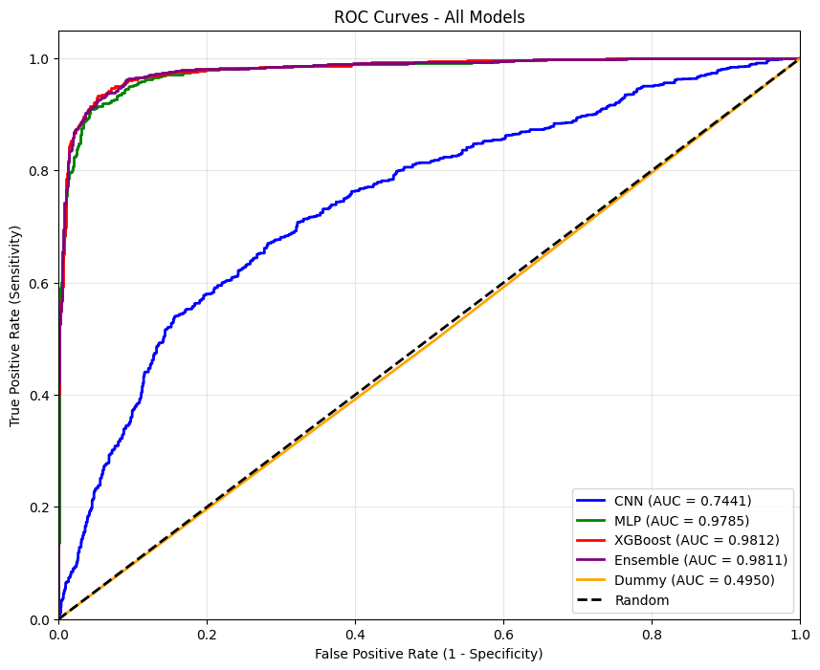
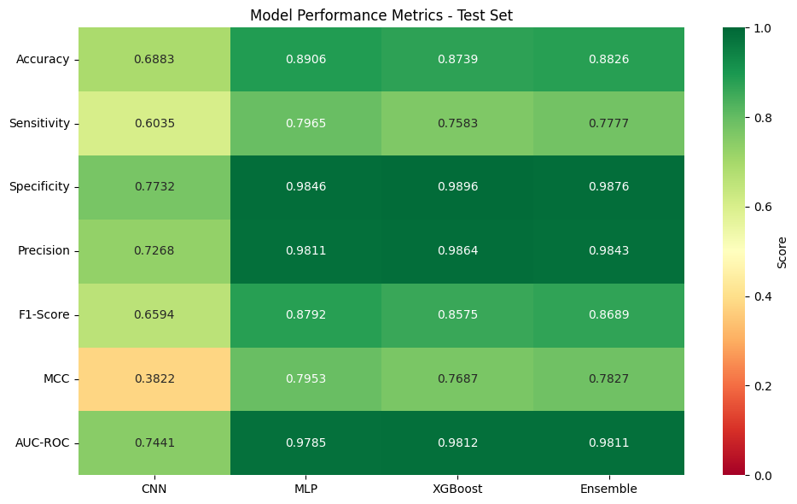
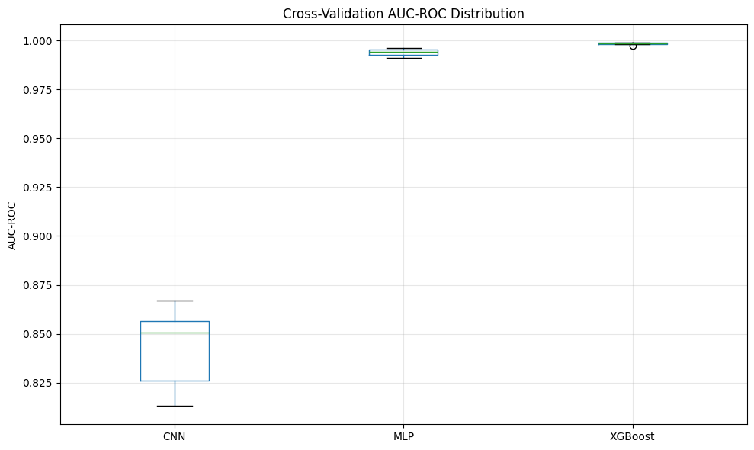
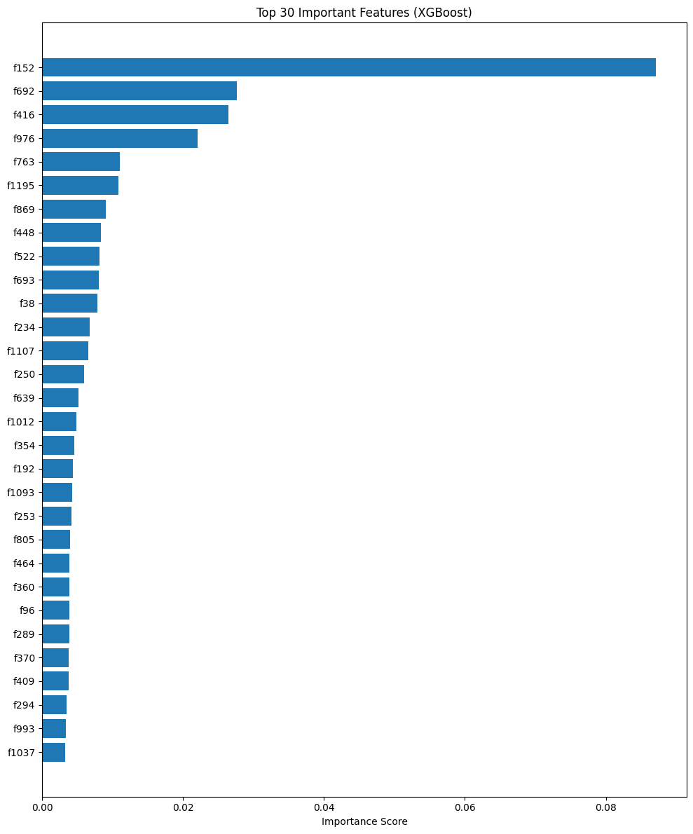
WARNING:absl:You are saving your model as an HDF5 file via `model.save()` or `keras.saving.save_model(model)`. This file format is considered legacy. We recommend using instead the native Keras format, e.g. `model.save('my_model.keras')` or `keras.saving.save_model(model, 'my_model.keras')`.
WARNING:absl:You are saving your model as an HDF5 file via `model.save()` or `keras.saving.save_model(model)`. This file format is considered legacy. We recommend using instead the native Keras format, e.g. `model.save('my_model.keras')` or `keras.saving.save_model(model, 'my_model.keras')`.

============================================================
💾 SAVING RESULTS
============================================================
Saving models...

============================================================
📋 FINAL SUMMARY REPORT
============================================================

Dataset Information:
Training samples: 16120 (8060 positive)
Test samples: 4030 (2015 positive)
Feature dimension: 1280

Best Model Performance (Test Set):
Model: XGBoost
AUC-ROC: 0.9812
MCC: 0.7687
Accuracy: 0.8739
Sensitivity: 0.7583
Specificity: 0.9896

Y-Scrambling Control:
All models showed AUC ~0.50 with scrambled labels
This confirms models learned real patterns

Files saved to: /content/drive/MyDrive/AllergenAI-new/results
- Models: /content/drive/MyDrive/AllergenAI-new/results/models
- Results: /content/drive/MyDrive/AllergenAI-new/results/metrics
- Plots: /content/drive/MyDrive/AllergenAI-new/results/plots

✅ Pipeline completed successfully!

