**Alpha Playtest**

# Pros (things already done well)

* Art + animations
* Player movement (most liked it)

# Cons (things to improve) (constructive feedback)

* Potentially add springs along the track (so placing dangerous items in the way that could knock you into the piston (may be too hard, would have to be careful with this one)
* Other feedback items that are more directly fixes that need to make to a bug, or quite clearly beneficial and ones we probably would have done anyways if we had time, are placed on the ToDo

# Actions from Feedback (ToDo)

Backlog items that probably won’t get done or are lower priority…

* When falling (after having not jumped) and touching a wall, jump is available (so you do a wall jump type thing)

**Table of items we are planning on doing**

| Task Description | Complete / In Progress / Backlog |
| --- | --- |
| W/Space both do jump | Complete (jeff) |
| Left Click grapple | Backlog |
| Have character flip direction when walking backwards | Backlog |
| Fixing bug of Dying while grappled = staying grappled..? | Complete (Lawrence) |
| Have death / respawn system built in | Complete (Lawrence implemented)  All else, add to their levels… |
| Have victory system built in (or at least some way other than dying to leave the level once the player wins) | Backlog |
| Make grapple momentum make more sense (either keep more momentum, or let player swing themselves on the grapple) | Backlog |
| Explore standing on textbox bug…? | Complete (Jeff) |
| Add some kind of ‘punishment’ / reason to not use spring shoes jump for every jump.   * Maybe take points from score * Maybe have durability, only 5 times to use per map (or a custom # of times) | Backlog |
| Re-evaluate piston (consider if we want to let players gain a small lead) (this could also be mitigated if we gave the players a larger camera, which some wanted…) | Backlog |
| Basic website built, operating, available | Complete (Lawrence) |

**Beta Playtest**

# Main Feedback

Need consistent Levels (camera, piston speed, design…), victory system/something after completing the level

# Plan made Wednesday (5/17):

| Consistent Levels | All |
| --- | --- |
| Victory system | Lawrence |
| Timing system (discuss friday) | Lawrence |
| Cropped background (no floor in picture) (+ tile it) + basic hero (no animation) (using the standing hero) | Jeff (hopefully have something by friday) |
| More intermediate / advanced tutorial | Malachi |

**POST BETA[Thursday May 18]**

# **Play Tester:** Ka Hin Choi

# Thoughts:

-Add Instruction page or at least need more time to read controls in tutorial

-left and right arrow keys work but not up arrow

-zoomed out felt more challenging rather than following a specific path, since you had to make decisions on how to move

-Left Shift to super jump is annoying/bad control

-wall jump bug/feature exists

-maybe add double jump

-noticed wall jump bug, enjoyed using it

**Tutorial Level 0 Notes:**

Add more grapple blocks at the end to make winning more satisfying

Add winning state, add menu capability as well

# Responses to questions:

**1-5 How difficult was it?** 3/5

**1-5 How fun was it?** 4/5

**What did you enjoy about it the most?**

The wall jump bug and multiple grapples back to back

**What was the most frustrating?**

Controls should have more time to learn.

Camera limits your view and choices on the more zoomed-in levels, I like the zoomed out ones like level 2 more (Jeff’s newer Level)

**What was missing?**

Double jump would be cool, controls page, main menu

**What might you want to add?**

Enhance wall jump or add double jump

**Final Playtests**

Data, Analysis, Implementation

# Feedback Received (raw data)

## Malachi (Tutorial)Forms response chart. Question title: Do you feel you understand how to play after completing the tutorial? . Number of responses: 12 responses.

* Remove the piston, it's the tutorial level.
* The circle around the grapple point doesn't line up with when you're able to grapple to it

might be better to say "hold space" instead of "press space" to jump

* Remove the boss
* Squidward
* If you can visual icons for the buttons that would be a good visual guide for players to understand their finger placement/
* I dont like the sliding mechanics and stuff, makes things a little difficult. the jumping over two blocks got me for some reason but I suck at games so it could just be me. the mechanics and keybindings are good, again i just suck at games but I can pick it up at some point. the grapple mechanic is a little bit confusing but I can pick it up eventually, if you could make it so that we see the rope rather than the circle around the thing (like if you shoot a grappling hook at it so we can see what we are doing) that would make life easier. ALSO I HATE YOU FOR MAKING THE SQUIDWARD CHAD FACE SHOOT F***ING MAGNETS AT ME
* I would have squidward spit out fireballs slower and less accuratley.
* the boss is good but he has a bit too much stun maybe lower the firing rate
* No
* Tutorial was straightforward and fun. Jumping and holding onto rope mechanics sometimes were not intuitive: For instance, when super-jumping, I tended to hold down L-SHIFT while tapping space to jump (which didn't give me the super-jump effect I intended), instead of just tapping L-SHIFT. This is a feature I personally would love. With rope mechanics, I sometimes was confused whether to use L-SHIFT or space - the previous suggestion of reducing the power of the L-SHIFT button might fix this confusion as well.

## Jeffrey (*old* level 1, current level 2) (level 1 & 2 were swapped after playtest)

**Enjoyment**

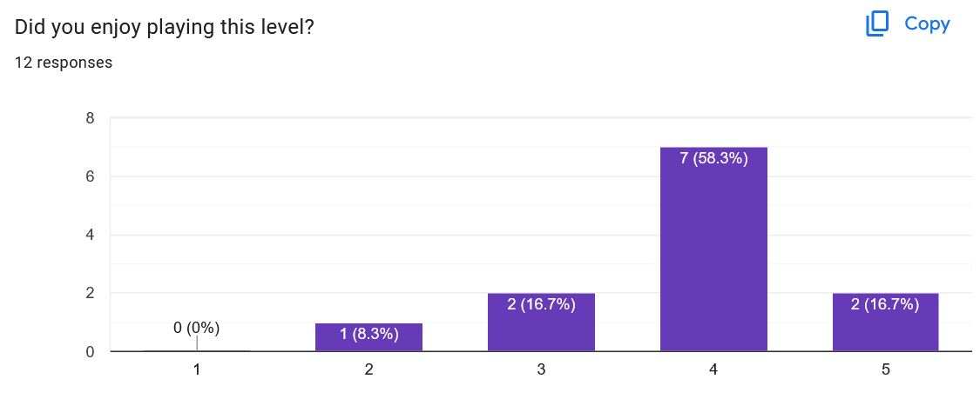

**Difficulty**

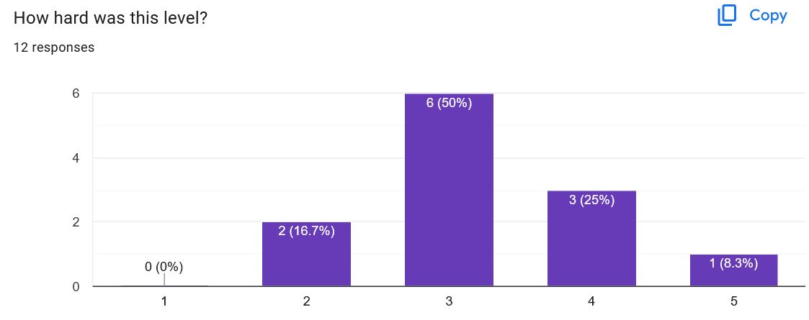

**Text Feedback**

**Note: Includes all feedback, including non-constructive feedback**

* Ur mum
* I could just be garbage at games but holy s*** this level was hard???? the springs were super fast and there are so many different lil grapple things and its hard
* I like the multiple routes you can take
* Instructions unclear for "left for respawn" does that mean to move left *a key*
* Expand the safe area for the grapple
* Liked the different paths.
* pain.
* too hard for level 1
* I enjoyed swinging on the ziplines.

## Lawrence (level 3)

**Enjoyment**

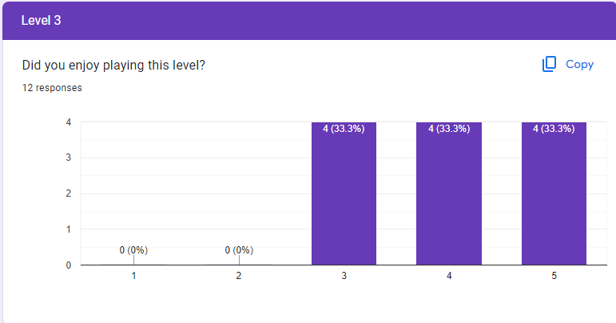

**Difficulty**

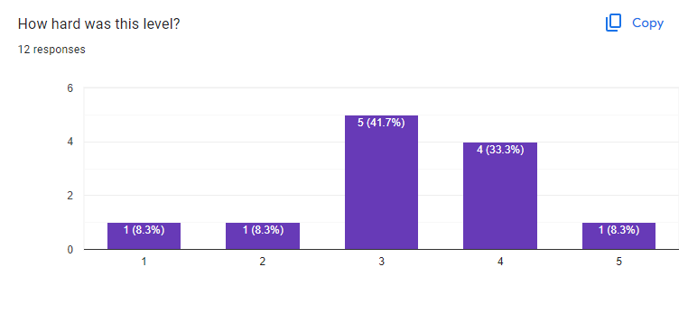

**Text Feedback**

**Note: Includes all feedback, including non-constructive feedback**

* Ur mum
* My guy i cant seem to get enough momentum with the 3 circle things
* The grapple section at the end is fun and helps practice for the boss level
* Don't really like being able to collide with the grapple boxes.
* Polatformee
* no
* I would make the grappel sections larger.

## Joseph (Boss Level)

**Enjoyment**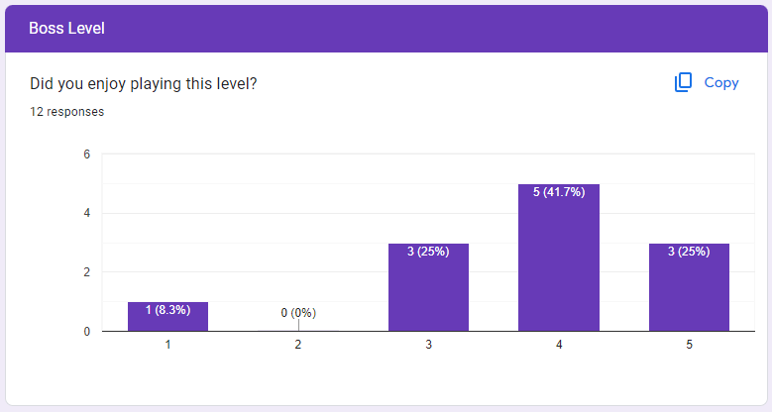

**Difficulty**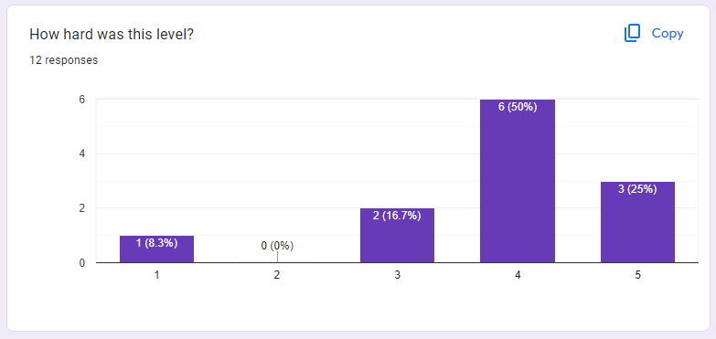

**Text Feedback**

**Note: Includes all feedback, including non-constructive feedback**

* bruh
* I like the difficulty, though having to start from the beginning was a bit annoying.
* eneme (should add a timer to see how fast people can get:)
* Projectiles shouldn't go through walls
* Too easy when you're a pro gamer and Filipino
* what the fuck was the momentum.
* The projectiles were a fun challenge.
* I think it would be cool if you could regain lots of momentum by swinging around on the grappling hook sections because if you mess up on a grappling hook there isnt really any of recovering you just have to go back to spawn and try again
* Ur mum
* I loved the skill and dexterity required to use the rope and to apply momentum mechanics to jump height, especially while momentum-squashers were being slammed my way. This level was really fun because I had to figure out some timings and also be lucky. :') I haven't gotten all the way through the Chad Squidward part yet but I'm excited to try again and again

## Entire Game (Overall)

**What do you like?**

* I appreciate that when a you fall you're respawned at the last area you we are at. The swinging mechanic is also a fun feature.
* Music, variation in difficulty of levels, good tutorial, piston look, game concept, momentum crusher concept
* Fun. Easy controls.
* Ur mum
* the simplicity of the game was nice and the spring-death animation was funny
* The difficulty of the boss level, the multiple routes in each level, and the projectiles that make you lose momentum instead of damaging you
* Overall course design, little details with the character movements, for instance when it shows an animation for jumping
* The movement, grapple mechanic, ultra jump
* I like the lore of the spring guy. It was a life changing experience.
* jumpy jump
* the part with handsome squidward
* I like the sprite character.

**What should be improved?**

* I think there are just some minor bugs sometimes when a player gets stuck at the wall. I also recommend some visual icons for the buttons in the tutorial so users can familiarize themselves with the controls.
* super jump mechanic (LSHIFT purpose), special boss level music :) or just faster, especially when squidward comes, add a little more color. mainly to finish line, hold space to jump continuously, length of space press should affect jump height more obviously
* Jumping with space is too short. May need more time to read instructions without being threatened.
* Ur mum
* movement mechanics, locations of stuff for grappling and jumping over, the momentum stuff was difficult
* The grapple mechanic is a bit clunky, mainly in terms of keeping/building momentum
* projectiles rate of fire, movement (feels like there is little gliding)
* The movement, grapple mechanic, and ultra jump.
* For the grapple mechanic, expand the area of the grapple and allow players to build up momentum by swinging back and forth, For the movement mechanic, add a sliding mechanic.
* Just get better at the game
* enemy fire rate
* sometimes the level design can be kind of confusing so maybe like some arrows to indicate ways you can go
* I think the grappeling circles should be bigger and you should have more swing on them

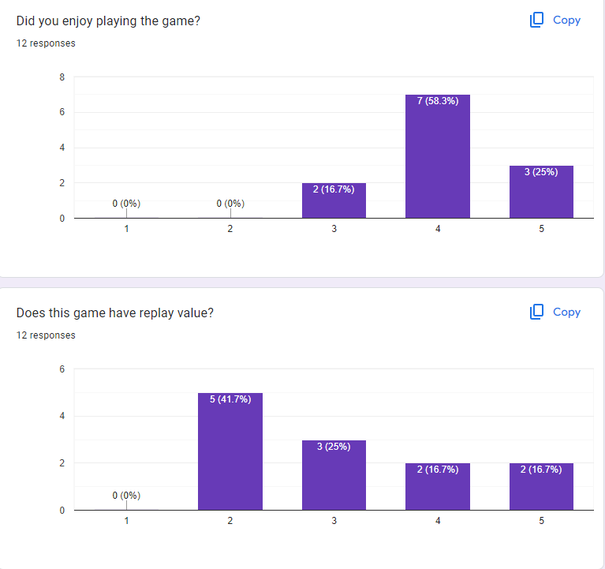

# Compiling Feedback (summarized data)

## Jeffrey (*old* level 1, current level 2) (level 1 & 2 were swapped after playtest)

**Enjoyment average**: 3.833 of 5. Overall, not bad, mostly 4’s and considering the time we had to do it, it was quite enjoyable, that is a good result. Higher is better, so pretty good result.

**Difficulty average**: 3.25 of 5. Overall ,this is probably about right. Most think it is an average difficulty with a slight weight towards it being more difficult. Because we want the earlier levels to not be overly difficult so we can ease people into the very challenging boss level, this is about perfect, challenging, but not infuriatingly difficult.

**Common Text feedback:**

* Expanded the areas for grappling (which makes crossing the gaps easier, meeting the feedback of it being too hard and the safe area for grappling being too small)
* Confusing text, this was said, and I noticed that it was confusing players, and because it is something they either would already know or quickly find out, there is no need for it to be there
* Fun level / I liked how x was
* Too difficult / x is too difficult

## Lawrence (level 3)

**Enjoyment average**: 4 of 5. Equal ratings of 3, 4, and 5 so overall, the level was positively viewed.

**Difficulty average**: 3.25 of 5. The level had a large spread in terms of what people felt the difficulty was with a bit of a bias in the higher end. This makes sense as the level does have some sections that would require a bit of familiarity with the mechanics in order to quickly navigate.

**Common Text feedback:**

* Comments related to grapple (make section longer, can’t get enough momentum, grapple is fun)

## Joseph (Boss Level)

**Enjoyment Average:**

**Difficulty Average:**

**Common Text Feedback:**

* Look at adjusting the springshot momentum, players seemed to enjoy the mechanic, but noted that a few areas have difficulty regarding momentum.

## Entire Game (Overall)

**Common Text Feedback:**

* Movement was enjoyed
* Art was well received
* The design of the courses was viewed positively
* Movement also had a lot of gripes and recommendations for improvement such as bigger grappling zones, more grappling momentum, player momentum, higher jumps, etc.
* Projectile fire rate needs to be tweaked

# Analyzing feedback (what can be fixed in the time we have left, what would be considered if we had more time)

## Jeffrey (*old* level 1, current level 2) (level 1 & 2 were swapped after playtest)

Feedback that didn’t need addressing:

* Fun level / I liked how x was

Feedback that needed consideration:

* Expand the areas for grappling (which also makes crossing the gaps easier, meeting the feedback of it being too hard and the safe area for grappling being too small)
* Confusing text, this was said, and I noticed that it was confusing players even when they didn’t say anything
* Too difficult / x is too difficult

## Lawrence (level 3)

Feedback item to consider, how it was addressed

* With the comment regarding that it was not good to collide with the grapple boxes themselves, it is something we probably want to fix as that is not the intended behavior we had for the grapple.

## Entire Game (Overall)

* With the main chunk of constructive criticism regarding the movement such as the mechanics and momentum, trying to address the majority of the movement related concerns would require editing the physics system of the game, something that would take too much time with the time we have now. However, some things like making jumps longer as space is held and expanding grapple areas are things we can address.
* One particular note is the projectile fire rate in the boss level needing to be tweaked which can easily be addressed.
* There was a bug mentioned regarding getting stuck in a wall which will be easy to fix.

# Implementation Notes

## Jeffrey (*old* level 1, current level 2) (level 1 & 2 were swapped after playtest)

Feedback item to consider, how it was addressed

* Expand the areas for grappling (which also makes crossing the gaps easier, meeting the feedback of it being too hard and the safe area for grappling being too small)
  + Areas for grappling were expanded
  + The safe landing areas after grappling didn’t need to be expanded because the larger grapple zones made the jump easier (in effect, making the possible landing zones larger)
* Confusing text, this was said, and I noticed that it was confusing players even when they didn’t say anything
  + Easy to remove, and the players either already learned it from the tutorial and their previous game experience or quickly learn with minimal pain that falling onto the respawn pads will kill them (making them lose) or have them respawn
* Too difficult / x is too difficult
  + Because of the changes made above making the game easier, and the fact that the average difficulty score was already about where it should be (near the middle), I don’t think there are any other balance changes needed to make it any easier.
    - Essentially, while most players though it was about the right difficulty, the few that found it too hard, should now have a slightly easier time, while also not making it way easier for those that found it about right

## Lawrence (level 3)

Feedback item to consider, how it was addressed

* Removed the collision with the grapple blocks in the whole game

## Entire Game (Overall)

Feedback item to consider, how it was addressed

* With all the movement related feedback, the ones we were able to address is the grapple block size and the jump mechanic.
  + Increased the radii of grapple blocks
  + Made it so that holding either jump button made you jump higher
* Projectile fire rate in the boss level was said to be too high, so the rate of fire was lowered.
* Bugs mentioned in the feedback such as getting stuck in a wall after respawning has been fixed.