Docker Command

Every commands use in the course.

* docker container run hello-world

docker image pull

run docker container create

docker container start

docker container exec

* docker container run alpine ls -l
* docker container run -it alpine /bin
* docker container exec container_id ls -l
* docker container stop container_id
* docker container run –name novoNome imagem
* docker container rm container_id
* docker container run --name ws1 -p 8080:80 -d(Segundo plano) nginx

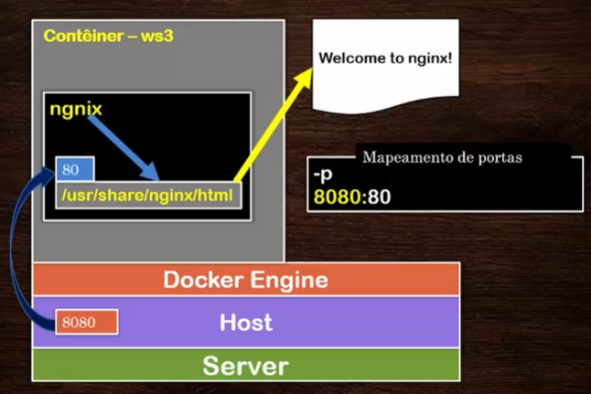

* docker container run --name wsTeste -p 8080:80 -v c:/users/Jefferson.ricardo/downloads/html:/usr/share/nginx/html -d nginx
* docker container inspect container_id