This document describes steps to convert a bot using Directline app service public extension (directline flex) to using a private drop of directline extension.

# Assumptions

1. You already have a bot configured to use the public directline extension , with the necessary application settings on the app service.

# Steps

1. Go to the kudu site for your bot - <yourbot>.scm.azurewebsites.net
2. Go to “Debug Console” and choose “cmd”
3. In the home folder, create a folder named “SiteExtensions”, go into “SiteExtensions” and create folder named “DirectLine”. Look at the screenshots below –

1. Go into the folder “DirectLine” and unzip the contents of the DirectLine.zip that I have provided.

If you drag the zip file into the kudu window to the right, it gives you an option to unzip the folder in there. It should look like below

1. On the azure portal, go to the app service for your bot. Go to “Configuration” -> “Application Settings”. Delete the setting – “DIRECTLINE_EXTENSION_VERSION”

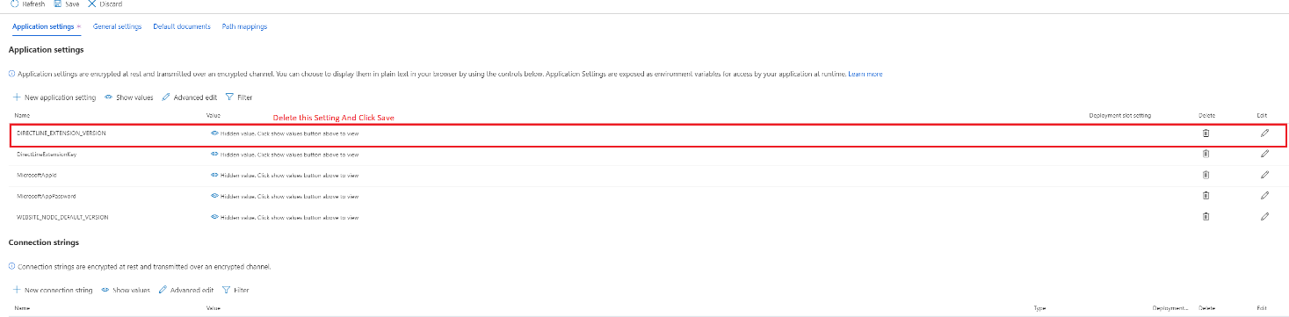

1. Restart your service.