**Direct Line App Service Extension Overview**

Direct Line App Service Extension is a new Bot Framework capability that allows clients to connect directly to bots using the Direct Line API. This offers many benefits, including increased performance and more isolation. Direct Line App Service Extension also uses a new set of streaming extensions to the Bot Framework protocol. These extensions replace HTTP as the transport for exchanging messages with a transport that allows bidirectional requests to be sent over a persistent WebSocket.

Before streaming extensions, the Direct Line API offered one way for a client to send Activities to Direct Line and two ways for a client to retrieve Activities from Direct Line: messages were sent via an HTTP POST, and messages were received by either an HTTP GET (polling) or by opening a WebSocket to receive ActivitySets. Streaming extensions expand on the use of the WebSocket to allow all messaging communication between the client and Direct Line to be sent on that WebSocket. Streaming extensions can also be used between channel services and the bot (more about this later).

To accomplish direct-to-bot connectivity, Direct Line App Service Extension is offered as an Azure App Service Site Extension that is pre-installed on all instances of Azure App Services in every data center around the world. The Direct Line App Service Extension is disabled on Azure App Services by default, but can be easily turned on so that it can connect to your hosted bot. Similar to how clients can use a persistent WebSocket to establish a bidirectional “stream” between a client and the Direct Line App Service Extension, Direct Line App Service Extension establishes a set of persistent named pipes to connect to your bot through a new BotAdapter that you can add to your bot. The overall architecture can be seen below:

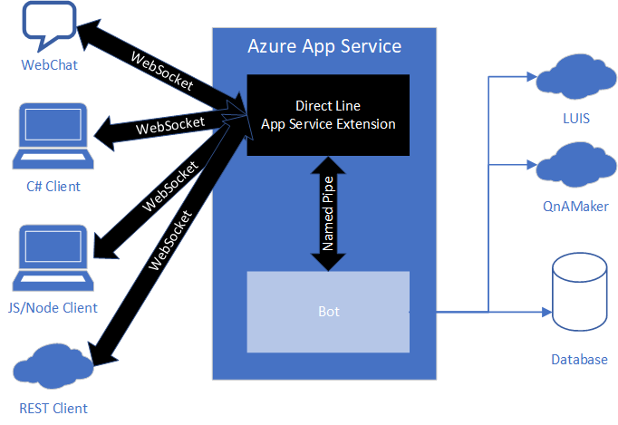

The Direct Line App Service Extension is maintained and managed by Microsoft meaning there is nothing extra for you to deploy onto your Azure App Service. As new versions of Direct Line App Service Extension are released, they are automatically published to your Azure App Service.