21BCE5097- SRUTHI RAMANAATHAN

10/01/2023

Get Time from The Server and Print It

OUTPUT: (codes typed below)

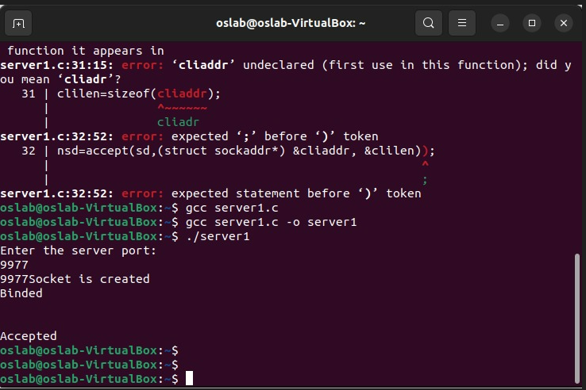

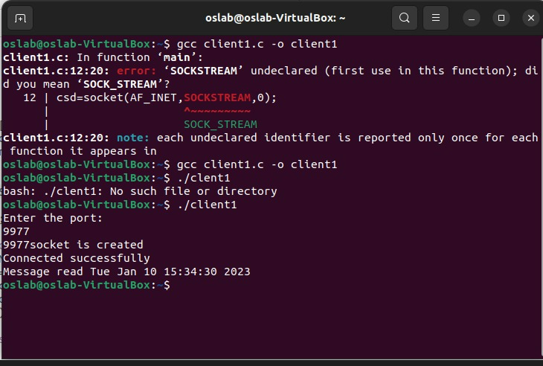

SERVER CODE:

//SERVER CODE

#include<stdio.h>

#include<sys/types.h>

#include<netinet/in.h>

#include<string.h>

#include<time.h>

int main(){

int sd, sd2, nsd, clilen, sport, len;

int port;

time_t ticks;

char sendmsg[100], rcvmsg[100];

struct sockaddr_in servaddr, cliaddr;

printf("Enter the server port: \n");

scanf("%d", &sport);

printf("%d", sport);

sd=socket(AF_INET,SOCK_STREAM,0);

ticks=time(NULL);

strcpy(sendmsg,ctime(&ticks));

if(sd<0)

printf("Can't create\n");

else

printf("Socket is created\n");

servaddr.sin_family=AF_INET;

servaddr.sin_addr.s_addr=htonl(INADDR_ANY);

servaddr.sin_port=htons(sport);

sd2=bind(sd,(struct sockaddr*) &servaddr, sizeof(servaddr));

if (sd2<0)

printf("Can't bind\n");

else

printf("Binded\n");

listen(sd,5);

clilen=sizeof(cliaddr);

nsd=accept(sd,(struct sockaddr*) &cliaddr, &clilen);

if(nsd<0)

printf("can't accept\n");

else

printf("Accepted\n");

send(nsd, sendmsg, 100, 0);

}

CLIENT CODE:

//CLIENT CODE

#include<stdio.h>

#include<sys/types.h>

#include<netinet/in.h>

#include<string.h>

int main(){

int csd,cport,len;

char sendmsg[100],revmsg[100];

struct sockaddr_in servaddr;

printf("Enter the port:\n");

scanf("%d", &cport);

printf("%d", cport);

csd=socket(AF_INET,SOCK_STREAM,0);

if(csd<0)

printf("Can't create\n");

else

printf("socket is created\n");

servaddr.sin_family=AF_INET;

servaddr.sin_addr.s_addr=htonl(INADDR_ANY);

servaddr.sin_port=htons(cport);

if(connect(csd,(struct sockaddr*) &servaddr, sizeof(servaddr))==-1)

printf("Can't Connect\n");

else

printf("Connected successfully\n");

recv(csd,revmsg,100,0);

printf("Message read %s", revmsg);

}