LAB-3

COMPUTER NETWORKS

Srivatsav V

21BCE1821

1. sending message for client to server

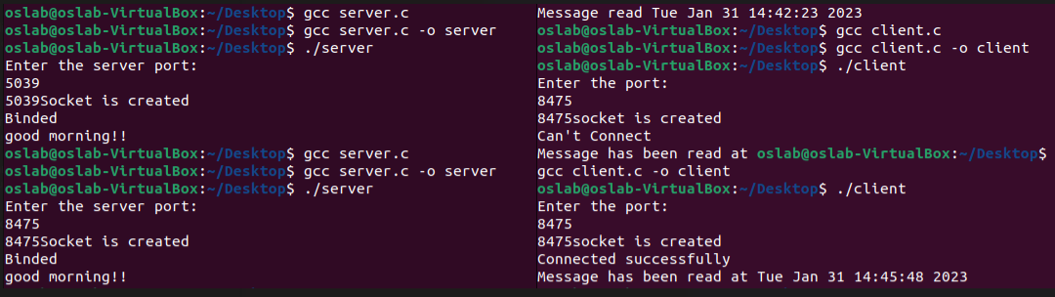

1. server to client

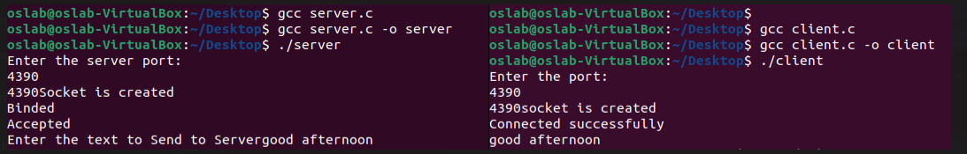

1. chat application

client side:

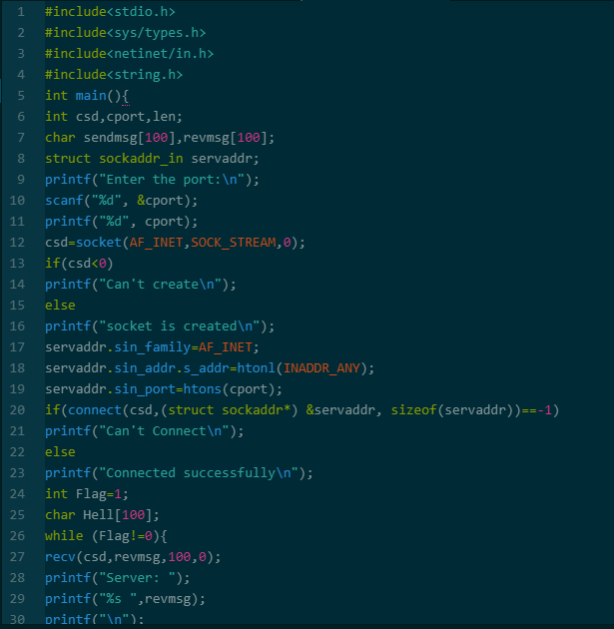

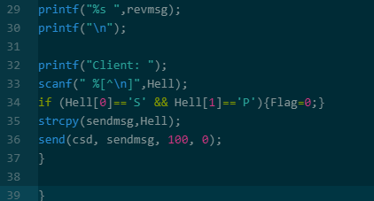

Server side:

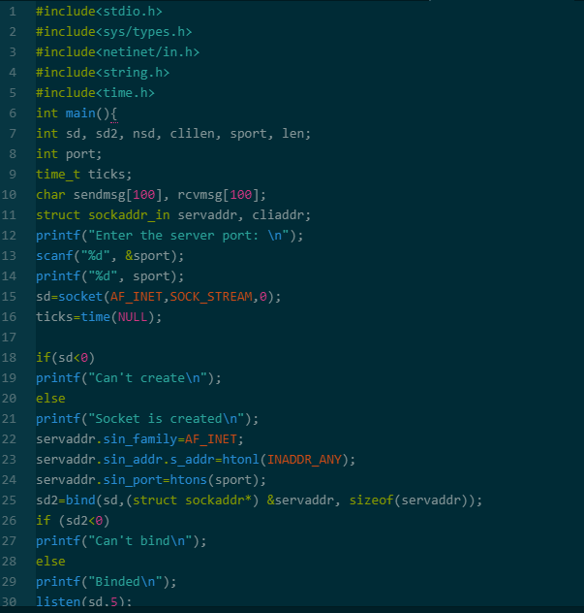

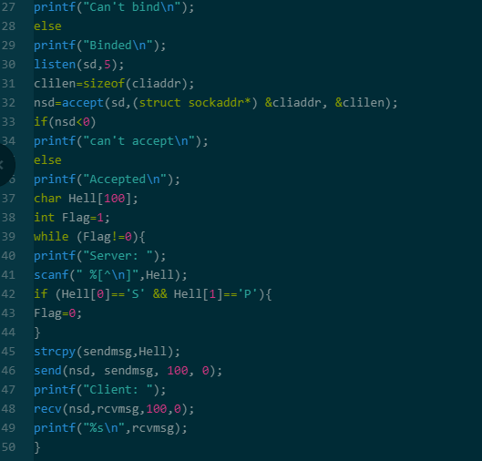

OUTPUT:

