DA -SUBMISSION MONGO DB

21BCE1025

Sundar Karthikeyan

1)Create a NoSQL database DB_Regno and a collection Emp_Regno

db DB_21bce2015

Use DB_21bce1025

Db.createCollection(“emp_21bce1025”)

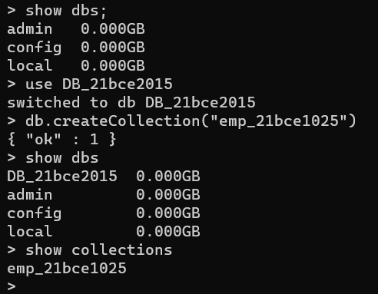

2) Insert the data given above in Emp collection and display all the employees’ information.

db.emp_21bce1025.find()

db.emp_21bce1025.find().pretty()

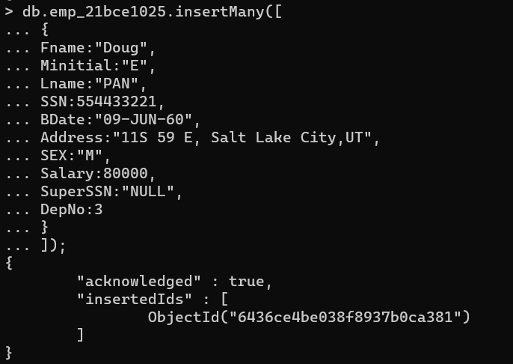

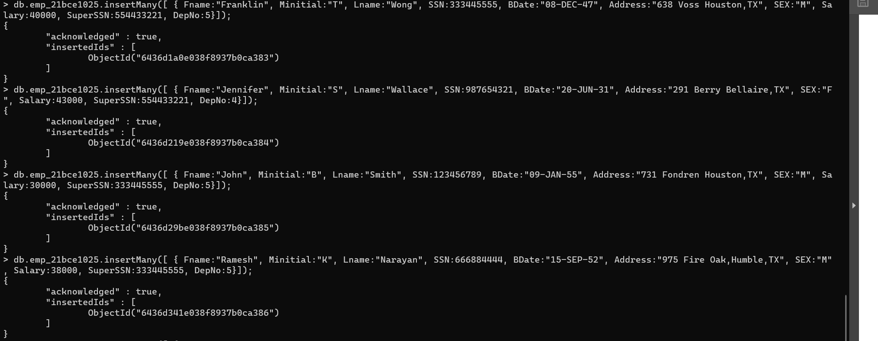

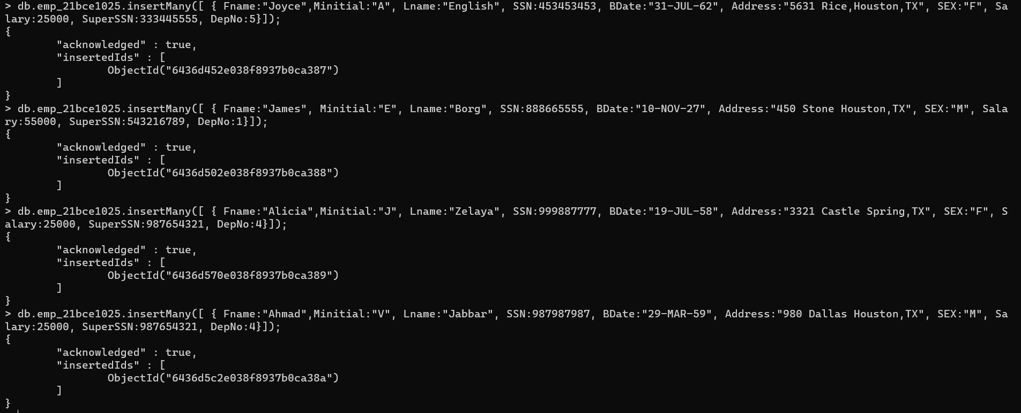

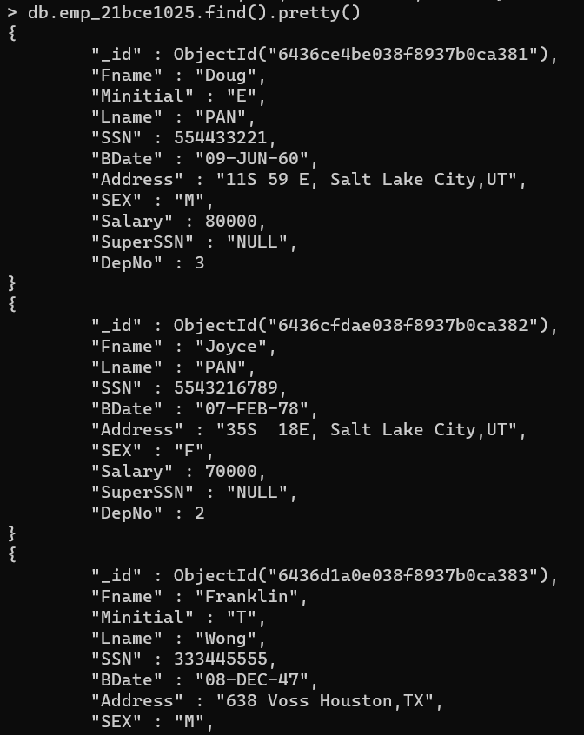

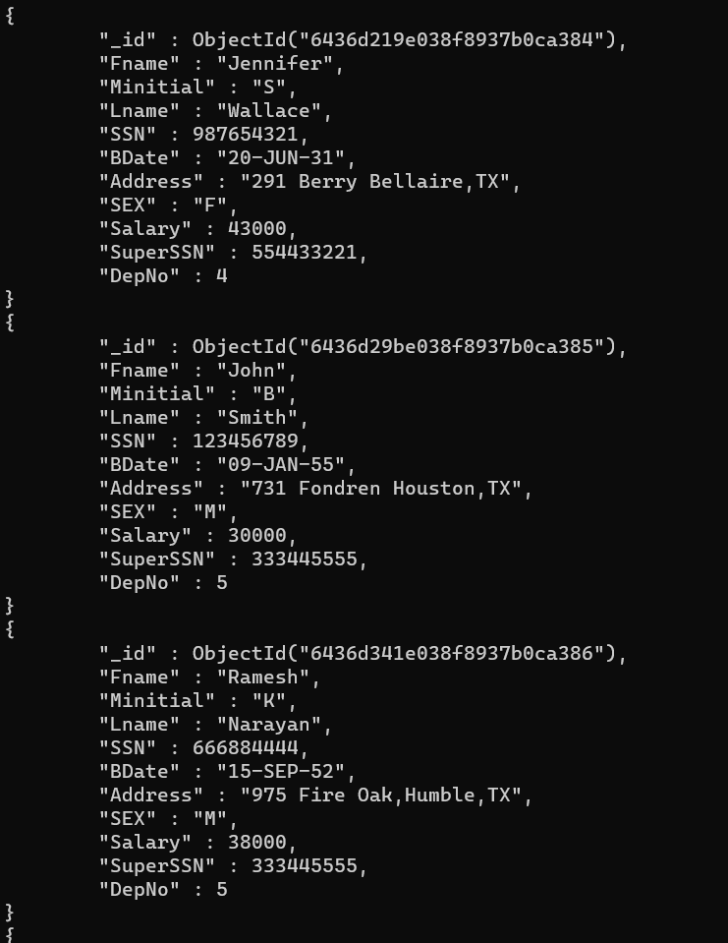

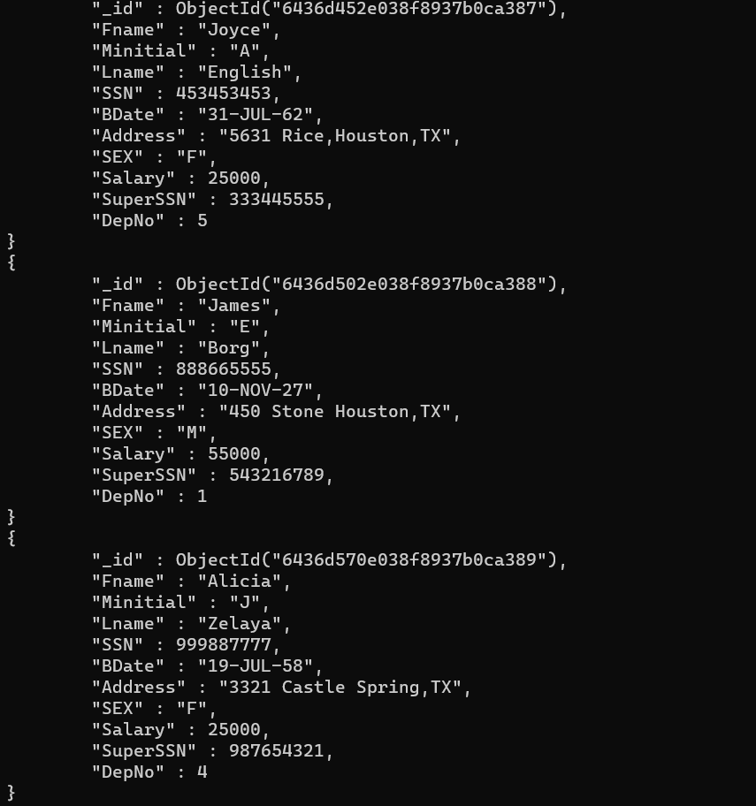

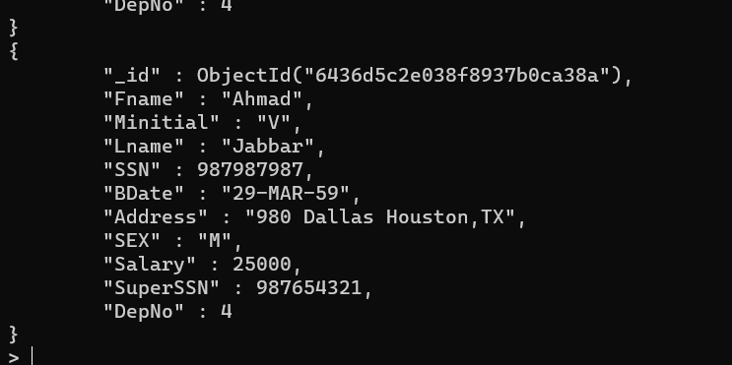

3)Display all Employee’s name along with respective SSN and Supervisor SSN.

db.emp_21bce1025.find({}, {Fname: 1, SSN: 1, Super_SSN: 1})

db.emp_21bce1025.find({}, {Fname: 1, SSN: 1, Super_SSN: 1}).pretty()

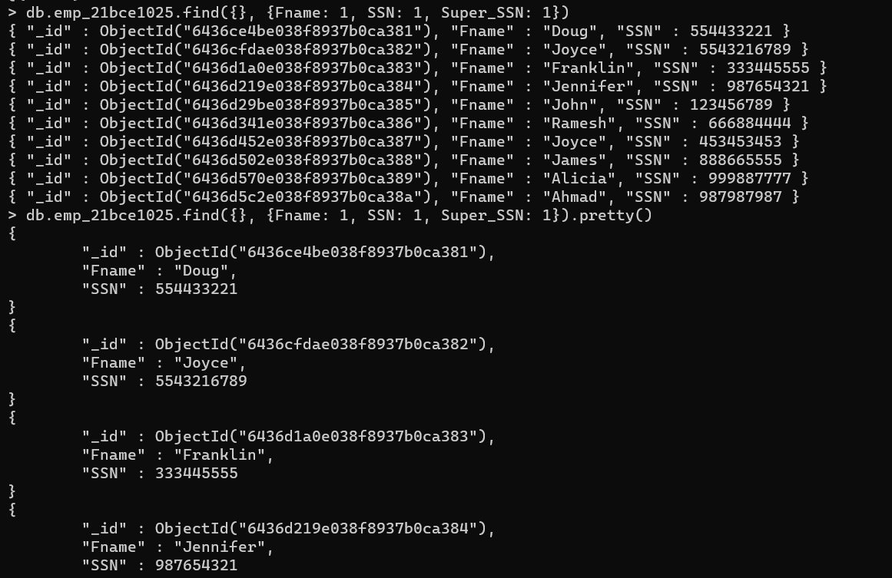

4)Find all the employees who work in dept 4.

db.emp_21bce1025.find({DepNo: 4}).pretty()

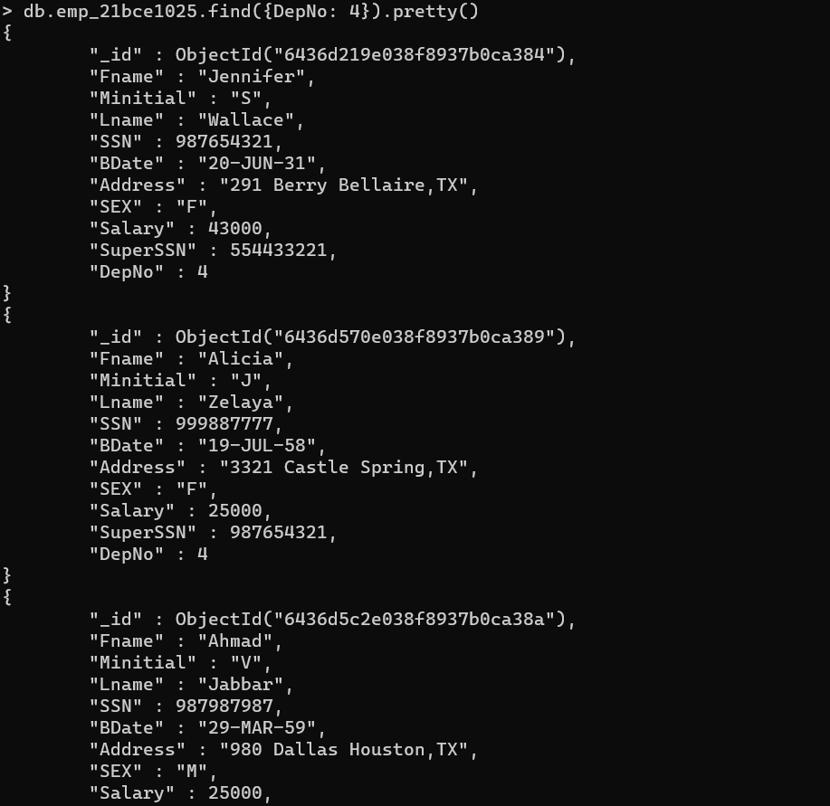

5) Find female employees who are earning more than 50000

db.emp_21bce1025.find({SEX: "F", Salary: {$gt: 50000}}, {Fname: 1}).pretty()



6)Update Alicia’s address as “Chennai”

db.emp_21bce1025.updateOne({Fname: "Alicia"}, {$set: {Address: "Chennai"}})

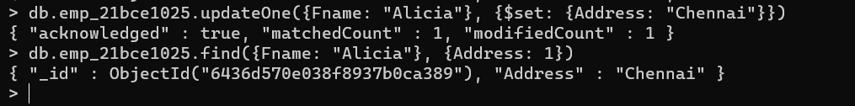

7. Remove James document as he is going to be relieved from the company.

db.emp_21bce1025.deleteOne({Fname: "James"})

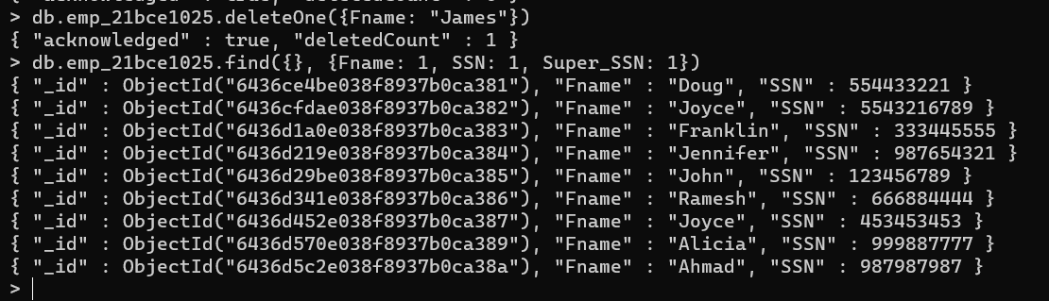

8.) Count the number of Female employees

db.emp_21bce1025.countDocuments({SEX: "F"})

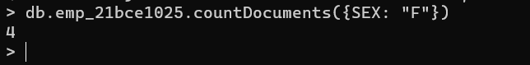

9)Display only SSN in descending order

db.emp_21bce1025.find({}, {SSN: 1, _id: 0}).sort({SSN: -1})

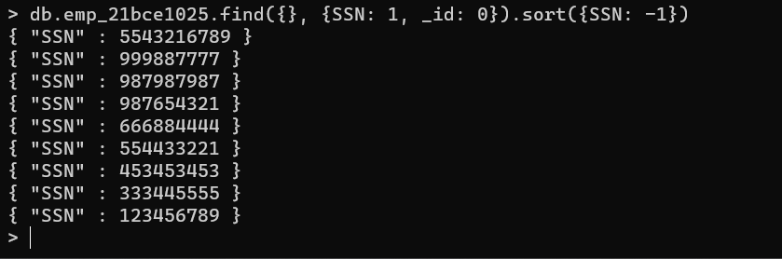

10) Find the one who is earning maximum salary.

db.emp_21bce1025.find().sort({ Salary: -1 }).limit(1)

