Compiler Design Exercise – 5
21bce1882
Jefferson David Kingston
- Design LALR parser using YACC & Lex tool to check the syntax of Arithmetic expression
Code:
Lex:
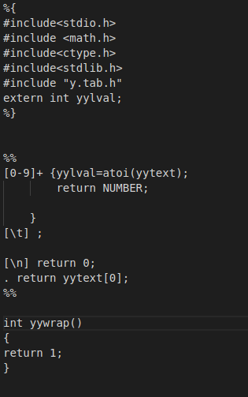

Yacc:
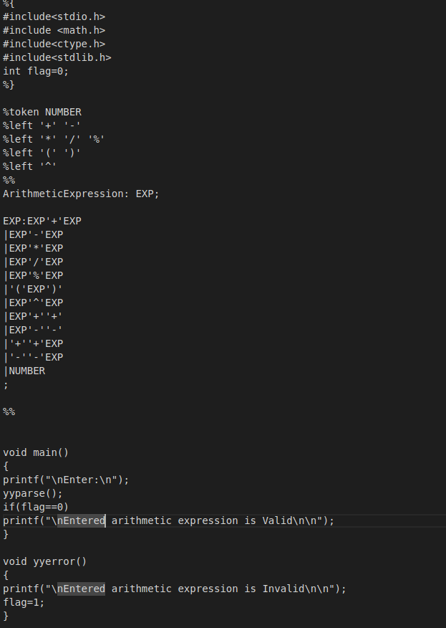

Output:

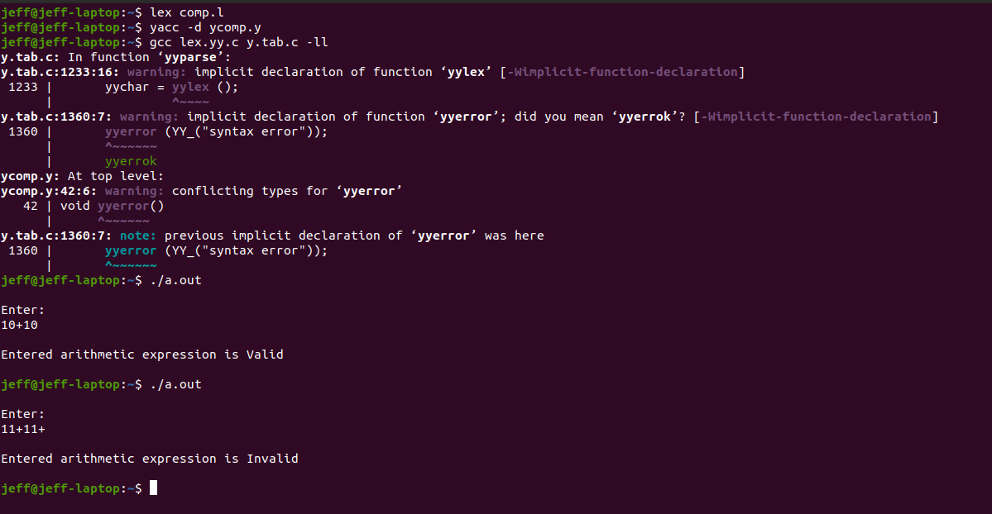

- Design LALR parser using YACC & Lex tool to calculate the value of the given Arithmetic expression based on precedence of the operators. Arithmetic expression contains following operator :
+, -, /, *, %, ^, (, ), ++, --

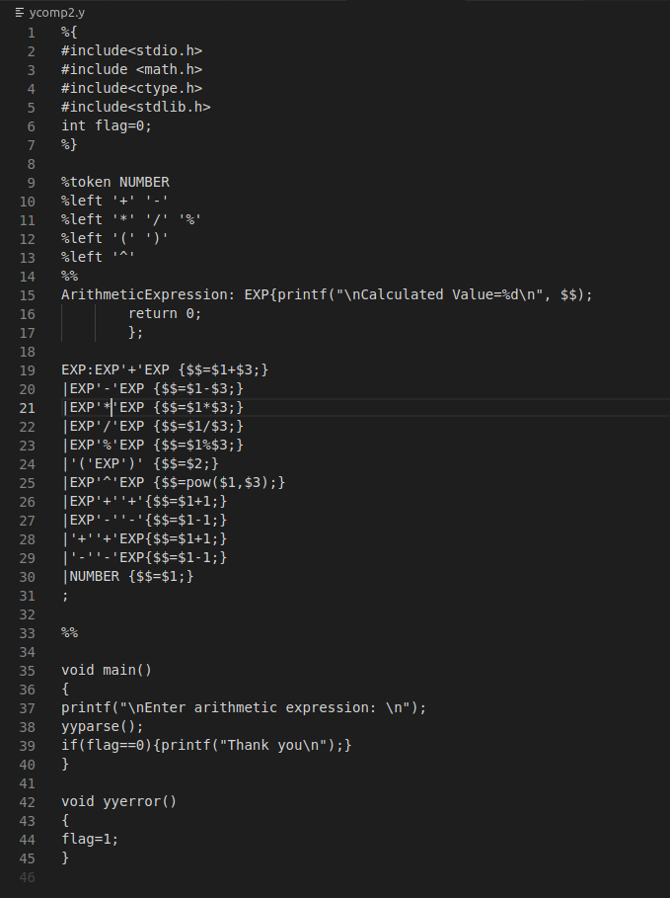
Yacc:

Output:
