Name: Jefferson David Kingston
Reg no: 21bce1882

Software Engineering lab

Use case diagram

Aim: To create a use-case diagram to represent the various functionalities of Fitness application.

Use case diagram:

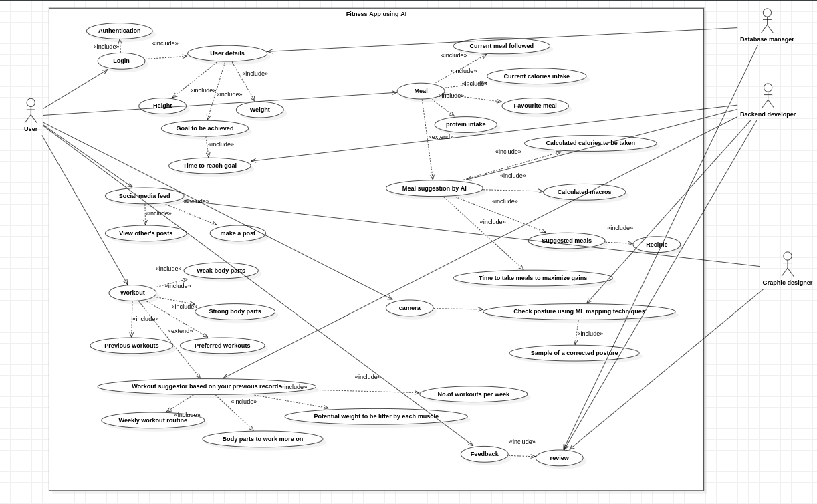

Conclusion: A use case diagram has been created to understand the processes involved in creating a Fitness app using AI

