Name: Jefferson David Kingston
Reg no: 21bce1882

Software Engineering lab

Sequence diagram

Aim: To create a Sequence diagram to represent the various functionalities of Fitness application.

Sequence diagram:
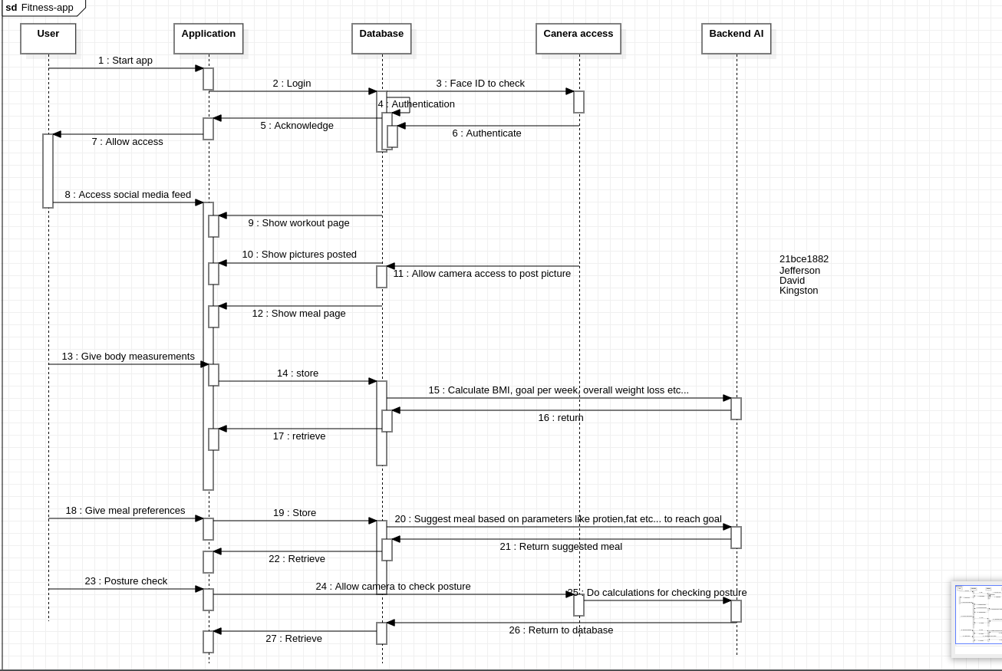

Conclusion: A sequence diagram has been created to understand the processes involved in creating a Fitness app using AI

