Name: Jefferson David Kingston
Reg no: 21bce1882

Software Engineering lab

Component and deoloyment diagram

Aim: To create Component and deployment diagram to represent the various functionalities of Fitness application.

Component and deployment diagram:
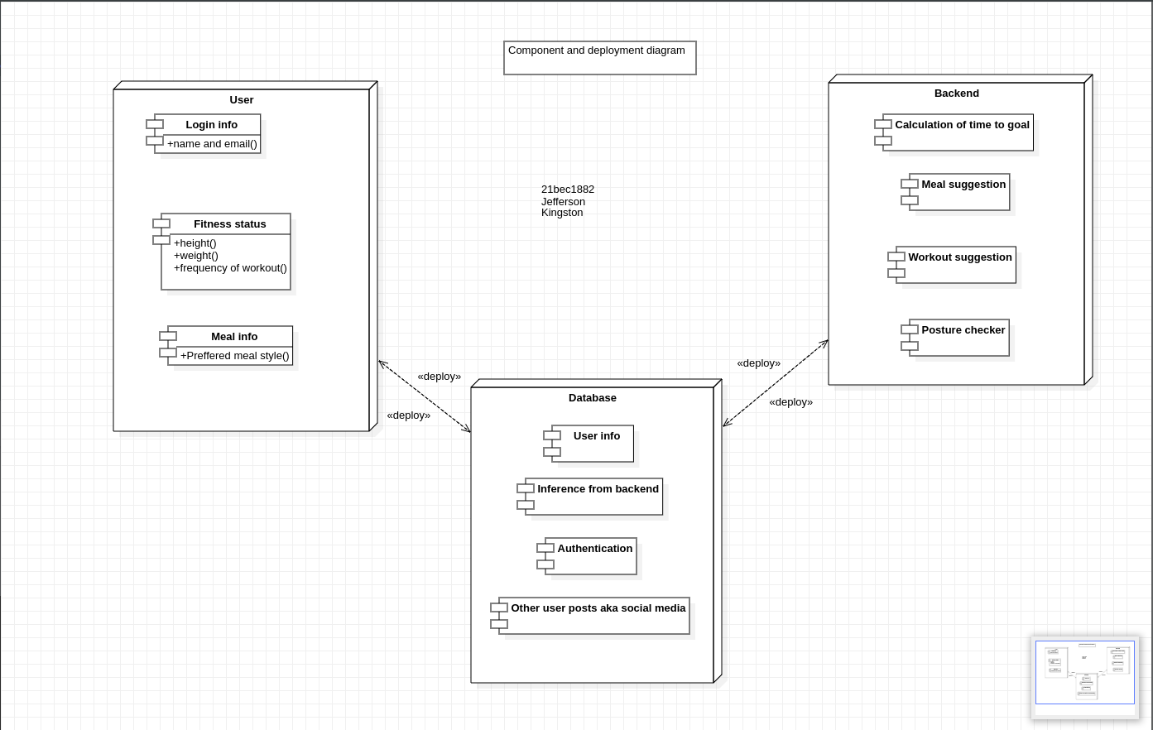

Conclusion: A Component and requirement diagram has been created to understand the processes involved in creating a Fitness app using AI

