# UML - Interaction Diagrams

From the term Interaction, it is clear that the diagram is used to describe some type of interactions among the different elements in the model. This interaction is a part of dynamic behavior of the system.

This interactive behavior is represented in UML by two diagrams known as **Sequence diagram** and **Collaboration diagram**. The basic purpose of both the diagrams are similar.

Sequence diagram emphasizes on time sequence of messages and collaboration diagram emphasizes on the structural organization of the objects that send and receive messages.

## **Purpose of Interaction Diagrams**

The purpose of interaction diagrams is to visualize the interactive behavior of the system. Visualizing the interaction is a difficult task. Hence, the solution is to use different types of models to capture the different aspects of the interaction.

Sequence and collaboration diagrams are used to capture the dynamic nature but from a different angle.

The purpose of interaction diagram is −

* To capture the dynamic behaviour of a system.
* To describe the message flow in the system.
* To describe the structural organization of the objects.
* To describe the interaction among objects.

## **How to Draw an Interaction Diagram?**

As we have already discussed, the purpose of interaction diagrams is to capture the dynamic aspect of a system. So to capture the dynamic aspect, we need to understand what a dynamic aspect is and how it is visualized. Dynamic aspect can be defined as the snapshot of the running system at a particular moment

We have two types of interaction diagrams in UML. One is the sequence diagram and the other is the collaboration diagram. The sequence diagram captures the time sequence of the message flow from one object to another and the collaboration diagram describes the organization of objects in a system taking part in the message flow.

Following things are to be identified clearly before drawing the interaction diagram

* Objects taking part in the interaction.
* Message flows among the objects.
* The sequence in which the messages are flowing.
* Object organization.

Following are two interaction diagrams modeling the order management system. The first diagram is a sequence diagram and the second is a collaboration diagram

### **The Sequence Diagram**

The sequence diagram has four objects (Customer, Order, SpecialOrder and NormalOrder).

The following diagram shows the message sequence for *SpecialOrder* object and the same can be used in case of *NormalOrder* object. It is important to understand the time sequence of message flows. The message flow is nothing but a method call of an object.

The first call is *sendOrder ()* which is a method of *Order object*. The next call is *confirm ()* which is a method of *SpecialOrder* object and the last call is *Dispatch ()* which is a method of *SpecialOrder* object. The following diagram mainly describes the method calls from one object to another, and this is also the actual scenario when the system is running.

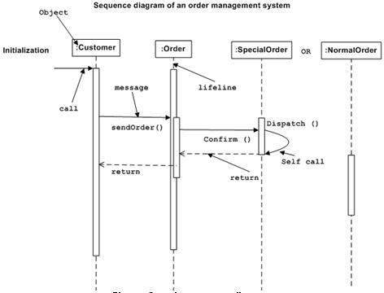

### **The Collaboration Diagram**

The second interaction diagram is the collaboration diagram. It shows the object organization as seen in the following diagram. In the collaboration diagram, the method call sequence is indicated by some numbering technique. The number indicates how the methods are called one after another. We have taken the same order management system to describe the collaboration diagram.

Method calls are similar to that of a sequence diagram. However, difference being the sequence diagram does not describe the object organization, whereas the collaboration diagram shows the object organization.

To choose between these two diagrams, emphasis is placed on the type of requirement. If the time sequence is important, then the sequence diagram is used. If organization is required, then collaboration diagram is used.

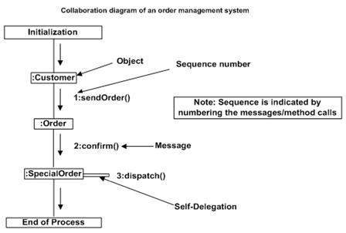

## **Where to Use Interaction Diagrams?**

We have already discussed that interaction diagrams are used to describe the dynamic nature of a system. Now, we will look into the practical scenarios where these diagrams are used. To understand the practical application, we need to understand the basic nature of sequence and collaboration diagram.

The main purpose of both the diagrams are similar as they are used to capture the dynamic behavior of a system. However, the specific purpose is more important to clarify and understand.

Sequence diagrams are used to capture the order of messages flowing from one object to another. Collaboration diagrams are used to describe the structural organization of the objects taking part in the interaction. A single diagram is not sufficient to describe the dynamic aspect of an entire system, so a set of diagrams are used to capture it as a whole.

Interaction diagrams are used when we want to understand the message flow and the structural organization. Message flow means the sequence of control flow from one object to another. Structural organization means the visual organization of the elements in a system.

Interaction diagrams can be used −

* To model the flow of control by time sequence.
* To model the flow of control by structural organizations.
* For forward engineering.
* For reverse engineering.

# UML - Component Diagrams

Component diagrams are different in terms of nature and behavior. Component diagrams are used to model the physical aspects of a system. Now the question is, what are these physical aspects? Physical aspects are the elements such as executables, libraries, files, documents, etc. which reside in a node.

Component diagrams are used to visualize the organization and relationships among components in a system. These diagrams are also used to make executable systems.

## **Purpose of Component Diagrams**

Component diagram is a special kind of diagram in UML. The purpose is also different from all other diagrams discussed so far. It does not describe the functionality of the system but it describes the components used to make those functionalities.

Thus from that point of view, component diagrams are used to visualize the physical components in a system. These components are libraries, packages, files, etc.

Component diagrams can also be described as a static implementation view of a system. Static implementation represents the organization of the components at a particular moment.

A single component diagram cannot represent the entire system but a collection of diagrams is used to represent the whole.

The purpose of the component diagram can be summarized as −

* Visualize the components of a system.
* Construct executables by using forward and reverse engineering.
* Describe the organization and relationships of the components.

## **How to Draw a Component Diagram?**

Component diagrams are used to describe the physical artifacts of a system. This artifact includes files, executables, libraries, etc

The purpose of this diagram is different. Component diagrams are used during the implementation phase of an application. However, it is prepared well in advance to visualize the implementation details.

Initially, the system is designed using different UML diagrams and then when the artifacts are ready, component diagrams are used to get an idea of the implementation.

This diagram is very important as without it the application cannot be implemented efficiently. A well-prepared component diagram is also important for other aspects such as application performance, maintenance, etc.

Before drawing a component diagram, the following artifacts are to be identified clearly −

* Files used in the system.
* Libraries and other artifacts relevant to the application.
* Relationships among the artifacts.

After identifying the artifacts, the following points need to be kept in mind.

* Use a meaningful name to identify the component for which the diagram is to be drawn.
* Prepare a mental layout before producing the using tools.
* Use notes for clarifying important points.

Following is a component diagram for order management system. Here, the artifacts are files. The diagram shows the files in the application and their relationships. In actual, the component diagram also contains dlls, libraries, folders, etc.

In the following diagram, four files are identified and their relationships are produced. Component diagram cannot be matched directly with other UML diagrams discussed so far as it is drawn for completely different purpose.

The following component diagram has been drawn considering all the points mentioned above.

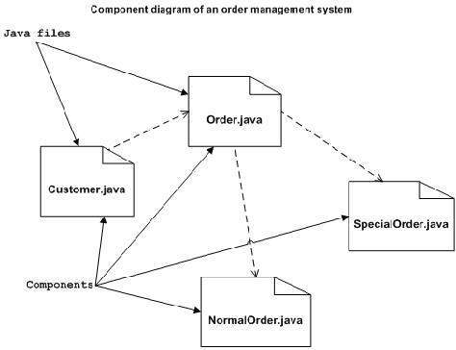

## **Where to Use Component Diagrams?**

We have already described that component diagrams are used to visualize the static implementation view of a system. Component diagrams are special type of UML diagrams used for different purposes.

These diagrams show the physical components of a system. To clarify it, we can say that component diagrams describe the organization of the components in a system.

Organization can be further described as the location of the components in a system. These components are organized in a special way to meet the system requirements.

As we have already discussed, those components are libraries, files, executables, etc. Before implementing the application, these components are to be organized. This component organization is also designed separately as a part of project execution.

Component diagrams are very important from implementation perspective. Thus, the implementation team of an application should have a proper knowledge of the component details

Component diagrams can be used to −

* Model the components of a system.
* Model the database schema.
* Model the executables of an application.
* Model the system's source code.

UML - Deployment Diagrams

Deployment diagrams are used to visualize the topology of the physical components of a system, where the software components are deployed.

Deployment diagrams are used to describe the static deployment view of a system. Deployment diagrams consist of nodes and their relationships.

## **Purpose of Deployment Diagrams**

The term Deployment itself describes the purpose of the diagram. Deployment diagrams are used for describing the hardware components, where software components are deployed. Component diagrams and deployment diagrams are closely related.

Component diagrams are used to describe the components and deployment diagrams shows how they are deployed in hardware.

UML is mainly designed to focus on the software artifacts of a system. However, these two diagrams are special diagrams used to focus on software and hardware components.

Most of the UML diagrams are used to handle logical components but deployment diagrams are made to focus on the hardware topology of a system. Deployment diagrams are used by the system engineers.

The purpose of deployment diagrams can be described as −

* Visualize the hardware topology of a system.
* Describe the hardware components used to deploy software components.
* Describe the runtime processing nodes.

## **How to Draw a Deployment Diagram?**

Deployment diagram represents the deployment view of a system. It is related to the component diagram because the components are deployed using the deployment diagrams. A deployment diagram consists of nodes. Nodes are nothing but physical hardware used to deploy the application.

Deployment diagrams are useful for system engineers. An efficient deployment diagram is very important as it controls the following parameters −

* Performance
* Scalability
* Maintainability
* Portability

Before drawing a deployment diagram, the following artifacts should be identified −

* Nodes
* Relationships among nodes

Following is a sample deployment diagram to provide an idea of the deployment view of order management system. Here, we have shown nodes as −

* Monitor
* Modem
* Caching server
* Server

The application is assumed to be a web-based application, which is deployed in a clustered environment using server 1, server 2, and server 3. The user connects to the application using the Internet. The control flows from the caching server to the clustered environment.

The following deployment diagram has been drawn considering all the points mentioned above.

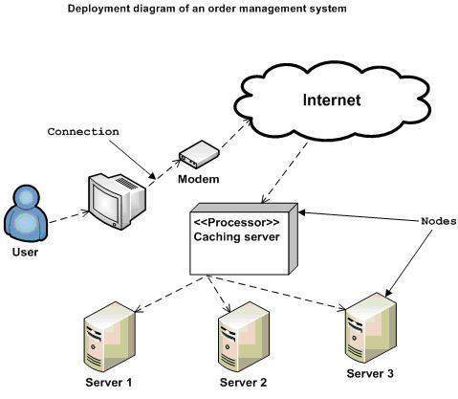

## **Where to Use Deployment Diagrams?**

Deployment diagrams are mainly used by system engineers. These diagrams are used to describe the physical components (hardware), their distribution, and association.

Deployment diagrams can be visualized as the hardware components/nodes on which the software components reside.

Software applications are developed to model complex business processes. Efficient software applications are not sufficient to meet the business requirements. Business requirements can be described as the need to support the increasing number of users, quick response time, etc.

To meet these types of requirements, hardware components should be designed efficiently and in a cost-effective way.

Now-a-days software applications are very complex in nature. Software applications can be standalone, web-based, distributed, mainframe-based and many more. Hence, it is very important to design the hardware components efficiently.

Deployment diagrams can be used −

* To model the hardware topology of a system.
* To model the embedded system.
* To model the hardware details for a client/server system.
* To model the hardware details of a distributed application.
* For Forward and Reverse engineering.