Capstone Project:

Kennerly Construction Web Application

5-Star Development

Arkansas Tech University

TABLE OF CONTENTS

User Manual 2

Employees 2

Users 3

USER MANUAL

**Introduction**

This manual is a guide on how to use the web application designed for Kennerly Construction. The purpose of this web application is to help the company keep up with important company information and to streamline processes that will help keep up with current company growth. This web application is to be used by employees with full access and regular users with limited access. The web application consists of a company home page, a payment portal, an employment application, and an employee-only access to a database to access company maintenance records and current projects information.

Anyone with minimum experience with navigating a webpage should be able to learn the layout and basic functions of this application with minimum training.

**Employees**

Employees can make use of any of the features in this web application, with their place of navigation being the member login tab, which lets employees access vehicle maintenance tab, and current jobs table.

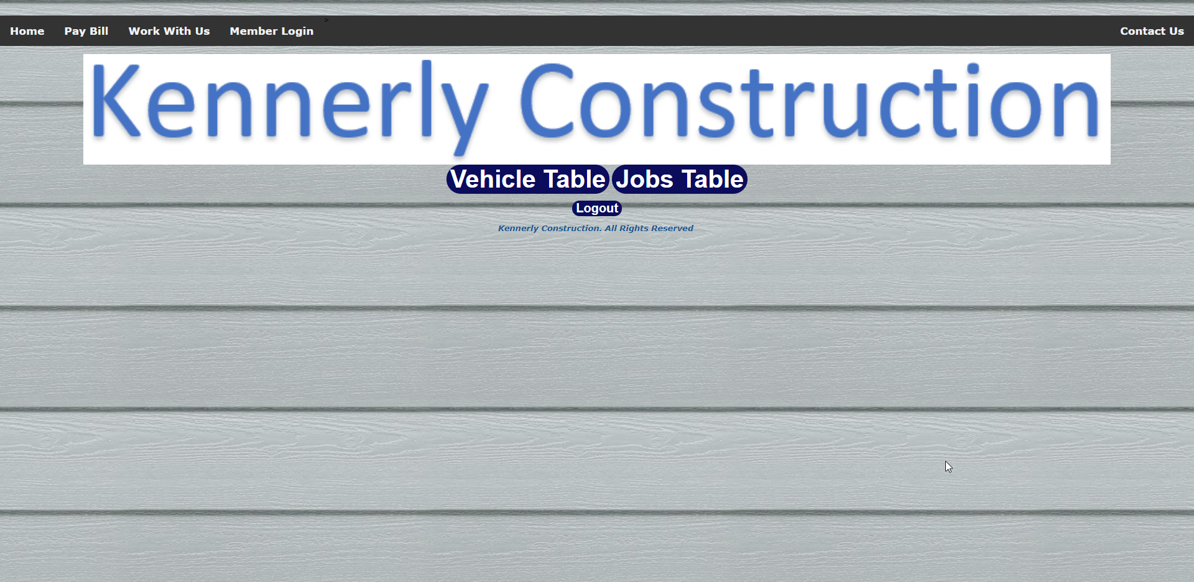

To access the vehicle or jobs tables employees need to create an account If password is forgotten, a new account will need to be created.

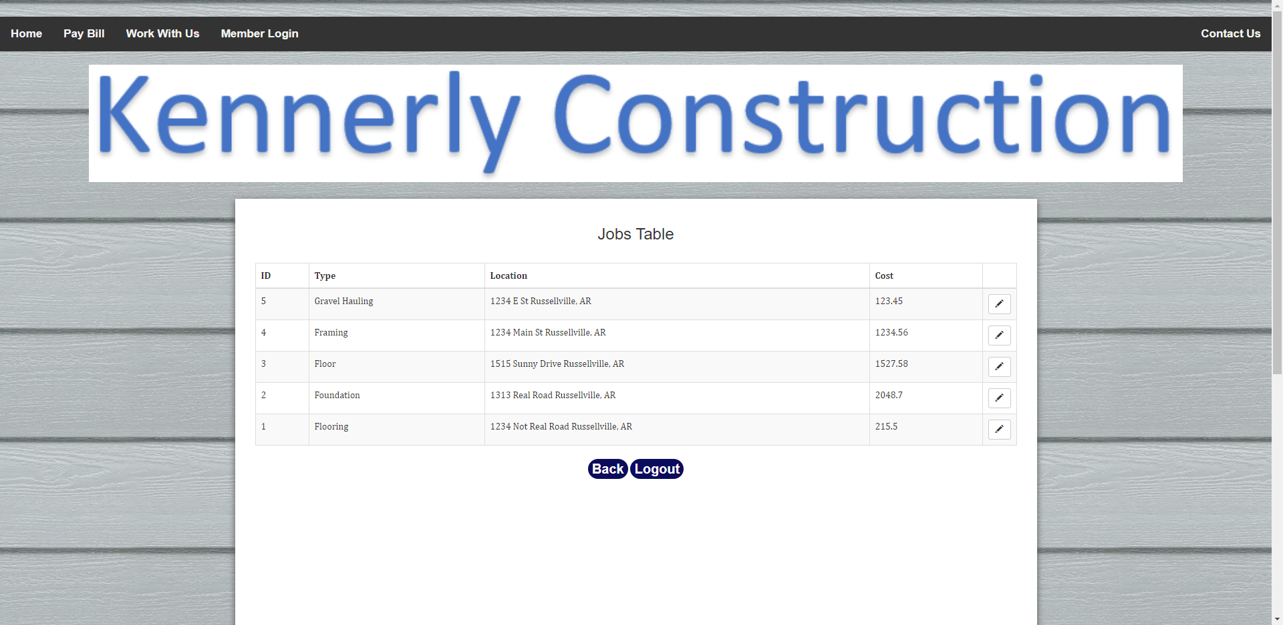

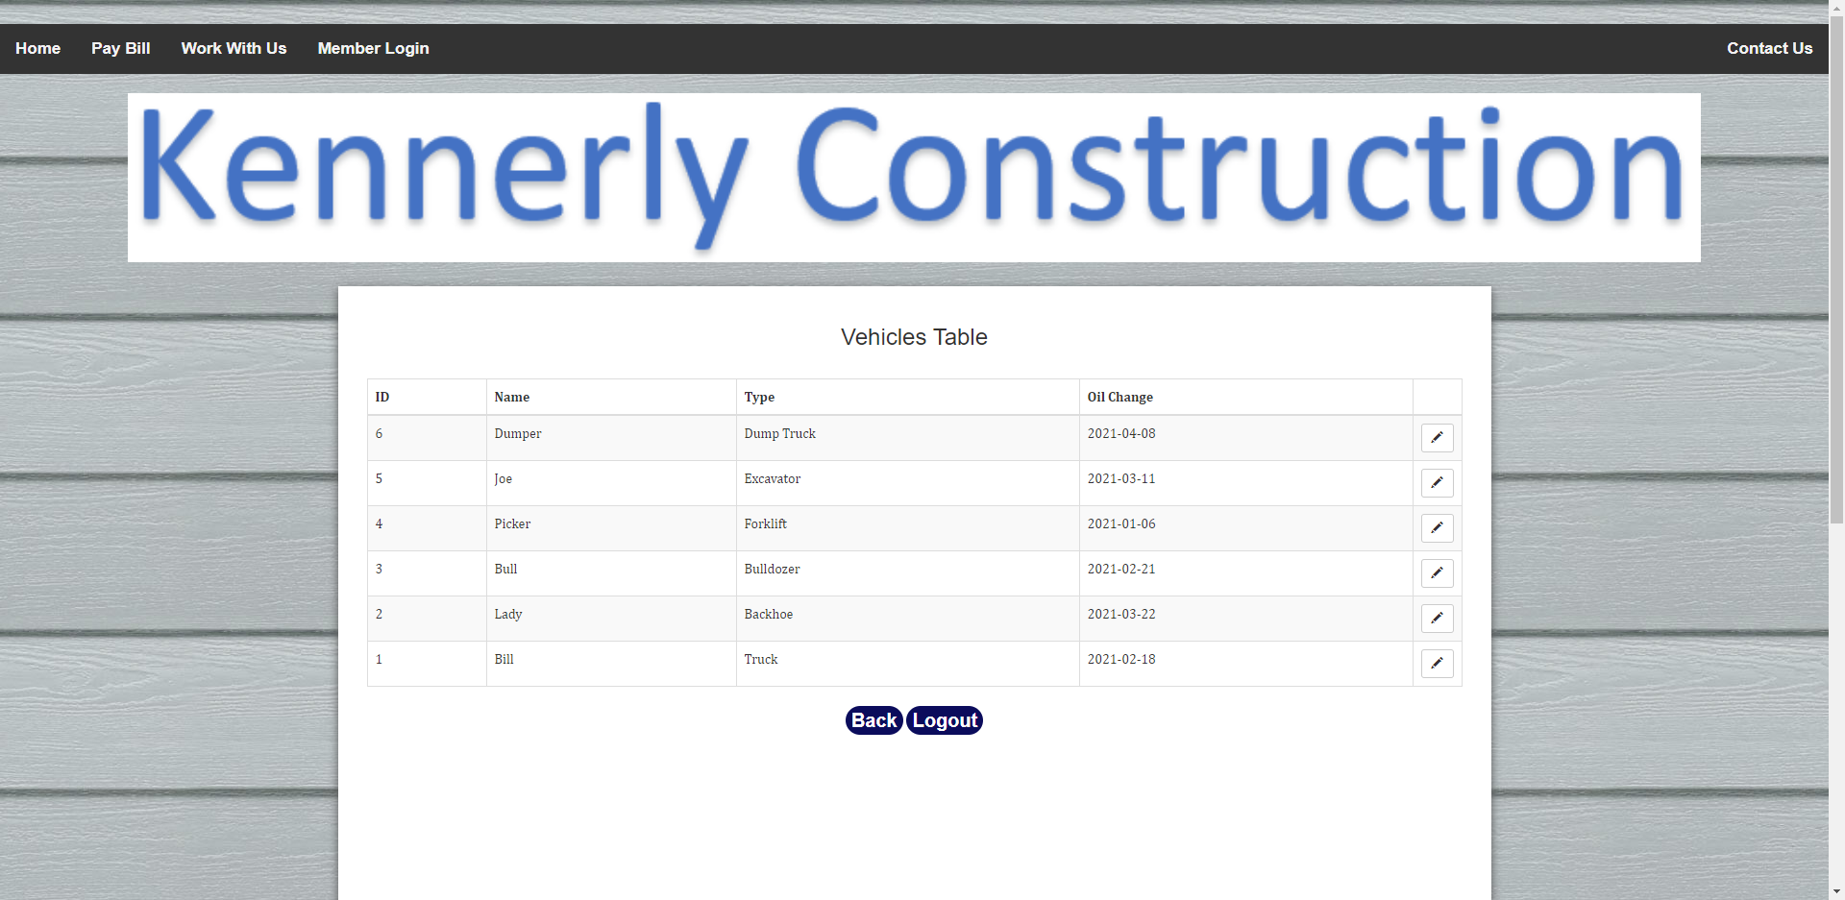

Once logged in, employees can edit the data inside the jobs and vehicles databases as needed, changes will be saves automatically.

**Users**

Regular users have access to all the tabs on the website, except for the member login tab. They can access the home page to learn about the company, make payments using the pay bill tab, and apply for employment at the company by filling out the employment application in the work with us page. Finally, if a user desires to leave a comment or request an estimate, they can click on the contact us page and fill out the form and be contacted by the company.

Home Page

Pay Bill tab

Employment application

Contact us page