**DIGITAL STAR GAMES LAUNCHER**

**OVERVIEW**

- This program was designed to help users get easy access to the game options provided by Digital Star Games. The launcher provides users with easy access to game options such as display resolution, sound settings, and game quality. It also provides the option for developers to post server status and current news in the system. To enter the main screen settings, a user account is required by the user, which can be a developer account or a user account. The system can be used by developers and users.

**Developer Options (Feature in Progress)**

- To access the system, developers will have a special account that will let them access the program and modify the settings set for regular users. Developers have the option to update server status, add and/or remove news and access user account information. Developers can also modify the system settings screen based on their needs.

**User Options**

- Users who have an account can save game progress and access game settings. Users who wish not to have an account will not be able to save game progress and/or access game settings. In case a user forgets a password, they will need to contact the developer team to create a new account.

**DIGITAL STAR GAMES LAUNCHER**

**TABLE OF CONTENTS**

**Introduction………………....…………………………………………………………………………...1**

**Development Team…………………………………………………………………………………...1**

**Project Details……………………………………………………………………………………...1**

**System Analysis………………………………………………………………………………………...2**

**Data Flow Diagrams………………………………………………………………………………….2**

**ER-Model…………………………………………………………………………………………….3**

**System Design…………………………………………………………………………………………..4**

**System Implementation………………………………………………………………………………..5**

**System Requirements………………………………………………………………………………….6**

**Conclusion……………………………………………………………………………………………….7**

**Introduction**: We were hired to build a Game Launcher for Digital Stars Gaming. It is an indie company established in 2018 that is currently working on their new game Elzia. The business wanted a system that was scalable for varying user setups, customizable and convenient, time saving and a new competitor on the market. For this setup we provided Digital Stars with an interface launchable by a single button. Customization options for audio, video, game and server settings. And a login page that stored username, password and birthdate in a database. The game launcher gave users access to all vital information while including all aspects that were required for the business needs.

**Development Team**: William Barrientos, Jackson Sheesley, Jefferson Stinson and Camron Stewart, Contact person for more information

**Project Details**:

Our project was separated by a couple of different parts: Website, and application.

Application - Made on visual studio, with a couple of steps.

1. Get window started and layout
2. Get buttons working
3. Create Artwork and fix up ui

Website - Created in notepad & notepad++ (<http://173.216.49.42/> & <http://173.216.49.42/login.php> )

1. Create news website and login portal
2. Create art for news website and write articles
3. Host website

**System Analysis**:

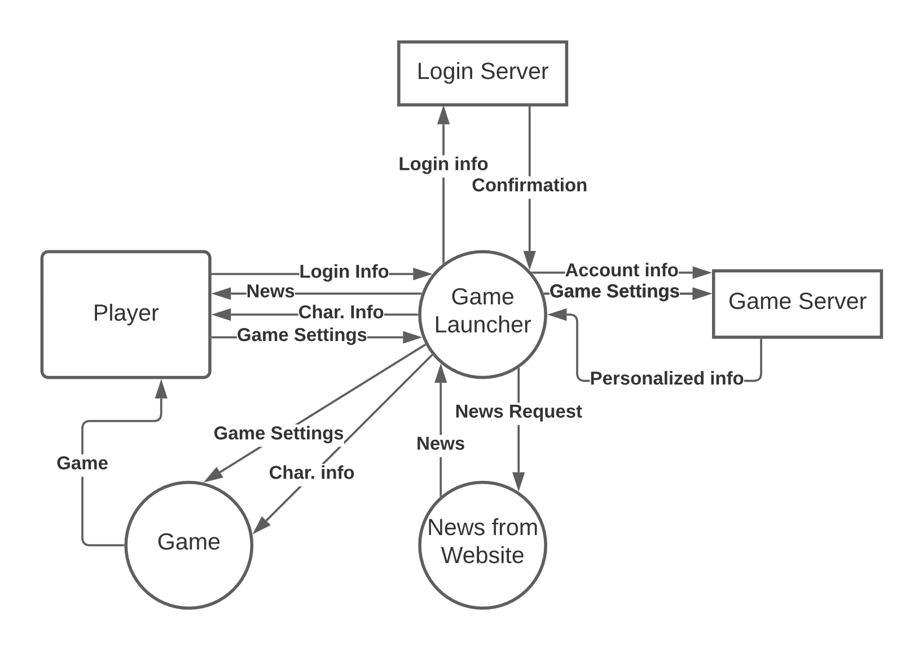

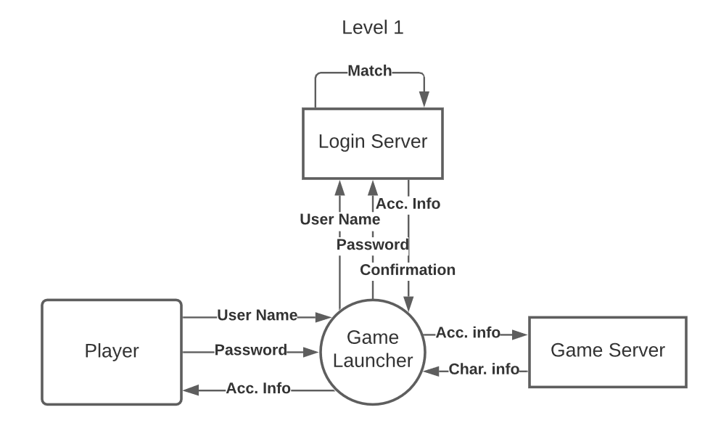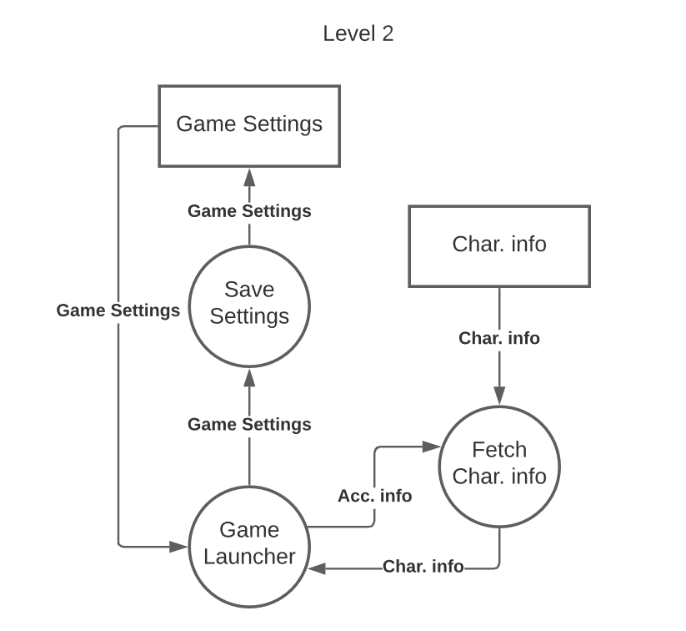

The data flow diagrams show how data is implemented and distributed throughout the system. The game launcher is the central point where information is processed from its external entities. Users request information from the launcher which sends a request to the correct server sending that information back to the launcher and displaying it to the user.

* Level 0 DFD shows the entire process as a whole and the game launchers corresponding data flows.
* Level 1 DFD shows a more in-depth look into how the launcher requests information and how the server processes that request for the user.
* Level 2 DFD is the most in-depth look at the data flow diagram. This shows how data is exchanged between the game server and the saved settings. The server will check the database for any new changes that need to be implemented.

The DFD’s were designed based on the business requirements needed for the client. The data flow shows distribution of information based on users actions.

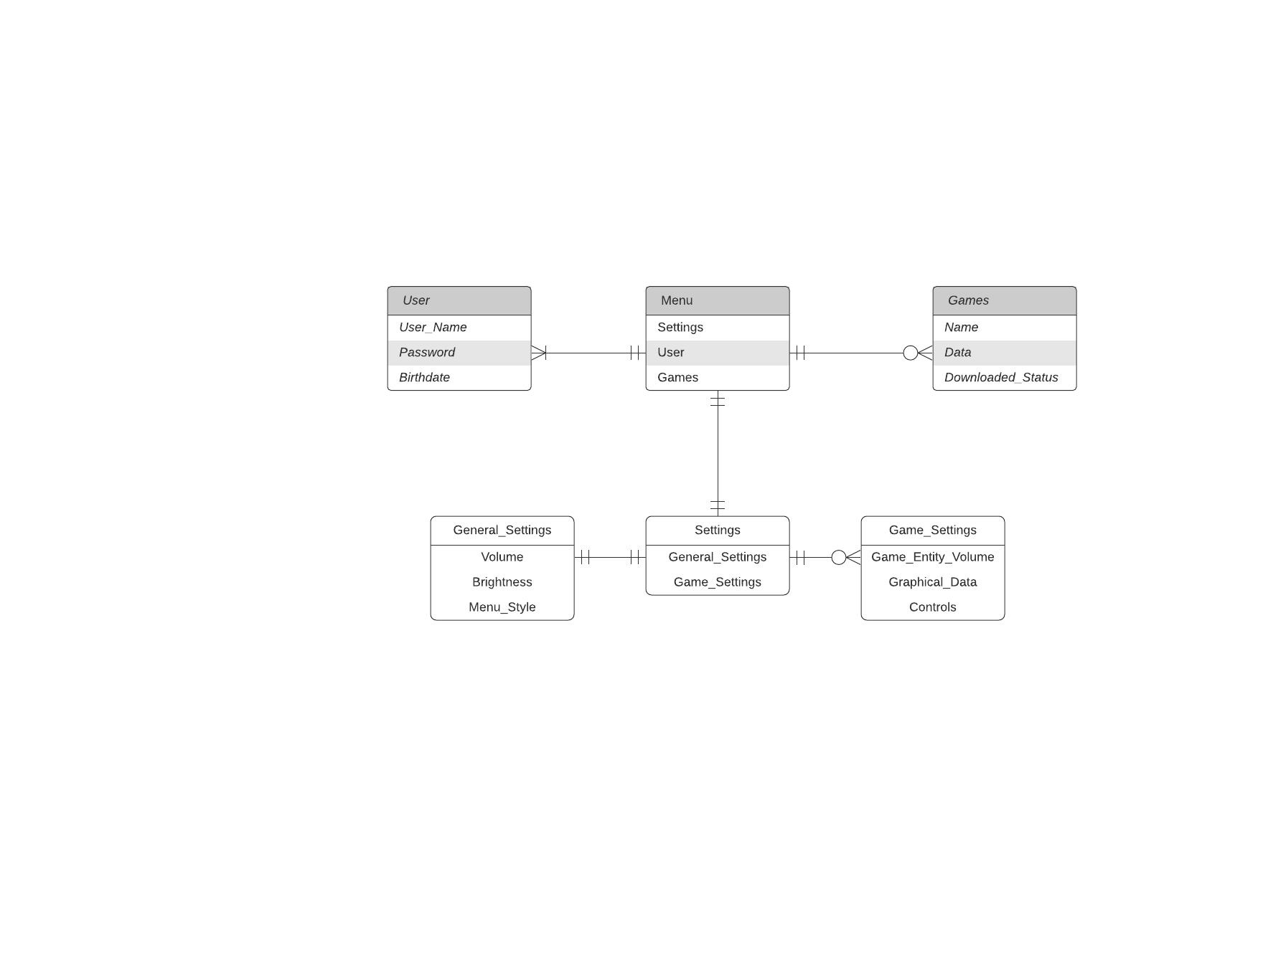

The ER-Models were built in reference to the designed database and website models. The users have to meet certain requirements in order to retrieve the requested information. Cardinalities were set to meet the criterias present in the database. The ER-Model represents how data will be processed and transported through the game launcher to produce the wanted results. For example, in the ER-Model a user must include their username, password, and birthdate to get a response from the system.

The analysis models were designed based on the business needs and UI models. The database was set up in a way that required certain cardinalities for each entity based on desired requests. The ER-Models provide a visual representation of how the database interacts with each entity and how data is distributed out of the system to the launcher. Data flow models were developed in accordance with the website we developed. The data models help give a visual representation of the data exchange going on in the server and database. It helps give the users and team members a reference to how the system was implemented based on the desired needs.

**System Design:**

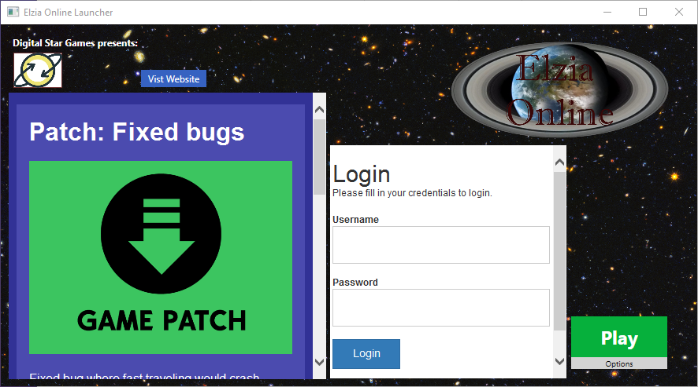

This is what you see when you first open the launcher, you have a couple of options on what to do: You can scroll through the news site and visit that website with the button, you can login to your account on Elzia Online, you can set your game options before you launch it, and you can also click play to start the game.

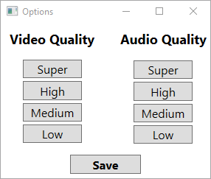

This is the window that pops up when clicking on the options menu, this is how you set the options the game uses when launched. The settings you click on save to an options.txt file so that the game can read them.

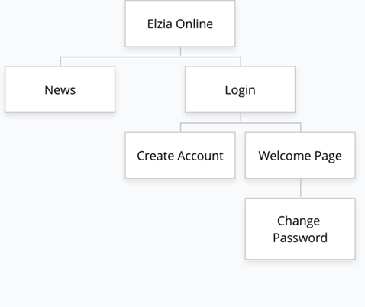

The site map here shows that there is a connection between the news site and the login page but no connection was made. This is due to a time constraint and also we did not feel it was entirely necessary. But this does show how you follow the login page.

**System Implementation**

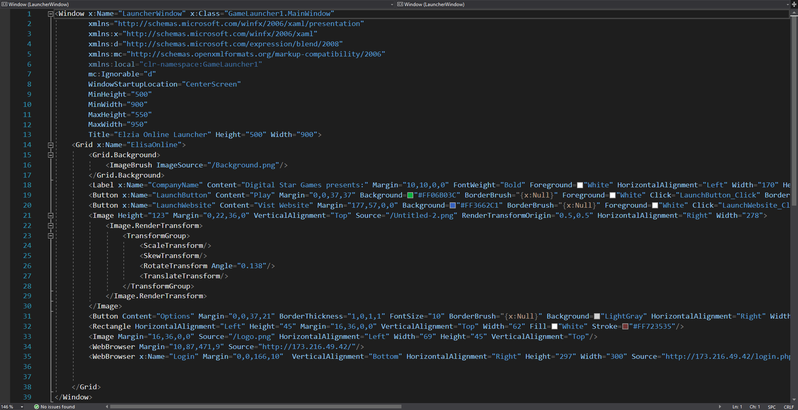

This is the main window, just a simple bit of C#, and it just shows how simple C# makes it to create a working window. 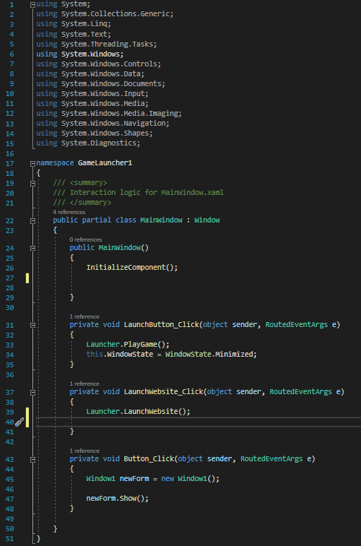

Image (left) shows how the buttons all work including some commented code that we forgot to get rid of. But this is all the working code when you click on the different buttons on the main window. We created a class to do the event handling of opening up the different applications and windows.

To install the program you can download the .zip file [here](https://drive.google.com/file/d/1l_Gy_X4HH_EUV4G7qw46as5N0NklNcIt/view?usp=sharing) that has everything you need in it, including the website files. Just none of the database stuff as the program I was using to host my website let me just create tables there.

In order to run this program you might need the .net framework unless you already have visual studio downloaded onto your computer with the C# framework installed. This will make a pop up if you do not have it with a link to install that so that you can run it.

**System Requirements**:

Hardware Requirements - Not much, I am sure you could run this on an older machine if needed

Software Requirements - you need the correct .net framework to run the window

**Conclusion**

The clients needs and requirements for the application were met with correct use and demonstration of models and software. The overall design and implementation of the game launcher was a success fulfilling the wishes of Digital Star Gaming. This documentation details the information collected over the course of the project. Reference models and informative data help illustrate the process from start to finish of the entire project.