jefferson lab
Version
1.0
Data Acquisition Group
JEventViewer
User’s Guide
Jefferson Lab Data acquisition group
JEventViewer User’s Guide

Carl Timmer
timmer@jlab.org

24-Jan-2014

© Thomas Jefferson National Accelerator Facility
12000 Jefferson Ave
Newport News, VA 23606
Phone 757.269.7365 • Fax 757.269.6248

Table of Contents

1. Evio Event-Viewing Gui 3

Evio Event-Viewing Gui
Section
1

There is a graphical user interface for looking at EVIO format files event-by-event, although it can also look at any file as a list of 32 bit integers. To run it simply execute:
java org.jlab.coda.eventViewer.EventTreeFrame

while making sure this class or the jar file JEventViewer-1.0.jar in is your CLASSPATH environmental variable. The following is a screen shot of the gui.

Figure 1.1: Event-viewing gui

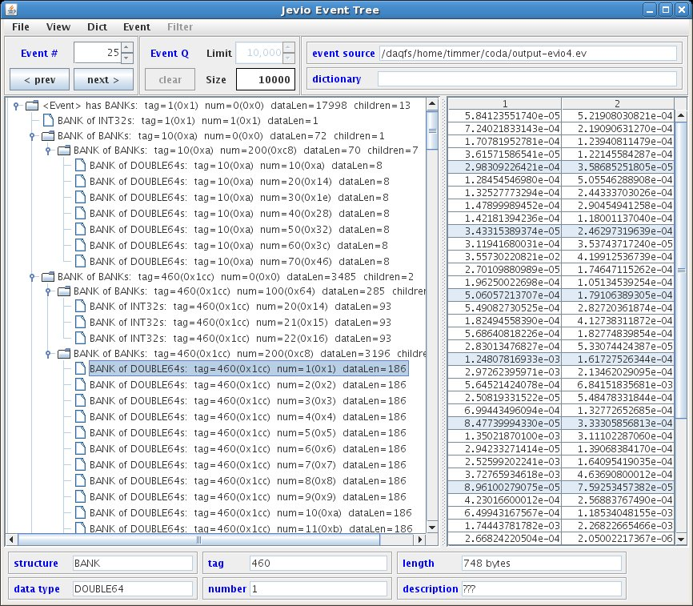
Here’s a quick list of all the available, user-selectable features:
- valid event sources are files, cMsg messages, and ET buffers
- fast compare ability for data from different events
- when receiving events through cMsg or ET, they can be filtered based on their CODA event type (physics, control, etc) and trigger type if physics event
- view integer data as hex or decimal
- select dictionary from event source or from separate file containing dictionary
- view the dictionary being used
- export any evio file in xml format (MUST BE TESTED)
- split between the event tree panel and the data panel may be vertical or horizontal
- can add or remove data columns
- view the contents of any file as 32 bit hex integers

Starting with the middle of the gui first, the left side shows a tree structure diagram of the whole, single evio event being viewed. Notice that the type of each evio structure is given (bank, segment, tagsegment), along with the type of data it contains, tag, num, size, and # of children. Tag and num are shown in decimal and hex. If a dictionary is being used, the dictionary name is displayed instead of the corresponding structure type, data type, tag, and num values.
The right side, on the other hand, shows the data of any selected bank, segment, or tagsegment that contains a primitive data type. The number of columns can be set in the “View” menu. Integers can be displayed in hex or decimal.
A fast compare feature is able to compare data from different events. If the current event is changed while viewing the data of its selected structure, and if the new event has a structure with the same hierarchy of tags that the previous selection had, it too is automatically selected. This facilitates comparing the same structure in each successive event by simply hitting the “next” event button.
A dictionary can be loaded from a separate xml format file, or it can come embedded in an evio format file or buffer (cMsg, ET). The viewer allows the user to switch, in the “Dict” menu, between the different dictionaries if more than one is available. Any dictionary being used can be displayed instead of the data.
Selecting an ET system or a cMsg server as an event source, in the “Event” menu, brings up other menus to allow the proper connections to be created and maintained. The only assumptions made are that in a cMsg message, the evio data is contained in the byteArray field. Any dictionary is first looked for in the evio data and if none is found, it is looked for in a String payload item called “dictionary”.
The box in the upper left (under the row of menu buttons), “Event #”, shows the event currently selected (in this case 25) and allows the user to navigate to the desired event.
The box to its right, “Event Q”, shows different things depending on if the data source is a file, cMsg messages, or ET events. For files it shows the total number of events (in this case 10,000). For cMsg messages and ET events, on the other hand, events are continually arriving. In this case, “Size” shows the number of events currently in an internal queue. “Limit” allows the user to set the size of this internal queue, while “Clear” will remove all events currently in the queue. Once this queue is full, nothing else is added. The “Event #” controls can be used to switch between events in the queue.
Switching between the different event sources can be done in the “Event” menu item. When selecting a cMsg or ET source, the “Filter” menu is enabled. With this menu, the user can choose to look at control, partially-built physics, physics events, or any combination as well as the selecting the run type of interest.
Notice that above the data, there are boxes containing the event and dictionary sources. Beneath the data are boxes containing information about the selected data structure.
In addition to looking at evio events, this viewer is useful when debugging evio-related applications by looking at files directly. The data in a file are viewed as 32-bit integers in hex. This can be done with the “File” menu item selecting the “View File Bytes” option and producing the following window:

Figure 1.2: General file viewing window

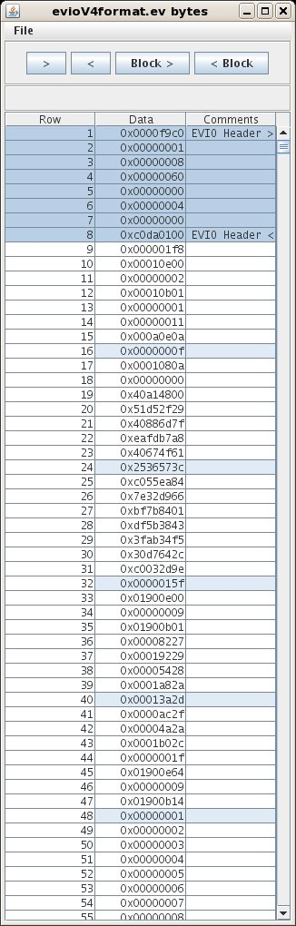

Endianness of the data can be switched using the “File” menu and comments can be added by hand in the right-most column. The arrows move the view up or down by one screen’s worth. The block buttons hop to the next or previous evio-format block header.
When an evio block header is found, it is labeled and selected as you see above.

