1

The pre-cleaning plant has been designed and built for the elimination, or reduction to acceptable levels, of oxygen, water and organic contamination inside the perfluorobutane (C4F10) to be used as Cherenkov radiator. A sketch of the system is shown in fig. 1.

The plant receives C4F10 in gas phase from a bottle containing the material to be cleaned. A compressor KNF Oil free Viton membrane pump N 145.2 ANE, makes the gas flow inside a 3A molecular sieve filter followed by an activated carbon filter (approximate volumes of the cylinders is 10 liters) to clean it from water and other contaminants, like aromatic organic compounds, which are captured by adsorption.

The processed gas is then liquefied in a liquid nitrogen driven freezer and drops in liquid form inside a clean bottle. A few 1/h N2 gas supply sets the working pressure inside the system. Oxygen is eliminated via periodical venting through a bubbler of the gas on top of the freezer, where the uncondensed gases accumulate.

A set of safety valves is mounted to release any pressure higher than 3 absolute bars which could endanger the system. One can see from the figure that there are two identical sets of filters, A and B. Once a set is exhausted, the system isolates it and switches to the other one.

At the same time the first one is regenerated by means of heating up of the cartridge to 200 °C for some hours while flowing argon.

The operational parameters can be modified according to the amount and type of impurities which are affecting the gas transparency. As general rule a transparency better than 85% down to 165 nm triggers the quality assessment making the gas usable for the operation into the RICH-1 detector.

For this reason the cold section of the pre-cleaning system can be lowered down to -80 Celsius as well as the pressure at which the venting valve will release the not liquefied gas part.

Typical operational values are 1.6 bar relative pressure.

Not all the gas which is circulated through the filters and is entering the cold section, is liquefied and collected into the clean gas tank, part of it is sent back through the so called back flow line.

The amount of gas recirculated is adjusted through a multi-turn needle valve from few l/h to several hundred l/h according to the needs: large amount of oxygen requires the gas phase to be re-circulated several times. The total flow, which is the sum of the gas flow out-coming from the dirty gas bottle and the recirculated one can be adjusted via a bypass needle valve across the input/output of the KNF pump.

In our system there is no O2 nor H2O measurement at the output venting line since the flow is intermittent and at a pressure that may damage the sensors or provide not reliable results.

Depending on the different material samples, the same light transmission has been obtained with material losses up to 50%. The large variation of loss rates is related to the different amount and nature of contamination impurities: ideally, the choice of the best filter should be sample dependent i.e. using Cu catalyst to remove O2.

Water contamination and Oxygen contamination ~5 ppm are achievable with the pre-cleaning system

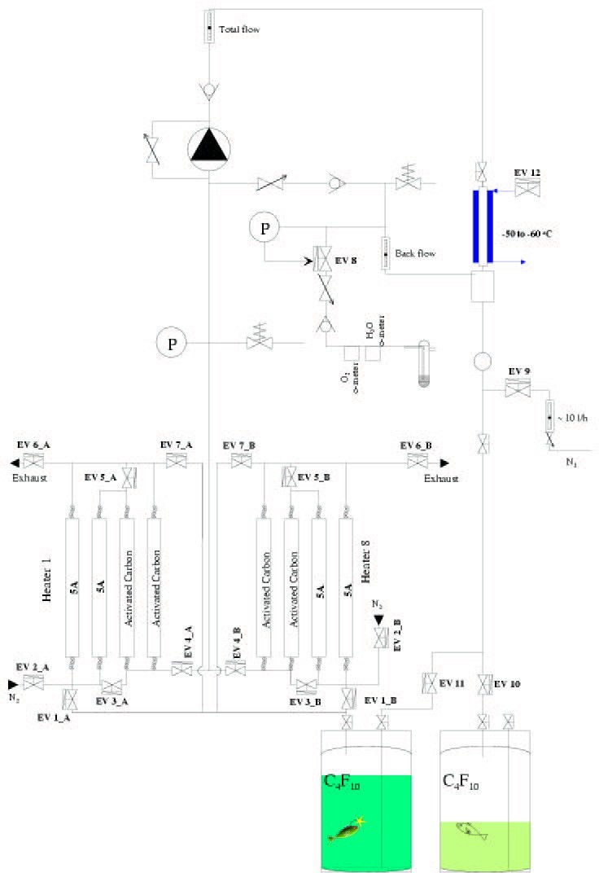

Fig , Schematics of the Pre-cleaning system used for the COMPASS RICH-1