**Attachment 1**

**Terms and Conditions for Coating of the Cylindrical Mirrors**

1. **General Description.**

The Cylindrical Mirrors for the Low Threshold Cerenkov Counter (LTCC) consists of 216 mirrors varying in dimension from 4”x6” to 7”x8”. The mirrors are grouped in sets of 36. One set correspond to one out of six LTCC units. A small and large cylindrical mirror are shown in Fig. 1. A schematic of the LTCC optics is shown in Appendix A.

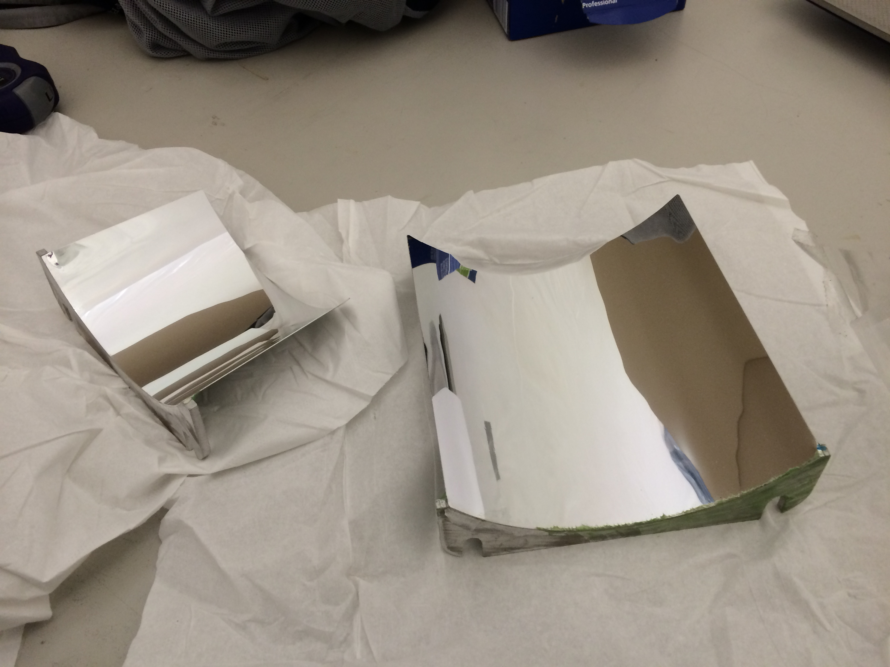

**Fig.1.** An example of small and large cylindrical mirror.

**II. Specifications and Technical Requirements**

**2.1 Definition**

Each mirror is designed to reflect Cerenkov light from a range of incident angles onto a relatively small circular area of approximately 6" in diameter. Its general shape is cylindrical.

The mirrors were coated approximately 17 years ago with Aluminum + Magnesium Fluoride. The 90% original reflectivity degraded to about 75%. Tests confirmed that re-coating the mirrors with AlMgF2 can restore reflectivity to approximately 90%.

**2.2 Delivery**

Each sector set of 36 mirrors ready for coating will be delivered in a cardboard box filled with appropriate packaging material. The front of the mirror facets will be covered with special paper for protection. The coated mirrors should be shipped to JLab in such a manner that no cleaning or any other additional maintenance would be required during storage or usage of the mirrors. Damage of any kind due to shipping and handling is not acceptable.

**2.3 Cleaning**

Cleaning of the working surfaces before coating by the Vendor Company is essential. No

defect should be introduced due to the cleaning performed by the Vendor Company.

**2.4 Coating**

We will require Al reflector coatings and MgF2 protective coatings. The application method for each should be vacuum (vapor) deposition. The coatings are required to meet the conditions of items 2.5.

**2.5 Requirements**

1. A Reflectivity of ~ 88% is required for wavelengths between 200nm and 600nm (Refer Reflectance vs. Wavelength Curve for Protected Aluminum, see Appendix B).
2. We will require a minimum lifetime of 30 years with no optical degradation.
3. The reflective surface coating should show no deterioration after a test exposure in air for 24-hours at a temperature of 49oC and 95% relative humidity.
4. The vendor may clean the reflective surface with only optical liquid if needed, but should avoid any other contact of the reflecting surface.
5. The reflecting surface coating should show no damage after 3M Scotch Brand No.610 adhesive tape (or equivalent) is placed against the coated surface and removed slowly.

**2.6 Working Conditions**

Recoated mirrors will be stored in a controlled humidity, clean room environment for a period of about 3 months. In the final configuration mirrors will be enclosed in a C4F10 (perfluorobutane) gas volume with a maximum net pressure of about 340Pa.

**III. Tests and Quality Assurance**

The vendor will perform direct or indirect checking of reflectance of each mirror facet coated and provide Jefferson Lab with corresponding tests. Coated mirrors will be tested at Jefferson Lab as well to check reflectivity and other parameters as specified in this document and compared with the results provided by the vendor. Mirrors that do not pass the tests will be sent back to the vendor for refurbishing or rejected**.**

**IV. Delivery**

The 216 cylindrical mirrors will be shipped for coating to the vendor in 6 boxes, one per sector, 36 mirrors in each box. Installation of the mirrors at Jefferson Lab is expected to start in March 2014, at a rate of one sector / month. Number of mirror facets in each installment, their delivery and testing rates can be modified and established by mutual agreement between Jefferson Lab and the vendor.

**VI. Payment**

Payment for coating of mirror facets, completely tested and accepted by Jefferson Lab, can be made upon request, without waiting for completion of coating of all the mirror facets. Other rules and regulations that are standard for all payments made by Jefferson Lab are applicable.

**Appendix A: Schematics of elliptical, hyperbolic, cylindrical mirrors and light collection (Winston) cones.**

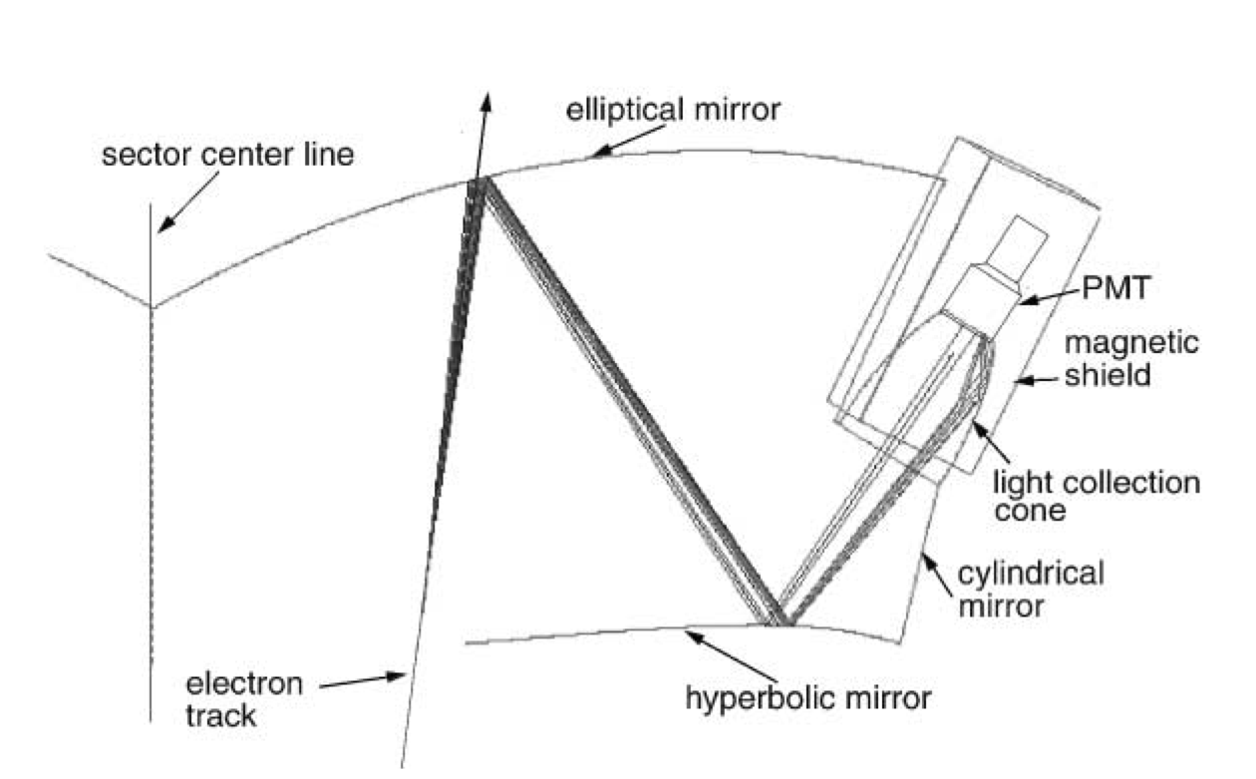

**Appendix B: Reflectance of (Al)MgF2 Coating as a Function of Wavelength**

