**Attachment 2**

**Terms and Conditions for Coating of Lexan Strips**

1. **General Description.**

The Elliptical and Hyperbolic Mirrors for the Low Threshold Cerenkov Counter (LTCC) consists of 432 mirrors varying in length from 5’’ to 55’’ and in width from 5’’ to 9’’. The reflective surface is a Lexan substrate coated with Al + MgF2 placed on three Kevlar layers 1’’ thick. The reflectivity of the coated mirrors degraded during the 15 years of operation. A series of test showed that removing the current coating and re-applying Al+MgF2 coating is not feasible. Thus we decided to coat new Lexan strips and glue them with Loctite 77 on top of the current mirrors. An example of an elliptical mirror is shown in Fig. 1. A schematic of the LTCC optics is shown in Appendix A.

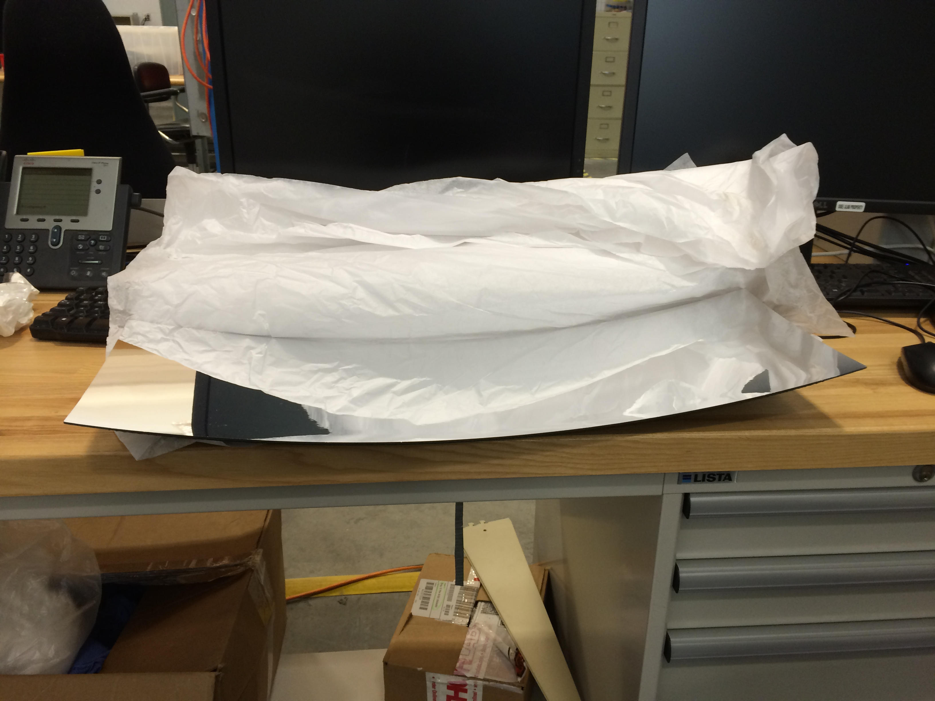

**Fig.1.** An example of elliptical mirror.

**II. Specifications and Technical Requirements**

**2.1 Definition**

It was determined that 10 mils (or 0.01 inches) is the ideal thickness of the Lexan strips. A minimum length of 36’’ is required. Two sets of widths, 9’’ and 10’’, were determined based on the mirrors widths. The quantities to re-coat all the LTCC mirrors are:

* 570 feet of the 9" wide, 10 mils thick.
* 450 feet of the 10" wide, 10 mils thick/
* 30 feet of 10" wide 36" long  50 mils thick

**2.2 Delivery**

The vendor will be responsible to provide the Lexan material. The coated surfaces should be shipped to JLab in such a manner that no cleaning or any other additional maintenance would be required during storage or usage of the mirrors. Damage of any kind due to shipping and handling is not acceptable.

**2.3 Coating**

We will require Al reflector coatings and MgF2 protective coatings. The application method for each should be vacuum (vapor) deposition. The coatings are required to meet the conditions of items 2.5.

**2.5 Requirements**

1. A Reflectivity of ~ 88% is required for wavelengths between 200nm and 600nm (Refer Reflectance vs. Wavelength Curve for Protected Aluminum, see Appendix B).
2. We will require a minimum lifetime of 30 years with no optical degradation.
3. The reflective surface coating should show no deterioration after a test exposure in air for 24-hours at a temperature of 49oC and 95% relative humidity.
4. The vendor may clean the reflective surface with only optical liquid if needed, but should avoid any other contact of the reflecting surface.
5. The reflecting surface coating should show no damage after 3M Scotch Brand No.610 adhesive tape (or equivalent) is placed against the coated surface and removed slowly.
6. The coated surface should be protected with an additional protective layer. This protective layer should cover only the coated surface. This layer should protect the coating even when a small amount of pressure is applied, which is equivalent to the pressure applied by a soft paint roller that is rolled across the surface.
7. Minimum length of each strip: 36’’.

**2.6 Working Conditions**

Recoated surfaces will be stored in a controlled humidity, clean room environment for a period of about 3 months. The non-protected, non-coated layer will be sprayed with Loctite 77 and glued on top of the LTCC mirror substrates. In the final configuration, mirrors will be inside a C4F10 (perfluorobutane) gas volume with a maximum net pressure of about 340Pa.

**III. Tests and Quality Assurance**

The vendor will perform direct or indirect checking of reflectance of each mirror facet coated and provide Jefferson Lab with corresponding tests. Coated surfaces will be tested at Jefferson Lab as well to check reflectivity and other parameters as specified in this document and compared with the results provided by vendor. Surfaces that do not pass the tests will be sent back to the vendor for refurbishing or rejected**.**

**IV. Delivery**

Installation of the coated surfaces onto the mirrors at Jefferson Lab is expected to start in January 2014, at a rate of 8/day. The number of mirror facets in each installment, their delivery and testing rates can be modified and established by mutual agreement between Jefferson Lab and the vendor.

**VI. Payment**

Payment for coating of mirror facets, completely tested and accepted by Jefferson Lab, can be made upon request, without waiting for completion of coating of all the mirror facets. Other rules and regulations that are standard for all payments made by Jefferson Lab are applicable.

**Appendix A: Schematics of elliptical, hyperbolic, cylindrical mirrors and light collection (Winston) cones.**

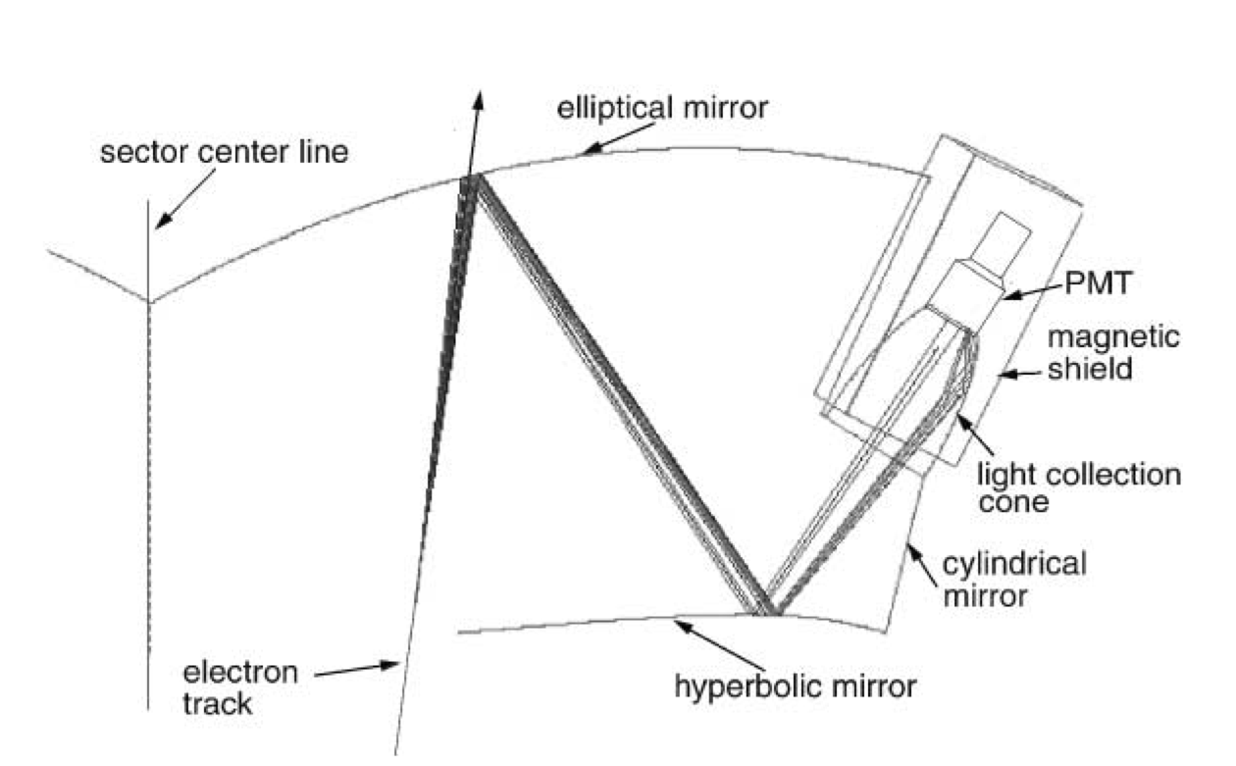

**Appendix B: Reflectance of (Al)MgF2 Coating as a Function of Wavelength**

