Activity 242242036

Wavelength Shifting tests

This activity started in August 2013 at Temple University.

Temple has the equipment to coat tubes with p-tephenyl.

Temple also built a setup to test the effect of the WLS, using modern data acquisition system. Below is an example of comparison of coated/uncoated PMT. A full presentation with preliminary results can be found here:

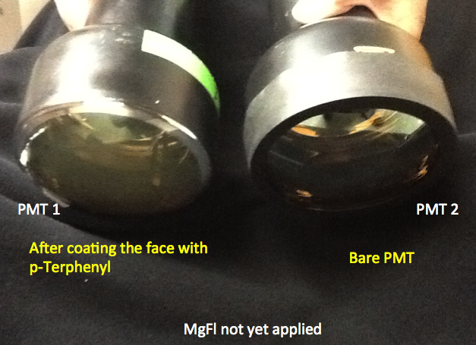

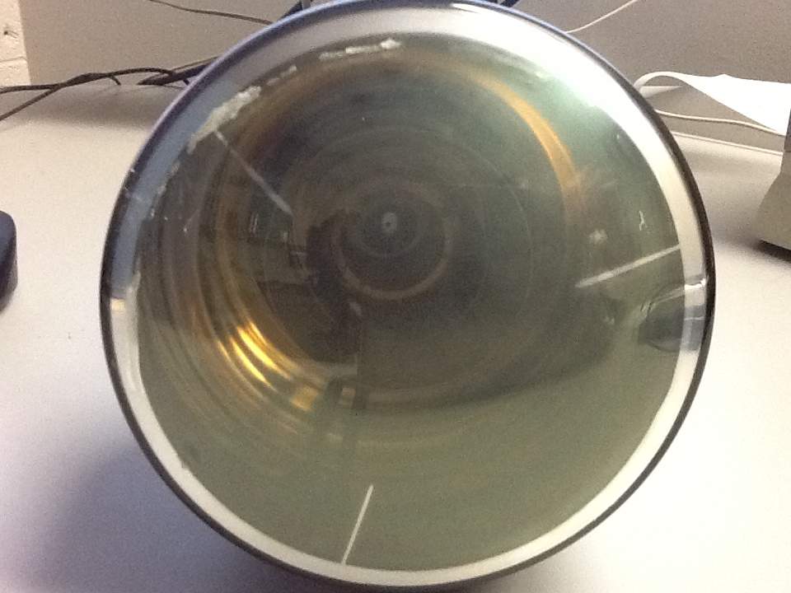

Better view of coated PMT