**Attachment 1**

**Scope of Work for Coating of PMT window**

1. **General Description.**

There are 216 PMTs in the Low Threshold Cherenkov Counter (LTCC). The PMT model is Photonis XP4500B (see Attachment 2). The window material is UV glass. The quantum efficiency of UV glass degrades below 300nm. However, the Cherenkov light peaks below 300nm.

A p-Terphenyl evaporated coat on the glass face will shift the UV wavelength from below 300nm to 385nm, thus increasing the photon yield in the sensitive range of the PMT. An example of such coating is shown in Fig. 1.

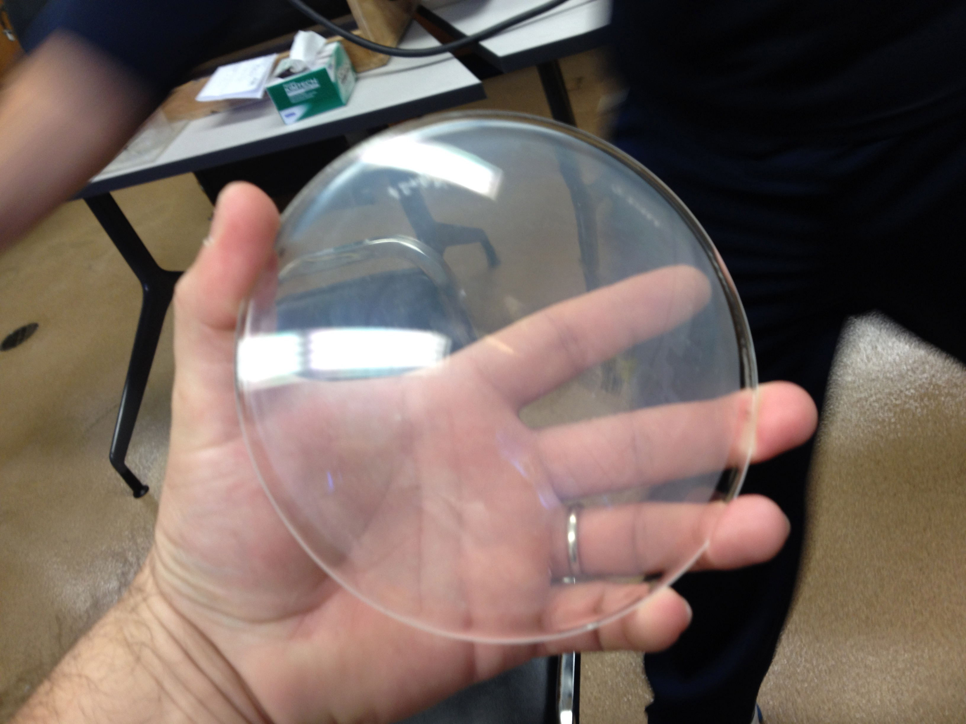

Fig 1: an example of UV glass window coated with p-Terphenyl

**II. Specifications and Technical Requirements**

**2.1 SPE Testing Requirement**

The Photonis PMTs are capable of showing a Single Photo-Electron peak due to thermal electrons in the photo-cathode. This capability has been deteriorating and would need to be tested and compared to previous performance. Therefore, a single photo-electron peak spectra is required for each PMT in the HV range 1400V-1900V.

**2.2 Coating Requirement**

We will require p-Terphenyl coating on the PMT window. The application method for each should be vacuum (vapor) deposition. The coatings are required to be at an ideal mass thickness of 100 micrograms/cm2 (+/- 15 micrograms/cm2).

**2.3 Delivery**

The 216 PMTs will be shipped for coating to the vendor in boxes, with 3 or 4 PMTs’s in each box, filled with appropriate packaging material. Installation of the PMT’s at Jefferson Lab is expected to start in April 2014, at a rate of one sector / month. The number of coated PMTs in each installment, their delivery and rates testing can be modified and established by mutual agreement between Jefferson Lab and the vendor.

**III. Tests and Quality Assurance**

The vendor will perform direct or indirect checking of the PMTs coating and provide Jefferson Lab with corresponding reports. Coated PMTs will be inspected at Jefferson Lab as well. Surfaces that do not pass the tests will be sent back to the vendor for refurbishing**.**

**IV. Delivery**

Installation of the surfaces onto the mirrors at Jefferson Lab is expected to start in March 2014, at a rate of one sector / month. The number of coated PMTs in each installment, their delivery and rates testing can be modified and established by mutual agreement between Jefferson Lab and the vendor.

**VI. Payment**

Payment for coating/testing of the PMTs can be made upon request, without waiting for completion of all the PMTs. Other rules and regulations that are standard for all payments made by Jefferson Lab are applicable.

**Appendix A: Schematics of LTCC components, including PMT.**

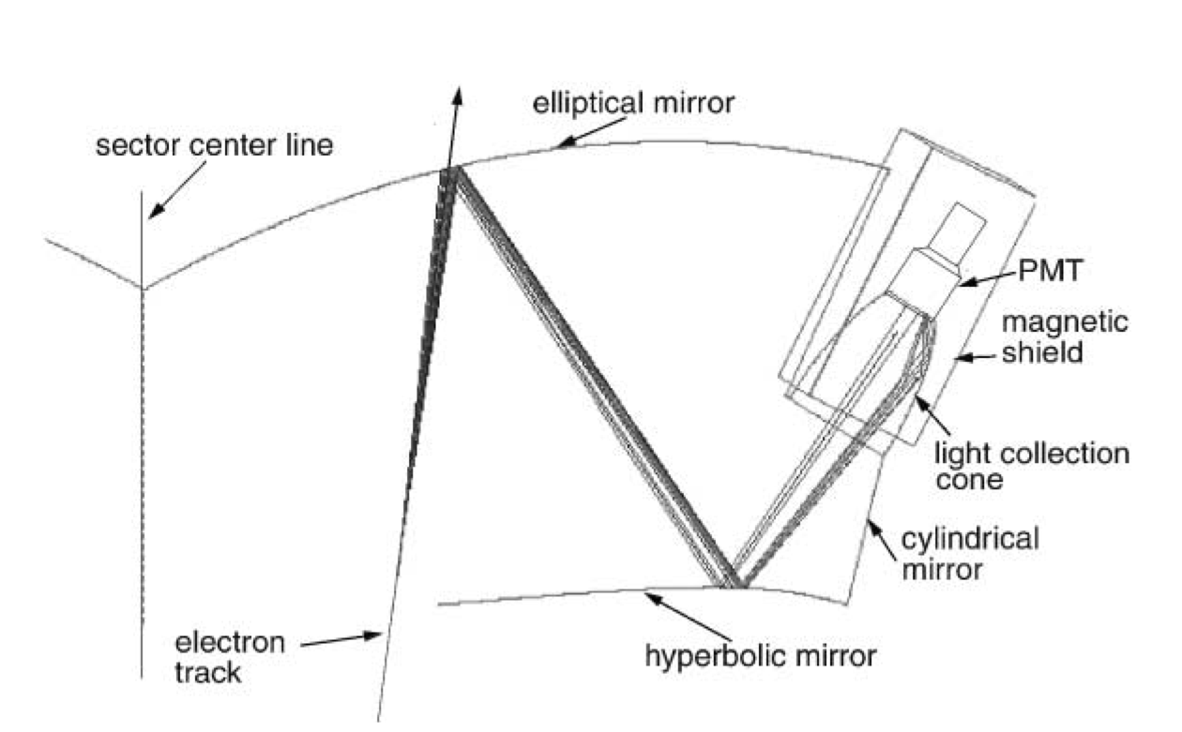

**Appendix B: Typical single photo-electron peak spectrum.**

