Extraction of F2N from Electron-Deuteron Scattering in an MEIC

Oz Amram

National Science Foundation, Research Experience for Undergrads Program

Carnegie Mellon University

Jefferson National Laboratory

Newport News, Virginia

August 1, 2014

Prepared in partial fulfillment of the requirement of the National Science Foundation’s Research Experiences for Undergraduates under the direction of Douglas Higinbotham at Thomas Jefferson National Accelerator Facility.

Participant: _______________________________

Signature

Research Advisor: _______________________________

Signature

**Abstract:**

The lack of free neutron targets has made it very difficult to study the internal structure of the neutron with high precision. The construction of a new Medium-energy Electron Ion Collider (MEIC) would allow us to use electron-deuteron scattering to obtain free neutron data by tagging the spectator proton. The focus of this project was to test a new model independent method of extracting the neutron structure function (F2N) from simulated cross section data. It was shown that the model independent method converges to a single value of F2N reliably for cross section data with limited random error. A model dependent modification of the method was shown to reduce error in the extracted F2N. This result demonstrates the proof of concept for a model-independent way of extracting F2N from cross section data. A better extraction of F2N from electron-deuteron scattering would fill in one of the major longstanding gaps in our knowledge of nuclear structure.

**Background:**

Previously, electron-deuteron scattering has been used as a substitute for true free-neutron target experiments.. Deuteron has a low binding energy so it is possible to approximate the proton and neutron as quasi-free. There is a lot of good data on proton scattering, which can be removed from the deuteron data to approximate free-neutron data. However, there exist high-momentum states within the deuteron nucleus where the nucleon-nucleon potential is very important. These states limit the accuracy of the free nucleon approximation. Without information about the initial state of the nucleus, these high-momentum states make it impossible to extract F2N with high precision.

In a fixed target experiment it is extremely difficult to detect the spectator proton at low momentums because they are moving very little. This means that in a fixed target experiment you cannot always know the initial momentum of the proton in the nucleus, which is key to an extraction of F2N. In the MEIC it would be easy to tag the spectator proton because it would have a great deal of momentum in the lab frame. This would allow for measurements of the initial proton momentum in the nucleus which can be used, in the method shown in this paper, to extract F2N.

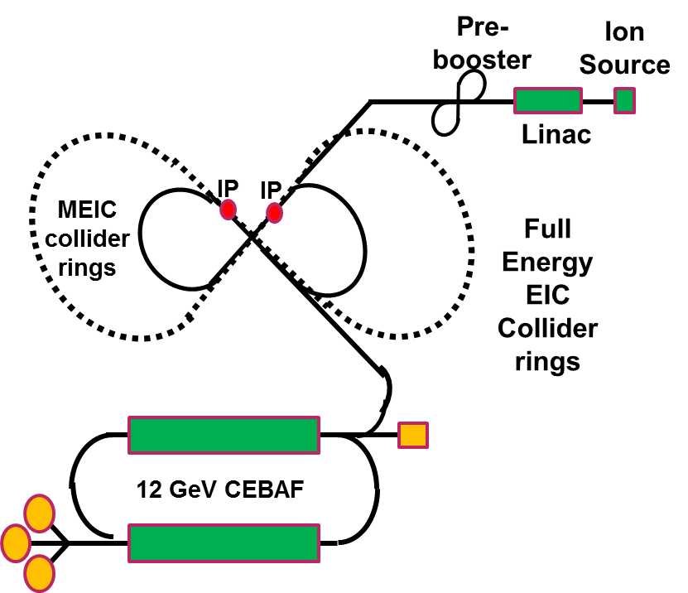

**Fig 1:** JLab MEIC Design[1]

The Jefferson Lab proposal for an MEIC is one facility where this measurement could be made. The proposed design is a ring-ring accelerator geometry that would use the already existing 12 GeV CEBAF facility as the electron source and construct a new ion source.

**Models Used:**

In this project a simple, yet analytically precise, model of electron-deuteron scattering, written by Christian Weiss, was used to generate sample cross section data. This simple model was used because it was easy to work with and to modify. However, it was first shown that, at low proton momentums, the simple model approximates a more complex and realistic model. The simple model was compared to a more robust model of electron-deuteron scattering, written by Misak Sargsian, which has a more realistic nucleon-nucleon potential and includes the correct high-momentum tail.

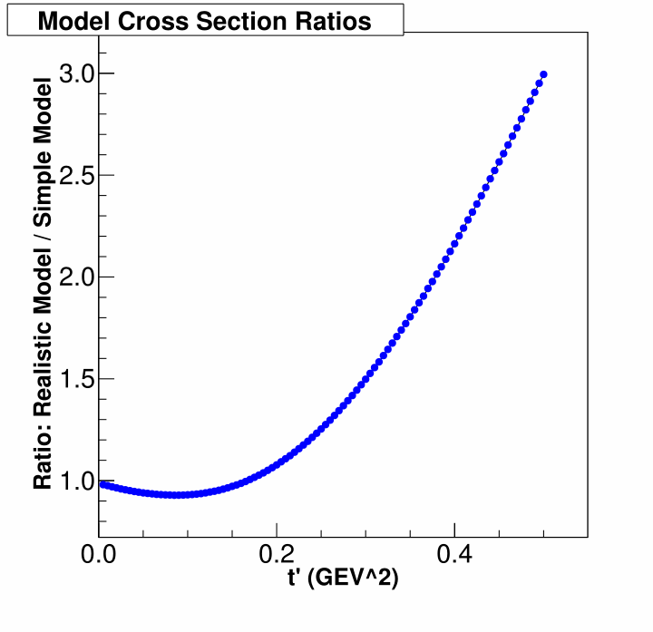

**Fig 2:** Ratio of simple model to the complex model versus proton momentum (t’).

As we can see from Fig. 2, in the low t’ region, which was the only region used in this project, there is pretty good agreement between the models because their ratio is close to one and the slope is close to zero. For higher proton momentums they begin to disagree because the high momentum tail present in the realistic model. This result provides justification for using such a simple model in this project.

**The Model Independent Method:**

The method of extraction F2N from cross section data is as follows:

1. Measure cross section as a function of proton’s initial transverse momentum (t’)
2. Take out the pole factor from the cross section data given by Eq. 1.

$POLE= \frac{RES}{{(t^{'})}^{2}}$ (Eq. 1)

1. Fit the cross section / pole function with a polynomial in a range of low t’
2. Extrapolate to the on-shell point, also called the pole, at t’ = 0
3. F2N is the value of this function at the pole

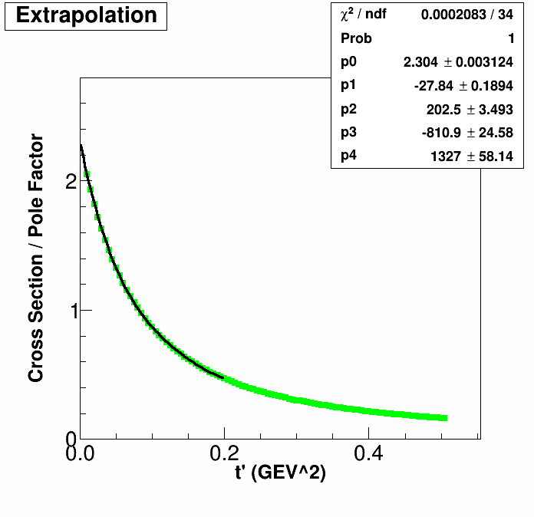

**Fig. 3:** An example of the F2N extraction process.

There are 2 main parameters to consider when performing the model independent fit: what range of t’ to fit over and what order of polynomial to fit with. There is no a priori order of fit or t’ range that are better than others. The goal is to choose a fit that has a small spread in extracted F2N. It is also important that there is no tension in the fit, biasing the result for F2N. The way to check for tension in the fit is by comparing multiple orders of fit for a given t’ range and see that there is good agreement between them on the value of F2N. Choosing the correct order of fit and t’ range it is a balance between stability and precision. The higher order fits more sensitive to error and less stable, especially for very low t’ ranges, but may describe the shape of the data better than lower orders of fit. Smaller ranges of t’ produce less stable fits, especially in the presence of random error, but the orders of fit diverge at larger ranges.

In order to determine these fit variables, a Monte Carlo method was used to generate many data samples. In order to create more realistic data, the binning in t’ was limited to the resolution we would expect from detectors in an MEIC and random errors were added to the sample cross section data outputted by the physics model. Then various fits of different ranges and orders were performed on the data. This was iterated many times to determine the spread in extracted F2N for specific fitting ranges and orders. The spread in extracted F2N’s as well as agreement with the next highest order fit were used to determine the best fit.

**Model Dependent Modification:**

A modified method, which constrains the fit based on theoretical models of the cross section, was also tested. In this method, a theoretical cross section over pole factor curve is produced with no error is produced and fit with the desired polynomial over the desired range. The values of the fitting coefficients are stored and then set as fixed onto the real data. The only parameter left free in the fit to real data is the 0th order term, or y-intercept, which is the value of F2N. The idea behind this method is that if there was a model which accurately described the shape of the cross section data, one could generate many theoretical curves for different values of F2N, pick the one which best describes the data, and then use this method to constrain the fit. By constraining the fit to just one variable, the spread in extracted F2N should be reduced significantly.

In this project, the same model that generated the sample data was used to generate the theoretical curve, but the theoretical curve had no random error added to it. This is the ideal case for this method because our model perfectly describes the shape of the data, and the same value of F2N was used to generate both curves.

**Model Dependent Ratios Method:**

Another model dependent method which constrains the fit in a slightly different way was also tested. This method takes advantage of the fact that at low t’ the cross section scales linearly with F2N, which we can see in Fig. 4[2].

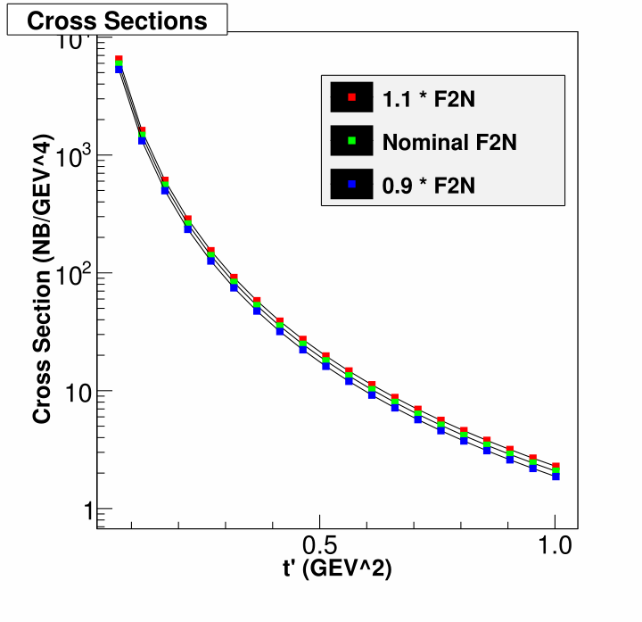

**Fig. 4:** A demonstration of the linear scaling of F2N with cross section.

This means that we can generate a theoretical curve with some parameterized F2N and then fit data that has the real F2N by fitting the ratio. The process would be to generate a theoretical cross section over pole factor curve, perform a fit with the desired polynomial over a certain t’ range and generate a function like Eq. 2.

$f_{model}\left(t^{'}\right)=c_{0}+c_{1}t^{'}+ c_{2}{(t^{'})}^{2}+ c_{3}{(t^{'})}^{3}…$ (Eq. 2)

Then, if our model is correct, we know that the function describing the real data is a linearly scaled version of the equation of the model. This is shown in Eq. 3, where $k$ is the ratio of the parameterized F2N, used in the model, to the real F2N of the data.

$f_{real}\left(t^{'}\right)=k* f_{model}\left(t^{'}\right)$ (Eq. 3)

We can then fit the real data using the function of the model as fixed.

$f_{real}(t^{'})=k*(c_{0}+c_{1}t^{'}+ c_{2}{\left(t^{'}\right)}^{2}+ c_{3}{\left(t^{'}\right)}^{3}…)$ (Eq. 4)

Once again we are only fitting one free parameter, but now it is a ratio and not a single coefficient. Once we have performed a fit to determine $k$, we can easily see that the value of the function at the pole (t’ = 0) is given by

$F2N= f_{real}\left(0\right)=k*c_{0}$ (Eq. 5)

This method is a more general model dependent extraction than the previous method because it does not rely on the model curve being generated with a very accurate F2N. It also gets rid of the less precise step of generating many theory curves with different F2Ns and choosing the best one.

In the testing of this method, the model curve was generated with a known F2N and the pseudo-data being fit was generated by the same model but with a different, unknown, F2N. This blind test was used to simulate how the method would be applied to real data.

**Results and Method Comparison:**

It was found that 3rd order fits were generally the best in terms of stability and precision. Lower orders of fit produced systematically lower extracted F2Ns and were never in good agreement with other orders of fit. The higher orders of fit proved to be too unstable when random errors were added to the data. 3rd order fits had very good agreement with 4th order fits if the right t’ range was chosen and showed more stability in lower t’ regions and in data samples with larger random error.

The correct t’ range for fitting was found to be dependent on the amount of random error in the data. With more random error added to the data, larger t’ ranges proved to be better because including more data points stabilized the fit against the random error. However, when less random error was present in the data, fits for lower t’ ranges worked fine. Fitting a lower range of t’ when possible is generally better because the different orders of fit diverge as the t’ range gets larger. Code was written so that the amount of random error in the data can easy be changed and different t’ ranges can easily be tested.

We can see from the following plots (Figs. 5, 6 and 7) that the model dependent method and the model ratio method significantly reduce the spread in extracted F2N. The model independent method compounds on the random error in the data; for a sample with a random error of 0.3% it extracts F2N with an error of 0.5%. It was also seen that with data sets above a certain threshold of random error, on the order of 1% random error, the process becomes highly unstable. We can see that the model dependent method reduces this spread in F2N by a factor of 10. In a blind test, the model ratios test is slightly worse than the model dependent method, but still reduces the spread in extracted F2N by a factor of 5.

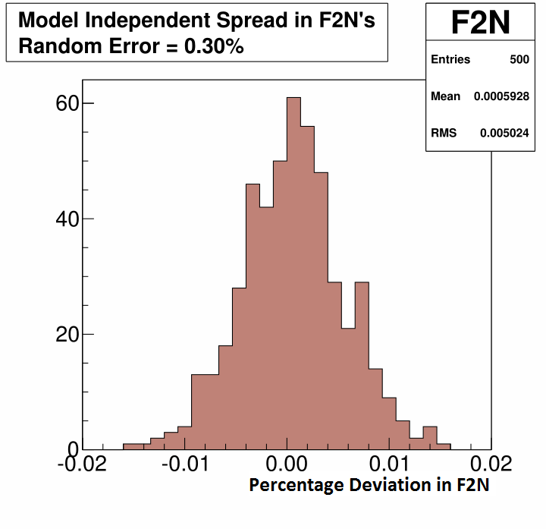

**Fig. 5:** Spread in F2N’s for model independent method.

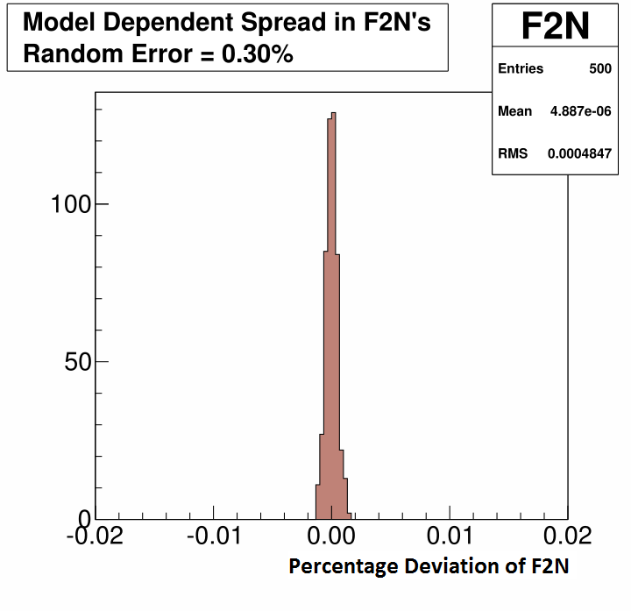

**Fig. 6:** Spread in F2Ns for model dependent method.

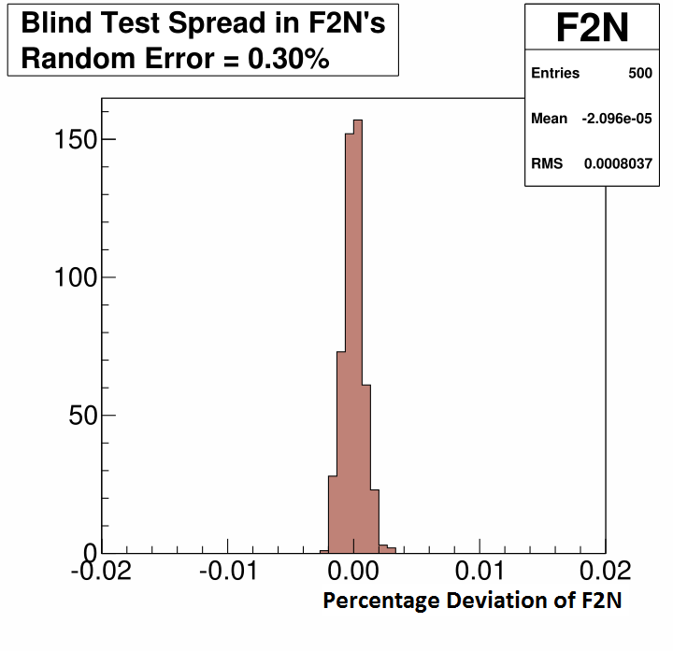

**Fig. 7:** Spread in F2Ns for results of blind test for the model ratios method.

**Conclusions:**

It was shown that the on-shell extrapolation, a model independent method of extracting F2N, can be successful. Generally 3rd order fits were the most stable and precise independent of the amount of random error. It was found that the correct t’ range for fitting is dependent on the amount of random error in the data. The model independent method is very sensitive to larger amounts of random error in the data. A model dependent modification to the method has been shown to produce and F2N with 10 times less error and another, perhaps more robust, model dependent method can produce F2N with 5 times less error. All of these methods are promising new approaches for extracting F2N. The next step in testing these methods would be to conduct full Monte Carlo simulations that include models of the detector systems. This would produce a more realistic idea of how precise we can expect to determine F2N from these methods. A better measurement of F2N would represent a significant improvement in our knowledge of neutron structure.

1. Lin, Fanlei. “MEIC Project at Jefferson Lab”. EIC 2014. Jefferson Lab, Newport News. 17 March 2014. Lecture.
2. It should be noted that this relationship was also confirmed with the more realistic model as well, but recent data shows that this relationship may not hold at larger t’. However for this method this only needs to be valid at low t’.