MyaViewer User’s Guide (v3.2)

By Chris Slominski and Michele Joyce

Introduction 2

Overview 2

The ordinate (Y) axis on MyaViewer charts 2

Ordinate axis rules 3

Adding to a chart, having one or more plotted signals 4

Charts and their types 5

Boxy looking plots! 6

Configuration sets 6

User preferences 6

Signal history binning 6

Discontinuities 7

Context menus 7

Channel Metadata 7

Scale to view - supplemental history fetches 8

Bit Masking 8

Command Line Options 8

The Graphical User Interface (GUI) 10

The legend 11

Adding Signals 11

The chart window 11

Rubber banding 12

Boundary markers 12

Axes 12

The Menu bar 13

File Menu 13

Properties Menu 13

Data Menu 19

View Menu 21

Special controls 24

The status bar 25

# Introduction

The *MyaViewer* utility is a tool used for visualizing EPICS control system signal history that was collected by the *Mya* archiving system, in addition to real time control system data. It is available only on Linux (rhel-4-0-ia32) architectures that have connectivity to the *Ops fiefdom* of the accelerator control system. These systems must have certain X server patches applied before they will properly handle the graphical interface needs of the *MyaViewer*. Contact the system administration group for details.

The tool is available via the OPS menu and direct command line invocation. You will get the default startup when selecting from the menu, and will have numerous startup options when running from the command line. See “Command Line Options”.

# Overview

The *MyaViewer* is a full featured tool. This section gives you an overview of the things you can do with the tool, as well as provides concepts that will make usage of the tool more intuitive.

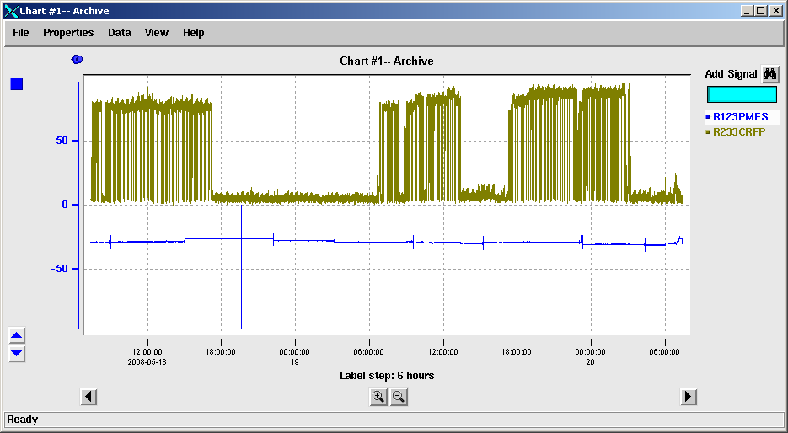

## The ordinate (Y) axis on MyaViewer charts

Denoting a signal’s values is straight forward when the chart contains only one signal’s history over time. Difficulties may arise when multiple signals are presented on the same chart, especially when each signal’s range of values differs by orders of magnitude.

The *MyaViewer* utility has a very sophisticated mechanism for controlling the ordinate axis of a chart. **Signals plotted on the chart may share an axis configuration with some other signals, while having yet additional signals plotted against a totally different axis configuration.** Note that only one axis configuration is shown at one time. It will be drawn in the color associated with the current focus signal. Color squares are shown along the axis to let you know which signal plots may be interpreted against that axis. You will not be able to judge values of signals not associated with the current axis configuration by simply scanning the axis labels. You will either need to **“mouse-over” points on the plot to obtain signal values**, or switch to the axis configuration for the desired signal plot. The fastest way to switch to a different signal configuration is to click the desired signal name in the tool’s legend.

There are several ways to move signals to and from various axis configurations; these are described in the various dialog popup sections of this manual. Note a quick way to separate a signal from an axis that contains multiple signal plots is to simply click the axis color square associated with the signal. A new axis configuration will be created for the signal.

**An ordinate axis configuration may be in one of two states; auto scale and fixed scale**. Auto scaling means that the tool chooses the range of values shown on the axis when the axis is created, additional signals are added to the axis, or the user modifies the range of the time (X) axis to view a larger portion of signal history. Users may place an axis into fixed scaling mode by manually entering an axis range on the axis properties dialog box (after deselecting the auto-scale checkbox), or stepping the axis using the tool’s axis step arrows. You can tell when an axis is in the fixed state because a thumbtack symbol is shown at the top of the axis. You can revert back to auto scale mode simply by clicking this thumb tack.

**A very convenient feature for viewing multiple signals on a chart is the *Tile Signals* option on the Y axis context menu.** It is used on a set of visible signals whether or not they are automatically or manually scaled. Multiple signal plots often occupy the same portion of the chart, making distinguishing features of individual plots difficult. The *Tile Signals* option allocates one horizontal region (tile) of the chart per each visible signal on the chart. It automatically scales the axis in such a way that the signal plots are contained within their tile, having no overlap with other signals.

### Ordinate axis rules

The following is a set of rules that will apply to the ordinate axis shown on the viewer tool charts. This includes all three different chart types; archive charts, live strip charts, and correlation charts. These rules dictate how a single ordinate axis will be shown when there may be multiple plots on one chart.

* **A chart will have one or more ordinate axes.** Only one axis will be visible at any time. Each axis will have a list of signals associated with it. **Some of these signals may be active, while others are inactive.** Hidden signals are not drawn on the screen, do not have any special color coded chart symbols shown on the chart, and do not impact auto scaling calculations of any axis.
* **An axis may have its bounds explicitly set by the chart user. Alternately, the axis may be set to auto scale, which will be a calculation of bounds made such that all active channels associated with the axis will take up the majority of the viewing height of the chart, centered as a set. The auto scale bounds may change as the bounds of the abscissa axis are modified, because the maximum and minimum values within the set of channels may change.**
* Explicit ordinate axis bounds will remain in effect until the user requests new bound values or enables axis auto scaling.
* **Each signal plot coexisting on a single chart will have a unique color assigned to it.** This color will also be used for the signal’s legend entry and other unique chart symbols associated with the signal.
* The initial ordinate axis is established on a chart when the first signal plot is created. Auto scaling of the ordinate axis is used by default, but the user may later specify axis bounds via the menu system. The color of the created axis will match the color of the signal plot.
* **When explicit axis scaling causes a signal plot to be entirely above or below the visible chart area, a color matched arrow will be shown on the appropriate chart edge indicating the direction to the plot.**

### Adding to a chart, having one or more plotted signals

* All signal plots added to a chart will be associated with the currently active ordinate axis. If the axis is in the auto scale configuration, the scale bounds will be recalculated considering the impact of the newly added signal. Otherwise in fixed scale mode, the plot will be made relative to the existing ordinate axis even if the added plot will be entirely off screen.
* There will be a focus plot for a chart. It will be the last signal added to the chart; however the user can also select the focus plot by left clicking a signal name in the chart legend. A new signal always becomes the focus plot. The ordinate axis associated with the focus plot will be the only axis shown, with other axes hidden from view. The color of the ordinate axis will match the color of the focus plot.
* The color of the ordinate axis, including labels and tick marks, matches the color of the focus plot. Since an axis may have other plots associated with it as well, this association will be portrayed to the user by having a small color coded square for each associated non-focus plot. These squares will be stacked vertically just to the left of the vertical ordinate axis line.
* Right clicking on a signal name in the legend provides a pop up menu relevant to the signal that was clicked. One option will be to modify the signal’s associated ordinate axis. Any changes made in this manner will only affect the axis of the selected signal. Therefore, if the channel belongs to a group of signals sharing an axis, the channel may be removed from the group and have an individual auto scale axis created for it.
* The menu system will provide the capability to modify the properties of the focus axis showing on the chart. Changes to the focus axis affect all plots that are associated with the axis. An exception to this is changes made to the focus axis by stepping the focus plot up or down using the ordinate axis arrow icons. When this is done, the focus plot will be automatically removed from any signal group sharing the axis, so that it can be separated individually from other plotted signals. The user will also be able to add or remove plots to the focus axis via the menu system. When a plot is removed from the focus axis, it will be given its own unique axis set to auto scale mode.

## Charts and their types

Users may open another chart window from the menu bar of any chart. These charts can be one of three specific chart types. The type of the initial chart is obtained from the command line arguments or the user preferences. The chart types include an **Archive Chart, Correlation Chart, and a Strip Chart.**

An archive chart shows signal history over a static, but modifiable, time range. It only shows data collected by the *Mya* archiving system. This differs from the *Strip Chart*, which shows live control system values over a dynamically changing time range. The strip chart merges live signal data with archived data, when archive data for the signal is available. You distinguish the two sets of data by the “now-line”, which is a vertical line drawn on the chart at the time where live collection began. Note the “now-line” will be moved forward to the present when various operations are requested on a strip chart.

Correlation charts are very different from the other types of charts. The X-axis of the chart is not time, but rather a range of values of the independent signal used in the correlation computation. Although there is no time axis in a correlation, a time span is still used to focus the correlation computations to a particular time of interest. Signal history data will only be obtained from the defined time window. There is a default time range for which data is collected, but the user may choose any time range desired from the *Data->Collection Info* menu. This menu also shows a maximum number of points that may be collected, which limits how much data will be collected when performing a correlation. The time range is divided into this many equal size spans and one sample of the independent signal is obtained from the span. Note that the creation of correlation plots is very slow and you should not request a large number of correlation points.

## Boxy looking plots!

You will soon notice that *MyaViewer* signal history plots look boxy instead of having ramps and sharp angles. If you haven’t yet, keep zooming in on a signal plot until you do. There are two reasons, as described below.

The *Mya* archiving system does not sample signal values at a regular interval, but uses control system monitors to be notified of changes to the signal. Additionally, *Mya* only saves changes that are deemed to be significant per a signal’s associated dead band value. So when you have a pair of signal history points, the one thing you know is that the signal value never varied by a significant amount until the time of the second point. Depicting this scenario by plotting the points as connected by a single line could be very misleading. A better representation is to **draw a plateau between the points with a vertical line rising to the new value at the time of the second point.**

For example, consider a beam current having a steady value over several days. At the end of the second day there is an RF trip and the current drops from 12 micro amps to zero. Connecting these points on a plot implies that there has been a gradual ramping down of current from 12 to zero over two days, which is very misleading.

***MyaViewer* allows the user to select plotting techniques as desired. You may choose to “connect the dots”, but the plateau style is selected by default because of the nature of the data collection described above.**

## Configuration sets

Many users of archive data choose to view the same set of signals regularly. *MyaViewer* configuration sets are a convenient way to request a commonly used set of charts. Once you have created one or more charts, you may request that a configuration set be created from the *File->Save config* menu.

Configuration sets are very useful. You recall them to show the same set of charts and signal plots that existed when you saved the configuration set, but they will be adjusted to correspond to the most recent time range. You can also override some of the saved chart configuration via command line parameters, giving you a very powerful way of obtaining charts that meet your signal history needs.

## User preferences

*MyaViewer* has a number of default settings that are in effect when you run it for the first time. Although these have been chosen carefully by the tool’s designers, you may have personal preference as to how the tool behaves. Each user has their own set of preferences created automatically, which may be modified via the *View->Preferences* menu.

## Signal history binning

Some of the archived signals have frequent updates and a very large amount of data is stored in their history set. You may ask for a signal plot over a time range that will require the database lookup, network transport, and plotting of many millions of points. The fetch time for this amount of data is long (~150,000 points per second) and the graphics refresh time is unacceptably jumpy as you attempt to interact with your charts. The *MyaViewer* tool will let you know when the number of points that will be fetched is prohibitively large. You may choose to go ahead with the entire fetch, or select signal history binning.

Signal history binning is a technique to **reduce the amount of signal history points obtained from the archiver, while still providing signal value trend information over a large time range.** The requested time range is divided into some number of equal size bins, and one signal data sample is obtained from the time bin. Note that there may not be any signal updates in a time bin, so the total number of signal points obtained is typically less than the number of bins requested.

After binning, you may zoom into a plot to get greater detail of an area of interest. When zoomed in, the number of signal data points may no longer be prohibitive and the sampling of the signal history may be hiding the details you are looking for. This is a good time to use the *Refresh* option found in the context menu of the signal legend. It will re-fetch channel history for the chart window.

## Discontinuities

There are times when archiving of a signal has not occurred. These period show up as gaps in continuity between plot segments for a signal. When you “mouse over” the last point in a segment, you will not only get the value and time associated with the point, but you will get the reason for the discontinuity as well. Note there are no discontinuities portrayed in binned plots.

## Context menus

You may “right click” over various *MyaViewer* elements to get a context menu of actions you may perform. Candidates are signal names in the legend and chart axes. These menus may also be accessed via the main menu bar.

## Channel Metadata

There is more than just value history associated with an archived signal. There is also some general information about the signal and how it is being archived. This information may be viewed via *View->Archive information* menu. Most of the available information is of no interest to the regular signal history user, but there are a few things that may be of use.

EPICS enumerations are archived by their numeric index. This makes plotting reasonable and is an efficient way to store an enumerated signal’s history. The viewer may however wish to know the text strings that are associated with the enumerated values.

The *Archive-delta* (ADEL) associated with a signal defines what is considered a significant change in the signal value, meriting archival. It acts as a dead band to reduce the amount of archived data that is just noise. Not all signals have an ADEL defined. They are defined by system owners and cannot be modified by users of signal history data.

## Scale to view - supplemental history fetches

The *MyaViewer* tool is very considerate to its users. It works hard to keep users from repeating signal history fetches of data already obtained. When you nudge the time range over, it just does a small fetch to supplement the signal history already obtained, instead of performing a large fetch over the entire new time range of the chart. This means you can hold down the time scroll arrow on the tool and see smooth transitions through signal history. You’re welcome (did you forget to say thank you? This wasn’t easy).

One ramification of this capability is auto scaling. The entire accumulated data set is used in auto-scaling operations. This gives continuity to transitions when scrolling back and forth or zooming in and out. You may however end up with a chart that does not look optimally auto scaled. This happens when the range of signal values are significantly less in the current chart view than what was viewed previously for the signal. In this situation, use the *Properties->Y axis->Scale to view* selection.

## Bit Masking

Some archived data is a composite of independent bit fields of information as opposed to a single data value. Plots of signals of this type can be very difficult to interpret because changes to bit fields that you are not interested in may obscure changes to the bit fields you are interested in. The viewer allows users to specify a mask value to be applied to all signal history values obtained from Mya. You enter a bit mask value, like 0xF0, in the entry box found on the *Data->Collection Info* menu to select fields of interest in your data.

# Command Line Options

-type <initial chart type> { Archive, Strip, or Correlation }

Example: MyaViewer.tcl -type Archive

-begin <begin time>

-end <end time>

The time format is 'YYYY-MM-DD HH:MM:SS' or a signed integer interpreted as the number of seconds relative to now. You may provide just the date or just the time in the absolute format, with the date defaulting to today and the time defaulting to 00:00:00. The relative offset integer may have a time unit suffix {s=sec(default) m=minute h=hour d=day w=week}. Note that the relative offset may have a '^' prefix to denote that the integer is relative to the begin or end time when a time span is provided.

Example: MyaViewer.tcl -begin 03:14:00 -end 13:30:00

-signal <signal(s) to plot> { Lists can be enclosed in “”'s }

example: MyaViewer.tcl -signal “R123PMES R124PMES”

-xsignal <independent signal> { Correlation chart }

Example: MyaViewer.tcl -type Correlation -xsignal R2XXITOT

-deployment <id> { specify MYA deployment (default is ops) }

Example: MyaViewer.tcl -deployment test

-file <cfg file> { load predefined configuration set }

Example: MyaViewer.tcl -file /usr/user2/erb/MyArchiveSave

-deployments { get list of valid Mya deployments }

# The Graphical User Interface (GUI)

The following sections describe the graphical user interface. The information provided pertains to all three chart types, unless specifically stated as otherwise.

**Archive Chart Picture**

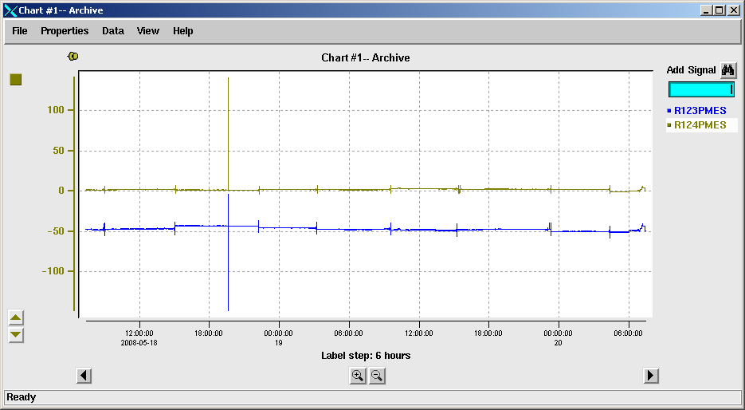

**Strip Chart Picture**

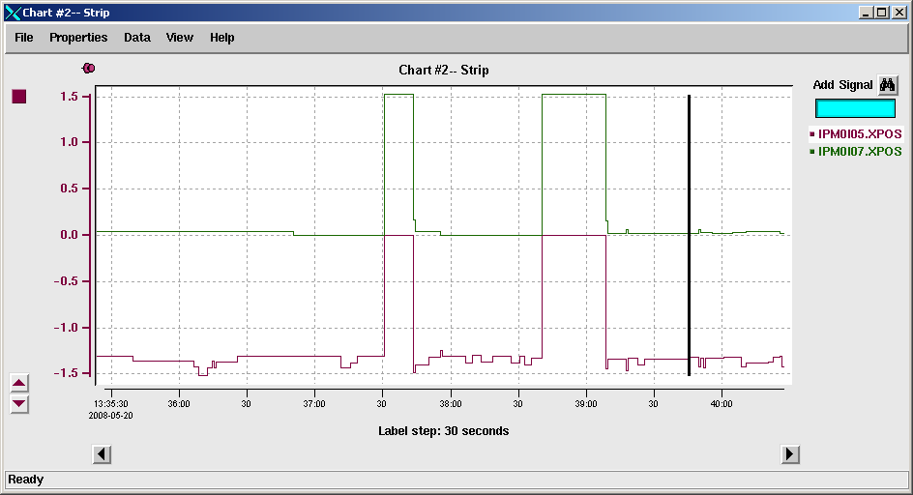

**Correlation Chart Picture**

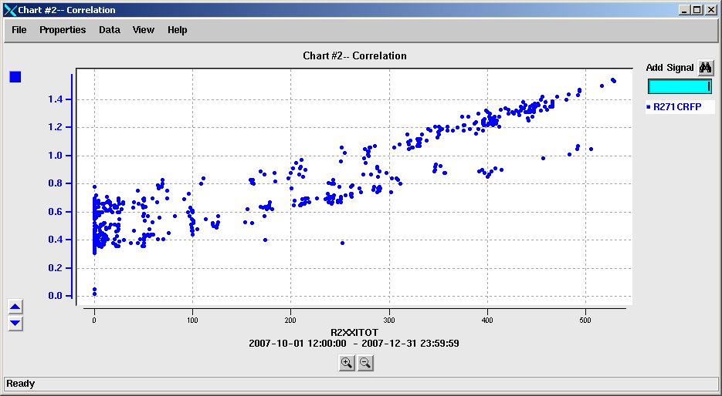

## The legend

The legend area appears on the right side of the GUI. It contains controls for adding signal plots to the chart area and lists the names of all signals currently plotted on the chart. Left-clicking any signal name in the legend makes it become the chart’s focus signal. You may hide the legend, via the menu system, to increase the chart window size.

### Adding Signals

Signals can be added to the plot in multiple ways. The **easiest** is to type the name of the signal of interest into the “Add Signal” entry field. You can also use the “Signal Selection” widget to **query the MYA archiver for signals**. The “Signal Selection” widget can be invoked wherever the “binoculars” button is available.

The Signal Selection Widget allows you to query the MYA database for archived signals. The results of the query will be displayed in the “Signal List” box. Selecting a single signal with a <Double-Click> or multiple signals with the “Add to Chart” button, will add the signal(s) to the plot. You can populate the list box in two different ways. You may select one of the predefined MYA archive groups from the dropdown, and the list of signals included in the group will be added to the list box. You may also enter a pattern into the entry field to add the names of signals matching that pattern to the list box. It is possible to select either UNIX “glob” or “regular expression” pattern matching.

## The chart window

This area of the window shows plots of EPICS signal values versus time or another signal (correlation charts). Charts have grid lines by default, but these may be turned off via the menus.

### Rubber banding

You may zoom in on an area of the chart by bounding the area in the chart with a mouse created rubber band box. Left click a corner of the desired rectangular region and move your mouse cursor to the adjacent corner of the region. A second left click will complete the bounding operation and cause the chart window to zoom in to the selected area. This serves as both an **X and Y axis zoom**. You may cancel a rubber band zoom by right clicking in the chart area after you have established the first corner of the bounding box. You may perform this type of zoom repeatedly. You may also back out of this type of zoom by right clicking the chart window and selecting “undo zoom”. You may undo all previously created zoom levels. Note that once you modify a chart’s axes ranges or signal set, all previous zoom levels are discarded and you will not be able to undo to previous configurations. By making a change to the chart, you are in effect establishing a new base zoom level.

Note that zooming with the rubber band on strip chart has different results. It is because strip charts must always have NOW as their rightmost time axis boundary. A zoom on a strip chart creates another chart for you automatically, which is a static archive chart showing the signal plots over the portion of time value space that you bounded with your rubber band.

### Boundary markers

You may notice that there are sometimes colored triangles drawn at the boundaries of the chart window, with a vertex of the triangle touching the boundary line. A triangle’s color matches the color of one of the currently plotted signals. The triangle provides information about portions of a signal plot that do not appear in the chart window’s area. Request a channel versus time plot and use the up arrow button to slew the plot upward. Keep doing so until the plot leaves the chart window. Note that a color matched triangle appears at the top boundary, letting you know where that darn plot is hiding.

Boundary markers on the vertical boundary lines are used a little differently. They are placed on the boundary line whenever the boundary line falls in a discontinuous portion of the signal. A triangle will be placed vertically at the position corresponding to the signal’s closest out of bounds point. You may hover the mouse cursor over the triangle to discover the value and time of the out of bounds point, providing information on how far you must reposition the time axis to view collected data for the signal.

## Axes

The ordinate (Y) axis shows a range of signal values. The tick spacing and values are automatically selected for you. You may use the menu system to increase or decrease the density of axis ticks, and define the range of values covered by the axis. This axis is complex and is thoroughly described in the “The ordinate (Y) axis on MyaViewer charts”.

The abscissa (X) axis represents time for archive and strip charts, and the independent signal’s values for correlation charts. Like the ordinate axis, label spacing and values are chosen automatically by the tool, but the menu system may be used to modify the appearance. The labels along the time axis of a chart may appear unusual to you. Take a look at the picture at the start of the overview. The full date and time string is not given at every axis tick to keep clutter to a minimum. Once the full date and time is established, only those fields that change are shown in following labels. Additionally, the amount of time between each tick label is shown as a caption to the time axis to aid in rapid data interpretation.

## The Menu bar

### File Menu

**New**

* From this cascading menu, you can create a new Archive Chart, Correlation Chart, or Strip Chart. Your original chart window is unaffected.
* (Strip chart only): **Convert the Strip Chart into an Archive Chart**.
* (Archive chart only): **Convert the Archive Chart into a Strip Chart.**

**Load Config: Load a pre-defined configuration set into the viewer.**

**Save Config:**

**Save your chart(s) in a configuration set to quickly restore your chart parameters.** Note that all time ranges are saved as relative times, so that you’ll get an updated time axis range upon loading.

**Print Chart:**

**Print the chart to the printer of your choice.** Only the chart from the window which this selection is made will be printed. The axes and legend (if enabled) will also be printed.

**Log Chart:**

**Create a log entry to the logbook(s) of your choice**. Only the chart from the window which this selection is made will be logged. An image of the chart for each individual Y axis will be included in the log entry.

### Properties Menu

**Signal Properties**

You can change the way the signal is displayed on the chart, or make changes to the axis to which the signal is attached.

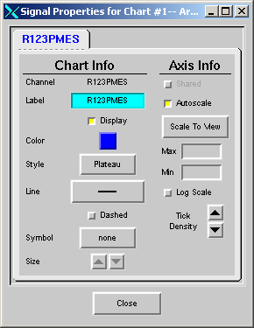

* **Plot Information** 
  + **Label – change the label of the signal to give a more meaningful name than the EPICS control system name.**
  + **Display – select/deselect this check button to show/hide the signal on the chart.**
  + **Color – invoke the color selection widget and select a new color for the signal.**
  + **Style – choose the point connection style for the signal. Choices include plateau, linear, cubic spline, and quadratic spline.**
  + **Line – modify the connecting line thickness for the signal plot, or simply display only the data points by selecting “None”.**
  + **Dashes – select or deselect this check button to represent the signal data with or without dashed lines.**
  + **Symbol – display the data points with a variety of symbols (including “none”). Note the arrows below this control the symbol size.**
* **Axis Information**
  + Shared - to assign the signal to an unshared axis, deselect the “Shared” check button. Attaching a signal to an existing axis must be done from the “Y Axis Properties” GUI.
  + **Auto scale –** let the viewer find the y axis limits based on the signal’s data.
  + **Scale To View** – push this button to auto scale only on the data that is currently in view, not buffered from previous fetches.
  + **Max/Min** – manually adjust the y axis limits
  + **Log scale** – modify the y axis to display a log10 scale
  + **Tick Density – increase or decrease the tick density (number of displayed labels) for the y axis.**

**X Axis Properties** (Archive and Strip Charts only)

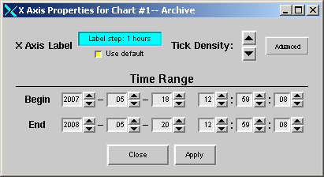

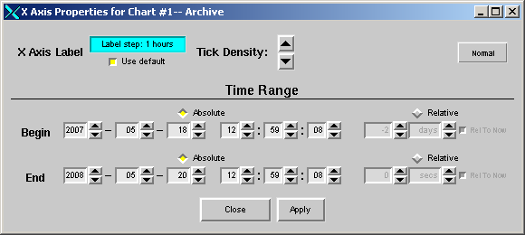

This dialog contains the primary means of defining a time range for a chart. It has a simple format that appears by default, where only absolute time ranges may be defined. Click the “Advanced” button for relative time range options.

* **Absolute Time Range** - the begin and end date/time can be selected from the spinners provided. Push “Apply” for the changes to take effect. Note: there is not an “end” date for a Strip Chart as the end date for this chart type is always considered to be “now”.
* Tick Density – increase/decrease the tick density (number of displayed labels) for the x-axis, using the up/down arrow buttons.
* Advanced – display advanced options for defining the chart’s time range.
* The expanded dialog allows you to specify the begin/end times as “absolute” (actual date/time) or relative (e.g. “-2 days”). **Relative times can be relative to “now” or relative to each other.** When not relative to “now”, only one of the times may be relative. For example, assume a begin time of “2007-06-13 12:00:00” (absolute). A relative to now end time of “0 days” means plot from the begin time to right now. With the “relative to now” button deselected, a 1 day relative end time would be interpreted as “2007-07-13 12:00:00”.
* X axis label – Redefine the label for the X axis from what is created by default. Revert to the automatic label by using the checkbox.

**X Axis Properties** (Correlation Chart)

A Correlation Chart can only have one independent signal; therefore, it can have only one X Axis. From this dialog you can redefine the independent signal, control the axis limits, and adjust the tick density

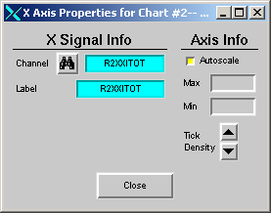

**X Signal Info**

* Channel – modify the independent signal by entering a new channel name into the entry field and pressing <Enter>, or use the “Signal Selection” widget.
* Label – change the label of the signal (i.e. R2XXITOT can be displayed as “Linac Current”)

**Axis Info**

* **Auto scale** – let the viewer find the x axis limits based on the attached signals’ data.
* **Max/Min** – manually adjust the x axis limits
* Tick Density -- Increase/decrease the tick density (number of displayed labels) for the axis, using the up/down arrow buttons

**Y Axis Properties this is going to depend on how you implement multiple Y axes**

Each axis, that has been created, and has signals attached, can be accessed from this tabbed GUI. From its tab, you can add/remove signals to/from the axis, control the axis limits, and adjust the tick density.

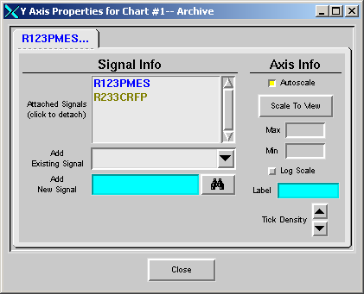

**Signal Information** (Adding/Removing Signals): Signals can be added and removed from an axis. This is especially important for auto scaling. When auto scaled, an axis uses the data only from attached signals. In this way, common signals can be grouped on the same axis for comparison.

* Attached Signals – the current list of signals attached to the axis, is displayed in this window. Clicking on a signal will detach the signal from the axis, and create a new axis for the signal.
* Add Existing Signal – add a signal that is currently attached to a different axis, to this axis, by selecting the signal from the “Existing Signals” selection box.
* Add New Signal – add a new signal to this axis by entering it into the “Add Signal” entry field, or from the “Signal Selection” dialog.

**Axis Information**

* **Auto scale** – let the viewer find the y axis limits based on the attached signals’ data.
* **Scale To View** – push this button to use only the data that is currently in view, and auto scale.
* **Max/Min** – manually adjust the y axis limits
* **Log scale** – modify the y axis to display a log10 scale.
* Tick Density – increase/decrease the tick density (number of displayed labels) for the axis, using the up/down arrow buttons.
* **Label** – Display the entered label for this axis.

**Chart Properties**

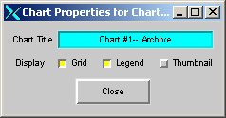

From the Chart Properties dialog, you can configure the look of your chart or turn your chart into a “Thumbnail” version of itself.

* **Chart Title – change the title of your chart.**
* **Show/Hide Grid – select/deselect this check button to show or hide the gridlines on the chart.**
* **Show/Hide Legend – select/deselect this check button to show or hide the chart’s legend.**
* **Thumbnail – select this check button to turn your chart into a thumbnail. Clicking on the resulting thumbnail will turn it back into a full size chart.**

### Data Menu

From this menu, options are available to display statistics, modify data collection parameters, and export your data.

**Statistics Not sure how/if this is used from the GUI**

A statistics tab will be displayed for each signal that has been plotted. Statistics are calculated on all of the data collected for a channel, even for the values that are currently not in view. You can use “Scale to View” to trim not seen channel data and adjust the statistics to be pertinent only to what is seen in the view window. These are simple statistics, not weighted by the duration of time a particular signal value persists. For accurate statistical analysis of channel history, you should use the “[myStats](http://devweb/controls_web/certified/myStats/myStats.pdf)” command line utility. Statistical information is not available on live strip chart plots. The following statistical parameters are currently displayed:

* Max – the maximum value displayed for the signal
* Min – the minimum value displayed for the signal
* Mean – the average of the signal’s data points.
* Standard Deviation – the standard deviation of the signal’s data points.

**Collection Info Not sure what’s used.**

The information contained on this simple dialog depends on the type of chart from which it was invoked.

* Deployment – the MYA archiver deployment from which this invocation of the viewer gets its data. The default deployment, if not otherwise specified is “ops.” The viewer’s archive deployment can be specified in multiple ways, but cannot be modified at runtime. Define the deployment at invocation with the –deployment argument on the command line. The deployment can be specified in a loadable configuration set, and the individual user can change the default deployment in their preferences.
* Always Bin (Archive and Strip Charts) – Setting this checkbox will make the viewer choose to use sampling of a signal’s values (binning) when a data fetch is larger than the threshold shown in the edit box, without popping up a window to ask for the user’s choice (see below). When not checked, the value in the edit box is the number of points above which you will be prompted to “bin” your data. For example, if “Max Points” is set to 350,000 points, and your archive request will produce 2 million points, *MyaViewer* will warn you of your large request, and give you the option of limiting this number by binning, or going ahead with your request unchanged. Note large data sets may adversely affect the performance of the viewer.
* Max Points (Correlation Chart) – this is the maximum number of data points desired for your Correlation Chart. The more points requested, the longer the correlation fetch will take.
* Collection ADEL (Strip Chart) – use the MYA ADEL (Archive Delta) while collecting live data. This option is available only if a signal is being archived by MYA, and the system expert has defined an ADEL for the signal. If selected, only data that changes by the ADEL amount will be recorded. If deselected, all data changes will be recorded.
* Bit Mask (Archive Chart) – The bit mask that is applied to each signal history value after the data is fetched from Mya.
* Absolute Time Range (Correlation Chart) – The begin and end date/time can be selected from the spinners provided. Push “Apply” for the changes to take affect.
* Advanced (Correlation Chart) – display advanced options for defining the chart’s time range, as is described in the X axis properties.
* Correlation Style (Correlation Chart) – The choice of picking dependent signal values when performing a correlation analysis. Since it is unlikely a dependent signal has an update at the exact time of an independent signal update, you must choose how the algorithm determines a representative dependent signal value at the time of the independent signal update, using the nearest updates before and/or after the time.

**Export**

From this dialog, you can export the visible data, or an image of your chart to a file.

* **Data Export** – data is exported in the CSV (comma separated values) format to the file of your choice.
* Image Export – generate a GIF image of your chart

### View Menu

From this menu, options are available to view MYA archive information about your signals, and to define your personal preferences. If you’ve created multiple charts from the same viewer, the charts will be listed here, click on a chart to raise it into view.

**Archive Information**

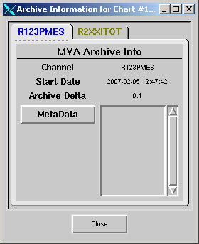

Each signal on your chart will have a tab on this tabbed dialog. The tab will display MYA Archive information for those signals that are being archived.

* Channel Name – the EPICS channel name that is being archived
* Archive Start Date – the date at which the signal started being archived
* Archive Delta – the archive delta for the signal
* Metadata – select from a list of available metadata keywords for which to display the desired information. Not all keywords are available for all signals.

**Preferences**

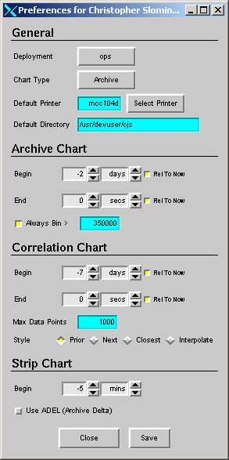

Define your personal default preferences from this dialog. Your personal defaults will override any developer defaults, but can be overridden by command-line options and the loading of configuration sets.

* General
  + **Deployment** – specify your default archive deployment.
  + **Chart Type** – specify the chart type that you'd like by default.
  + **Default printer** – where print requests will be sent.
  + **Default Directory** – the directory that will be used for exporting data.
* Archive Chart
  + **Begin** – select a default relative begin time. This begin time can be relative to “now” (when the chart is invoked) or be relative to the End time.
  + **End** – select a default relative end time. This end time can be relative to “now” (when the chart is invoked) or be relative to the Begin time.
  + Max Point Alert – the number of data points above which you'd like to be reminded of the binning option. If the Always Bin checkbox is selected, the viewer will down sample the signal’s history without giving the user the option to sample or fetch all of the data.
* Correlation Chart
  + **Begin** – select a default begin time to collect your correlation data. This begin time can be relative to “now” (when the chart is invoked) or be relative to the End time.
  + **End** – select a default relative end time to collect your correlation data. This end time can be relative to “now” (when the chart is invoked) or be relative to the Begin time.
  + Max Data Points – this is the maximum number of data points to fetch for a correlation chart.
  + Style – see the description of this parameter under the *Data->Collection Info* menu options.
* Strip Chart
  + **Begin** – select how far back to fetch archive data.
  + **Use ADEL** – whether or not to strip chart live signals using the archiver’s built in dead band.

## Special controls

There are three pairs of controls that may appear on various chart types. These are the horizontal and vertical slew controls and the time axis zooming controls.

The **slew controls** are arrow buttons. They may be held down to cause a continual slewing or pressed once to cause a single step. They are used to move the plots on the chart up, down, left, or right. The vertical slew controls only move the focus signal. They are used primarily to separate a signal from the clutter of other plotted signals. If the focus signal is a member of a Y-axis group of signals, it will be removed from its group and given its own fixed scale Y-axis.

The horizontal slew controls are different. You select the slew right arrow to move the time range into the future. *MyaViewer* will automatically fill in the newly exposed segments of the plotted signals for you.

The **zooming controls** are buttons with magnifying glasses on them. The one with the ‘+’ zooms in and the one with the ‘-‘zooms out. The zooming operation is in the abcissa axis only, and is performed about the central point of the axis.

## The status bar

The status bar is attached to the bottom of the *MyaViewer* window. It shows supplemental information from ongoing operations and gives “mouse-over” help when the user is interacting with the GUI.