jefferson lab
Version
1.0
Data Acquisition Group
cMb User’s Guide
Jefferson Lab Data acquisition group
cMb User’s Guide

Vardan Gyurjyan
gurjyan@jlab.org

13-August-2010

© Thomas Jefferson National Accelerator Facility
12000 Jefferson Ave
Newport News, VA 23606
Phone 757.269.7365 • Fax 757.269.5519
Table of Contents

1. Introduction 3
1.1. Where to get cMb package? 3
1.2. Installing cMb 3
1.3. Terminology 4
2. Message Structure 5
2.1. daLogMsg message structure 5
3. Message Visualization 7
3.1. Internal Message Queue 8
4. Graphical Interface 9
4.1. Command Line Arguments 9
4.2. Platform Menu 9
4.3. Control Menu 10
4.4. Additional Controls 12
5. Data Mining 13
A. Contact Information 14

Introduction
Section
1

The cMsg Message Browser user interface (cMb) is a Java-based user interface for displaying CODA cMsg messages. cMb can be used as CODA AFECS platform monitoring and data visualization tool, as well as a tool to build experiment alarm systems. cMb uses cMsg pub/sub communication protocol to access messages from CODA AFECS based experiment control systems.
This application requires Sun's Java Runtime Environment (JRE) Release 1.5 or later.

Where to get cMb package?

cMb is in the main CODA repository at:
file:///daqfs/source/svnroot/ECS/cMb-1.0
, also from Download section on the JLAB Data Acquisition Group portal at:
http://coda.jlab.org

The package contains:
- All the source code (the package is self-contained).
- jar file containing all cMb classes.
- cMb users manual and complete set of java-doc documentation.

Installing cMb

To install cMb download cMb-1.0.tar.gz file from CODA ftp site. After untaring it you will get cMb distribution with the cMb-1.0 being the top level directory. Simply include cMb-1.0/cMb-1.0.jar, along with provided jar files from the cMb-1.0/lib and you are ready to run the application. cMb-1.0/bin directory contains Unix csh script, as well as Windows batch file to run the application. In order to run the browser through the provided scripts you must set CMB_HOME environmental variable pointing to the cMb-1.0 directory.
To compile the project locally, change the directory to cMb-1.0, and type ant.

Terminology

The most commonly used terms and their definitions are listed below.
- UDL Universal Domain Locator is a string used to specify how to find
and connect to a cMsg messaging server. UDL contains the host
name and port number of the cMsg server running as a part of
the normative administrative agent of the CODA AFECS
platform.
- Host The host of the cMsg messaging server.
- Port The port of the cMsg messaging server.
- Expid Experiment ID. Together with the host and port defines CODA
AFECS experiment control platform.
- Session Entire COAD AFECS control space is divided into sessions. In the
AFECS platform multiple, parallel running experiment, system,
sub-system, or device control sessions.
- RunType Control session can have one or many runtypes. Runtype
contains state machine of the specific control. If sessions can
coexist independently, runtypes inside the session are the
integral part of the session control state machine.
- CodaClass Type (class) of the CODA component. For example, ana, sms,
slc, wnc, er, eb, emu, roc, ts, rcs, etc.
- Name Given name of the component. Names are unique inside the
control platform.
- Severity The severity of the message. CODA defines 16 levels of
message severity: 4 levels of Info, Warning, Error and
Severe- Error respectively.
- Payload Tag-Value structure of the message content. Values can be any
primitive types and/or arrays of primitive types.
- Text ASCII test of the message
- Subject, Type The subject, combined with the type determine how messages
are delivered (effectively the address of the message). The
uses of wild cart characters are allowed.
- Subscription In order to send or receive specific message user must
subscribe to a subject/type combination.

Message Structure
Section
2

cMb is message structure agnostic. It will show all the messages in the MS (message space) table of the GUI (see Figure 1), published to entire message space (subject = * and type = *). Table 1 below shows the column structure of the MS table.

Column | Description | Value Type
Subject | Subject of the message | String
Type | Type of the message | String
Sender | Message author | String
Text | Text of the message | String
ByteArray | Length of the byte array attached to the message | Int
PayloadItem | Count of the payload items of the message | Int

Table 1

daLogMsg Message Structure

CODA log messages (called daLogMsg) are initiated at the physical component level and got passed to the experiment control platform through their representative agents. At this level daLogMsg messages are passed through the point-to-point communication protocol (cMsg rcDomain), and are private messages between component and its agent. The agent then publishes daLogMsg message after adding more information to it. This approach gives the component representing agent the option of passing on or filtering received messages in some way (e.g. load balancing).
daLogMsg message, at the agent (as well as at the component level, is published to the type=“rc/report/dalog”. The subject of the message is the name of the author of the message. The table below describes the payload structure of a daLogMsg.
Tag | Description | Value Type
Expid | Experiment Name | String
codaName | Component Name | String
codaId | Component ID | Int (Coda2 only. 0-255)
Hostname | Host Name | String
Username | User Name | String
Session | Session | String
Config | Control Name (runType) | String
runType | Config ID | Int (Coda2 only)
runNumber | Run Number | String
Text | Text of the message | String
Severity | Severity | String (INFO, WARN…)
severityId | Severity ID | Int (0-15)
State | Component State | String
codaClass | Component Type | String (ROC, ER…)
Tod | Time | String
Table 2

Message Visualization
Section
3

cMb visualizes CODA messages in table, text, chart and histogram formats. Messages are displayed in two different tables. Upper-table MS has a predefined column structure, and is used to display message standard payload items, including sender, subject, type, text and the number of payload items in the message (see table 1).
cMb subscribes to the subject = “*”, and the type = “*”, meaning that it will receive messages from the components/agents of entire experiment (with specific experiment ID) control space shown in the MS table. Selecting a row in the MS table, representing specific message, will tell the program to start showing messages in the SM table having the same message type of the selected message. In case user needs to follow messages with exact subject and type of a selected message, than selection must be done in the MS table by clicking desired sell in the Subject column. In case selected message from the MS table is a dalogMsg message the lower SM table will be created with predefined column structure, shown in the Table 3. Otherwise selected message payload item structure will define SM table column structure.

Column | Description | Value Type
Sender | Author of the message | String
CodaClass | Coda component class (ROC, EB, etc.) | String
Session | Control system session | String
Config | Control system configuration | String
State | State of the component | String
Text | Text of the message | String
Severity | Severity description of the message | String
Date | Message origination date | String

Table 3

Click on any sell to select a desired message (row) in the SM table of the GUI. Then click explore button to monitor and analyze the selected message in the tabbed Explorer panels. XML representation of the message will be shown inside of the Text tab of the Explorer panel. In case the selected cell of the SM table contains single primitive data type it will be visualized in the Line tab as a time dependent chart. When the selected cell contains an array of primitive types it will be shown in the Histogram tab as a histogram. explore buttons of the GUI will initiate a subscriptions based on the selection, so Explorer panel tabs will be active and will be updated when specific messages arrive. To change the subscription and monitor different messages and their specific contents, user must click a cell in the SM table, followed by a click one of the explore buttons of the GUI.

Internal Message Queue

cMb is designed to visualize control platform online messages. Yet, the program is capable of archiving messages, by storing them in the local message queue for later filtering and analysis. cMb supports filtering of the dalogMsg messages based on the message originator, codaClass, control system session, and message severity. Internal message queue size is controllable through the command line argument, as well at runtime, using cMb Control menu options.

Graphical Interface
Section
4

This section includes the instructions for using important features in cMb.

Command Line Arguments

The bin directory of the distribution contains Unix csh script and Windows batch file, that will set the CLASSPATH environmental variable and start the program.
To start cMb in Unix, enter the following at the command line:
$CMB_HOME/bin/cmb [option value]
This assumes that CMB_HOME environmental variable is set to point the cMb-1.0 distribution directory. The table below shows the acceptable command line options. Options are case insensitive.

Option | Description
-h or –help | Prints help
-name | The name of cMb instance (mandatory and unique)
-udl | The platform UDL
-subject | The subject of the subscription
-type | The type of the subscription
-queueSize | dLb internal queue size
-title | The title of the GUI

Platform Menu

The Platform Menu contains menu items to connect (or disconnect) to the specific experiment control AFECS platform, characterized by the UDL. In case –udl command line argument is missing it will try to connect to the platform with the experiment ID defined through EXPID environmental variable.

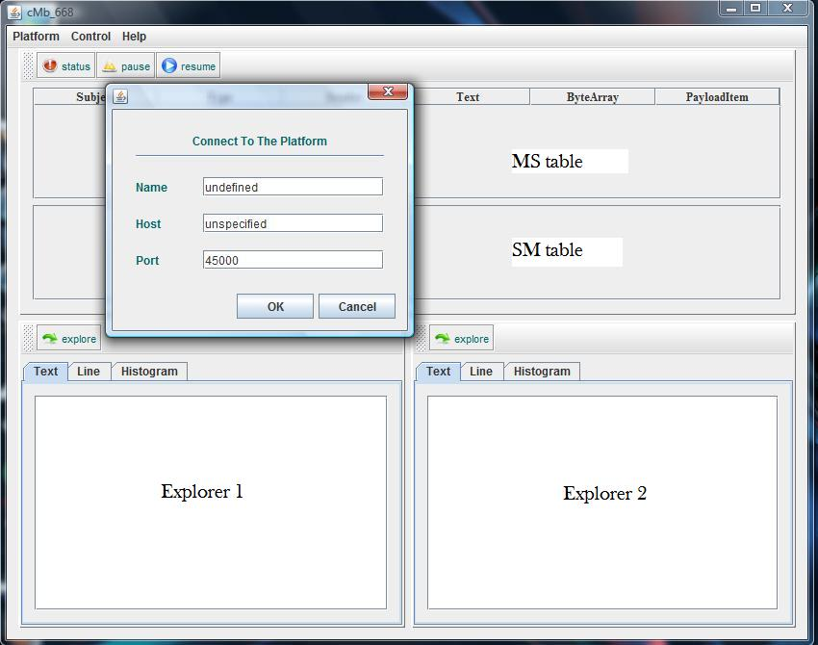
Figure1

Clicking on the Connect menu item will open the platform connection window (shown in the Fig. 1). Here the user is offered to enter name, host and port of the control platform. In case host name of the AFECS platform remains unspecified, GUI will try to find an AFECS platform using experiment ID by performing UDP multicast.
Exit menu item will disconnect first from the platform and then dispose the main frame of the cMb graphical interface.

Control Menu

Control Menu provides further control options to manage internal queue, message table and dalogMsg message various filtering options. (see Fig.2).

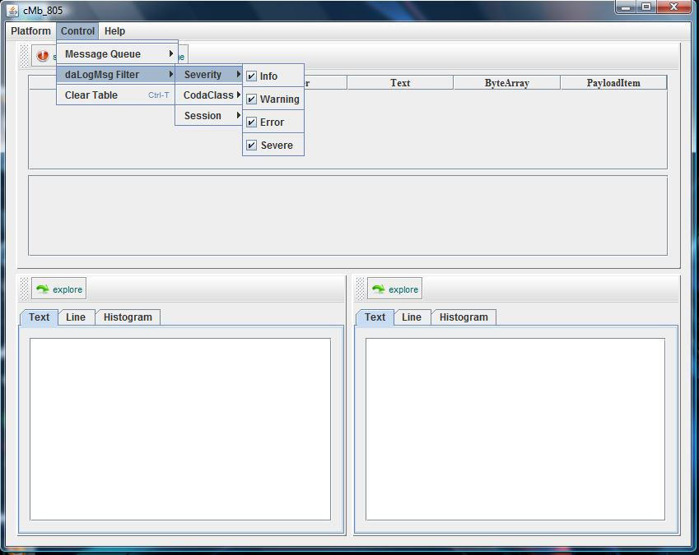
Figure 2

Clear Table selected request will clear SM lower message-table, while keeping all the received messages in the internal queue. The filtering algorithm will be applied first to the stored messages in the message queue and then to all new arriving messages.
Message Queue- Clear request will start the confirmation dialog window, and if confirmed will clear all messages stored in the message queue. The set of menu items for filtering messages based on the message severity level, session and message author is provided in the dalogMsg Filter sub-menu. For example selecting specific severity level of the message (check/uncheck specific severity level check box) will filter and show only message having the required level of severity. Messages not having severity payload item will not be affected with this filtering procedure.
It is important to mention that cMb will receive messages based on the subscription request at the start of the program (subject = * and type=*, using command line arguments -subject and –type), yet the program will record in its internal queue only dalogMsg messages.
Control Menu Set Message Queue Size menu item can be used to set the internal queue size at run-time.

Additional Controls

Status button of the user interface informs user about the current connection details, including platform UDL, the subject and type of the subscription, as well as dalogMsg message filtering details.
The pause and play buttons can be used to ease the table cell selection for filtering or data mining purposes. This can become handy in case the rates of messages of interest are high.

Section
5

Data Mining

Even though the contents of the CODA message payload items are displayed in the upper-table, user has the ability to monitor the content of the specific payload item in the form of simple text, time-graph, and histogram.
cMb provides two independent data explorer areas. To start data visualization click the interested cell in the SM table, followed by clicking explore of the specific Explorer area. Explorer areas of the interface have 3 tabs, displaying selected data in the text, line, and histogram forms. Based on the data type of the selected payload value the program will define appropriate visualization mode. For example, if the data is the array of primitive types it will visualize it in a histogram form.

Contact Information
Appendix
A

The Jefferson Lab Data Acquisition Portal is located at http://coda.jlab.org. The author’s email address is listed on the second page of this manual. Bug/feature requests can be made by following the “Request Tracker” link on the portal (we use the Mantis Request Tracking package). Further contact information can be found by following the link on the portal.

