Forward Tagger Tracker Operation Manual V1.1

Table of Contents

1 Introduction 3

2 System description 3

2.1 General: 3

2.2 Gas: 5

2.3 FT tracker readout system 6

2.4 Data Format 7

3 Controls and monitoring 8

3.1 Detectors high voltage 8

3.2 Low voltage for the front end electronics 9

3.3 Slow control of the front end electronics 9

3.4 Front end cooling 10

4 Procedures 10

4.1 General procedure 10

4.1.1 Installation 11

4.1.2 Gas On and Gas off 11

4.1.3 HV on / off 12

4.1.4 Powering up and down the FT tracker readout system 12

4.2 Interlocks 13

4.2.1 gas 13

4.2.2 HV 13

4.2.3 LV 13

4.2.4 Electronics Cooling 14

4.3 Response to Hall B alarm 14

4.3.1 Gas system 14

4.3.2 HV & LV 14

5 Abbreviations 14

6 References 14

# Introduction

This document details how to operate the Forward Tagger Micromegas detector. The instructions reported in the following are for trained personnel. A shift taker manual will be developed as simplified monitor and control interfaces are developed based on the CLAS12 slow controls system.

**Gaz**

(Ar + 10% isobutane)

**Drift** (HV 2)

Strip readout

Ionizing particle

**Mesh** (HV 1)

**e-**

Conversion

gap

3 mm

Amplification

gap

100 µm

**E ~ 50 kV/cm**

**E ~ 1kV/cm**

**Strips**

Figure 1 - Schematic of a Micromegas detector

# System description

## General:

The Forward Tagger Tracker (FT-Trck) is made of Micromegas detectors disposed in four layers. A Micromegas (MICROMEsh GAseous Structure) is a gaseous detector based on a parallel plate electrode structure and a set of microstrips for readout as seen on Fig. 1. The presence of a micromesh between the strips and the drift electrode allows for separating the conversion gap, where particles create primary electrons by interacting with the gas, from the amplification gap, where the primary electrons will create an avalanche in the presence of a high electric field. If this field is high enough compared to the field in the conversion gap, the micromesh is transparent for the electrons, but not for the ions coming from the avalanche. This special feature allows a very fast collection of the ions created in the amplification gap (around 100 ns, compared to several microseconds for a drift chamber). For this reason, Micromegas detectors have a very high-rate capability. The detectors used in the case of FT-Trck have a disk shape.

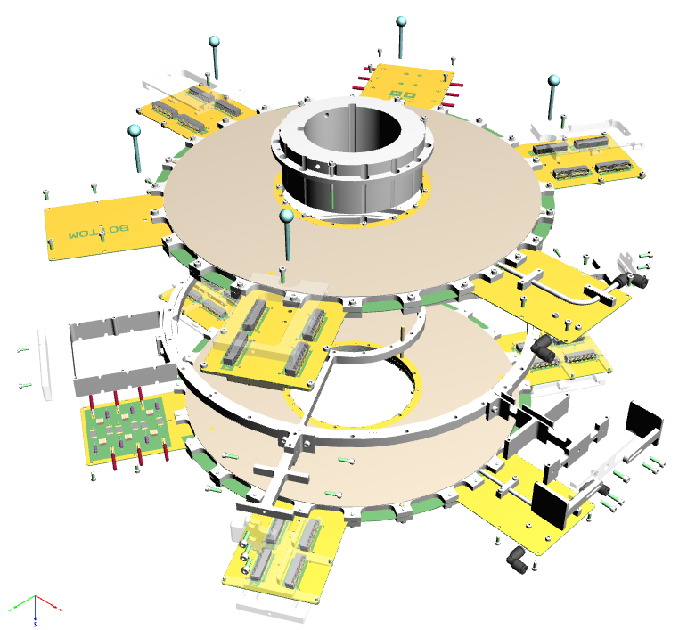

Figure 2 – Exploded view of the Forward Tagger Tracker

The Forward Tagger Tracker is composed of two double-sided Micromegas double-stage gaseous detectors. The detectors are based on the resistive Micromegas technology: a coating of resistive strip material is deposited on the top of the readout strip thus allowing to operate the detectors without spark at high rate; In this configuration the mesh is grounded and the high voltage for amplification is positive on the resistive strips. This technology is also employed in the CLAS12 Central Micromegas tracker. Each detector consist of two planes with strips oriented along the X and Y axis, respectively, separated by 10 mm. Each plane has 768 strips with 560 μm pitch. The FT tracker covers the polar angle region from 2.5 to 4.5 degrees from the target. The gas that will be used is a mixture of 90% of Argon and 10% of isobutane. Fig. 2 shows an exploded view of the FT-Trck.

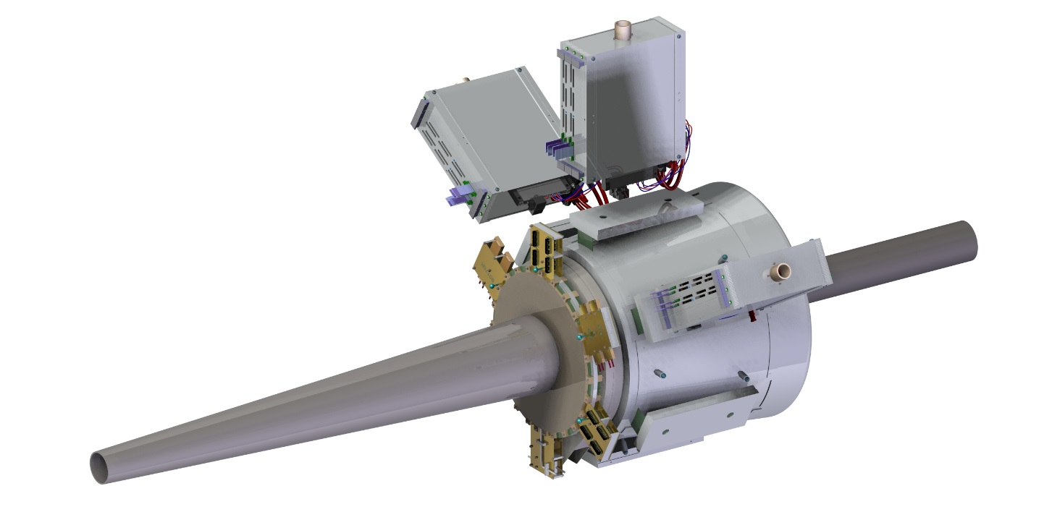

Figure 3 – View of the Micromegas tracker mounted in the Forward Tagger

In order to hold the FT-Trck in the operating position, i.e. in front of the FT hodoscope and calorimeter as shown in Fig. 3, the Micromegas detectors are supported at the center by a stainless steel ring, which is designed to fit onto the FT calorimeter inner support pipe. Three custom crates containing the readout boards are mounted on the calorimeter outer case, as shown in Fig. 3 and 4. The connection between detectors and readout is done using 1.5 m long flex cables.

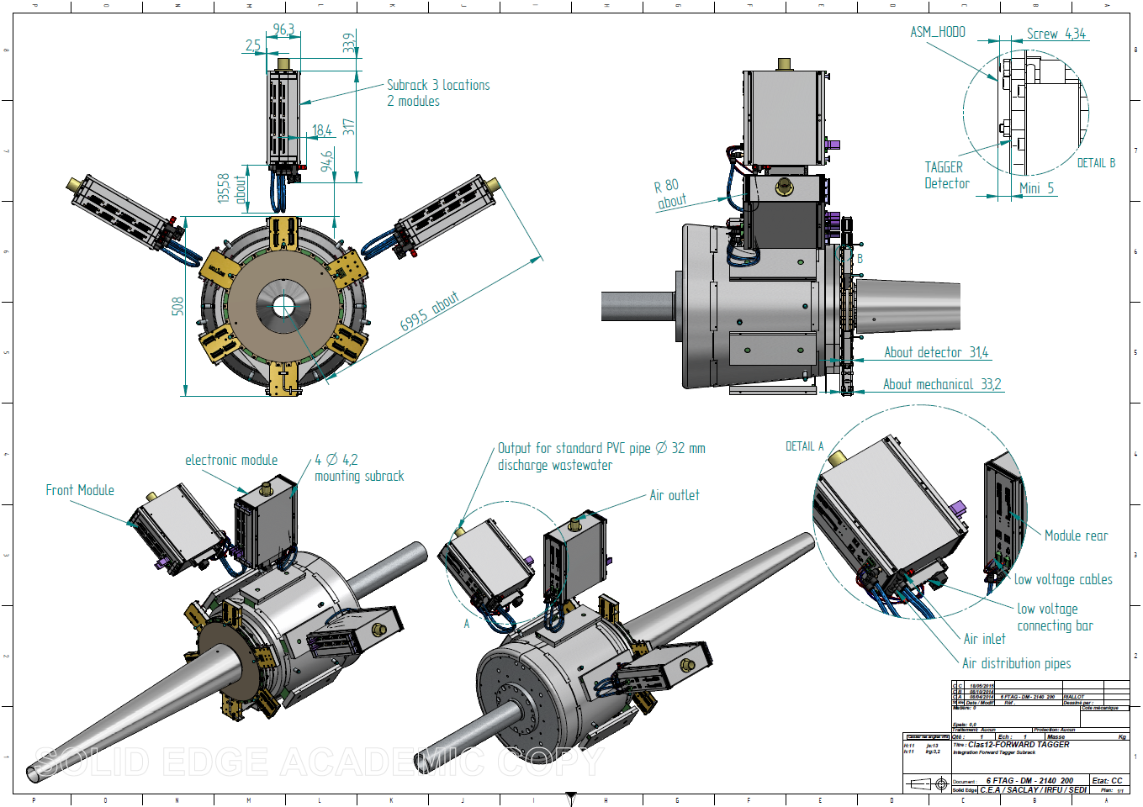

Figure 4 – Front view of the Forward Tagger with the tracker and related electronics

In operation, a Micromegas detector has to be polarized by three high voltages (HV), the two active areas corresponding to the anode and the drift plane (cathode) 5 mm above the anode. The nomenclature used is summarized in Table 1. Each double side detector has an input and an output gas connection.

|  |  |  |
| --- | --- | --- |
| Naming convention | Detector number | Drift |
| FTT_X_STRIPS | X |  |
| FTT_X_DRIFT | X | ● |

Table 1 - Nomenclature of the high voltage for the FT tracker detectors, x=1..4

## Gas:

The Micromegas are continuously flushed with gas in order to keep a good purity and overcome the normal outgassing of the detectors. The gas is Argon with 10% of isobutane. The flow rate is 4 l/h (liter per hour) for the full set of detectors in serial. The gas is rejected outside Hall B.

Argon tank

Gaz bottle

(Isobutane)

Mixing

building

Hall B

FTT Gas rack

Detectors



Figure 5 - General view of gas lines

The gas system will be partially shared with the CLAS12 MVT barrel detectors. The gas lines for the all Micromegas detectors are coming from the gas shack. The line for the FT-Trck ends at a gas rack located on the floor at the entrance of Hall B. The rack has a mass flow meter at the entrance and two flow meters at the exit (normal gas exhaust and overpressure). The monitoring of the pressure and of the mass flow meter is done through a 1200 series Siemens PLC. If a difference of flow is found (a leak), the system is stopped and a leak check can be done using rotameter providing gas for a double-sided detectors. Thus while waiting for opportunity to repair the leak, the system can work with a line of double-sided detector disabled.

A gas control panel located in the FT rack under the subway allows operating the gas rack in manual (with fixed values for the flow and pressure) or in automatic (by PLC).

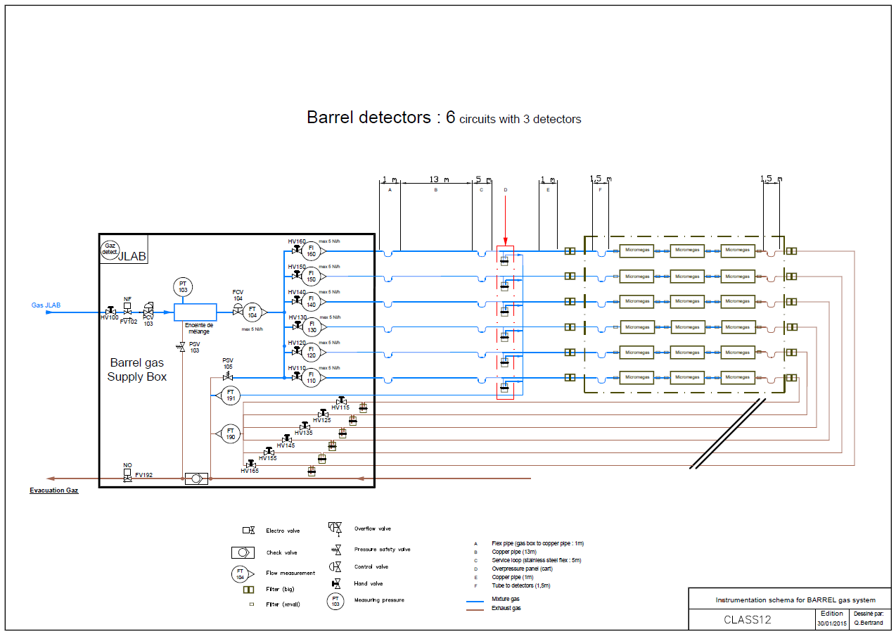

Figure 6 - Schematic of the CLAS12 MVT Barrel gas rack. A similar layout is employed for the FT-Trck gas rack with only one line going to and from the detectors.

## FT tracker readout system

The extremely tight design of the CLAS12 Forward Tagger puts strong constraints on the overall space allocated for the tracker. Consequently, a readout architecture based on the off-detector frontend electronics has been adopted. It is shown on Fig. 3 and 4. Lightweight micro-coaxial cable assemblies with low linear capacitance carry bare unamplified signals to the frontend units (FEU) housed in crates attached to the calorimeter case. The frontend electronics are responsible for the pre-amplification and shaping of the detector signals, for holding the latter in a pipeline waiting for trigger process to yield, for the digitization and compression of the selected event data and for their delivery to the backend electronics. The backend is responsible for data concentration event-wise. It provides an interface with the CLAS12 event building system. It also ensures a fixed latency path between the CLAS12 trigger system and the FEUs. It receives the system clock and trigger from the CLAS12 trigger supervisor and synchronously conveys them to the FEUs over bidirectional optical links.

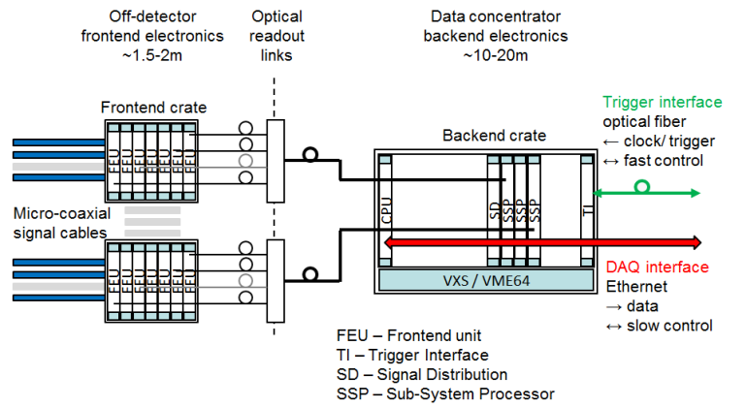

Figure 7 - Schematic of readout system.

To improve FT-Trck readout noise immunity the readout takes advantage of the continuous sampling of detector signals. Pickup noise usually affects groups of neighboring signal lines. It is possible to determine and remove this coherent noise greatly smoothing the induced fluctuations. For each trigger the signal samples are compared to the channel discriminating threshold after the common mode noise subtraction. For channels with charge deposits above the thresholds, a fixed number of consecutive samples are kept for offline analysis. The retained samples describe the signal development in the channel. Fitting their values with a known function allows accurate estimation of deposited charge and of signal timing.

The system is dimensioned to read out the 3K channels of the FT-Trck. The expected 50 MHz physics background results in strip-hit rates of 100 kHz. The readout system is compliant with the CLAS12 requirement of a 20 kHz maximum trigger rate and provides a sufficiently deep data pipeline to cope with a trigger latency as long as 16 µs.

## Data Format

The back end of the data acquisition system of the FT Tracker is based on JLAB standard VME/VXS hardware including TI, SD and SSP boards. Dedicated firmware and software was designed to ensure full compatibility with the CODA DAQ software environment deployed in Hall B. FT tracker data files comply with EVIO requirements. Raw data files can optionally be collected for debugging purposes. Otherwise, the FT tracker data is disentangled event-wise and files are structured following the composite EVIO data format with self-contained description string as follows:

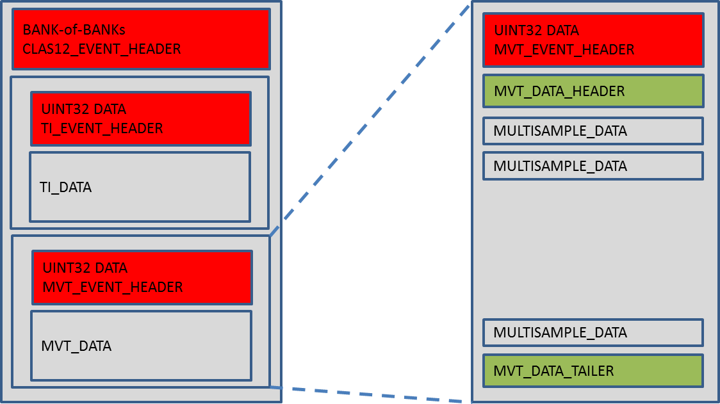

|  |  |  |  |  |  |
| --- | --- | --- | --- | --- | --- |
| **FTT_EVENT_HEADER** | | | | | |
| **word** | **desc.** | 32-bits | | | |
| 0 | type | Exclusive length | | | |
| bits | [31:0] | | | |
| 1 | type | tag | pad | type | num |
| bits | “” [31:16] | “” [15:14] | “” [13:8] | “” [7:0] |

|  |  |  |  |  |  |
| --- | --- | --- | --- | --- | --- |
| **FTT_DATA_HEADER** | | | | | |
| **word** | **desc.** | 32-bits | | | |
| 0 | type | Exclusive length | | | |
| bits | [31:0] | | | |
| 1 | type | tag | pad | type | num |
| bits | “” [31:16] | “” [15:14] | “” [13:8] | “” [7:0] |

|  |  |  |  |  |  |  |  |  |  |  |
| --- | --- | --- | --- | --- | --- | --- | --- | --- | --- | --- |
| **Multisample FTT composite data**  **c,i,l,N(s,Ns)** | | | | | | | | | | |
| **8 bits** | | | **Back end board ID – Front end board ID** | | | | | | | |
| **BEU ID [7: 5]** | | | | | **FEU ID [4 : 0]** | | |
| **32 bits** | | | **Event number** | | | | | | | |
| **64 bits** | | | **Timestamp** | | | | | | | |
| **“00”[63:62]** | | | **BEU time stamp (4ns) [61:16]** | **“0” [15]** | | **FEU time stamp (8ns) [14:3]** | **FEU fine time stamp (8ns) [2:0]]** |
| **32 bits** | | | **Number of channels hit** | | | | | | | |
|  | | | | | | | | | | |
|  | **16 bits** | | | **Channel ID** | | | | | | |
| **32 bits** | | | **Number of samples** | | | | | | |
|  | | | | | | | | | |
|  | **16 bits** | | | **samples** | | | | | |

|  |  |  |  |  |  |
| --- | --- | --- | --- | --- | --- |
| **FTT_DATA_TAILER** | | | | | |
| **word** | **desc.** | 32-bits | | | |
| 0 | type | Exclusive length | | | |
| bits | [31:0] | | | |
| 1 | type | tag | pad | type | num |
| bits | “” [31:16] | “” [15:14] | “” [13:8] | “” [7:0] |

# Controls and monitoring

## Detectors high voltage

Each FT Micromegas detector needs two high voltage potentials to operate (+ground); the resistive strips are at a potential of ~ 480 V and the drift at a potential of ~ -600 V.

The high voltage is provided by a CAEN A1536HDM card with four positive and four negative channels. The card is installed in a CAEN crate located on beam-left side of Level 1 space frame and hosting the HV card for the FT hodoscope and calorimeter. From the crate to the detectors, standard high voltage cables are used. The crate is controlled by the EPICS slow control system. The HV system has 3 settings “OFF”, “WAIT”, and “PHYSICS”. In “OFF” state, all the HV are set to 0 V (ground), in “WAIT” the detectors are polarized but with no gain, and in “PHYSICS” mode the detectors are active and ready to take data.

The detectors HV should always be OFF when the gas mixture is not ok.

|  |  |  |  |  |  |  |  |  |  |  |
| --- | --- | --- | --- | --- | --- | --- | --- | --- | --- | --- |
| **Detector** | **Layer** | **Item** | **HV ch.** | **Polarity** | **VSET** | **VMAX** | **ISET** | **TRIP** | **RUP** | **RDN** |
| 1 | Top | Strip | 02 | + | 480 V | 510 V | 3 uA | 20 s | 10 V/s | 50 V/s |
| 1 | Top | Drift | 08 | - | 600 V | 1000 V | 3 uA | 2 s | 20 V/s | 50 V/s |
| 1 | Bottom | Strip | 03 | + | 480 V | 510 V | 3 uA | 20 s | 10 V/s | 50 V/s |
| 1 | Bottom | Drift | 09 | - | 600 V | 1000 V | 3 uA | 2 s | 20 V/s | 50 V/s |
| 2 | Top | Strip | 04 | + | 480 V | 510 V | 3 uA | 20 s | 10 V/s | 50 V/s |
| 2 | Top | Drift | 10 | - | 600 V | 1000 V | 3 uA | 2 s | 20 V/s | 50 V/s |
| 2 | Bottom | Strip | 05 | + | 480 V | 510 V | 3 uA | 20 s | 10 V/s | 50 V/s |
| 2 | Bottom | Drift | 11 | - | 600 V | 1000 V | 3 uA | 2 s | 20 V/s | 50 V/s |

#### Table 2 – HV settings.

## Low voltage for the front end electronics

The frontend electronics is powered from a remote supply placed in in the FT racks under the subway. Voltage drop is ineluctable on the over the long power cables connecting the crates with the power source. Single PL506 modular power supply system from Wiener [Win] is used. It has 4 independent programmable power supply modules with 100 A capability in the output range from 2 to 7 Volts. One module powers one frontend crate. Two 6 mm2 cross-section power cables and two 1.5 mm2 sense cables are used to connect a module and a crate. The power cables are chosen with the cross-section exhibiting not more than 1 V drop over the cable length. The sense cables are needed for power regulation. The powering scheme is shown on Fig. 8.

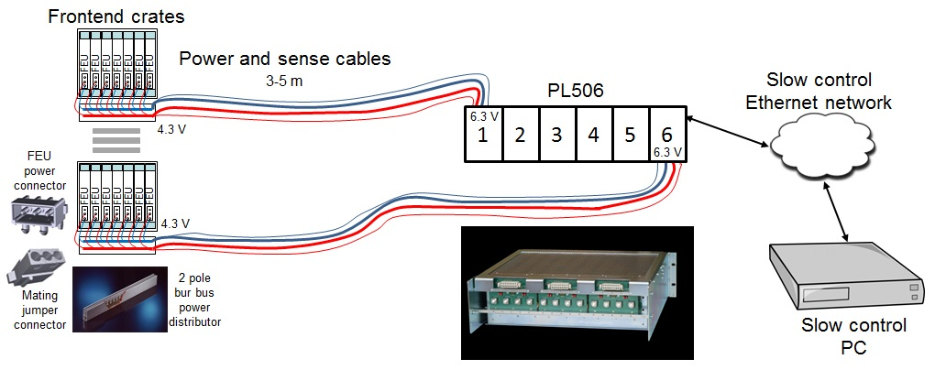

Figure 8 - Powering of the FT tracker front-end electronics

A 2-pole power distribution bus bar from Schroff is attached to each crate [Pbb]. Each of its rails is rated from 60 to100 A, depending on ambient temperature. The power and the sense cables are connected to the rails. Short two-wire jumpers deliver the 4.5 V power from the bust bar to FEU-s. The voltage drop on the jumpers is negligible.

The desired output voltage and current values, as well as the operating temperature range of the PL506 power supply is programmed by a slow control PC via an Ethernet network. The PC also monitors the power supply operation. The SNMP protocol is used for the control and monitoring operations. Each power supply channel is interlocked with the cooling system of the corresponding crate.

## Slow control of the front end electronics

A low level remote slow control of FEU-s is based on the 4-wire JTAG standard. Each FEU has a 24-pin 2 mm connector to access one of its 3 JTAG chains at a time. One of the chains groups a Xilinx XC6VLX75T Virtex-6 FPGA and two associated XCF32P configuration Platform flash PROM-s. This chain allows for remote programming of the FPGA and/or flash PROM-s, as well as for reading FPGA core and IO voltages and its temperature values. The second JTAG chain comprises a single MAX16031 system monitor chip. The power consumption of the module, various onboard generated voltages, the values of three temperature sensors are monitored by this chain. Yet a third JTAG chain includes an auxiliary Xilinx XC9572XL CPLD giving access to the board hardware ID, the FPGA boot status and some other additional information.

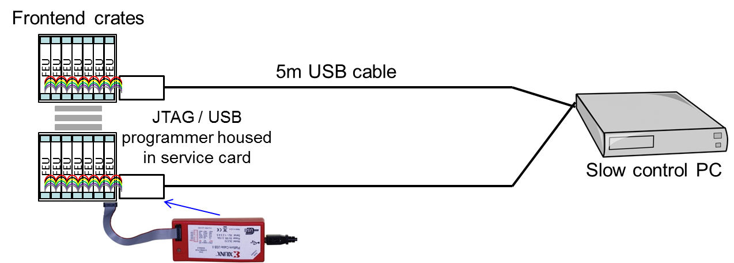

Figure 9 - Slow control for the FTT front-end electronics

The organization of the slow control network proposed for the frontend electronics is sketched on Fig. El3. A Xilinx USB programmer [Prg] is installed in the service card in each frontend crate. A flat ribbon cable jumper carrying the four JTAG signals connects the programmer to all FEU-s in the crate. A 5m long USB cable connects the programmer to the remote slow control PC. The PC controls several USB programmers each connected to a frontend crate.

For monitoring operations, standalone program acting as an EPICS server periodically or on a user request scans a group of FEU-s reading requested information, populating specific databases with it and eventually presenting it in a user readable form. The program allows for remote updates of the FEU firmware as well as for a “cold” restart of the FEUs by rebooting them.

## Front end cooling

Since the front-end electronics is located close to the detectors, in a region with potentially significant stray magnetic field due to the proximity with the CLAS12 magnets, standard fans cannot be used in the FEU crates. Therefore, for every front-end electronics crate, a remote fan is placed 6 m away with a pipe bringing fresh air from the hall and a fan removing the heated air in the hall. An interlock system on the fans will shut down the low and high voltages if the fans are not powered. Additional safety controls on the electronics board prevent the system from overheating.

# Procedures

## General procedure

Here follows the general procedures for turning ON and OFF the FT-Trck system:

Turning FT-Trck system ON:

1. Turn on gas,
2. Turn on cooling system,
3. Turn on Electronics Low Voltage,
4. Turn on Electronics High Voltage,
5. Take a Pedestal run, check noise levels, write configuration file,
6. Ready for physics.

Turning FT-Trck system OFF:

1. Turn off Electronics High Voltage,
2. Turn off Electronics Low Voltage,
3. Turn off gas,
4. Turn off cooling system.

### Installation

The tracker is inserted on the FT support pipe after the installation of the hodoscope. Keys on the tracker and hodoscope support rings and matching keyways on the calorimeter pipe will ensure the relative alignment of the three detectors. A survey is done by JLab engineers using precision targets on the FT-Trck and on the FT-Cal to the absolute position of the whole FT with precision comparable to the tracker resolution.

The FT tracker is tested with its electronics using comic rays in order to check efficiency and noise levels.

### Gas On and Gas off

Procedure to turn the gas ON:

The detectors HV must be “OFF” (HV are different when air or Argon are in the detector).

Step 1: purging the detector with argon (to remove air, i.e. oxygen)

1. set the FT-Trck gas control system in manual mode,
2. push the “gas On” button on the FT-Trck gas control system,
3. open the Argon tank valve (in gas shack),
4. open the FT-Trck gas rack valves,
5. flush the in line with 40 l/h of Argon (using the Argon mass flow meter of the mixing unit)
6. open the 2 rotameters of the barrel with 4 l/h each,
7. check the 2 return bubblers for bubble,
8. wait for 4 hours (flush of ~ 4 time the volume, including pipes).

Step 2: flowing detectors with Argon + 10% isobutane (can be done only after Argon purging)

1. set the FT-Trck gas control system in automatic mode,
2. push the “gas On” button on the FT-Trck gas control system,
3. open the Argon tank valve and Isobutane bottle valve,
4. open the FT-Trck gas rack valves,
5. flush the in line with 3.6 l/h of Argon and 0.4 l/h of isobutane (using the mass flow meter of the mixing unit),
6. check the 2 return bubblers for bubble,
7. check the value of the mass flow meter of FT-Trck gas rack (EPICS),
8. wait for 2 hours (flush of ~ 2 time the volume, including pipes),
9. ready for HV ON.

Procedure to put the gas OFF for short time (without Argon purging):

1. push the “gas OFF” button on the FT-Trck gas control system (can be done with EPICS).

Procedure to put the gas ON after short time off (without Argon purging):

1. push the “gas ON” button on the FT-Trck gas control system (can be done with EPICS),
2. wait for 2 hours.

Procedure to put the gas OFF for long time (with Argon purging) or prior dismounting detectors:

The flammable gas mixture must be removed from the detectors and replaced by Argon:

1. set the FT-Trck gas control system in manual mode,
2. push the “gas On” button on the FT-Trck gas control system,
3. open the Argon tank valve (in gas shack),
4. open the FT-Trck gas rack valves,
5. flush the in line with 4 l/h of Argon (using the Argon mass flow meter of the mixing unit),
6. open the 2 rotameters of the barrel with 5 l/h each,
7. check the 2 return bubblers for bubble,
8. wait for 4 hours (flush of ~ 4 time the volume, including pipes),
9. detector purged of flammable gas, ready to be dismounted).

### HV on / off

In order to switch the HV on the FT-Trck detectors must have first been flushed with the Ar+10% gas mixture.

To power ON the HV

1. Switch the HV crate ON using the key,
2. Enter the password if necessary,
3. Check the strip value of HV for each channel,
4. Check the strip I max value HV for each channel,
5. Check the value for drift HV,
6. Put ON each positive HV for the strips,
   * wait for HV to establish,
   * check for overcurrent,
7. put ON each negative HV for drift,
   * wait for HV to establish,
   * check for overcurrent.

### Powering up and down the FT tracker readout system

The powering scheme of the front-end electronics is shown on Fig. 8. After each general shutdown of the FT-Trck system, it is necessary to power up the PL506 low voltage supply in order to be remotely controlled via the overall CLAS12 slow control network. The frontend cooling system must be up and cooling interlock connector inserted at its front panel to be able to power individual modules supplying frontend crates. The FT-Trck backend electronics, being housed in the JLAB VXS/VME crates, is powered up following the standard procedures. It is preferable to power the FT-Trck backend electronics first, following by the power up of the frontend electronics. The following is the FT-Trck readout activation sequence:

1. Make sure the PL506 power supply is on,
2. Power up FT-Trck backend electronics crate,
3. Start FT-Trck frontend electronics cooling system,
4. Power up individual modules within the PL506 system,
5. Scan all frontend units to check their state.

The power down has to be done in the inversed order, but first one has to make sure that the FT-Trck high voltage is off.

The PL506 low voltage power supply is remotely controlled and monitored via EPICS software. It has four low voltage modules, one per crate plus one spare. The modules are configurable individually, even though their settings are identical. Table 3 lists the configuration parameters and their typical values.

|  |  |  |
| --- | --- | --- |
| Parameter | Value | Comment |
| Sense voltage (V) | 4.5 | Frontend operating voltage |
| Current limit (A) | 15 | 2 FEU x 5 A plus power up rush current |
| Ramp up (V/s) | 20 |  |
| Ramp down (V/s) | 100 |  |
| Moderate regulation | set | FTT cables are 15 m long |
| Min sense voltage (V) | 4.3t | Low limit for operating voltage |
| Max sense voltage (V) | 4.7t | High limit for operating voltage |
| Max terminal voltage (V) | 5.5 | Takes into account power drop over the cables |
| Max current (A) | 25 |  |
| Max Power (W) | 140 W |  |
| Max temperature (°C) | 80 |  |

Table 2 - Low voltage configuration parameters

## Interlocks

### gas

Gas flows and pressures are controlled by Siemens 1200 series PLC, then sent to EPICS. In case of a global gas leak or overpressure, the PLC will shut down the gas system automatically and send an alarm.

### HV

The HV settings should be switch to “OFF” in the following events:

- Electronics is not powered,

- Gas mixture is not the nominal one (pure argon will damage the detector is they stay ON).

### LV

In case of HV failure, the LV shuts itself down. Global slow control detects LV failures and/or powers down FEUs. No damage can occur to equipment or personnel.

### Electronics Cooling

If the electronics cooling interlock is activated, the LV system is shut down followed by a HV system shut down. In case the interlock fails, the global slow control & local FEU monitoring continues to operate.

## Response to Hall B alarm

### Gas system

In case of a fire alarm in the Hall, the gas system will also shut itself down.

### HV & LV

In case of a fire alarm in the Hall, the HV and LV systems will shut themselves down in that order.

# Abbreviations

BEU Backend unit

FEU Frontend unit

JTAG Joint Test Action Group

LVDS Low voltage differential signaling

FT Forward Tagger

FTT or FT-Trck Forward Tagger Micromegas tracker

TI Trigger interface

# References

[Drm] P. Baron; E. Delagnes; C. Flouzat; F. Guilloux, “DREAM, a Front End ASIC for CLAS12 detector”, User Manual, Production Version, Document 1.0, Sept. 25, 2012

[Feu] I. Mandjavidze, “FEU a frontend unit for Micromegas trackers”, User’s Manual, March 14, 2016

[Pbb] Schroff, Power distribution bus bars, reference: 20100-008

[Prg] Xilinx, “Platform Cable USB II”, DS593, v1.2.1, March 17, 2011

[Win] W-Ie-Ne-R, “PL512/PL506, Modular