  - Optical Requirements

The upgraded CLAS12 spectrometer incorporates several major components inherited from CLAS such as Forward Time-of-Flight Counters, Low Threshold Cherenkov Counter, Forward Electromagnetic Calorimeter, and will be build in the same experimental area. This put certain constrains on the overall CLAS12 design and consequently on all detector components to provide most efficient acceptance coverage.
The High Threshold Cerenkov Counter (HTCC) occupies very limited space downstream of the Central Detector and is mounted between Microstrip Silicon Tracker and Region I drift chambers. Figure 2.1.1 illustrates the basic optics of the detector, and on Figure 2.1.2 is shown 3D-view of mirror and PMTs for one sector.
It has been defined such that most photons are reflected only once by one of the elliptical mirrors and then directly hit the photocathode of photomultiplier tube. In order to provide a forgiving light collection, i.e. to have optics less sensitive on target length and position, and on a smearing of photon distribution due to the influence of magnetic field of Central Solenoid on the particle trajectories, the 5 photomultiplier tubes are equipped with Winston Cones.

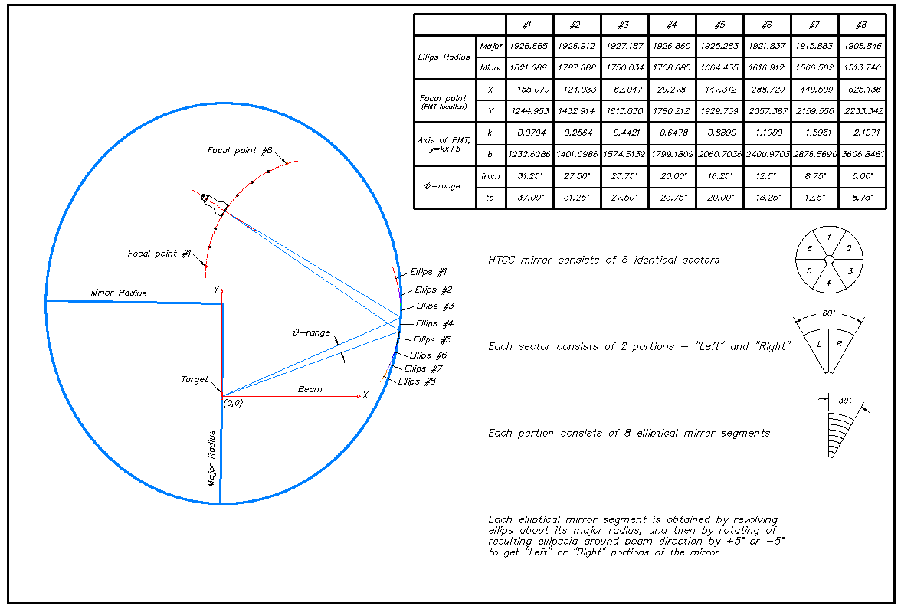

Fig. 2.1.1 Geometry and main parameters of HTCC

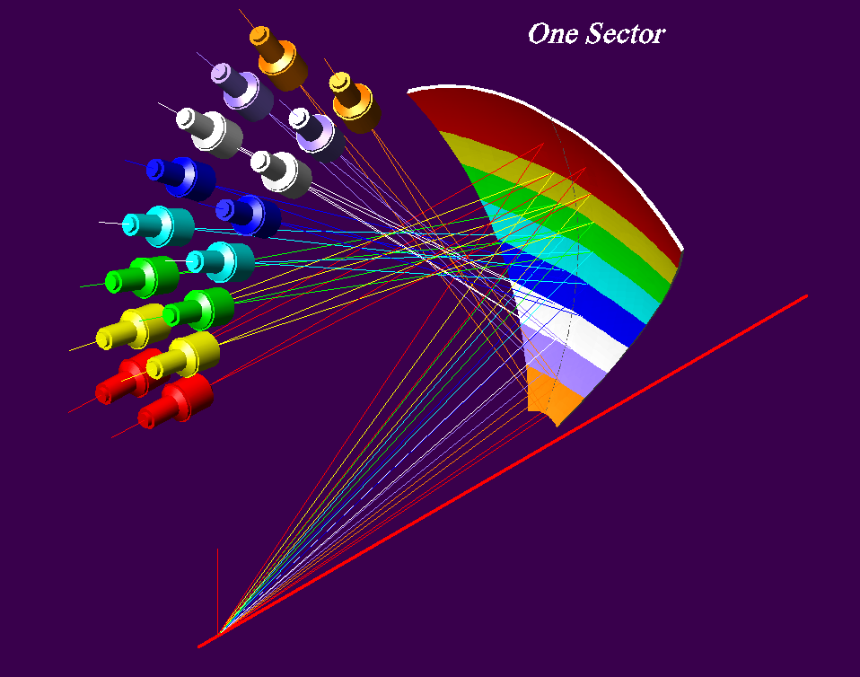

Fig. 2.1.2 3D-view of mirror and PMTs for one sector

Optical properties of mirrors, Winston Cones and photomultiplier tubes are optimized for Cherenkov light detection. Working surfaces of mirrors and cones will be covered with aluminum and magnesium fluoride (MgF₂) protection coating. To minimize UV light absorption, which is critical for Cherenkov light detection, the Photonis XP4508 photomultiplier tubes with quartz face plates will be used. Equally important is to provide appropriate tolerances and quality of finishes of custom build Winston Cones and mirrors.

  - Physical Environment

The HTCC is a single module detector covering all six sectors for scattering angles in range of θ = 5 to 37 in the entire Δϕ = 2 acceptance. The Detector as one unit can be moved along beam direction or removed from the beam if necessary. It is located in strong magnetic field of superconductive solenoid of Central Detector. Light collection geometry of the HTCC is such that all 96 photomultiplier tubes are located in the fringe field domain at radial distances of 124.5cm or greater from electron beam. That distances are chosen to be maximal but still small enough to allow moving of the detector upstream for CLAS12 alignment and maintenance purposes to fit in the Hall B main frame infrastructure (Figure 2.2.1).

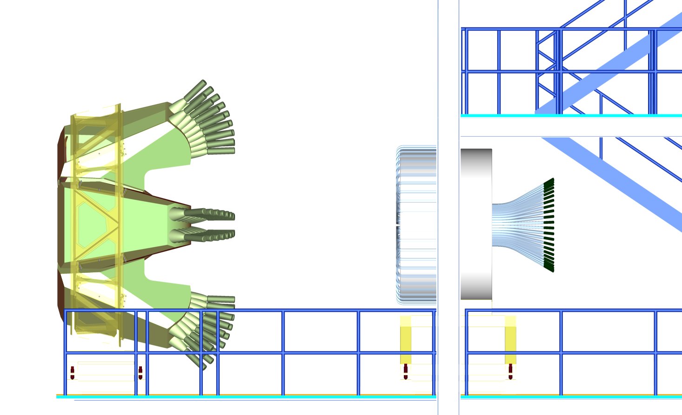

Fig 2.2.1 HTCC and Central Detector (moved upstream under Main Frame)

The space occupied by HTCC along beam direction defines what would be a signal strength expected at given pressure of working gas. The design of CLAS12 specifies that the entry window of Cherenkov Counter is located at ∼0.1 distance downstream the SVT of Central Detector, and the exit window is 1 upstream of R1 drift chambers. That leaves distances that scattered electrons travel in CO₂ radiator equal to ∼131cm at angles 5 and ∼181cm at 35. The geometry of HTCC is optimized to keep difference in path lengths minimal. Locations of focal points (PMTs), distribution of magnetic fringe field were taken into consideration as well. Estimated signal strength is discussed in ChapterXXX.
The angular and momentum resolutions of CLAS12 along with its capability of running at high luminosities put serious constrains on both thicknesses and materials that can be used in HTCC. These limitations on materials and estimates of required and achievable thicknesses are given in Chapter XXX.
Another constrain that is being addressed in the design comes from the acceptance specifications for R1, R2 and R3 drift chambers located downstream, after the Cherenkov Counter. A polar angle acceptance for them is in range of θ = 5 to 44, which is wider as compared with one for HTCC. Since the elliptical mirror is meant to be supported along its entire perimeter only than the corresponding support structure has to be located in a relatively narrow “shadow” region in coil planes of CLAS12 Torus Magnet and be built of light materials. So there are no support parts within acceptances of R1, R2 and R3 drift chambers or HTCC.

  - Overall design

Overall approach to workout requirements for HTCC design is a twofold task – first to outline general demands on Cherenkov Counter performance and then define ranges for critical parameters such as for elliptical mirror as a major HTCC component.
The main requirements are:

- High electron detection efficiency, low background
- Capability of running at luminosity L→10³⁵cm⁻²×sec⁻¹
- Angular acceptance 5° õθõ 35° and Δϕ ≈ 2π
- Lightweight, as less material as possible within acceptance to meet the expected angular and momentum resolutions of CLAS12, – δθ1.5mrad, δϕ5mrad, and Δp/p1%

The view of HTCC is given in Figure 2.3.1.

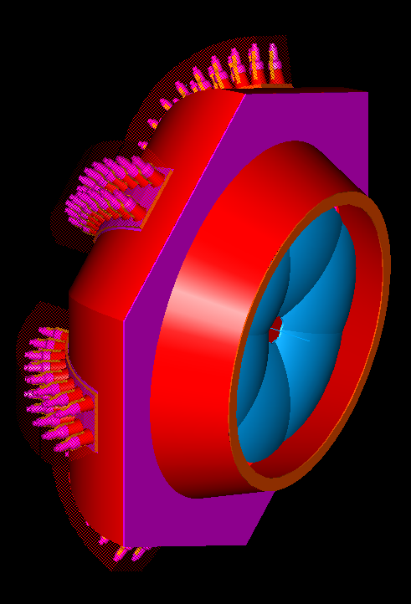

Fig 2.3.1 Back view of the HTCC, in blue shown Elliptical mirror
A detailed description of detector’s design current status is provided in Chapter XXX. Some specific features are:
- Thin entry and exit windows (∼0.6mg/cm² of Polyethylene and ∼16mg/cm² of ROHACELL XF31 foam sheet respectively)
- Ultra thin self supporting mirror
- Capability of working with different types of high density Möller shields
Total radiation length of the detector is ∼1.6% including contributions of CO₂ radiator, ∼0.8%, and of the mirror, which does not exceed 0.8%. Since number of photons per event is proportional to a total radiation length of radiator, then the only resource to possibly decrease “thickness” of the detector without compromising its performance is to use thinner mirrors. Figures 2.3.2a,b and c illustrate changes in CLAS12 resolutions for different mirror thicknesses: standard (∼200mg/cm²) and reduced to ∼100mg/cm².

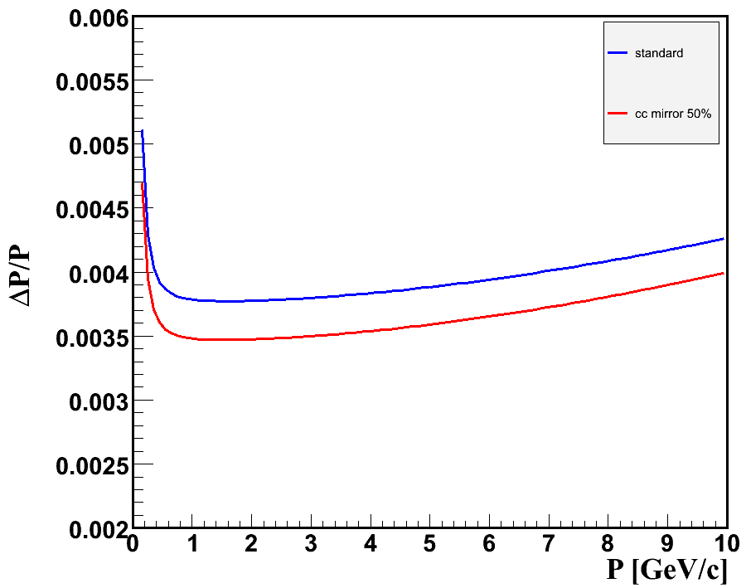
(a)
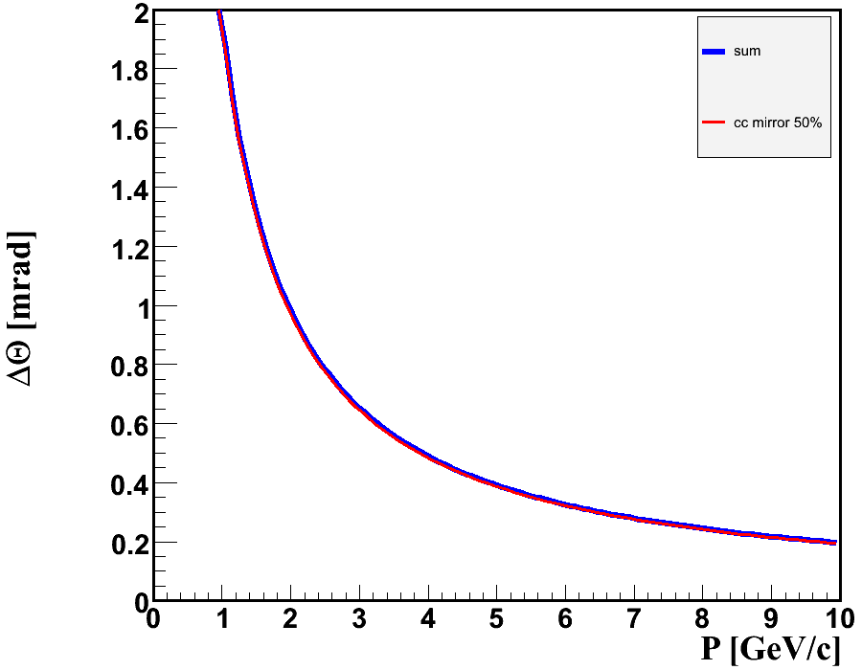
(b)

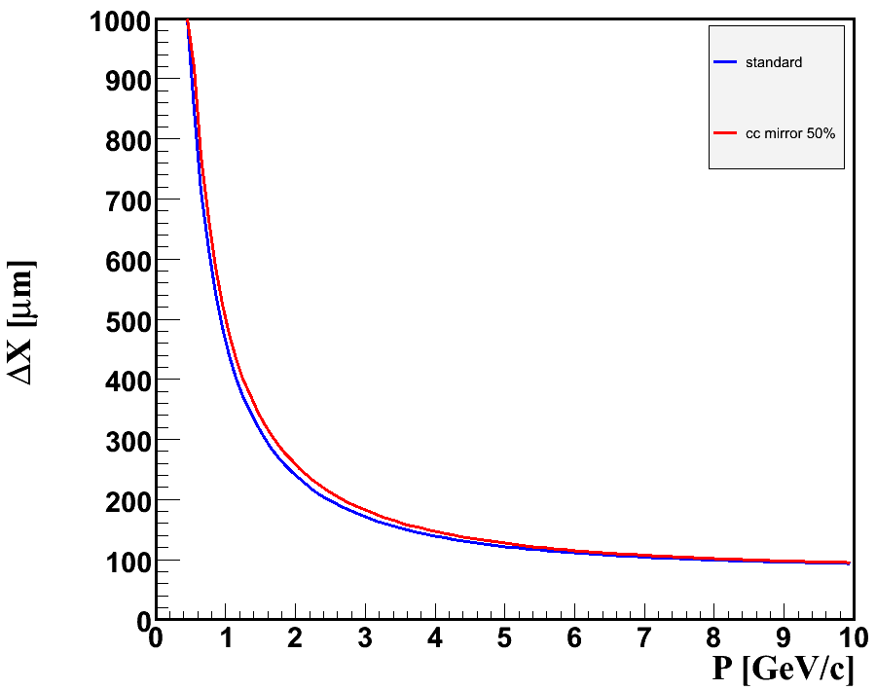
(c)
Fig.2.3.2 a–momentum, b–angular, and c–spatial resolution of CLAS12.

Results show a small improvement in momentum, angular and spatial resolutions indicating that the influence of HTCC (mirror) thickness is small and not dominating as compared with contributions of other CLAS12 detector components.

  - Details of Light Collection Cones Design

GEANT simulations of HTCC optics and performance show that for point like target with no magnetic field almost all Cherenkov photons are focused on photocathode of diameter 110mm, which is minimal for 5 PMTs from Photonis. In experiments on CLAS12 a standard cryogenic targets are 50mm of length, and in some experiments targets as long as up to 100mm can be used. For all experiments with electron beam superconductive solenoid and Cherenkov counters will be used. As it was mentioned in section 2.1, to have efficient Cherenkov light collection for extended targets in magnetic fields a light collection cones are necessary. To define main parameters for Winston Cones we required an opening diameter of 7.5 and distance from PMT photocathode (110mm) to be equal 8 allowing magnetic shields be extended far enough beyond photocathode. Direct comparison of such Winston Cone angular acceptance with results of MC simulations showed that the Winston Cone’s acceptance is much wider, and the opening diameter is big enough to collect at least 95% of Cherenkov light in experiments with two possible polarities of CLAS12 Torus Magnet without any adjustments of PMTs location or orientation.
There is available well established and experimentally checked technology of building Winston Cones. Such light concentrators were built for the existing Low Threshold Cherenkov Counter of CLAS using that technology and have revealed good performance. Technical specifications and requirements of proposed Winston Cone for HTCC similar of those used in CLAS are given in Table 2.4.1. Corresponding parameters are given in Figure 2.4.1.

Table 2.4.1 Specifications for HTCC Winston Cones for CLAS12 spectrometer

SPECIFICATION | DATE | SOURCE
Winston Cone Definition
A Winston Cone is a non-imaging light collector designed to collect light from a range of incident angles on a given circular area and “collect” that light onto a smaller area. The Winston Cone is not a focusing device, but it is highly efficient in collecting light. Its general shape is that of a parabola revolves about an axis of symmetry of the parabola.
BASIC
Material =copper outer surface with inner coatings of nickel, aluminum, and magnesium fluoride (see below) | 12/2006 | P. Stoler
Weight = 4 lbs (approximately) | 12/2006 | Y. Sharabian
Life time = 30 years with no optical degradation | 12/2006 | P. Stoler
Dimensions = ∅7.5″x8.0″ long | 12/2006 | Y. Sharabian
Optical and structural properties tolerant to high radiation dose 20 Megarad/20 years | 09/1991 | C. Zorn
Most radiation is in x-ray region, some relativistic particles | 05/1992 | C. Zorn
MANUFACTURING
Slope errors <1º | 12/2006 | D. Kashy
Displacement errors < 0.02″ | 12/2006 | D. Kashy
Surface finish of Root Mean Square = 0.5 μm (microns) | 12/2006 | Y. Sharabian
Scratches occurring in forming operation etc. need not be removed provided in the final product there are less than 4 /cone and  - they are less than 2.54 cm in length  - they are less than 0.15 μm (microns) deep  Open Ends flat within 0.03″ | 12/2006 | Y. Sharabian
OPTICS | 12/2006 | Y. Sharabian
MATERIAL | 12/2006 | P. Stoler
Copper:
Thickness = 0.040″ nominal
Application method = electroformed
None-magnetic
Nickel:
Thickness = 0.0005″ nominal
Application method = electroformed
Allowable magnetic properties
Aluminum:
Thickness ≈ 0.04 μm(microns)
Application method = vacuum (vapor) deposition
None-magnetic
Magnesium fluoride (protective coating)
Thickness = as required to meet reflectivity specifications
Application method = vacuum (vapor) deposition)
None-magnetic
ENVIRONMENTAL | 12/2006 | Y. Sharabian
Operating @ CO₂ at 1.001 atmosphere, temperature = 22ºC
Stored in plastic bag w/ambient air to avoid dust contamination
DO NOT contact reflective surface with anything
Wash reflective surface w/only optical liquid (Check this spec)

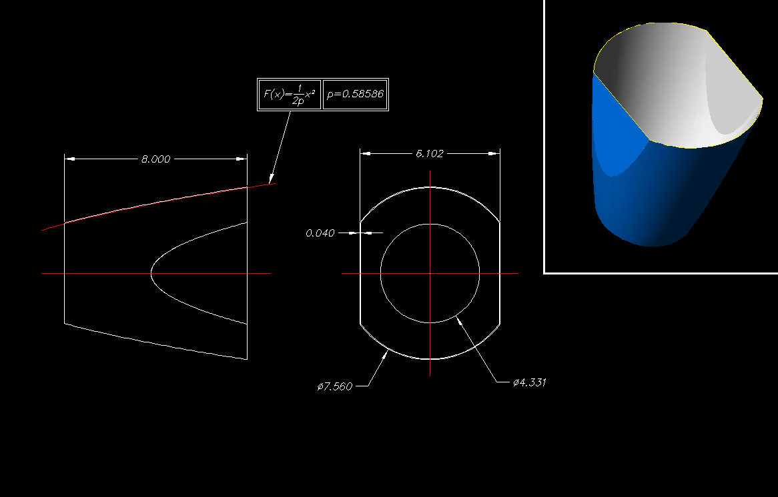

Fig. 2.4.1 Winston Cone for HTCC

  - Details of Light Collection Cones Design

(Details and discussion will be provided later)

 | Item | Un | Amn | Price, $/unit | Source of Estimate | Cost, k$ | Date | Comments
1 | Winston Cone | EA | 96 | 325.00 | Vendor | 38.70 | 02.07.07 | Set-up fee 7.5k is added
2 | PMTs, XP4508, concave – convex quartz window | EA | 96 | 3256.00 | Vendor | 312.58 | 10.23.06 | Options available
3 | Dividers, VD105K negative, passive | EA | 96 | 169.00 | Vendor | 16.22 | 10.23.06
4 | Magnetic Shield, MS175 | EA | 96 | 408.00 | Vendor | 39.17 | 10.23.06
5 | Deposition of reflector and protection coating onto the substrates | EA | 96 | 177.08 | Vendor | 17.00 | 03.09.07
6 | HV Cables | km | 3.0 | 656.17 | Catalog | 1.97 |  | To be updated
7 | HV Connectors | EA | 288 | 11.30 | Catalog | 3.35 |  | To be updated
8 | Signal Cables | km | 7.68 | 1706.04 | Catalog | 13.1 |  | To be updated
9 | BNC Connectors | EA | 288 | 6.90 | Catalog | 1.99 |  | To be updated
Subtotal (procurement of components) : 444.08k
1 | Mechanical Structure | HR | 900 | 50.00 | Engineering Judgment | 45.00 |  | PRELIMINARY
2 | Manufacturing of auxiliary equipment for mirror construction | HR | 1500 | 50.00 | Prototyping Document | 75.00 | 30.09.06-13.14.07 | PRELIMINARY
3 | Construction of 96pc of substrates | HR | 2400 | 50.00 |  | 96.00 | 30.09.06-13.14.07 | PRELIMINARY
4 | Aluminum Angles ( 331/2 ) | FT | 300 | 6.32 | Vendor | 1.90 | 03.14.07
5 | Polyurethane Foam  FR – 6710, Sheet  ( 14896 ) | EA | 22 | 155.00 | Previous Procurement | 3.41
Subtotal (machine shop expenses) : 221.31k
Total : 665.39k

