Response to the second round of comments to g12 note. The comments are in bold, and answers are not.

1. **Monte Carlo simulation and efficiency.**

**1.1 Drift chamber wire efficiency map. It is not a good idea to keep data in private directory particularly if the owner is not around any longer. Please move it to some appropriate place, preferably under clasg12 account and also would be good idea to back them up to the silo.**

The wire efficiency map is in the calibration database, and can be viewed interactively:<https://userweb.jlab.org/~ungaro/maureepage/proj/dceff/dc_periods/g12.html>. For bookkeeping purpose, the files are now located under the clasg12 directory.

**1.2 The smearing parameters fro drift chambers seem to reproduce residuals. Show how simulated resolution matches resolution from the data. Compare simulated and experimental invariant mass and width of *Ks*. φ -meson is not a good choice because its mass is very close to sum of masses of 2 kaons.**

In Figure 1, the mean and width of the Ks from g12 data (Left) and simulation (Right) are compared. The simulation reproduces the mass position of Ks exactly, and the width (resolution) is within 1MeV. Note that this particular simulation does not simulate the detached vertex. We think its fair to say that g12 simulation procedures are sufficient to reproduce the data.

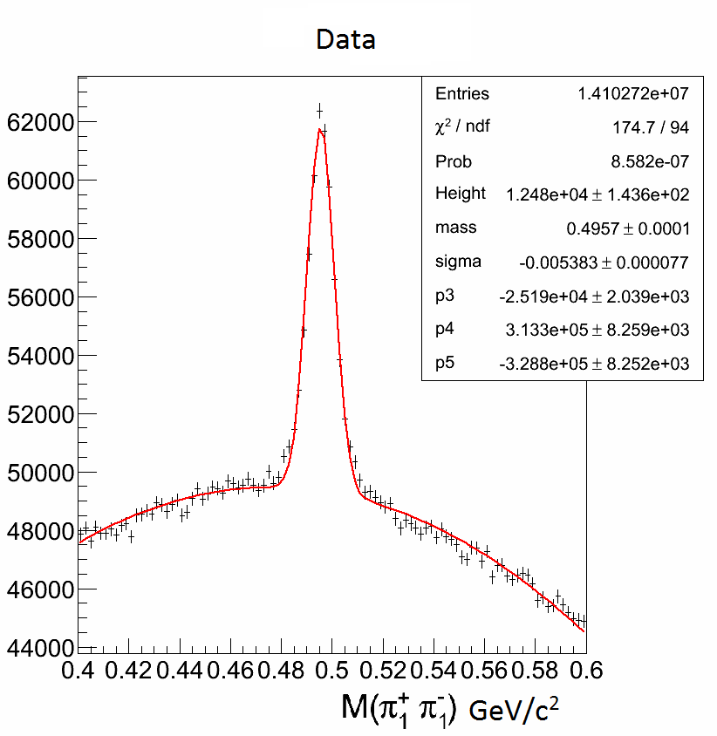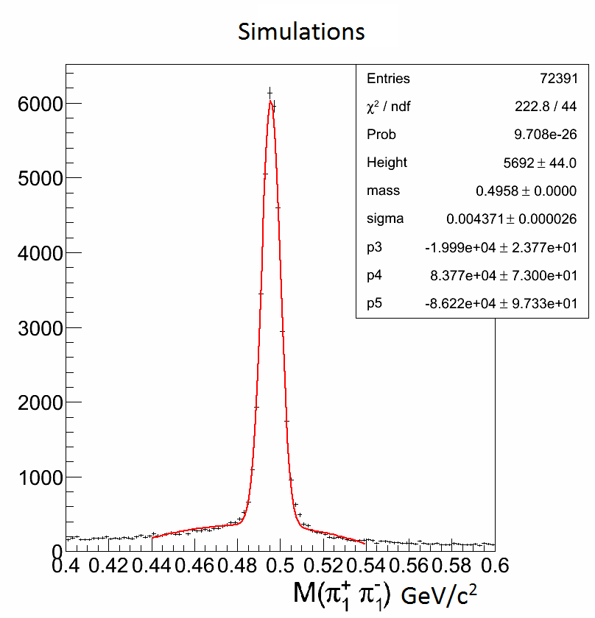

Figure 1: The mean and width of Kshort from g12 data (left) and simulation (right). The mass positions are dead on. The width from data is 5.4MeV, and the simulation 4.4MeV.

**1.3 Dead area removal and efficiency. Fig. 2 of the response shows that there are differences between the simulation and the data. Compare 2D angular distributions θ − φ for γ *p* → *p*π +π − from the simulation and the data of all three particles. Compare occupancies of DC and TOF as well**.

The 2D angular distributions for proton, pi+ and pi-, are shown in Fig. 2, comparing the data (left) and simulation (right). The simulated employed both the g12 wire efficiency map, and TOF knockout (dead paddles and those that are unstable). The combined TOF knockout removes about 7% data for each track. The relative statistical uncertainty increase is small compared with the other systematic uncertainties. Overall, g12 simulation reproduces the dead regions faithfully. It should be noted that the simulation shown below is based on phase space, and as a result the particles populate the detectors differently. Any inefficiency in the data that is not reproduced by the data, will be addressed by the efficiency correction map that has been derived by g12. A new map, with the TOF knockout applied, was already derived.

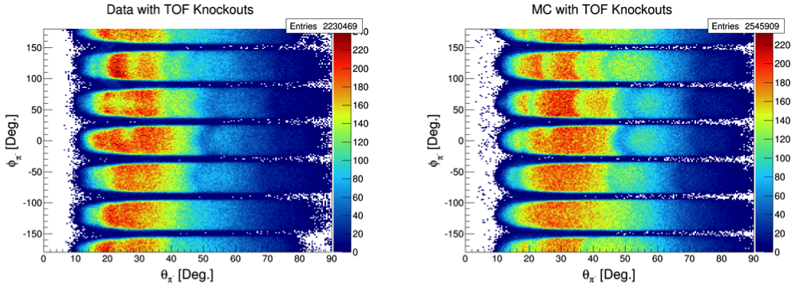

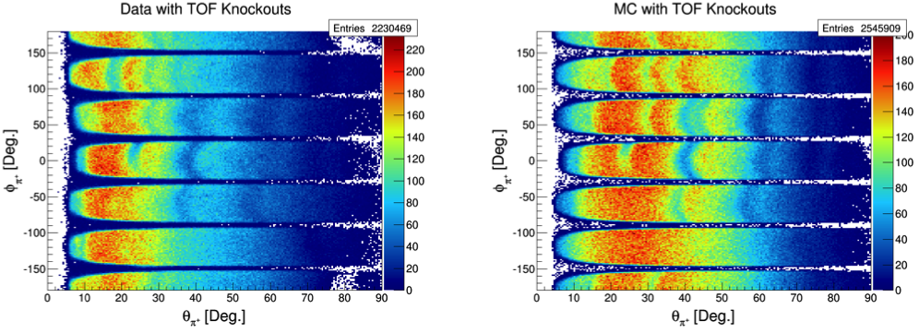

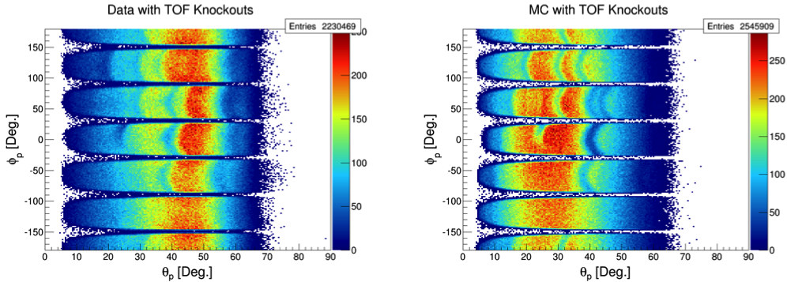

Figure 2: The  VS  angular distributions for   and proton, are shown in Fig. 2, comparing the data (left) and simulation (right), using the exlusive reaction of . The simulation was based on phase space.

**2. Normalization**

**2.1 Flux. At the end of the flux section include final numbers for systematics associated with differences of tagging ratio and with the normalized yield stability. This number should be considered as the lower limit for normalization systematic uncertainty of any g12 analysis. We don’t understand the first paragraph of 4.3 what is 0.5% and what is 10%**

**2.2 Table 26 shows Normalization uncertainty of 1.8%. Where is this number came from?? It is too good to be true.**

Comments 2.1 and 2.2 are related. The 1.8% normalization uncertainty shown in Table 26 is incorrect and indeed too good to be true as pointed out. The g12 overall normalization uncertainty is about 5.7%, derived from the difference between the normalized yields of omega using two current settings (60nA and 65nA) that consist the bulk of the g12 data. All g12 cross section measurement need to use this as the lower limit of the normalization uncertainty. (The 0.5% and 10% in the first paragraph of 4.3 is simply based on the fitting results of Fig. 81 in the note. That graph shows, within uncertainty, g12 did not have high inefficiency we need to correct for at production current. ) The note is modified accordingly.

**2.3** **Target. You did not answer question about target length and thermal contraction. You only discuss density. In addition to the target density you also need the target length. You still list it as 40 cm. 40 cm is the length measured at room temp. When it is filled with liquid hydrogen it contracts by something around 0.6%. You must account for this contraction unless you apply cuts smaller than the actual length. Take a look at eg2 note: https://userweb.jlab.org/~xiaochao/eg2/main\_072503.ps Also, if your vertex cut is larger than the size of the cell do you subtract a background from the target cell walls?**

The eg2 study is obviously very well done. We will adopt their overall results of 1% uncertainty related to target (density, length, contraction, etc.) We do not see that there is any statistical significant data from the target cell walls, and do not subtract a background from the target cell walls. Standard g12 analysis should choose events from within the target, taking into account the contraction. If a particular analysis chose to cut outside of the target, they would have do the systematics study accordingly.

**2.4 ω cross sections. Show angular distributions in log scale. Also show comparison between g12 and g11 as a ratio of cross sections.**

The angular distrubtions for are shown in Fig. 3 and Fig. 4, in log scale. It is clear that g12 is consistently higher than g11 at the last four energy bins. We compared the results from the two experiments separately (in Fig. 5). It is clear that the g11 results had a suddent drop at 3.4 GeV and above, by about a factor of two or more. At the same time, the decrease of the cross sections in g12 is more smooth and there is not sudden drop, at the same higher energy bins. This would suggest that the g12 results should be more credible at the higher energy bins. In addition, the g12 efficiency correction map that is dependent on vertex, momentum and angles are a dynamic correction, that resulted in an overall correction on the order of 15% similar to what g11 had. That there would be certain disagreement between g11 andg12 should be expected due to this dynamic correction. Noting that all plots in Fig 3 to Fig 8 only included statistical uncertainty, it is safe to conclude that the overall procedure in g12 cross sections measurements are sound and adequate.The ratio of the results from g12 and g11 are shown in Fig. 6 and 7. All of the ratios are plotted in Fig. 8 (excluding the last four energy bins from E 3.6 to 3.8 GeV). Most discrepancies came from the most forward and backward regions, where the cross sections and acceptance is rapidly changing. The final results would require differential cross sections being fed back to simulation, which currently is based on phase space. We suggest that the finer details of each analysis be left for the individual review, instead of the overall g12 group review.

**iMac :Users:leiguo:talks:2015:CLASOct_g12_guo:xsecOmega1.pdf**

Figure 3: Angular distributions (CM frame) for  cross sections, for E range of 1.55 to 2.7GeV. g12 results are in black compared with g11 (red). Only statistical uncertainties are included.

**iMac :Users:leiguo:talks:2015:CLASOct_g12_guo:xsecOmega2.pdf**

Figure 4: Angular distributions (CM frame) for  cross sections, for E range of 2.75 to 3.8 GeV. g12 results are in black compared with g11 (red). Only statistical uncertainties are included.

**iMac :Users:leiguo:talks:2015:CLASOct_g12_guo:drop_pattern_g12.pdfiMac :Users:leiguo:talks:2015:CLASOct_g12_guo:drop_pattern_g11.pdf**

Figure 5: Angular distributions (CM frame) for  cross sections, for E range of 3.35 to 3.8 GeV. Results from g12 are shown on the left, showing smooth transitions. Results from g11 are on the right, showing a sudden drop at 3.6GeV.

**iMac :Users:leiguo:Library:Containers:com.apple.mail:Data:Library:Mail Downloads:A1C28460-8DEA-4BAA-81D9-E9BF3BEB1E5D:ratio_MKCorr_1.eps**

Figure 6: The ratios of the cross sections from g12 to g11, shown as a function of CM angles, for E range of 1.55 to 2.7 GeV.

**iMac :Users:leiguo:Library:Containers:com.apple.mail:Data:Library:Mail Downloads:34A43EE3-BEBA-4932-9500-8625B4A277EF:ratio_MKCorr_2.eps**

Figure 7: The ratios of the cross sections from g12 to g11, shown as a function of CM angles, for E range of 2.75 to 3.8 GeV.

****

**Figure 8:** The ratios of the  cross sections from g12 to g11, excluding the higher energy bins (3.6-3.8GeV). The mean of the ratio is 1.09 from the Gaussian fit, indicating a 9% difference, without including any systematic uncertainties from either experiments. Improvements in the forward and backward regions are expected from better simulation than simply phase space that is currently used.

**3. Lepton ID. We can approve the procedure applicable only to lepton pairs. For single lepton the ID cuts should be more strict.**

We agree. **4. Momentum correction. The section is still somewhat ambiguous. Needs clarification.**

We will modify the note to include the clarifications.