Response to the third round of comments to g12 note. The comments are in bold, and answers are not.

**1. Normalization**

**1.a: You take as systematic uncertainty estimate for normalized yield the overall shift between two beam intensities. You did not comment on the width of the distribution for given intensity. Is it consistent with the expected statistical width? If it is large than statistical you should add this to your systematics.**

The width of the normalized yields distributions for given intensity in fact is consistent with the expected statistical widths. In Fig 86 of the note, one can see that the widths are 6.2E-10 (60nA) and 4.7E-10(65nA). The expected statistical width (shown in Fig. 1 here) are actually 4.9E-10 (60nA, RMS: 2.6E-10) and 4.8E-10(65nA, RMS: 2.9E-10). These are consistent with each other and we should stick to the currently quoted lower bound of the systematic uncertainty for the g12 normalization of 5.7%.

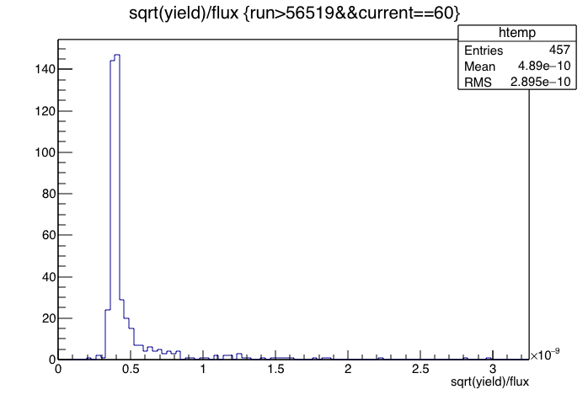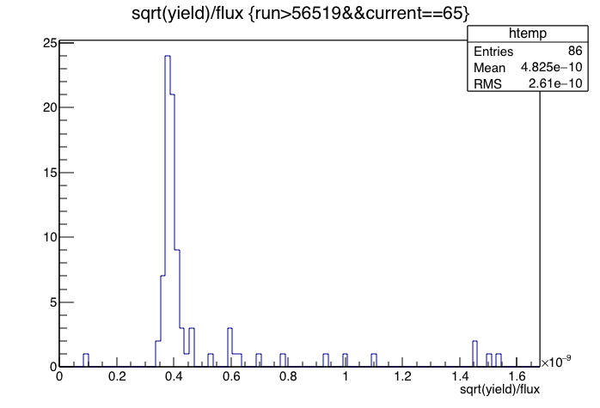

Fig.1. Expected statistical uncertainty for the flux normalized omega yields, for 60nA runs (left) and 65nA runs (right).

**1.b. Target. You answered our question in the response but it did not propagate to the note. Please fix.**

This is done now in the note in the section of target density (last paragraph).

**2. omega cross sections. Same as previous. There are requested plots in the response but they are missing on the note.**

Done. We added/replaced the plots in the notes.

**3. Beam polarization. Provide a table with the information which Moller measurement should be used for given run range. Also indicate run numbers when half wave plate was changed.**

We check the log book entries for the entire g12 running period. The half-wave plate actually was not changed. The variable of “1/2 waveplate” stayed “0.00” throughout the whole running period. An example of that information is shown below in Fig. 2. We also doube-checked this with Stepan. A side note is that there is actually one more moller run at 57317 at the end of the running period, that what was listed in Table 21. The polarization of that run was statistically consistent with the prior measurement at 57283. We changed the table to make it clear what the polarization value is valid for what run range.



Fig. 2. An example of the log book entry after the moller run.

**4. TOF knock out. In the response and in the discussions you state unstable and poor resolution counters were added to the knock out list and single particle efficiency were recalculated. However from the note is not clear what is the final knock out list. Please clarify this in the note.**

The multiple tables are a bit confusing, because they address different reasons for the knock out. We do provide the final knock out list in a new table at the end of the TOF knock out section.

**5. We suggest moving Fiducial cuts subsection 5.4 from section 5 to section 3.**

This is a good suggestion. Done.