Response to the third round of comments to g12 note. The comments are in bold, and answers are not.

**1. Normalization**

**1.a: You take as systematic uncertainty estimate for normalized yield the overall shift between two beam intensities. You did not comment on the width of the distribution for given intensity. Is it consistent with the expected statistical width? If it is large than statistical you should add this to your systematics.**

The width of the normalized yields distributions for given intensity in fact is consistent with the expected statistical widths. In Fig 86 of the note, one can see that the widths are 6.2E-10 (60nA) and 4.7E-10(65nA). The expected statistical width (shown in Fig. 1 here) are actually 4.9E-10 (60nA, RMS: 2.6E-10) and 4.8E-10(65nA, RMS: 2.9E-10). These are consistent with each other and we should stick to the currently quoted lower bound of the systematic uncertainty for the g12 normalization of 5.7%.

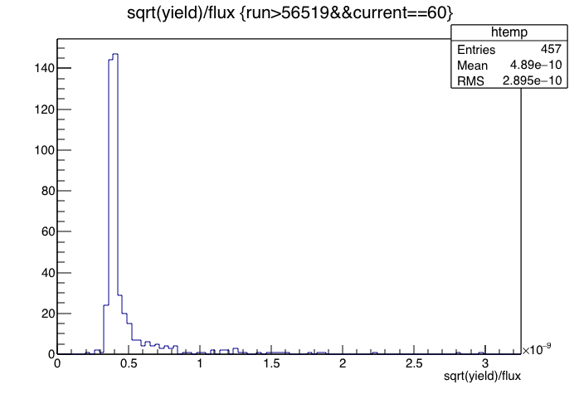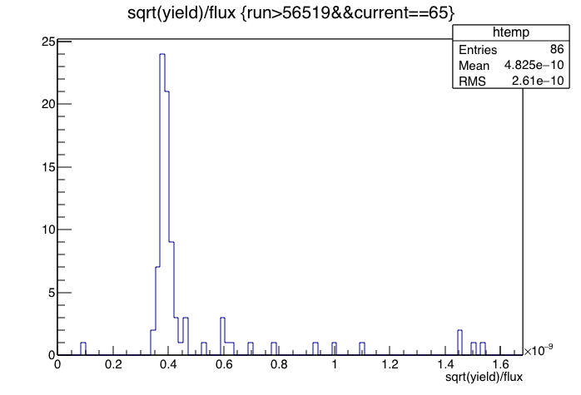

Fig.1. Expected statistical uncertainty for the flux normalized omega yields, for 60nA runs (left) and 65nA runs (right).

**1.b. Target. You answered our question in the response but it did not propagate to the note. Please fix.**

This is done now in the note in the section of target density (last paragraph).

**1.c. omega cross sections. Same as previous. There are requested plots in the response but they are missing on the note.**

Done. We added/replaced the plots in the notes.

**2. Beam polarization. Provide a table with the information which Moller measurement should be used for given run range. Also indicate run numbers when half wave plate was changed.**

We check the log book entries for the entire g12 running period. The half-wave plate actually was not changed. The variable of “1/2 waveplate” stayed “0.00” throughout the whole running period. An example of that information is shown below in Fig. 2. We also doube-checked this with Stepan. A side note is that there is actually one more moller run at 57317 at the end of the running period, that what was listed in Table 21. The polarization of that run was statistically consistent with the prior measurement at 57283. We changed the table to make it clear what the polarization value is valid for what run range.



Fig. 2. An example of the log book entry after the moller run.

**4. We suggest moving Fiducial cuts subsection 5.4 from section 5 to section 3.**

This is a good suggestion. Done.

**5. TOF knock out. In the response and in the discussions you state unstable and poor resolution counters were added to the knock out list and single particle efficiency were recalculated. However from the note is not clear what is the final knock out list. Please clarify this in the note.**

The multiple tables are a bit confusing, because they address different reasons for the knock out. We do provide the final knock out list in a new table at the end of the TOF knock out section.

**6. Momentum and photon beam energy correction. Chapter 3.3**

**6.a. In the latest response, you state that you will modify the note to include clarifications, but this has not been done. Also, a lot of our previous specific comments on that chapter have not been implemented.**

We might have uploaded a wrong version of the note. We believe now all has been implemented.

**6.b. Clarify if the photon-energy corrections derived and reported in the note were obtained after the application of the phi-dependent momentum corrections reported in 3.3.1. This correction should be derived after e-loss and phi-dependent momentum corrections are applied.**

Yes, this is exactly what happened. The final and standard g12 photon-energy corrections were re-derived after the momentum correction and e-loss corrections were applied.

**6.c Some of us are concerned that the photon energy correction may absorb any remaining systematic biases in the pion momenta. In such a case, the method by which the photon energy correction is derived ensures that the missing mass peaks are placed right at the nominal mass of the missing particle, but the calculated kinematics at which you report your observables (W, Cm angles) will be incorrectly estimated. We would like to see control distributions that provide evidence that after e-loss and phi-dependent momentum corrections, there are no remaining systematic biases in the particles' momenta:**

* **Plot the pi+pi- invariant mass (Ks) as a function of the p_pi+ and p_pi- momenta. On each plot show with a solid line the mean of the integrated invariant-mass distribution.**
* **Plot the pi+pi- invariant mass (Ks) as a function of the p_pi+ and p_pi- theta lab angles. On each plot show with a solid line the mean of the integrated invariant-mass distribution.**
* **Plot the pi+pi- invariant mass (Ks) as a function of the p_pi+ and p_pi- common Z vertex. On the plot show with a solid line the mean of the integrated invariant-mass distribution.**
* **Plot the pi+pi- invariant mass (Ks) as a function of run number. On the plot show with a solid line the mean of the integrated invariant-mass distribution.**

We understand the concern. It is worth pointing out that the momentum corrections are very small and really had negligible impacts on the physics results. On the other hand, we did check extensively the kinematic dependency of the Ks masses. In Fig. 2, the Ks masses are stable across all pi+ momentum range (Left) and pi- momentum range (Right). In Fig. 3, the Ks masses are also mostly flat as a function of beam energies. While it is hard to say that there all the correlation between the various the beam energy correction and momentum correction has been removed, judging from these stability plots, the effect of the remaining correlation is small and negligible. In the note, Fig. 62 also shows that the Ks mass is within 1MeV, the missing proton mass was 9MeV apart, indicating it is really the beam energy correction that is the main reason that missing masses were not in the right positions at the beginning. The angular dependence of the Ks masses are shown in Fig. 4 and Fig. 5. Large deviation at particular bins from PDG masses are usually result of low statistics.

We did not have all the plots asked for this item, due to the deletion of files that we

used to obtain the other Ks mass monitoring plots. However, we hope what has been provided is sufficient to convince the committee that the momentum correction is doing what it is supposed to do, and the effect are very small in the first place.

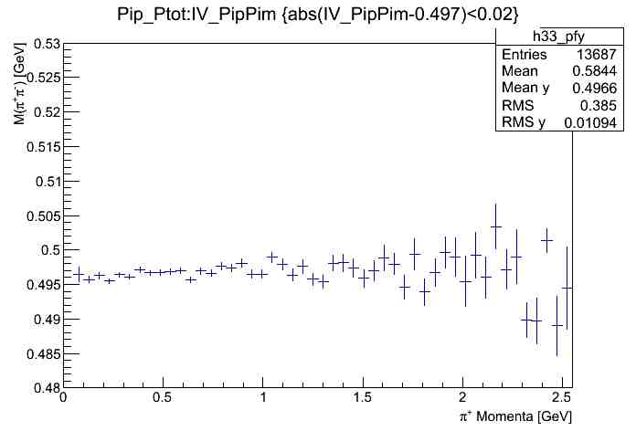 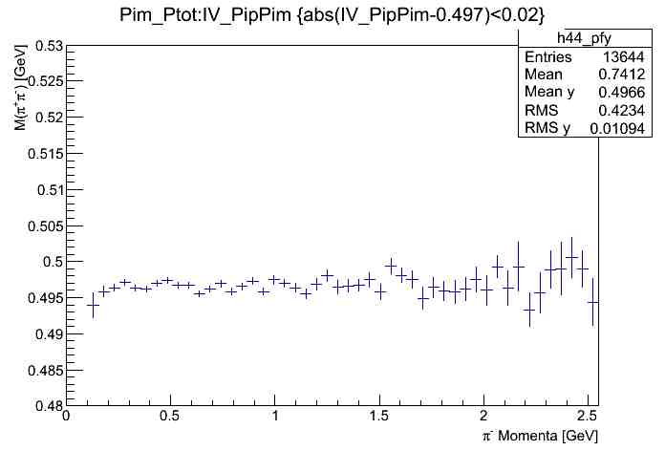

**Fig 3. Ks mass as a function of   momentum (Left) and  momentum**

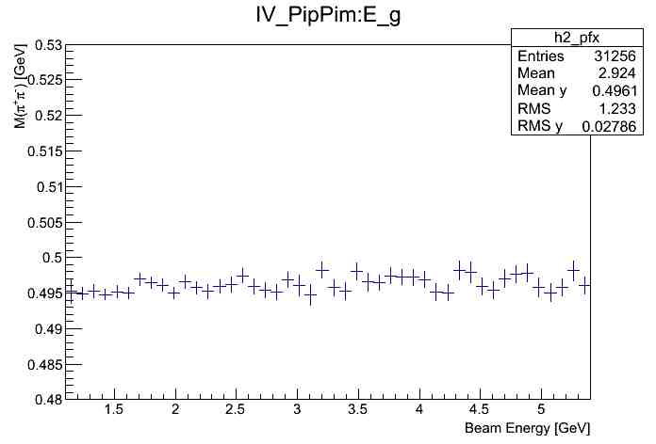

**Fig 3. Ks mass as a function of photon beam energies**



**Fig 4. Left: Ks mass at different  Lab  Lab Right: Statistics for the corersponding fits used to determine the Ks mass shown on the left**



**Fig 5. Left: Ks mass as a function of  Lab  Lab Right: Statistics for the corersponding fits used to determine the Ks mass shown on the left**

**6.d Show plots that the exclusivity cuts described after Eq. (14) indeed remove the background in your sample (this is important for the identification of the position of the missing mass peak later).**

The way it was written in the note is a bit confusing. The cuts are actually done on the missing energy and missing mass squared. The quoted Eq. really served no particular purpose. We removed that eqn now to avoid the confusion. Fig. 69 actually shows the effect of these cuts.

**6.e In Fig. 69 you show a fit consisting of a polynomial and a Gaussian - if the purpose of the polynomial is to describe any remaining background, provide arguments why you use a 3rd order polynomial shape (it seems to has a maximum right at the mass of your good events). In any case, if there is remaining background its shape has to be fitted properly. If, instead the purpose of the polynomial is to describe the tails of the peak, then a double Gaussian with a common mean is a better way to fit. We are not sure how much any of these would change your results for the corrected peak position - address.**

The purpose was to show the accuracy of the proton mass determination. The background function really should have no impact on the results, since the parameters of “Mean” and the fitted “Proton Mass”, are 0.9377 and 0.9378 (GeV/c2 ). Having an additional Gaussian should not have any effect.

**6.f show the the polynomial background curve and label the fit parameter giving the peak position in the fit report consistent with the label in Fig. 69, i.e. "Neutron Mass" instead of "Factor".**

This was a very old plot and not easy to change. We have incorporated that in the caption instead.

**6.g Fig. 72 caption: Clarify the corrections applied in the order as listed. o p.69, paragraph 1 in "The problem was first noticed by g12**

**participants at the analysis level in which missing particle masses were systematically low." - Explain if this observation was made after the g12 momentum corrections were applied.**

Yes.

**6.h Some editorial suggestions:**

* **p. 69, change "There was also features..." to "There were also  features...".**
* **p. 69, last paragraph: change "...for runs 56515 and 57130  revealed only a mass deviation of ≈1.4 MeV in which disclosed that the problem with the g12 data stream to be solely in the photon beam energy." to "...for runs 56515 and 57130 revealed only a mass deviation of approx. 1.4 MeV, which suggested that ...is most likely in the photon beam energy."**

Thanks. It’s done.

**7. Single particle efficiency. Comments from Yordanka. I looked at MK's thesis for the dynamic efficiency corrections. They were derived using kinematic fitting of ppi+pi- events, for each particle separately, for the real and for the simulated data. I cannot see how we can approve these efficiency corrections without reviewing the full analysis that produced them. The only independent (of analysis) g12 argument at this time that can be acceptable in my view about the validity of the correction would be that after the corrections, the omega cross sections from three-track and two-track events are consistent with each other, but I did not see a comparison of these in MKs thesis.**

In section 4.13.4 of MK thesis, there depicts a comparison of several π0differential cross-sections from g12 using the dynamic g12 correction com- pared to the g11 method derived for the g11 experiment. Shown is a good agreement between the 2 methods, however there is slight deviations in the forward cos θ direction. We attribute this deviation to the difference in the method of calculating the efficiency, where g12 is dynamic, while the g11 correction was a static ”global“ correction. Furthermore, in the analysis note procedure, the π0 differential cross sections are shown to be in good agreement with previous measurements obtained from CLAS and other world measurements.  If we use the mean values of the over efficiency corrections, our corrections would have been very similar to what g11 used.



**Fig 6**: The over-efficiency correction for all g12 p pi+ pi- events; Top Left: Over all errors. Top right: Proton tracks. Bottom left: pi+ tracks. Bottom right: pi- tracks.

**Some major concerns:**

**7.a According to MK thesis, the kinematic fit was done after e-loss and beam- energy corrections. Phi-dependent momentum correction was not done. This is not consistent with the analysis chain in the g12 latest note.**

It is not explicitly stated, however when kinematic fit is performed, the phi-dependent momentum corrections are performed (Prior to the fit, but in the fit procedure).

**7. b The parameters of the pull distributions of the simulated and the real data are not consistent with each other within their reported uncertainties. (The error matrices for the simu- and real-data fits seem to have been tuned independently. I wonder how the error matrices compare with each other). I suspect that one of the reasons for that discrepancy are residual differences between the resolutions of the simulation and the data. These would not be necessarily caught by comparing integrated distributions, such as invariant and missing masses, but would become prominent as one "zooms" in a particular bin of (p,theta,phi, z).**

From MK’s thesis, page 127, the pull distributions are shown and are consistent with each other. It is true that there exists two tunes, one for MC and one for data. Each tune has a flag to tell the fitter if it is MC or data. The independent tune was performed because it was seen that using the residual parametrization from the data for the TBER matrices was not sufficient. However, the simulated widths, momentum, θ and φ angles were consistent between MC and data, this can be seen in MK thesis pages 134-139.

**7. c For a better estimate of the magnitude of the issue above, one would need to see differences, such as p_calculated-p_measured for the narrow kinematic bin (theta,phi,z) as a function of momentum (etc), plotted together for simulated and real data (mean values, widths).**

See above  response to 7.b.

**7. d The counting of detected particles was done by checking if a real particle was detected with kinematics falling within the kinematic bin of interest. On average, that is not a problem, if one derives an overall correction, since bin migration tends to average out. However, that can be very dangerous if the local resolutions in the simulation and the real detector do not match. Different bin migrations will cause a local bias in the efficiency.**

The local resolutions of MC and data are consistent in the g12 experiment. This is documented in section 5.2 of the analysis note procedure.  We understand the concern. Having a global correction certainly has advantages, however, it ignores precisely these local discrepancies the committee has pointed out. We feel that it is better to have a kinematics-dependent correction, rather than a global one, especially when the exact causes of these efficiency discrepancies between the simulation and data are not pinpointed and likely a result of many factors.

**7. e The uncertainty of the correction has not been estimated (this may take care of my concern in d) as long as the biases are randomly distributed over the (p,theta,phi,z) bins) as far as I could see. The quoted value of 3% for 3-prong events seems to account for photon multiplicity effects in the correction, but not for inherent effects, such as resolution mismatches simulation-data.**

You are right. There is uncertainty simply as a result of limited statistics. These factors are obtained by computing the ratio of the efficiencies, and natually has associated statistical uncertainties. Plotting statistical uncertainties of the efficiency correction factors for all tracks (p pi+ pi- data), we argue that the MPV is a good measure of the systematic uncertainty of the track efficiency corrections. For proton, it would be about 1.3%, for pi+, it would be 1.4%, for pi- it would be 1.5%. When applying all these together, for p pi+ pi- events, the error of 2.6% is consistent with adding them in quadrature. It is reasonable to quote a 3% global uncertainty on the g12 track-dependent efficiency correction for p pi+ pi- events. For other topologies, the uncertainties could be estimated similarly.



**Fig 7:** The statistical uncertainties distributions for the over-efficiency correction for p pi+ pi- events; Top Left: Over all errors. Top right: Proton tracks. Bottom left: pi+ tracks. Bottom right: pi- tracks.

**7. f In MK's thesis, the detection efficiencies for p, pi+, and pi- are shown both for the simulation and for the data. While, the simulated results nicely show the location of the coils, the real data do not. A relatively high efficiency is for the regions of the coils for the data, where we expect zero. One explanation would be that in the determination of the thetacosphi and thetasinphi bins, the bins covering the coil areas contain areas both with zero efficiency and with high efficiency. I would like to see if the efficiency for that bin was reported for the actual average of the events' kinematics in that bin, or the for the middle of the bin (which is unacceptable). I also wonder if the procedure of correction evaluation did check that the actual mean values of the kinematic bins, for which the ratio of efficiencies simu/real was formed, did indeed match, or one trusted the middle of the bins. Again, this may not be an issue for observables reported for wide bins, but brings into question potential errors of the correction (i.e. systematic biases).**

The plots referred to in MK’s thesis did not include fiducial cuts. The evaluation done on the track efficiency was to only show the over simulation of events. However, the final pi0 mesurments obviously did include them eventually. Below is a typical plot that shows the effect of actually applying them.



**Fig 8:** After applying the fiducial cuts, the coil positions are nicely shown.