Alaska Tasseled Cap analysis

Peta Library root directory:

/work/earthlab/permafrost/projects/

**Methods**

*Remote sensing data*

For this analysis, all of the MODIS 8-day Surface Reflectance product (MOD09A1) between July 1 – August 31 are used. These are ordered from LPDAAC’s AppEEARS tool, and are mosaiced using the a buffered shapefile for Alaska and part of the Canada (Yukon). This return 1 file with each band. Mosaiced raw data are on the PetaLibrary

Data Location: alaskaTasseledCap/AppEARS/allAK/MOD09A1

Shapefile: AK_LCC_GCS_WGS84_b20k.shp

Original from Geographic Information Network of Alaska. Buffered to 20 km

Peta Library location: alaskaTasseledCap/GINA

*Processing*

1. Generate representative Tassled Cap images

MOD09 Data are processed to derive the Tasseled Cap index for each image. The loading are the same as presented in Lobser and Cohen (2007). For each year, the median value for each pixel is used and then saved out: one file for TC component (Bright, Green, Wet) each year.

Git Hub Script: [**alaskaMODISTasCap**](https://github.com/ozjtigger1/alaskaMODISTasCap)**/procTCTimeSeries.py**

Processed files location: alaskaTasseledCap/AppEARS/allAK/output

1. Generate trend images

Per pixel trends are then calculated using the Theil-Sen regression.

Git Hub Script:[**alaskaMODISTasCap**](https://github.com/ozjtigger1/alaskaMODISTasCap)/**calcTCTrends.py**

Processed files location: alaskaTasseledCap/AppEARS/allAK/output

1. Identify structure in data by classifying them

Several different clustering algorithms were tried, but Gaussian Mixture Clustering seemed to produce interesting results. When considered wholeistically, there were ~5 clusters in the data. In particular, fire history is encoded in 1 class, and some type of glacial change seems to be encoded in another class. Remaining 3 are open ended questions (Figure 2).

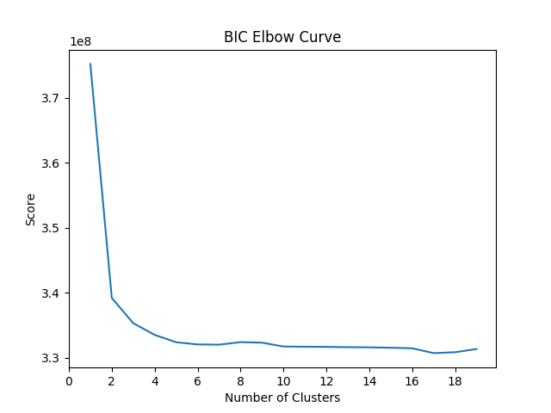

Figure 1: Elbow curve suggests there are approximately 5 clusters in the TC trend data.

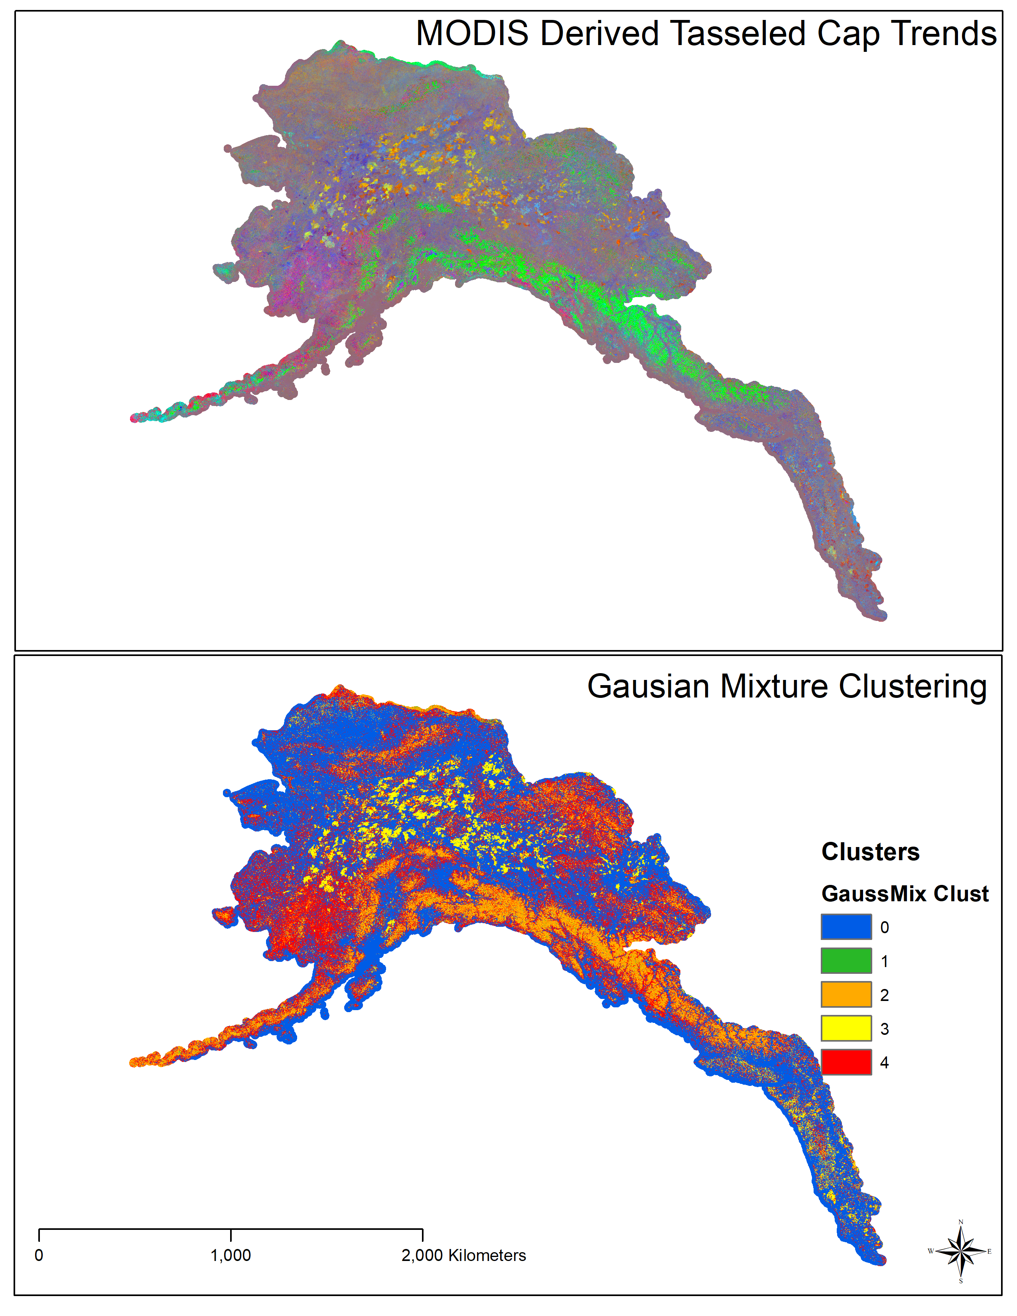

Figure 2. Tasseled Cap trend data and the resulting Gaussian Mixture Clustering

Git Hub Script:[**alaskaMODISTasCap**](https://github.com/ozjtigger1/alaskaMODISTasCap)**/idNumGaussMixClust.py**

Processed files location: alaskaTasseledCap/AppEARS/allAK/output

Images: alaskaTasseledCap/AppEARS/allAK/images

Maps: /work/earthlab/permafrost/projects/maps

1. Comparisons with Permafrost Zonation Index

Comparisons between the Permafrost Zonation Index (Gruber 2012) and the TC trends data (Figure 3)

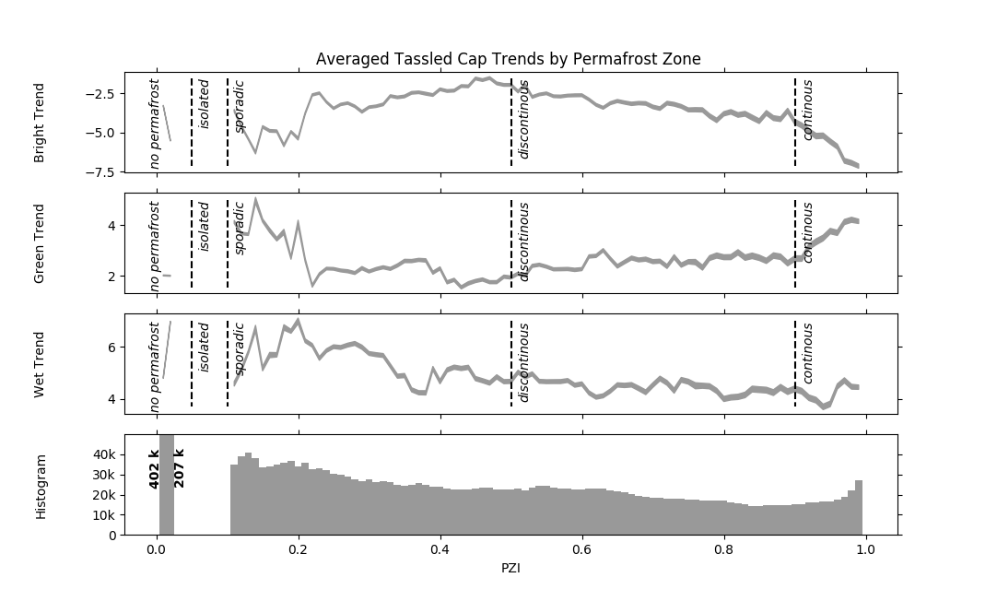

Figure 3. Averaged Tasseled Cap trends aggregated for individual PZI zones.

Git Hub Script:[**alaskaMODISTasCap**](https://github.com/ozjtigger1/alaskaMODISTasCap)**/exploreAKTasselCap_vs_PZI_Data.py**

Processed files location: alaskaTasseledCap/AppEARS/allAK/output

Image Locations: alaskaTasseledCap/AppEARS/allAK/images

Maps: /work/earthlab/permafrost/projects/maps

**References**

Lobser & Cohen (2007) MODIS tasselled cap: land cover characteristics expressed through transformed MODIS data, International Journal of Remote Sensing, 28:22, 5079-5101, DOI: 10.1080/01431160701253303