从官网上下的数据集

**from** matplotlib **import** pyplot **as** plt**from** tensorflow.examples.tutorials.mnist **import** input_data​mnist **=** input_data**.**read_data_sets("MNIST", one_hot**=**True)**for** i **in** range(12):

plt**.**subplot(3, 4, i**+**1)

img **=** mnist**.**train**.**images[i **+** 1]

img **=** img**.**reshape(28, 28)

plt**.**imshow(img)plt**.**show()

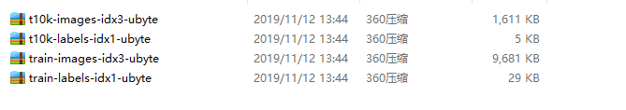

实际上就是图片的压缩形式：

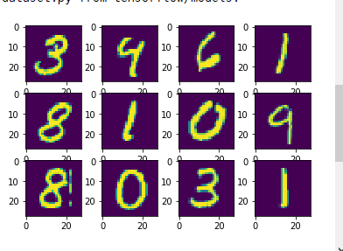

具体模型及训练：

import os

import tensorflow as tf

from matplotlib import pyplot as plt

from tensorflow.examples.tutorials.mnist import input_data

mnist = input_data.read_data_sets("MNIST", one_hot=True)

BATCH_SIZE = 64

def visualization(_mnist):

for i in range(12):

plt.subplot(3, 4, i+1)

img = _mnist.train.images[i + 1]

img = img.reshape(28, 28)

plt.imshow(img)

plt.show()

#可视化

class LeNet(object):

def __init__(self):

pass

def create(self, X):

#第一层网络

X = tf.reshape(X, [-1, 28, 28, 1])

with tf.variable_scope("layer_1") as scope:

w_1 = tf.get_variable("weights", shape=[5, 5, 1, 6])

b_1 = tf.get_variable("bias", shape=[6])

conv_1 = tf.nn.conv2d(X, w_1, strides=[1, 1, 1, 1], padding="SAME")

act_1 = tf.sigmoid(tf.nn.bias_add(conv_1, b_1))

max_pool_1 = tf.nn.max_pool(act_1, ksize=[1, 2, 2, 1], strides=[1, 2, 2, 1], padding="SAME")

#第二层网路

with tf.variable_scope("layer_2") as scope:

w_2 = tf.get_variable("weights", shape=[5, 5, 6, 16])

b_2 = tf.get_variable("bias", shape=[16])

conv_2 = tf.nn.conv2d(max_pool_1, w_2, strides=[1, 1, 1, 1], padding="SAME")

act_2 = tf.sigmoid(tf.nn.bias_add(conv_2, b_2))

max_pool_2 = tf.nn.max_pool(act_2, ksize=[1, 2, 2, 1], strides=[1, 2, 2, 1], padding="SAME")

#展开成向量

flatten = tf.reshape(max_pool_2, shape=[-1, 7 * 7 * 16])

#全连接1

with tf.variable_scope("fc_1") as scope:

w_fc_1 = tf.get_variable("weight", shape=[7 * 7 * 16, 120])

b_fc_1 = tf.get_variable("bias", shape=[120], trainable=True)

fc_1 = tf.nn.xw_plus_b(flatten, w_fc_1, b_fc_1)

act_fc_1 = tf.nn.sigmoid(fc_1)

#全连接2

with tf.variable_scope("fc_2") as scope:

w_fc_2 = tf.get_variable("weight", shape=[120, 84])

b_fc_2 = tf.get_variable("bias", shape=[84], trainable=True)

fc_2 = tf.nn.xw_plus_b(act_fc_1, w_fc_2, b_fc_2)

act_fc_2 = tf.nn.sigmoid(fc_2)

#全连接3

with tf.variable_scope("fc_3") as scope:

w_fc_3 = tf.get_variable("weight", shape=[84, 10])

b_fc_3 = tf.get_variable("bias", shape=[10], trainable=True)

tf.summary.histogram("weight", w_fc_3)

tf.summary.histogram("bias", b_fc_3)

fc_3 = tf.nn.xw_plus_b(act_fc_2, w_fc_3, b_fc_3)

return fc_3

def train():

# 1. 输入数据的占位符

x = tf.placeholder(tf.float32, [None, 784])

y = tf.placeholder(tf.float32, [BATCH_SIZE, 10])

# 2. 初始化LeNet模型，构造输出标签y_

le = LeNet()

y_ = le.create(x)

# 3. 损失函数，使用交叉熵作为损失函数

loss = tf.reduce_mean(tf.nn.softmax_cross_entropy_with_logits(logits=y_, labels=y))

# 4. 优化函数，首先声明I个优化函数，然后调用minimize去最小化损失函数

optimizer = tf.train.AdamOptimizer()

train_op = optimizer.minimize(loss)

# 5. summary用于数据保存，用于tensorboard可视化

tf.summary.scalar("loss", loss)

# 6. 构造验证函数，如果对应位置相同则返回true，否则返回false

correct_pred = tf.equal(tf.argmax(y_, 1), tf.argmax(y, 1))

# 7. 通过tf.cast把true、false布尔型的值转化为数值型，分别转化为1和0，然后相加就是判断正确的数量

accuracy = tf.reduce_mean(tf.cast(correct_pred, tf.float32))

merged = tf.summary.merge_all()

writer = tf.summary.FileWriter("logs")

# 8. 初始化一个saver，用于后面保存训练好的模型

saver = tf.train.Saver()

with tf.Session() as sess:

sess.run((tf.global_variables_initializer()))

writer.add_graph(sess.graph)

i = 0

for epoch in range(5):

for step in range(1000):

batch_xs, batch_ys = mnist.train.next_batch(BATCH_SIZE)

summary, loss_value, _ = sess.run(([merged, loss, train_op]),

feed_dict={x: batch_xs,

y: batch_ys})

print("epoch : {}----loss : {}".format(epoch, loss_value))

writer.add_summary(summary, i)

i += 1

# 验证准确率

test_acc = 0

test_count = 0

for _ in range(10):

batch_xs, batch_ys = mnist.test.next_batch(BATCH_SIZE)

acc = sess.run(accuracy, feed_dict={x: batch_xs, y: batch_ys})

test_acc += acc

test_count += 1

print("accuracy : {}".format(test_acc / test_count))

saver.save(sess, os.path.join("temp", "mode.ckpt"))

train()

训练完之后

在tensorboard上可视化

