## Supervised Learning

In supervised learning, we are given a data set and already know what our correct output should look like, having the idea that there is a relationship between the input and the output.

Supervised learning problems are categorized into "regression" and "classification" problems. In a regression problem, we are trying to predict results within a continuous output, meaning that we are trying to map input variables to some continuous function. In a classification problem, we are instead trying to predict results in a discrete output. In other words, we are trying to map input variables into discrete categories.

## Unsupervised Learning

Unsupervised learning allows us to approach problems with little or no idea what our results should look like. We can derive structure from data where we don't necessarily know the effect of the variables.

We can derive this structure by clustering the data based on relationships among the variables in the data.

With unsupervised learning there is no feedback based on the prediction results.

## Linear regression with one variable

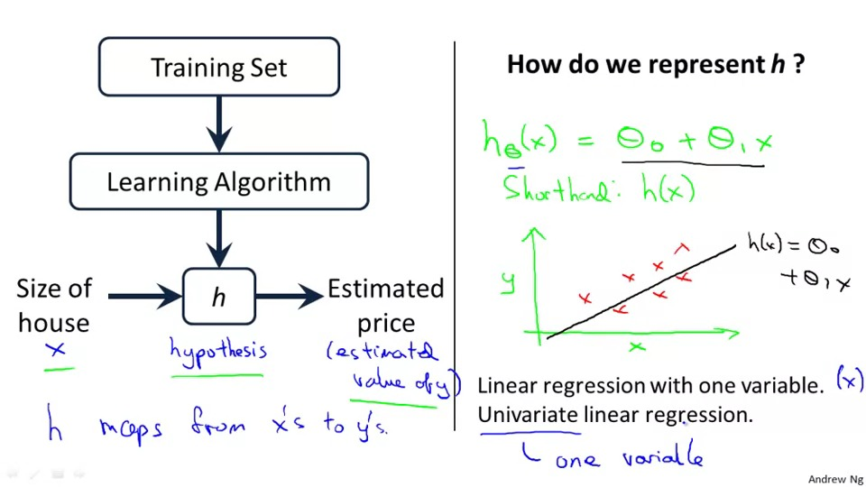

**Cost function**

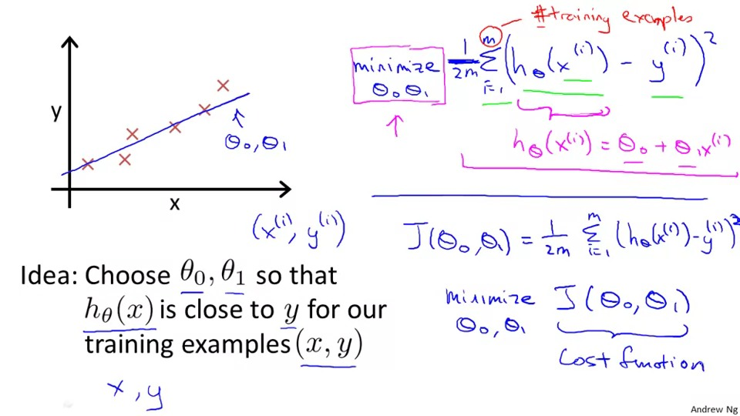

**Gradient descent（梯度下降算法）**

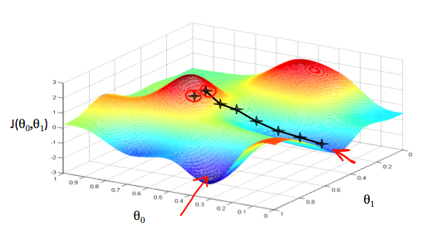

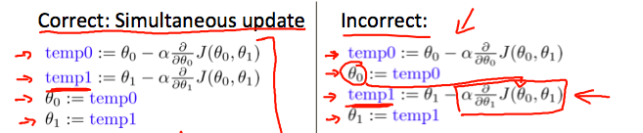

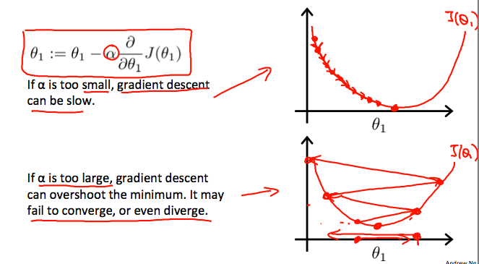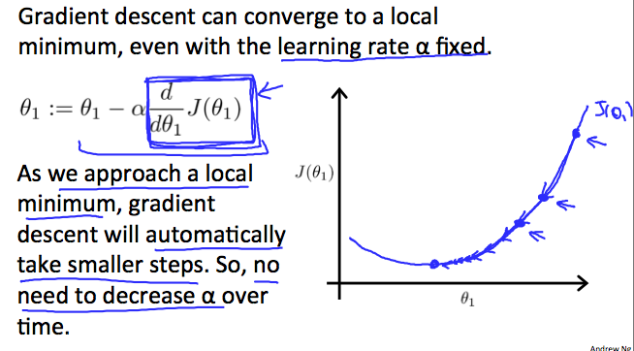

**Gradient descent for liner regression**

