# Matrices Learning

Review

# Linear Regression with multiple variables

1571108972(1)

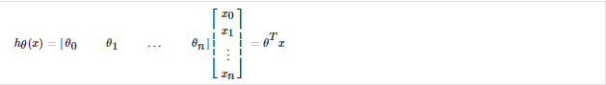

n=1 to n>=1:

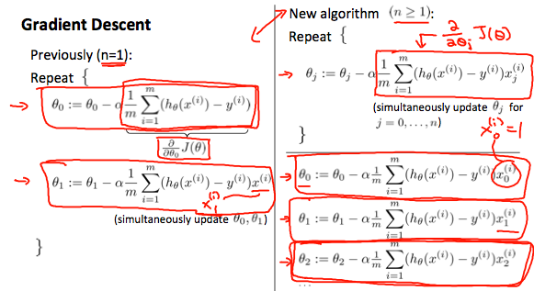

**Feature Scaling(speed up gradient descent)**

Two techniques to help with this are ****feature scaling**** and ****mean normalization****. Feature scaling involves dividing the input values by the range (i.e. the maximum value minus the minimum value) of the input variable, resulting in a new range of just 1. Mean normalization involves subtracting the average value for an input variable from the values for that input variable resulting in a new average value for the input variable of just zero. To implement both of these techniques, adjust your input values as shown in this formula:

1571129975(1)

For example, if x_ixi​ represents housing prices with a range of 100 to 2000 and a mean value of 1000, then,

**1571130029(1)**

**Learning Rate**

