# Features and Polynomial Regression

自定义features和归一化过程

# Normal Equation

1571205616(1)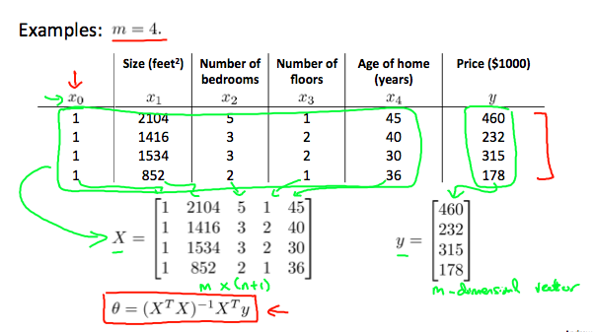

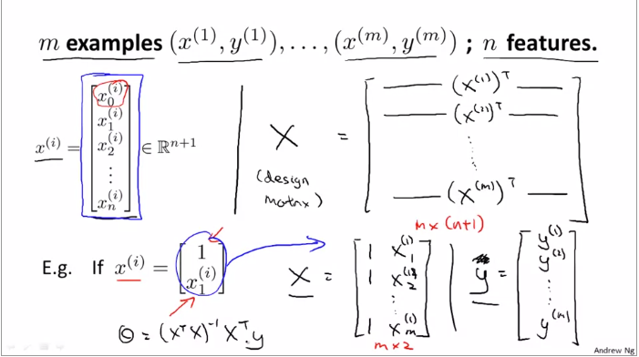

# Octave Learning