# 神经网络学习

# Model Representation I

Visually, a simplistic representation looks like:

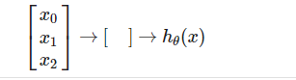

If we had one hidden layer, it would look like:

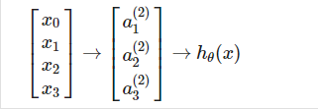

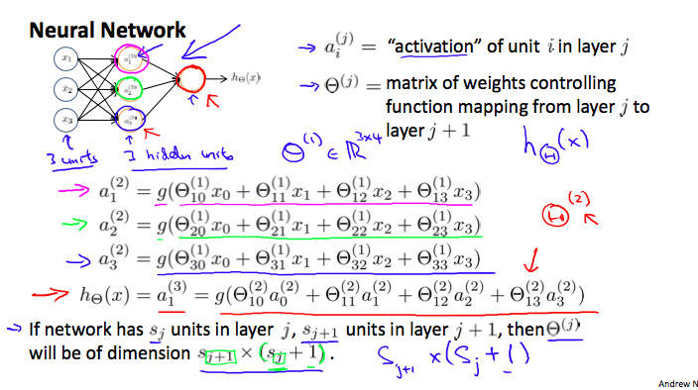

# Model Representation II

for layer j=2 and node k, the variable z will be:

IMG_256

向量化

# Examples

# 1.OR function

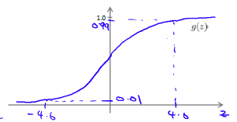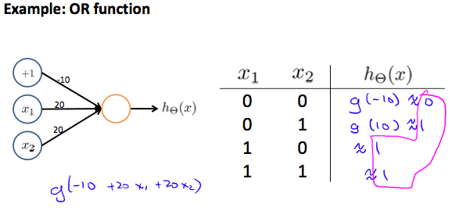

# 非线性的假设函数

And there we have the XNOR operator using a hidden layer with two nodes! The following summarizes the above algorithm:

