# Evaluating a Hypothesis

* Getting more training examples
* Trying smaller sets of features
* Trying additional features
* Trying polynomial features
* Increasing or decreasing λ

# Diagnosing Bias vs. Variance

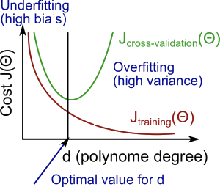

# Regularization and Bias/Variance

