

WICKRIO SETUP AND CONFIG

Prepared for: Wickr Inc, Engineering Group

Prepared by: Paul Cushman, Project Lead

Date: September 21, 2018

Version: 4.54.15

# WICKRIO

## Objective

This document contains information associated with the installation and configuration of the WickrIO system.

## Assumptions

This document is intended for those that are familiar with the installation of Docker containers as well as the security of the host system running Docker software.

Wickr staff is available to assist in the deployment and configuration, but for security reasons, at no time should Wickr have access to the actual machine where the deploy is taking place. Screen sharing sessions can be used for troubleshooting.

### Document Overview

The following is a list of sections in this document:

* Solution Overview
* Software Installation
* Configuration
* Troubleshooting

# SOLUTION OVERVIEW

## WickrIO Components

The WickrIO software is distributed via a Docker repository. You will have to supply an appropriate host machine to run the WickrIO Docker container.

### Host Machine

The WickrIO Docker container should run on any host machine capable of running Docker Ubuntu based containers. The WickrIO client software will require access to the file system running on the host machine so that persistent data can be stored.

NOTE: the software running in the WickrIO docker container will ONLY have access to the areas you give it access to. This is important to remember when interacting with the WickrIO client software.

### WickrIO Docker Container

The WickrIO Docker container contains the WickrIO client and any other WickrIO software necessary to support the creation and running of WickrIO bot clients. The WickrIO bot clients provide a software Interface to a subset of the Wickr client capabilities. Access to a WickrIO bot client is via a Node.js Addon API interface (described in a separate document). This interface provides the ability to send and receive messages, as well as create secure rooms and group conversations.

Wickr provides a HTTP/HTTPS integration that allows access to a REST API that can be used to access a WickrIO bot client running on the WickrIO system.

# SOFTWARE INSTALLATION

## WickrIO Installation Steps

The following sections will describe the installation of the WickrIO software. This is a list of those steps:

1. Host machine setup: install Docker and define shared filesystem location(s)
2. WickrIO Docker container: pull the appropriate WickrIO Docker container
3. Run the WickrIO Docker container

After installing the WickrIO software you can proceed to configuring the WickrIO bot clients that will be running from the WickrIO Docker container.

### Host Machine Setup

The host machine used to run the WickrIO Docker container needs to be setup to be running the appropriate Docker software. Details on how to setup Docker software on your host machine is not included in this document.

The WickrIO Docker container will also require access to the host file system. Depending on what type of host operating system you are running on you may need to define this before running the WickrIO Docker container. You will need to specify this location to the docker image when you run it. Persistent data will be stored in this location, so that you can restart or upgrade the WickrIO Docker Image without loosing the state of your WickrIO clients. The WickrIO software stores, what should be, persistent data in the following location:

* /opt/WickrIO

The host machine should be secure so that it is impossible for people to tamper with the system.

### WickrIO Docker Container

The WickrIO Docker repositories are found on the Docker hub (https://hub.docker.com). This is a public repository. The following is an example of the docker repository and tag that can be used to install and run the WickrIO software, version numbers will change:

* wickr/bot-cloud:4.54.15.03

The WickrIO Docker container can be pulled down to the host machine using the following command (note: the version number may change):

docker pull wickr/bot-cloud:4.54.15.03

The WickrIO Docker contain includes all the necessary software to run the WickrIO client.

### Running the WickrIO Docker Container

Once you have installed Docker on your host machine and downloaded the appropriate version of WickrIO, you can start the WickrIO Docker container. The WickrIO presents a command line interface by default. This interface is described in the next section.

To start the WickrIO Docker container the following command should be entered, replace the version number with the appropriate version number. Note, if the version specified is not already pulled from the Docker hub it will perform the pull of that version. Also note the identification of the shared directory in the command line.

docker run -v /opt/WickrIO:/opt/WickrIO -ti wickr/bot-cloud:4.52.01.03

or run the image in the background so that it will run continuously.

nohup docker run -v /opt/WickrIO:/opt/WickrIO -d –restart=always -ti wickr/bot-cloud:4.52.01.03 &

If you do run the docker container in the background you will have to attach to the associated container, which will give you access to the WickrIO docker command line. Run the *docker ps* command to find the container that you wish to attach to, then the *docker attach* command to attach to it, for example:

docker ps

docker attach <container ID>

Setup and configuration of the WickrIO bot clients is described in the next section.

# CONFIGURATION

## WickrIO Configuration Steps

Once the software has been installed, there are a few steps you need to perform before a WickrIO bot client can be used. This is a list of those steps:

1. Create WickrIO bot client using Wickr Admin Console
2. Add the client to the WickrIO system using the WickrIO console: run "add" command
3. Start the client using WickrIO console: run "start" command

After performing the installation steps, you can create and configure one or more WickrIO bot clients. There is currently no limit to the number of clients you can setup on a WickrIO system, but for performance purposes you should limit the number.

### WickrIO Bot Client Creation (via Wickr Admin Console)

The WickrIO bot client will need to be created using the Wickr Admin console. Once you start the Wickr Admin console, select the appropriate network and then the Active Bots screen within the Users tab, see below:

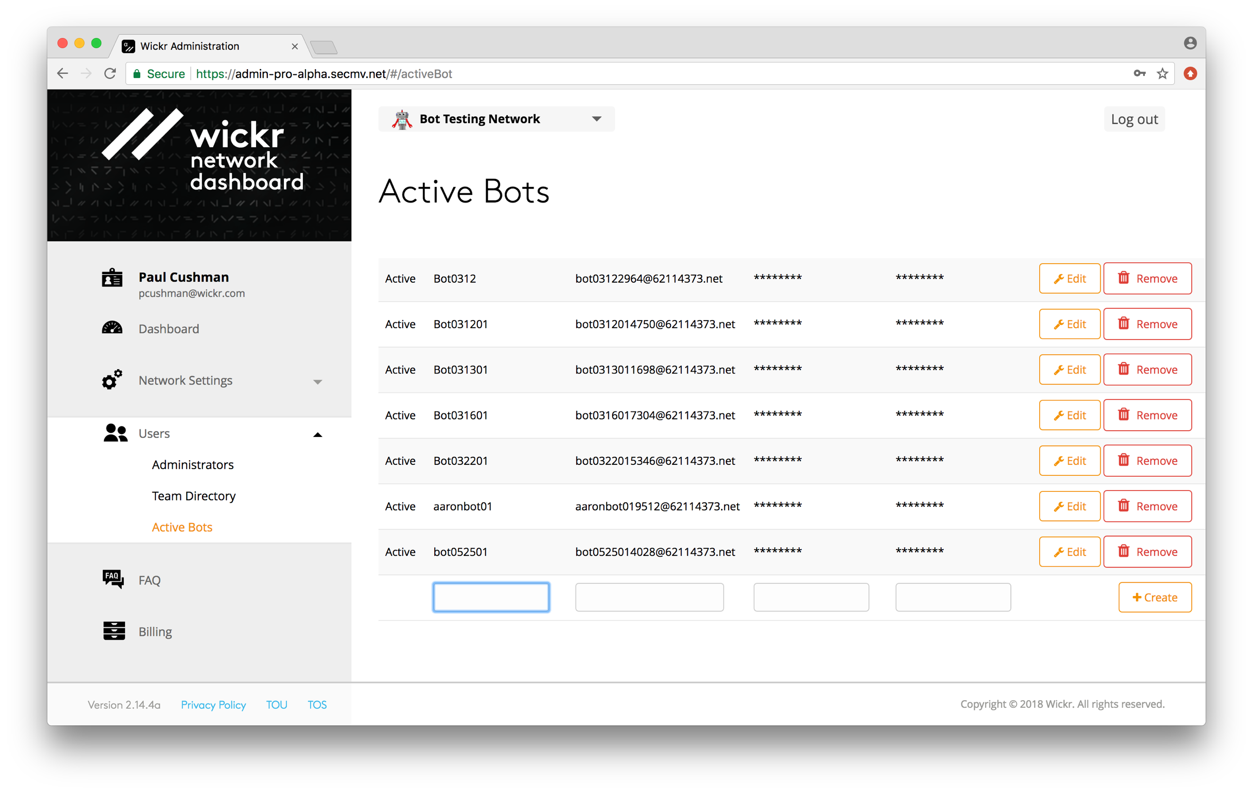

When adding a Wickrio bot to the Active Bots screen you will input the Bot display name, Bot user name and the WickrIO bot client's password. You will need the Bot username and password fields to add the WickrIO Bot client on the WickrIO console.

## WickrIO Bot Client Provisioning and Configuration (via WickrIO Console)

When you run the WickrIO Docker container for the first time there will be no WickrIO clients configured, you will see a welcome message describing the WickrIO commands and the following output:

There are no clients currently configured!

Enter command:

When you enter the WickrIO Docker container, after having configured one or more WickrIO clients, the list of currently configured WickrIO clients will be displayed. You will then be prompted to enter a command. You will have the choice of entering the following commands:

* add: add a new client
* delete: deleting a client
* Integration: support for adding custom bot Integration software
* list: see a list of currently created clients
* modify: modify the settings of a client
* pause: pause a running client
* start: start a client
* update: update Integration software for a client
* quit: exits the docker container
* help or ‘?’: display the list of commands

When you are creating a new WickrIO bot client use the “add” command. Initially, you will be prompted for two fields, the Wickr username and password. These are the same values you entered in the Wickr Admin console. The “add” command will then provision this WickrIO bot client with the Wickr back-end system.

You will be prompted to select an Integration bot to associate with the WickrIO bot client you recently created. Every bot must have a integration bot associated with it. There are several choices of integrations to select from, including hubot, hello_world_bot and file_bot. The hello_world_bot and file_bot are fairly simple to modify if you want to customize them.

If you are configuring a Hubot you will be prompted with a list of questions specific to the type of features supported by the Wickr Hubot Integration. The following Is sample output and Input associated with configuration the Hubot Integration:

Installing hubot software for hubot048119@62114373.net

Begin configuration of hubot software for hubot048119@62114373.net

Would you like to install the following integration(y/n): gitlab:

y

Would you like to install the following integration(y/n): pagerduty:

y

Would you like to install the following integration(y/n): slack:

y

Would you like to install the following integration(y/n): chatter:

y

Would you like to install the following integration(y/n): bugsnag:

y

Would you like to install the following integration(y/n): uber:

y

Would you like to install the following integration(y/n): subreddit:

y

Would you like to install the following integration(y/n): maps:

y

Would you like to install the following integration(y/n): pugme:

y

Would you like to install the following integration(y/n): shipit:

y

Would you like to install the following integration(y/n): remind:

y

Done installing Scripts!

Enter the port the hubot integration will listen on:

5005

Enter your: SLACK_CLIENT_ID:

abc

Enter your: SLACK_CLIENT_SECRET:

abc

Enter your: SLACK_REDIRECT_URI:

abc

Enter your: CHATTER_CLIENT_ID:

abc

Enter your: CHATTER_CLIENT_SECRET:

abc

Enter your: CHATTER_REDIRECT_URI:

abc

Enter your: UBER_CLIENT_ID:

abc

Enter your: UBER_CLIENT_SECRET:

abc

Enter your: UBER_SERVER_TOKEN:

abc

Enter your: UBER_REDIRECT_URI:

abc

Enter your: GOOGLE_MAPS_KEY:

abc

Enter your: GOOGLE_MAPS_GEOCODE_KEY:

abc

Enter your: GOOGLE_MAPS_GEOLOCATE_KEY:

ab

End of setup of hubot software for hubot048119_62114373.net

At this point your new WickrIO client will be fully configured, you can now start the client by running the “start” command. If you have added more than one WickrIO bot client, you will have to identify which one to start by including the appropriate index number of that bot. You can get the number from running the “list” command. The “list” command will also display the current status of each WickrIO bot client.

If you want to create custom integrations you can use the "integration" command. The "integration" option provides commands that allow you to Integrate custom bot integrations into the WickrIO system. These custom integrations will only work with the Node.js APIs at this point. The integration capability Is documented in another document.

# TROUBLESHOOTING

## Troubleshooting WickrIO Components

This section will describe some possible issues you may run into while using the WickrIO client and the associated services.

### WickrIO Client does not start

First you need to determine if the WickrIO client is running or not. To do so you can run the ps command to see that the client process is running. The following should return an entry for each WickrIO client that is running:

ps -aef | grep wickrio_bot

The console of the WickrIO Docker provides commands that you can use to help diagnose the client issue.

1. Enter the “list” command to see the list of WickrIO clients.
   1. If the WickrIO client’s state is “Paused”, then use the “start” command to start the client.
   2. If the WickrIO client’s state is “Running”, and there was no associated process running, then check the output file for the background services (described later) to see if the background service is having a problem starting the client. If this does not fix the issue the contact Wickr support for further assistance.

Further diagnosis of problems with the WickrIO client or other Wickr software should be done with the help of the Wickr support team.

### Log and Output Files

The WickrIO Client and the background service will generate log and output files that can be used to determine possible issues. These files should be sent to Wickr Support to allow them to diagnose any issues that cannot be easily fixed. Output and log files will only be allowed to reach a certain file size. Once that size is reached a new file will be created. The maximum number of files saved to disk should only be 5.

The WickrIO Client log and output files are located in the following location, depending on how you setup the shared files:

/opt/WickrIO/clients/<client name>/logs

There are several files found in that directory. The file with the “.output” extension contains the most information and is useful in diagnosing issues with the WickrIO client.

The background service will write log and output files to the following location:

/opt/WickrIO/logs

The name of the background service files will start with WickrIOSvr. These files will also be limited in size and number of saved files. The background service output file can be used to diagnose any possible issues with starting a WickrIO client.