CprE 381, Computer Organization and Assembly-Level Programming, Fall 2015

Lab Report for Lab 1

Lab Partners _____Collin Farrell____________________________________

_____Jeffery Schons_____________________________

______________________________________________

Section /Lab Time _____A / Tuesay 12____________________

Refer to the highlighted language in the lab 1 instruction for the context of the following questions.

- [Part 1 (b)] Reference the circuit diagram at the end of this document (some parts simplified). There are 30 labeled areas in the diagram. For each of these labels, specify where (VHDL file and line number) these values are located – some will be found in more than one place. Also attempt to explain the functionality of each label as it occurs in the code. (3 points)

1) Quadratic.vhd, line 49; line 68, standard input integer
2) Quadratic.vhd, line 25; line 69, standard input integer
3) Quadratic.vhd, line 50, standard input integer
4) Quadratic.vhd, line 51, standard input integer
5) Quadratic.vhd, lines 24; 35; 42; 67*2; 73; 82; 88; 97, Adder.vhd, lines 28; 38; 40, Multiplier.vhd, lines 28; 38; 40, standard clock
6) Quadratic.vhd, lines 43; 68; Multiplier.vhd, lines 29; 38; 41, number to multiply in g_Mult1
7) Quadratic.vhd, lines 44; 69; Multiplier.vhd, lines 30; 38; 41, number to multiplier in g_Mult1
8) Multiplier.vhd, line 41, multiplies iB and iA
9) Multiplier.vhd, line 40, sends signal from number 8) only when there is a rising edge from iCLKs frequency
10) Quadratic.vhd, lines 45; 70, Multiplier.vhd, lines 31; 41, Output to sVALUE_Ax
11) Quadratic.vhd line 66, g_Mult1 multiplies cA and iX and outputs it to sVALUE_Ax during a rising iCLK edge
12) Quadratic.vhd, lines 43; 74, Multiplier.vhd, lines 29; 38; 41, number to multiply in g_Mult2
13) Quadratic.vhd, lines 44; 75, Multiplier.vhd, lines 30; 38; 41, number to multiplier in g_Mult2
14) Quadratic.vhd, lines 45; 76, Multiplier.vhd, lines 31; 41, Output from g_Mult2
15) Quadratic.vhd line 72, g_Mult2 multiplies cB and iX and outputs it to sVALUE_Bx during a rising iCLK edge
16) Quadratic.vhd, lines 36; 89, Adder.vhd, lines 29; 38; 41, output from g_Mult2 to add into g_Add1
17) Quadratic.vhd, lines 37; 90, Adder.vhd, lines 30; 38; 41, standard input to add into g_Add1
18) Adder.vhd, line 41, adds iB and iA
19) Adder.vhd, line 40, sends signal from number 18) only when there is a rising edge from iCLKs frequency
20) Quadratic.vhd, lines 45; 91, Multiplier.vhd, lines 31; 41, Output from g_Add1
21) Quadratic.vhd, lines 43; 83, Multiplier.vhd, lines 30; 38; 41, number to multiplier in g_Mult3
22) Quadratic.vhd, lines 44; 84, Multiplier.vhd, lines 30; 38; 41, number to multiplier in g_Mult3
23) Quadratic.vhd, lines 45; 85, Multiplier.vhd, lines 31; 41, Output from g_Mult3
24) Quadratic line 81, g_Mult3 multiplies sVALUE_Ax and iX and outputs it to sVALUE_Axx during a rising iCLK edge
25) Quadratic.vhd, lines 36; 98, Adder.vhd, lines 29; 38; 41, output from g_Mult3 to add into g_Add2
26) Quadratic.vhd, lines 37; 99, Adder.vhd, lines 30; 38; 41, output from g_Add1 to add into g_Add1
27) Quadratic.vhd, lines 38; 100, Adder.vhd, lines 31; 41, Output from g_Add2
28) Quadratic.vhd line 96, g_Add2 recieves inputs sVALUE_Axx and sVALUE_BxpC and adds them to an output oY during a rising iCLK edge
29) Quadratic.vhd, line 26, standard output integer
30) No lines, Calculates the point on a line using inputs cA, iX, cB and cC as coordinates and of course the clock (iCLK)
31) Quadratic.vhd line 87, g_Add1 recieves inputs sVALUE_Bx and CC and adds them to an output sVALUE_BxpC during a rising iCLK edge

- [Part 1 (h)] In your report, provide a brief explanation of how the timing waveform corresponds to your understanding of the adder design. (2 points)

The output doesn't change until the first rising edge, which is what we knew because all of the components relied on the clock's rising edge to output their values. The inputs remained constant and the clock cycled at the the specified rate of 100ns.

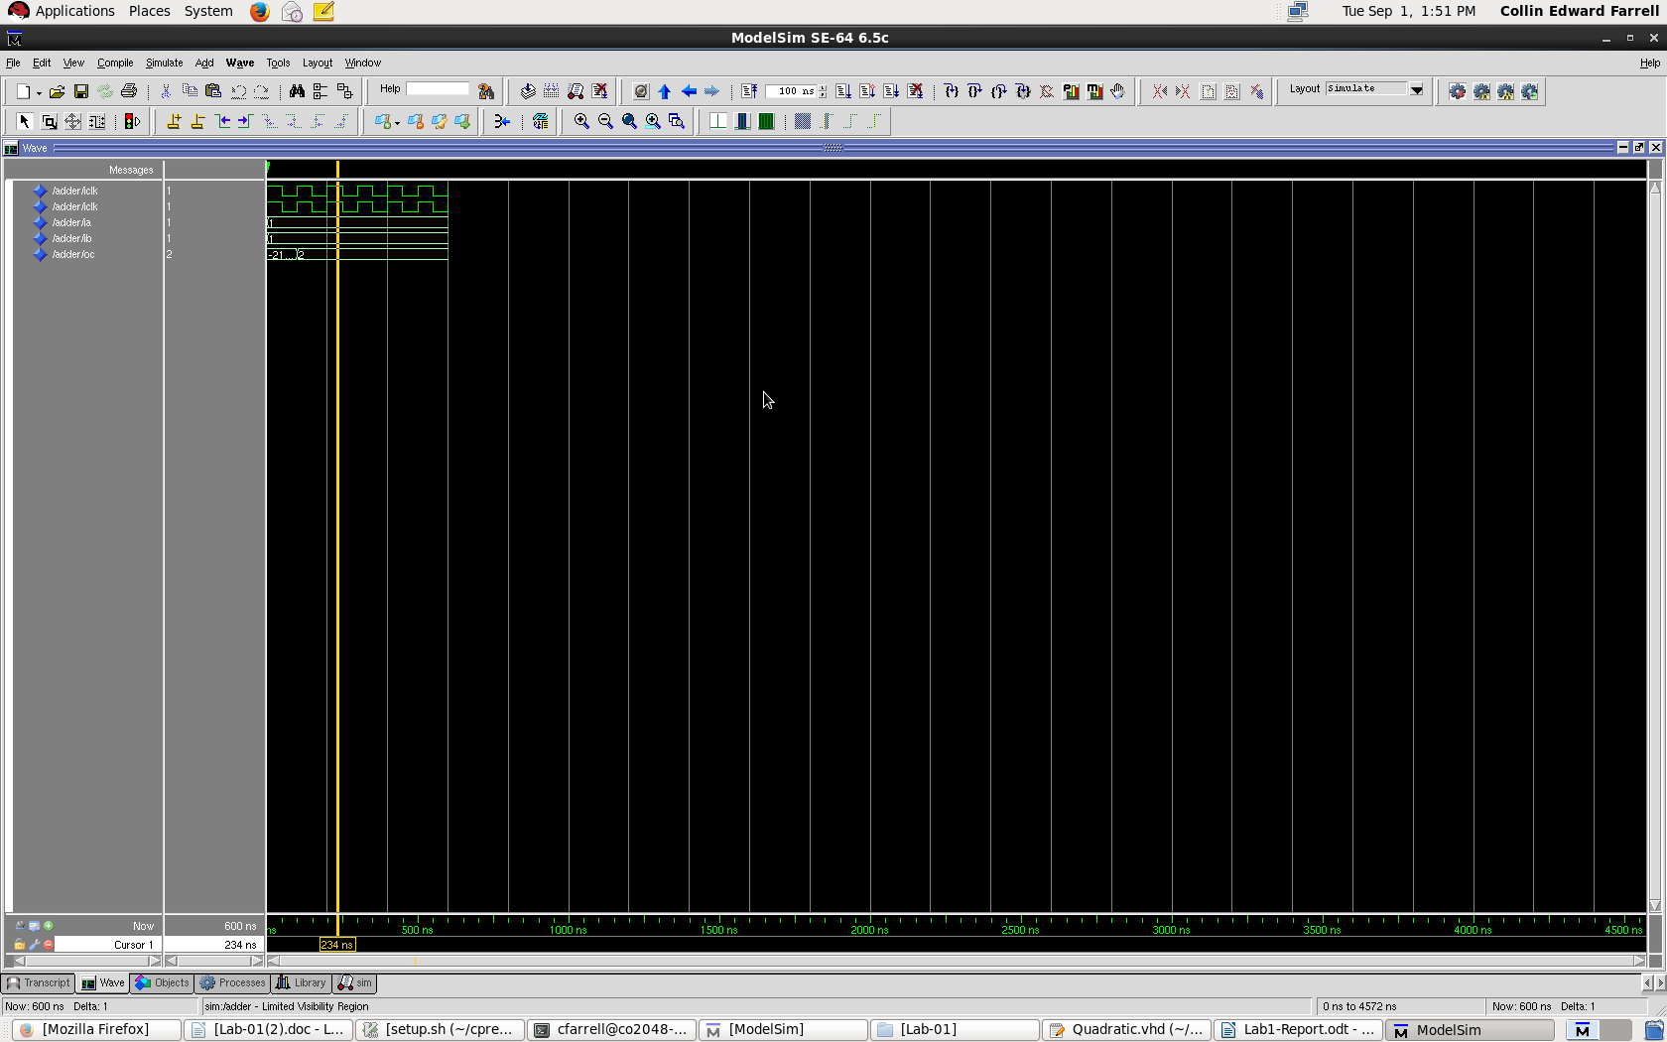

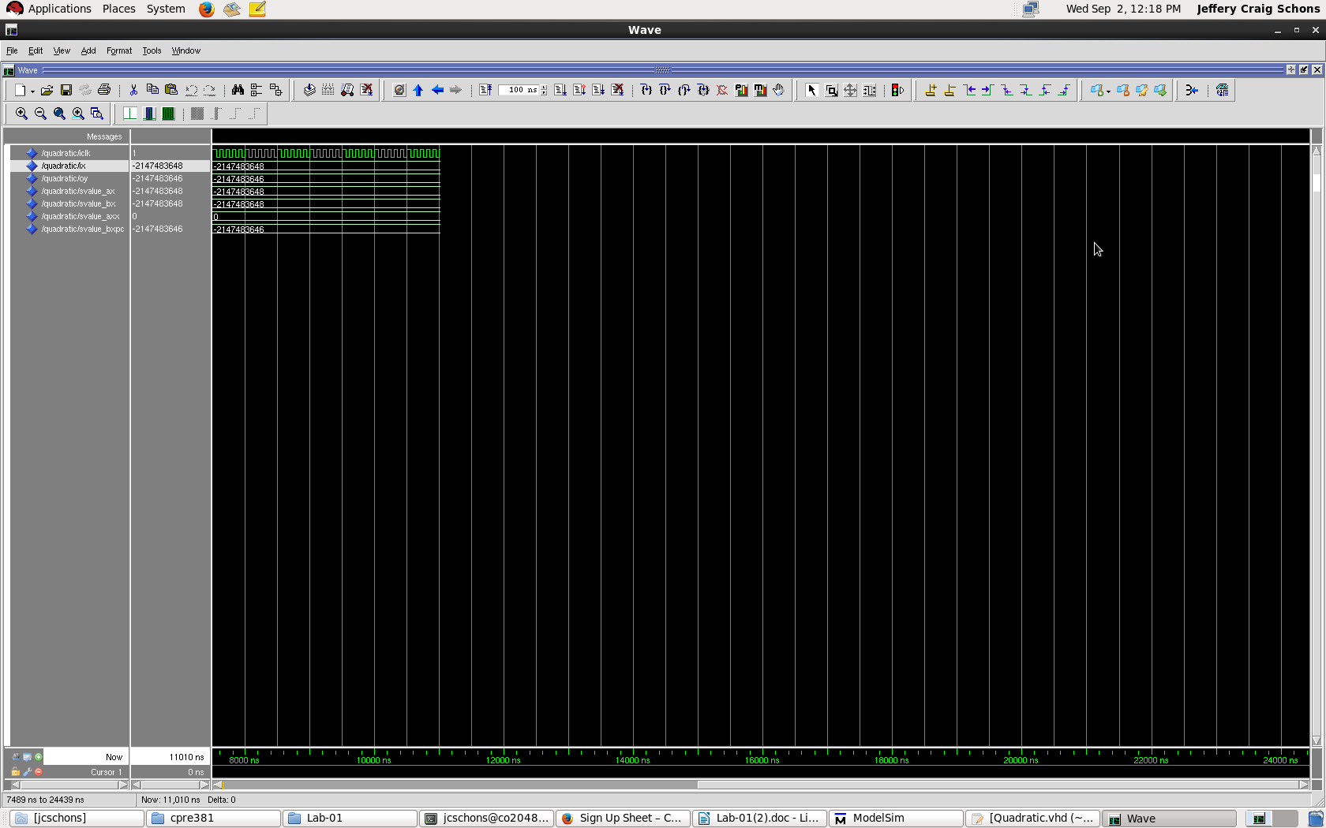

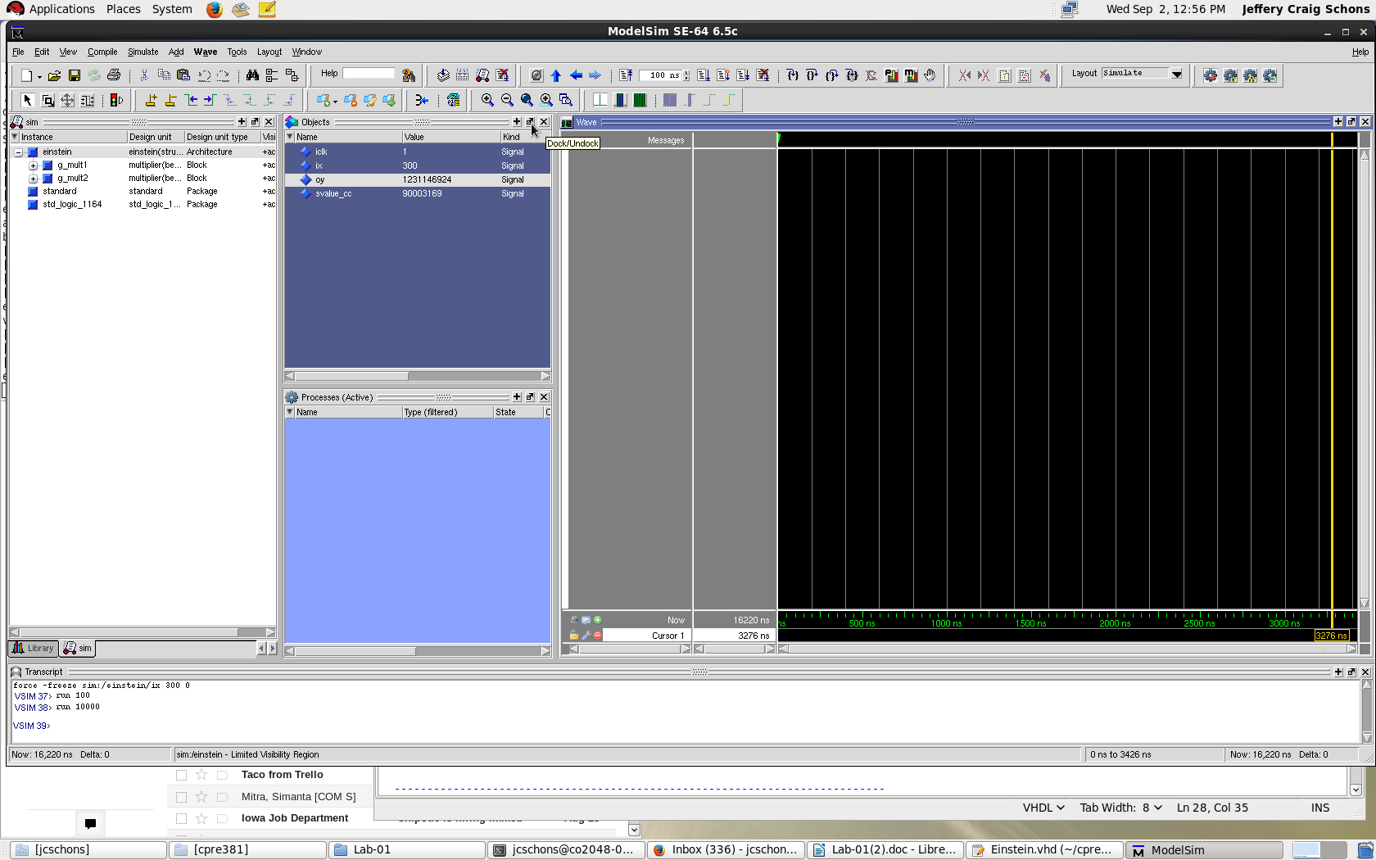
Mass = iX

