CprE 381, Computer Organization and Assembly-Level Programming, Fall 2015

Lab Report for Lab 2

Lab Partners Collin Farrell and Jeffery Schons

Section A /Lab Time Tuesday @ 12pm

Refer to the highlighted language in the lab 1 instruction for the context of the following questions.

Number of points: 15

- [Part 1 (e)] Include a waveform screenshot in your report PDF. (1 point)
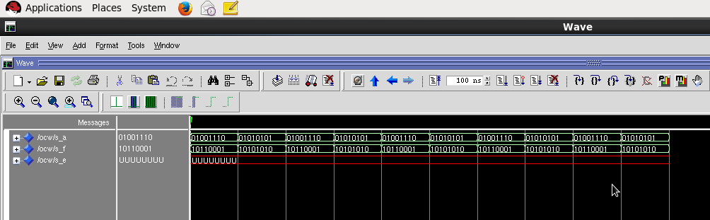

- [Part 2 (a)] Draw the truth table, Boolean equation, and Boolean circuit equivalent (using only two-input gates) that implements a 2:1 mux. Include this in your report PDF. (3 points)

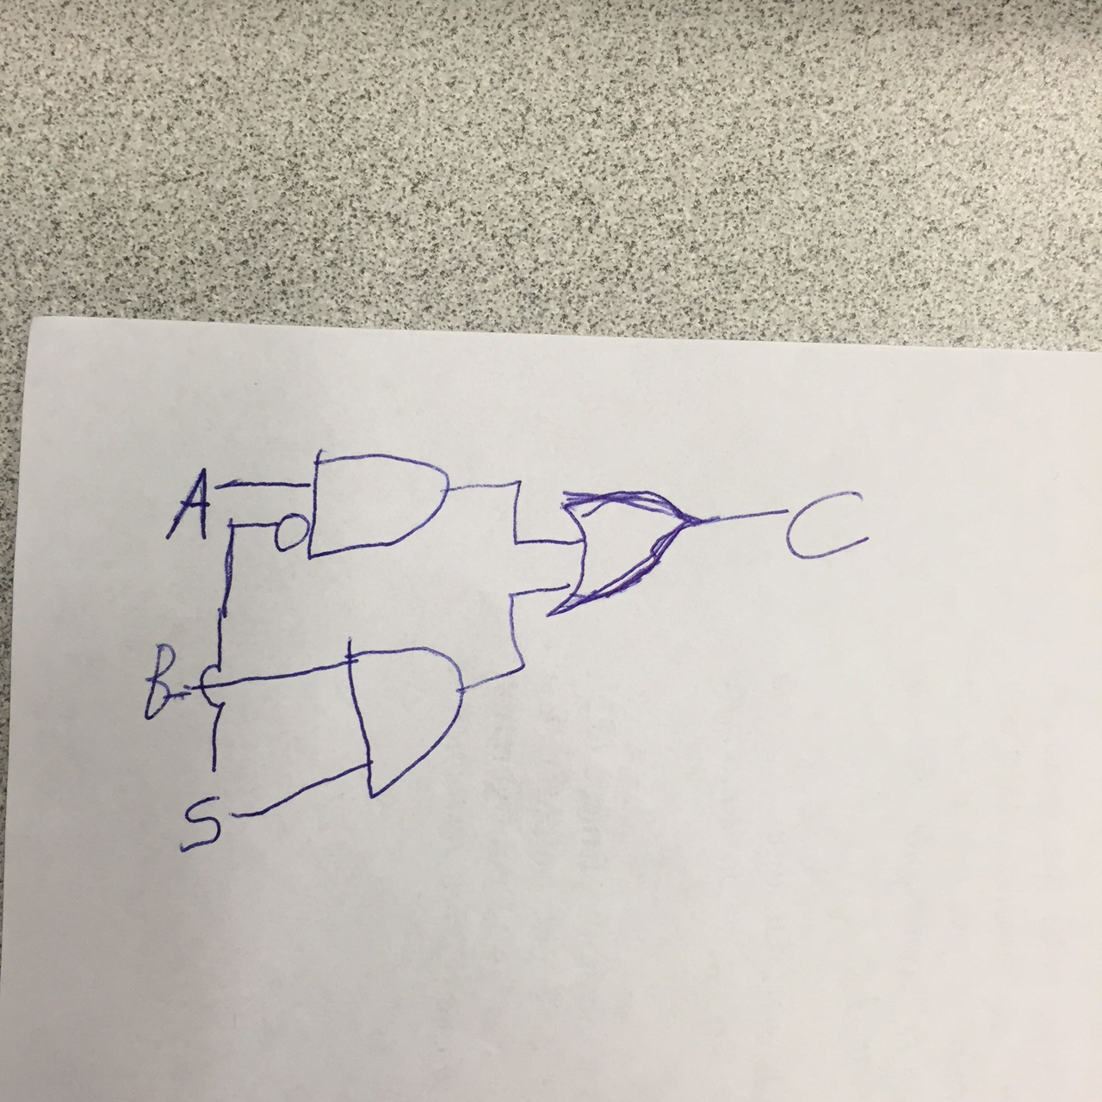

Z=(A*~S)+(B*S)

- [Part 2 (e)] Include a waveform screenshot in your write-up. (1 point)
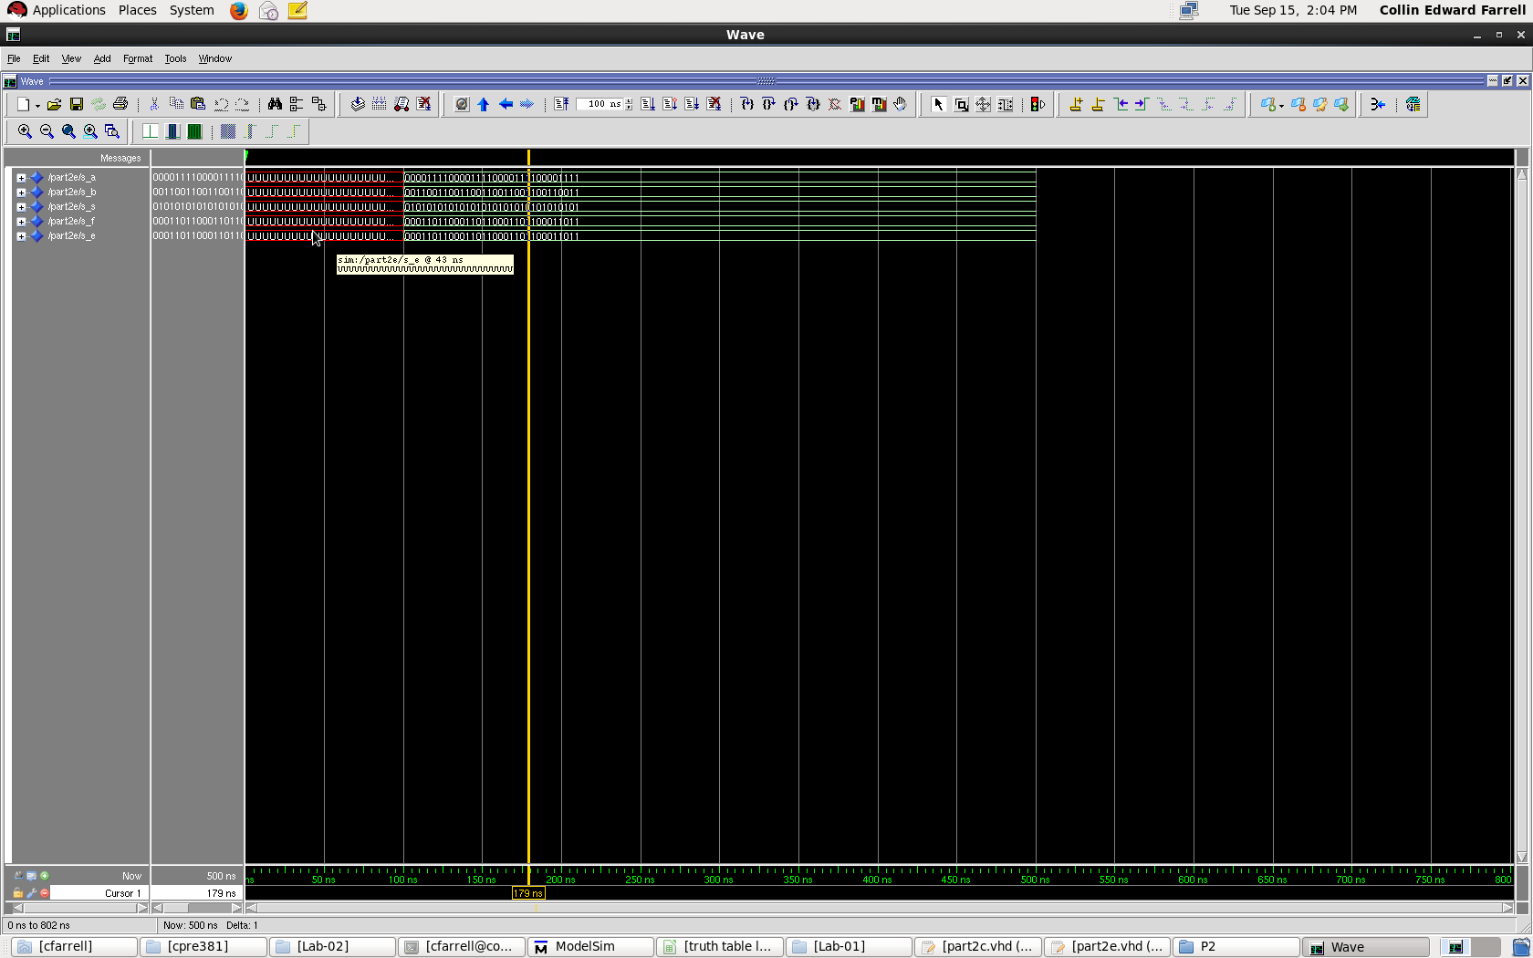

- [Part 3 (a)] Draw the truth table, Boolean equation, and Boolean circuit equivalent (using only two-input gates) that implements a full adder. (3 points)

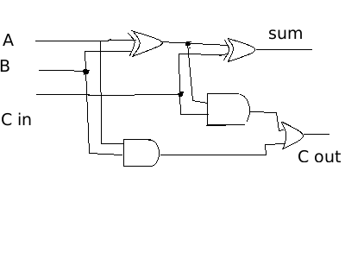

- [Part 3 (e)] Include a waveform screenshot. (1 point)
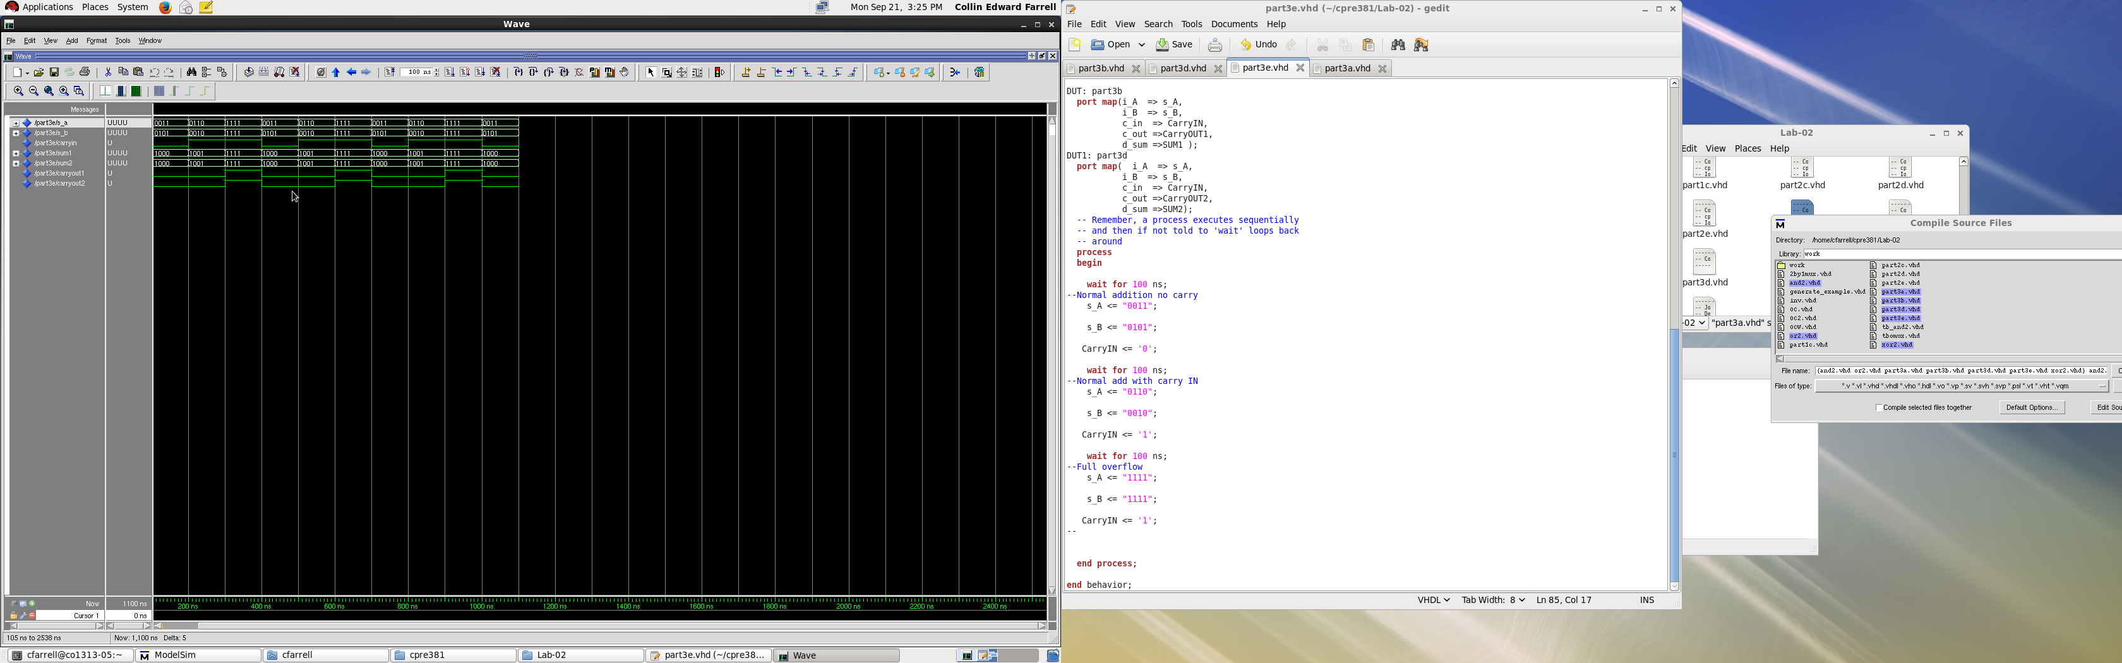

- [Part 4 (a)] Draw a schematic showing how an N-bit adder/subtractor with control can be implemented using only the three main components designed in problems 1), 2), and 3) (the N-bit inverter, N-bit 2:1 mux, and N-bit adder). How is the ‘nAdd_Sub’ bit used? [3 points]
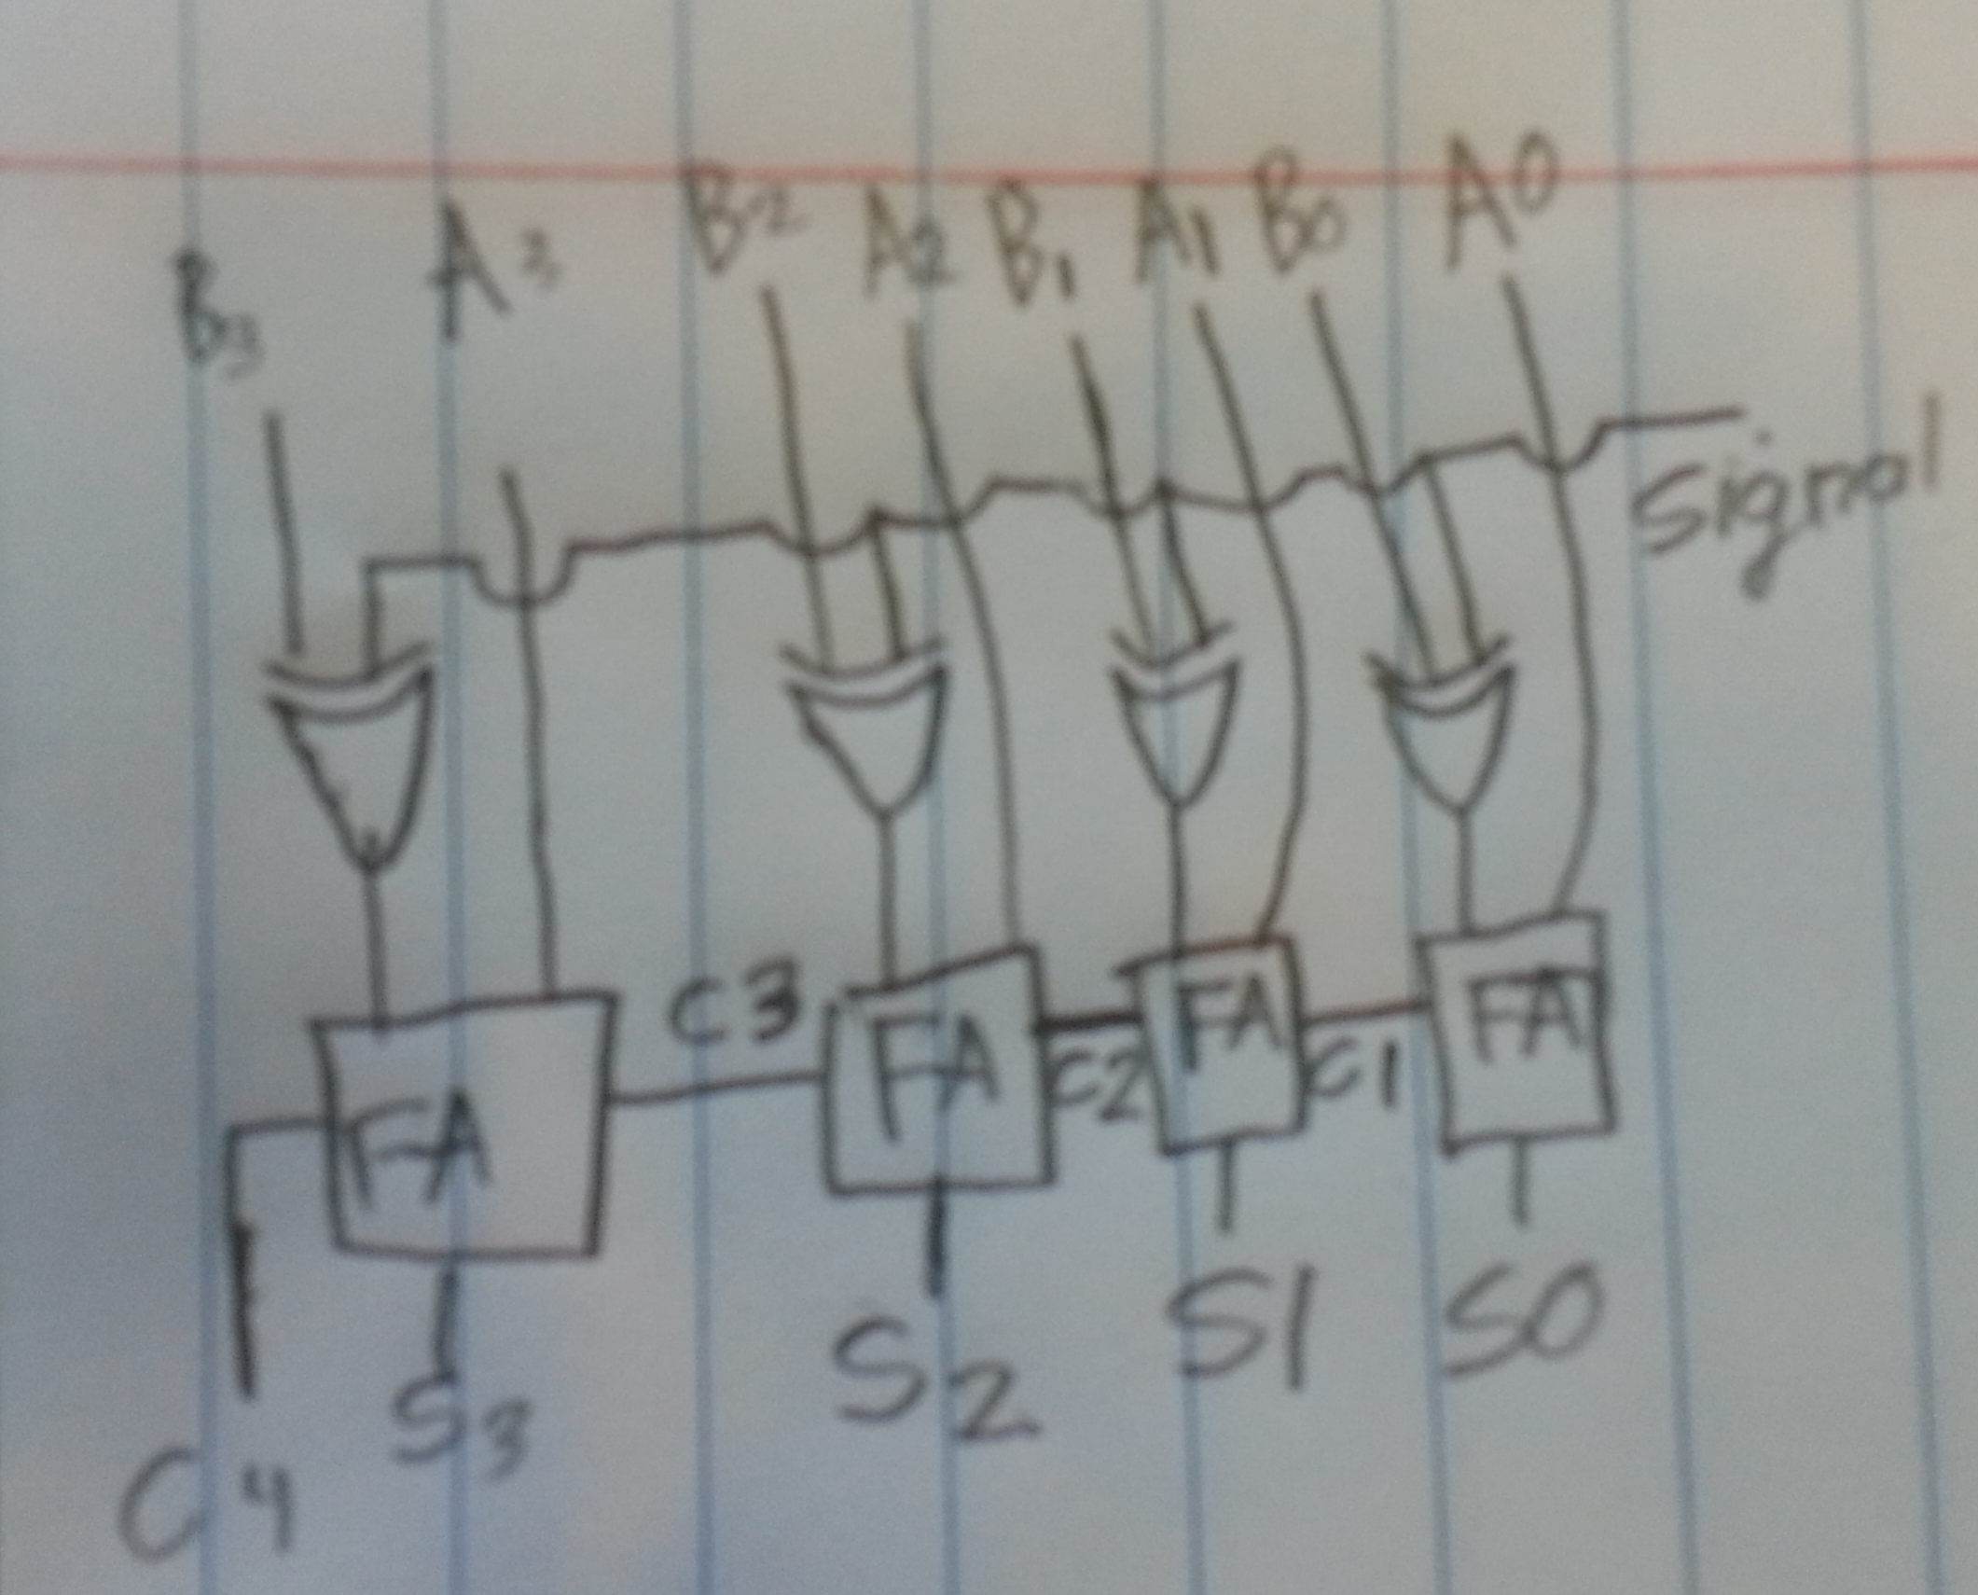

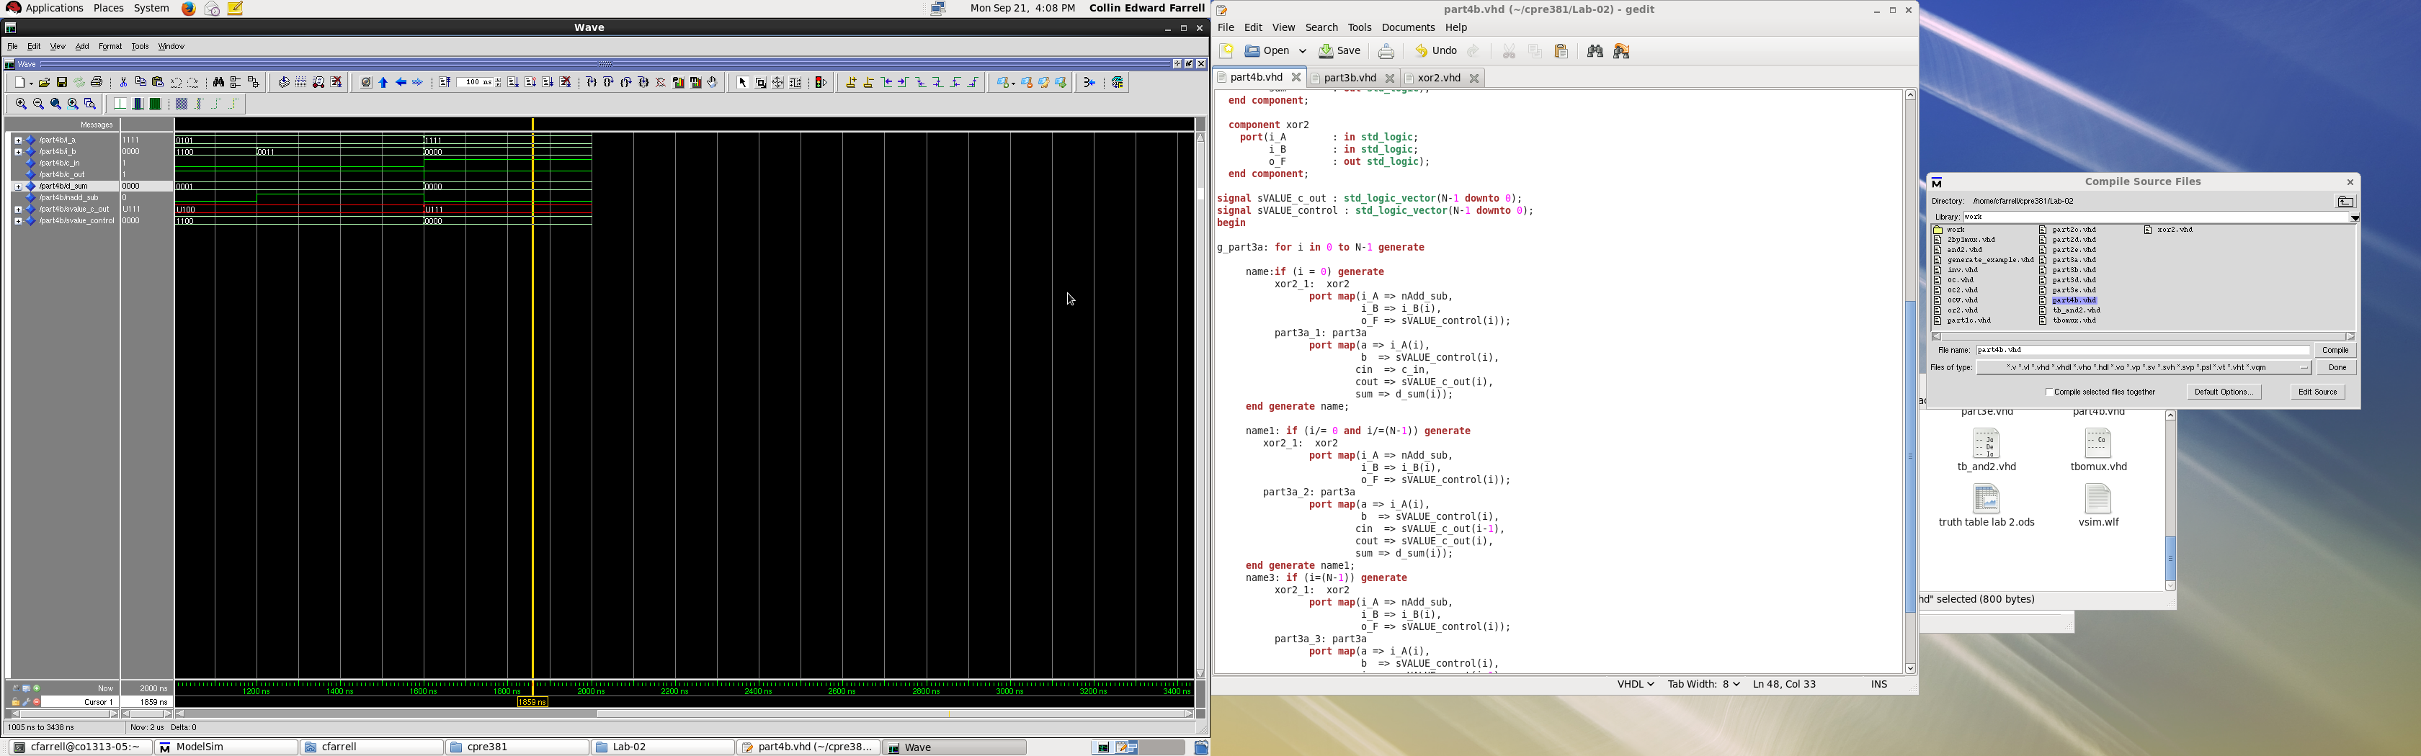
- [Part 4 (c)] Provide multiple waveform screenshots in your write-up to confirm that this component is working correctly. What test-cases did you include and why? [3 points]

