CprE 381, Computer Organization and Assembly-Level Programming, Fall 2015

Lab Report for Lab 3

Lab Partners _Collin Farrell______________________________________

Jeffrey Schons_______________________________________

______________________________________________

Section /Lab Time ______noon tuesday___________________

Refer to the highlighted language in the lab 3 instruction for the context of the following questions.

Number of points: 10
Bonus points: 4

- [Part (a)] Include a waveform screenshot in your report PDF. (1 point)

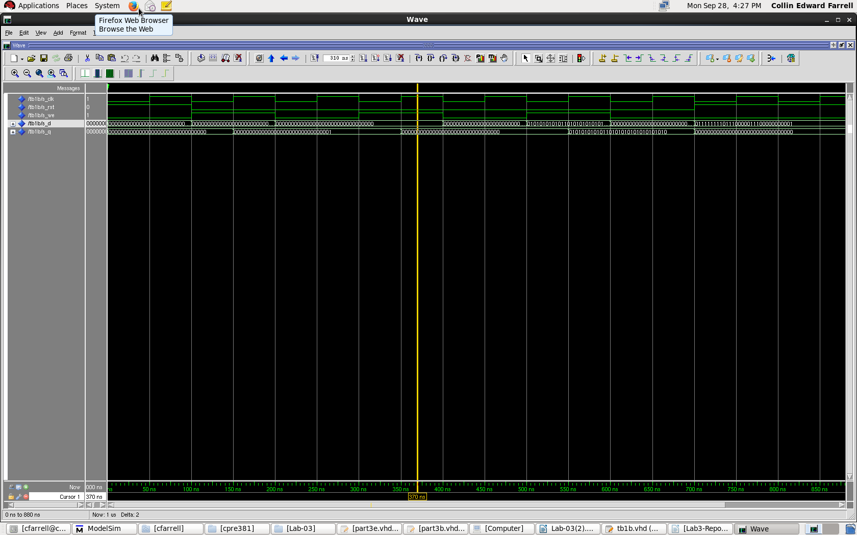

- [Part (c)] What type of decoder would be required by the MIPS register file and why? (1 point)

5x32 bit decoder.

- [Part (f)] Draw a (simplified) schematic for the MIPS register file, and using only the VHDL components you have created in parts a), d), and f). (3 points)

