SVR Kernel Comparison
for Stock Prices
  - New York University • FRE-GY.7773.C • Assignment for Lecture 5
Six SVR settings are tested on historical Apple closing prices. Callable Laplacian gives the closest training fit and the lowest cross-validation RMSE. RBF gives the lowest final test RMSE. Laplacian fits fastest on this dataset; Linear and Polynomial have nearly tied prediction times. These conclusions depend on the evaluation period and selected parameters.

1 Data and experiment design
The experiment uses the public Plotly Apple stock-data snapshot [1]: 506 daily observations from February 17, 2015 through February 16, 2017. The target is AAPL.Close, the historical unadjusted closing price in USD. No adjusted prices, volume, or technical indicators are used. Dates are sorted and checked for duplicates and missing or invalid prices.
The single input is calendar time, encoded as a full date ordinal. This avoids repeating day-of-month values across different months. Both the input and target are standardized using only the observations used to fit each model; predictions are converted back to USD.
Partition | Observations | Dates
Training and model selection | 446 | 2015-02-17 to 2016-11-18
Final held-out test | 60 | 2016-11-21 to 2017-02-16

All 60 future prices are predicted from one fixed origin, without updating models with test prices. Three expanding-window validation folds inside the first 446 observations select parameters. Their training sizes are 266, 326, and 386, each followed by 60 validation observations. The final test period is never used for tuning.

2 Kernel extensions
The extended predict_prices function evaluates all four named mathematical kernels supported by SVR, the precomputed interface, and a callable kernel [2–4]. In the table, x and z are standardized dates, γ is gamma, c₀ is coef0, and d is degree.
Setting | Kernel or implementation
Linear | K(x,z) = xz
Polynomial | K(x,z) = (γxz + c₀)ᵈ
RBF | K(x,z) = exp(−γ(x − z)²)
Sigmoid | K(x,z) = tanh(γxz + c₀)
Precomputed RBF | The same RBF function, supplied as a Gram matrix
Callable Laplacian | K(x,z) = exp(−γ|x − z|), supplied as a Python callable

Precomputed is a kernel interface, not a fifth mathematical kernel. Its training matrix has shape 446 × 446; prediction uses a 60 × 446 test-to-training matrix. Its RBF parameters match the built-in RBF model, allowing a direct implementation check.

3 Comparison of all fitted curves
The six panels use identical axes. Solid colored lines show fitted values on the training period, and dashed lines show predictions for the held-out period. Gray shading marks the test dates; the black curve is the observed closing price.
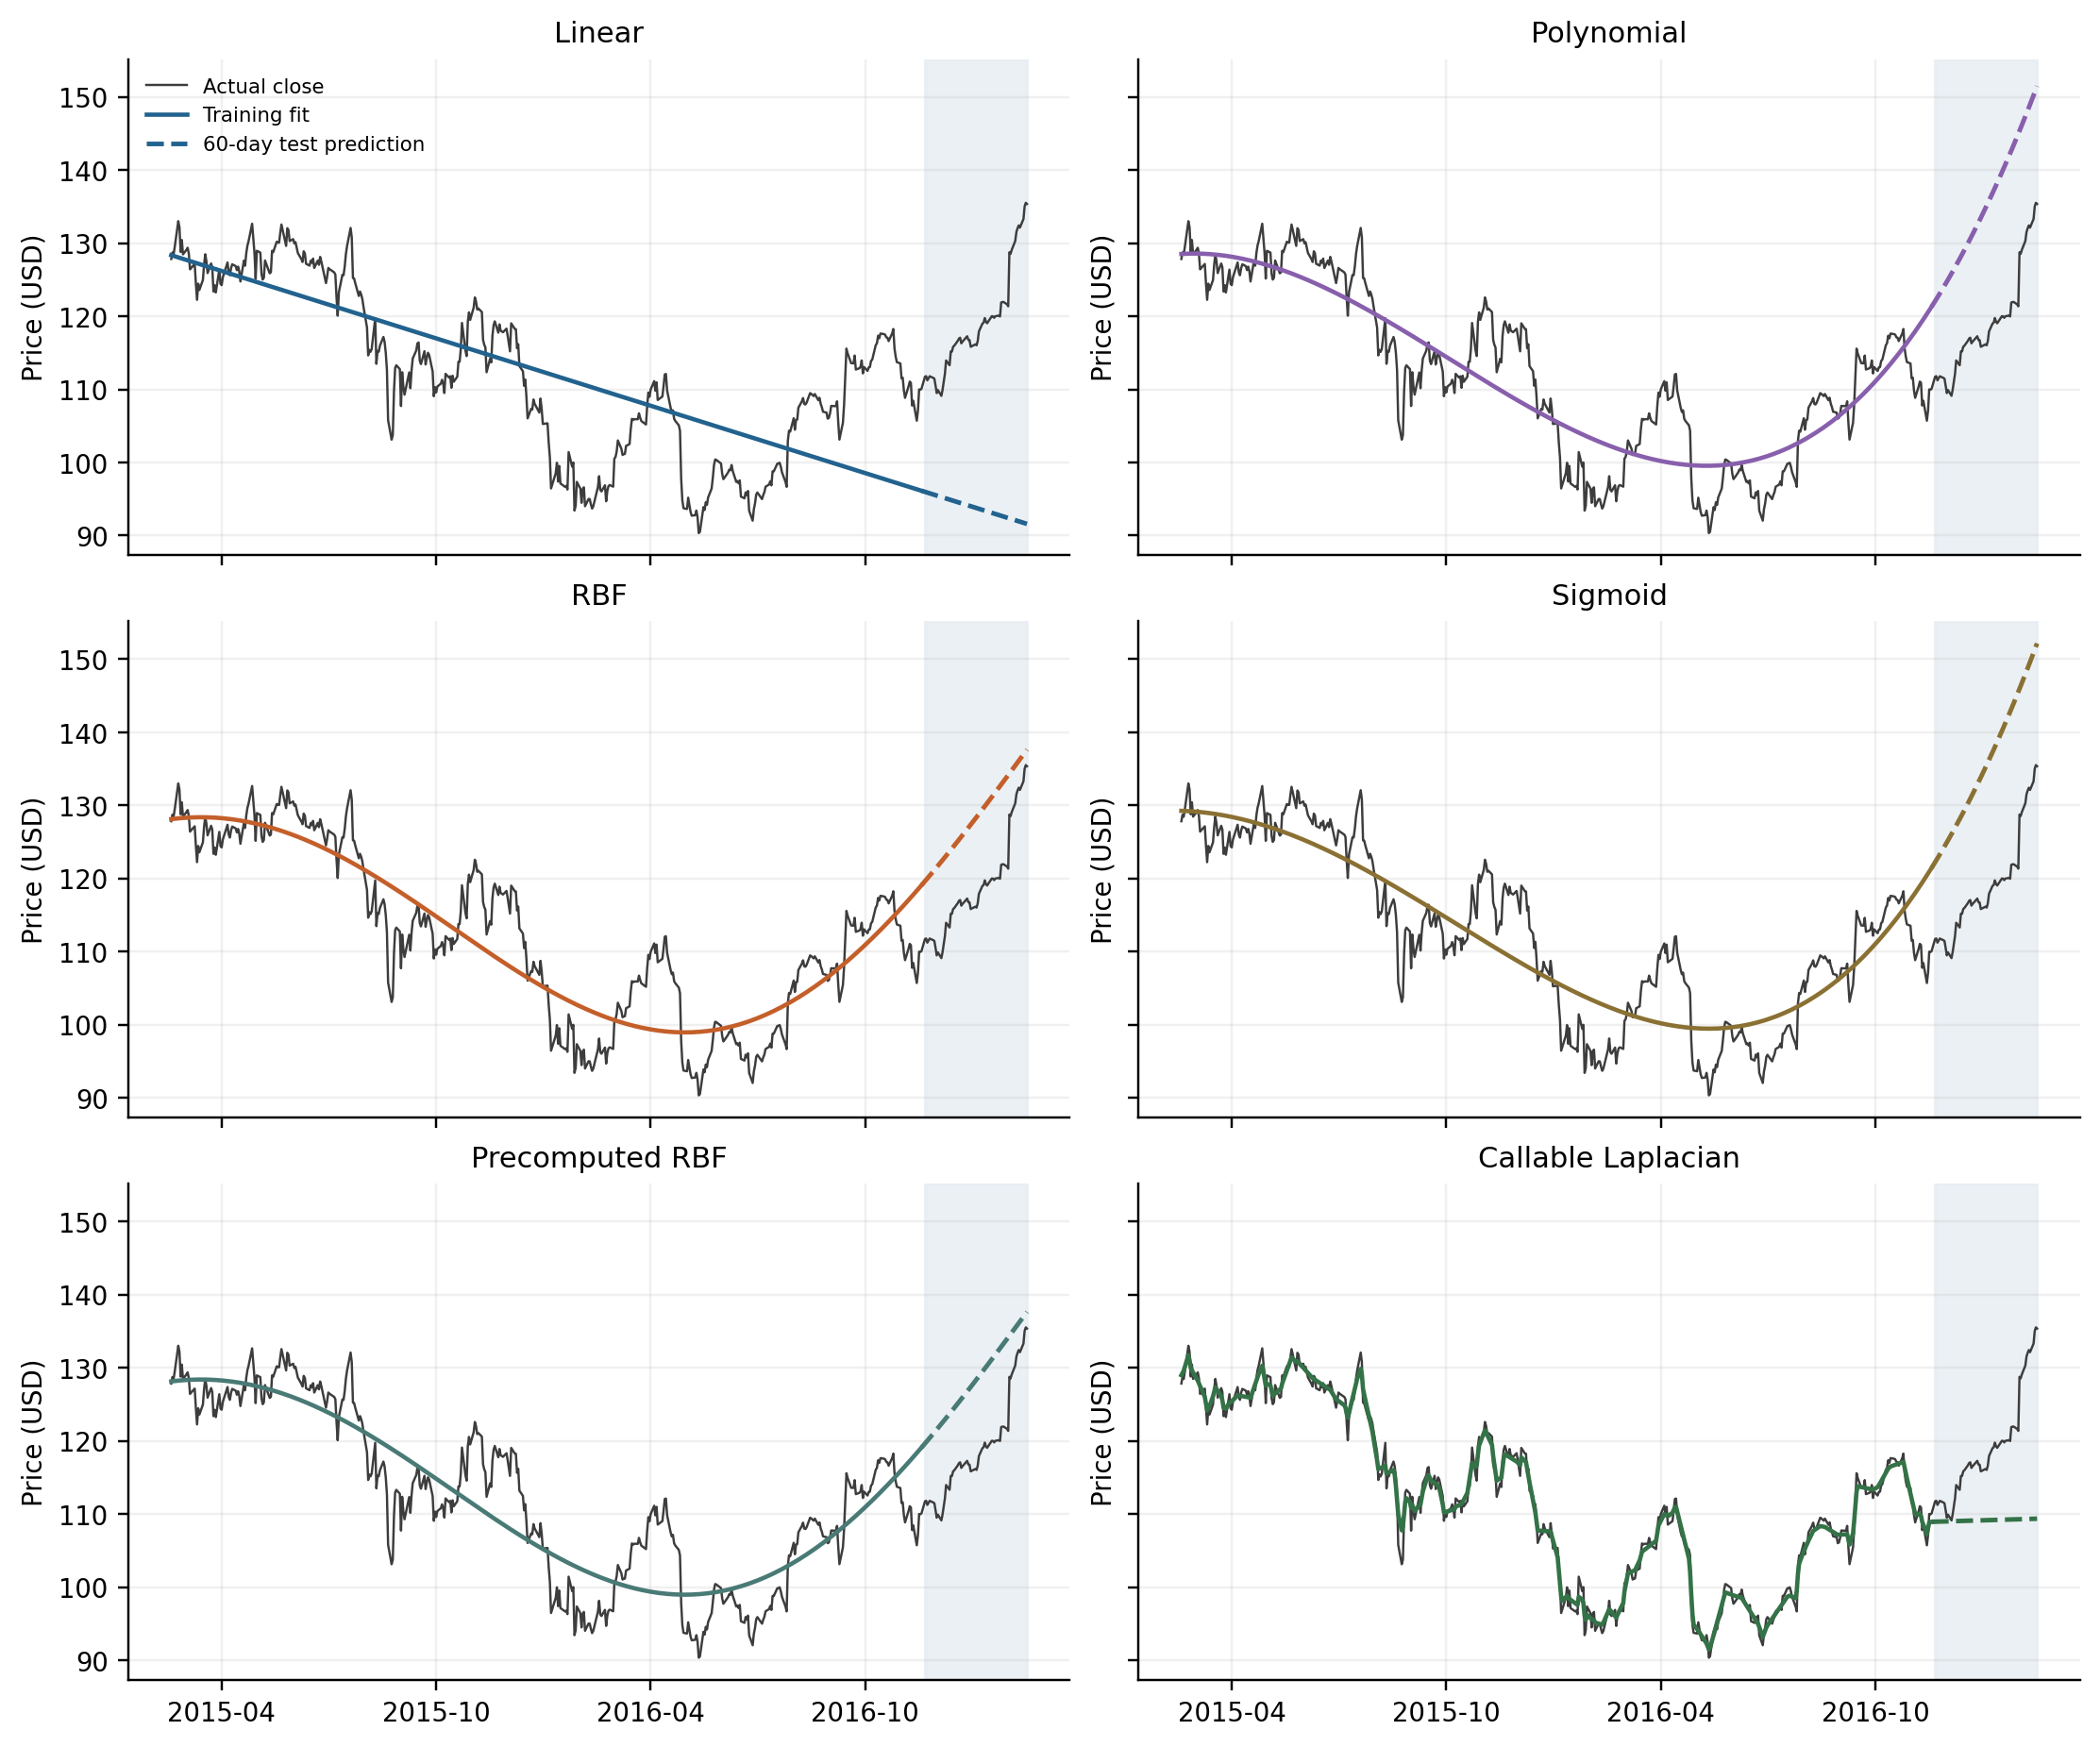
Figure 1. All six SVR settings fitted to the same 446 training observations. The precomputed RBF curve overlaps the built-in RBF curve to numerical precision. The panels display every observation.

Why the fits differ
Linear can express only one global slope, so it misses reversals in the historical series. Polynomial and Sigmoid capture the broad decline and recovery but smooth over daily fluctuations. Their upward extrapolations overshoot the test prices. The selected RBF also gives a smooth curve, with a less steep extrapolation over this particular test interval.
Laplacian has a less smooth kernel than RBF and can follow local changes in the training sample. Its training RMSE is $1.0648, versus $5.2234 for RBF. However, the date-only Laplacian forecast is almost flat beyond the training boundary and misses the subsequent rise. A close historical fit therefore does not by itself establish useful forecasting ability.

4 Accuracy results and interpretation
Errors are evaluated in USD. RMSE = √mean((prediction − actual)²), MAE = mean(|prediction − actual|), and R² = 1 − Σ(prediction − actual)²/Σ(actual − mean(actual))². CV RMSE is the mean RMSE across the three forward validation folds.
Setting | CV  RMSE $ | Train  RMSE $ | Test  RMSE $ | Test  MAE $ | Test R²
Linear | 13.4416 | 8.4307 | 26.8911 | 25.5080 | -12.6429
Polynomial | 8.7536 | 5.3142 | 16.7767 | 16.4799 | -4.3101
RBF | 7.9150 | 5.2234 | 9.7007 | 9.2333 | -0.7754
Sigmoid | 8.1481 | 5.3178 | 17.2043 | 16.8953 | -4.5842
Precomputed RBF | 7.9150 | 5.2234 | 9.7007 | 9.2333 | -0.7754
Callable Laplacian | 5.6832 | 1.0648 | 12.4101 | 10.1316 | -1.9056

A fixed last-close benchmark predicts $110.06 for every test date, using only the final training observation. Its test RMSE is $11.7437 and MAE is $9.2743. It uses the same forecast origin and horizon as the SVR models.
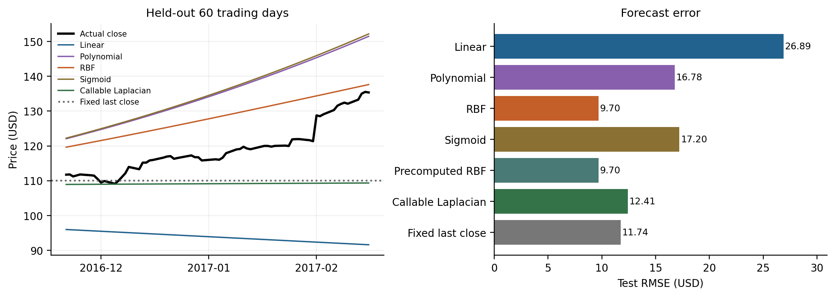
Figure 2. Test-period predictions and RMSE. Precomputed RBF is omitted from the left panel because it is indistinguishable from RBF; it remains in the numerical comparison.

Which setting is more accurate
For training fit, Laplacian is best. It is also the choice that would have been made using validation alone: CV RMSE is $5.6832, compared with $7.9150 for RBF. On the final test period, RBF and precomputed RBF are best among the tested settings, with RMSE $9.7007, 17.4% below the fixed last-close benchmark. This is a retrospective test ranking, not a reason to retune on the test set.
The validation-selected Laplacian model has test RMSE $12.4101 and does not beat the benchmark. The rank reversal shows that fitting and selection results from earlier periods do not reliably carry into a later market regime. All test R² values are negative: each model is worse than a constant equal to the test-period mean, an unavailable future quantity used only in defining this diagnostic.
These are date-only, 60-step forecasts on one stock and one final test period. The observed RBF advantage is specific to this experiment; it does not establish that RBF is universally superior or that the model provides a profitable trading strategy.

5 Computational performance
Timing uses the final selected settings on 446 training dates and a prediction batch of 60 dates. Each setting is warmed up, then measured in 41 rounds with randomized model order. Each prediction measurement averages 20 repeated calls. The table reports medians and interquartile ranges (IQR), in milliseconds, with numerical-library threads limited to one.
Setting | Support  vectors | Fit  median | Fit IQR | Predict  median | Predict IQR
Linear | 437 | 3.229 | 3.182–3.264 | 0.210 | 0.208–0.211
Polynomial | 429 | 3.846 | 3.824–3.886 | 0.207 | 0.204–0.209
RBF | 382 | 3.770 | 3.730–3.805 | 0.533 | 0.521–0.539
Sigmoid | 383 | 4.100 | 4.071–4.148 | 0.220 | 0.219–0.222
Precomputed RBF | 382 | 3.650 | 3.602–3.690 | 0.319 | 0.317–0.323
Callable Laplacian | 184 | 2.885 | 2.851–2.908 | 0.220 | 0.217–0.222

Fit timings include scaler fitting, model construction, kernel-matrix construction where applicable, and the solver. Prediction timings include input scaling, kernel evaluation or matrix construction, SVR prediction, and inverse target scaling. Downloads, imports, hyperparameter search, and plotting are excluded. The run used Python 3.12.14 and scikit-learn 1.7.2 on macOS 15.7.3, arm64.
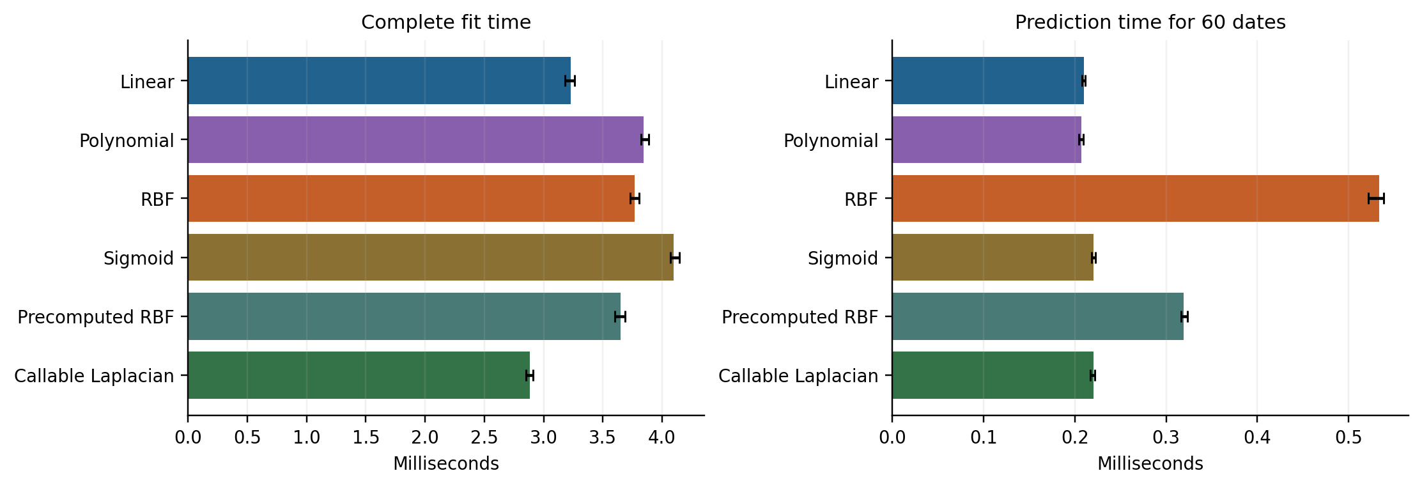
Figure 3. Median wall-clock times; error bars show IQR. These are complete fit and prediction paths, including the cost of precomputed and callable kernels.

Which setting is more performant and why
Laplacian has the lowest fit median, 2.885 ms, followed by Linear at 3.229 ms. Laplacian uses 184 support vectors, compared with 382–437 for the other settings, and a small dense kernel matrix is inexpensive here. This is consistent with efficient computation on this dataset; support-vector count alone does not determine training time.
Polynomial and Linear have the lowest prediction medians, 0.207 and 0.210 ms, with overlapping IQRs. They should be treated as effectively tied in this run. RBF takes 0.533 ms, while precomputed RBF takes 0.319 ms including matrix construction. Vectorized dense evaluation can be efficient for this small, one-feature problem; precomputation is not automatically faster on larger data.
The 446 × 446 float64 Gram matrix occupies approximately 1.52 MiB, and its storage grows quadratically with the number of training observations. Timings also depend on solver iterations, implementation, and selected C, ε, and γ. They compare the fitted settings in this experiment, not an intrinsic speed ranking of kernel formulas [2,3].

6 Parameter selection and reproducibility
Each kernel uses the same forward validation folds and minimum mean validation-RMSE rule. The search is deliberately finite: C ∈ {1, 10, 100}; ε ∈ {0.02, 0.1}; γ ∈ {0.1, 1, 10} when applicable. Polynomial additionally uses degree ∈ {2, 3} and coef0 ∈ {0, 1}; Sigmoid uses coef0 ∈ {−1, 0, 1}. Parameters irrelevant to a kernel are not searched.
Setting | C | ε | γ | Degree | coef0
Linear | 1 | 0.02 | — | — | —
Polynomial | 10 | 0.02 | 0.1 | 3 | 1
RBF | 10 | 0.1 | 0.1 | — | —
Sigmoid | 100 | 0.1 | 0.1 | — | −1
Precomputed RBF | 10 | 0.1 | 0.1 | — | —
Callable Laplacian | 100 | 0.1 | 0.1 | — | —

The ε values apply to the standardized target, not directly to dollars. Scalers are refitted within every validation fold and again on all 446 final training observations. The libsvm tolerance is 10⁻⁵, cache size is 200 MB, and iteration cap is 2,000,000. Of 168 parameter candidates, 21 reached the cap in at least one fold (1 Linear and 20 Polynomial) and were excluded. All six final fits converged.
The grids differ in size across kernels, so this is a comparison under stated searches, not an equal-compute or exhaustive optimization study. Precomputed RBF reuses the RBF parameters rather than performing a duplicate search. Polynomial search took about 14.05 seconds; the other searches each took less than 0.34 seconds on this run. Search costs are separate from the repeated fit timings.

Numerical checks and limitations
Built-in and precomputed RBF predictions differ by at most 1.62 × 10⁻¹² dollars. Independent refits reproduced saved predictions and error metrics; date ordering, data hash, training-only scaling, scalar date queries, and final solver convergence were checked. The source snapshot and all candidate validation results are included with the code.
Sigmoid requires particular care. Its selected training Gram matrix has minimum eigenvalue about −338.25, so it is indefinite in this experiment. LIBSVM permits sigmoid kernels, but they need not be positive semidefinite [5]; solver convergence is not a guarantee of the usual convex-kernel optimum. Sigmoid is included to compare the supported option, with this limitation recorded.

Files and reproduction
assignment5.py provides the extended predict_prices function, tuning, fitting, timing, and figures. Run python assignment5.py --out results_reproduced after installing requirements.txt. Run python verify_results.py to check the supplied numerical results. The archive includes the stock CSV, source metadata, predictions, complete timing observations, and figures in PNG and vector PDF formats. Timing values will vary across runs.

References
[1] Plotly datasets. finance-charts-apple.csv. Public historical data snapshot.
https://github.com/plotly/datasets/blob/master/finance-charts-apple.csv
[2] scikit-learn 1.7.2. SVR API reference.
https://scikit-learn.org/1.7/modules/generated/sklearn.svm.SVR.html
[3] scikit-learn 1.7.2. Support Vector Machines user guide.
https://scikit-learn.org/1.7/modules/svm.html
[4] scikit-learn 1.7.2. laplacian_kernel API reference.
https://scikit-learn.org/1.7/modules/generated/sklearn.metrics.pairwise.laplacian_kernel.html
[5] LIBSVM FAQ. How do I choose the kernel.
https://www.csie.ntu.edu.tw/~cjlin/libsvm/faq.html

