--Q1.1

create database chocolate

use chocolate

CREATE TABLE Item (

ItemId INT PRIMARY KEY,

ItemName VARCHAR(10)

);

INSERT INTO Item (ItemId, ItemName)

VALUES

(1, 'Bar-One'),

(2, 'KitKat'),

(3, 'MilkyBar'),

(4, 'Munch');

select \* from Item

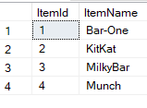

CREATE TABLE Shop (

ShopId INT PRIMARY KEY,

ShopName VARCHAR(20)

);

INSERT INTO Shop (ShopID, ShopName)

VALUES (1, 'Amal Stores'),

(2, 'Jyothi Stores'),

(3, 'Indira Stores');

select \* from Shop

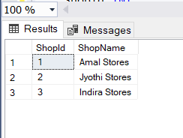

create table Unit(

Unitid int primary key,

Unitname varchar(10)

)

insert into Unit values(1,'Piece'),(2,'Box Pack')

Select \* from Unit

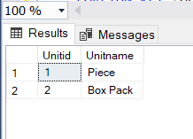

drop table sales

CREATE TABLE Sales (

SaleId INT PRIMARY KEY IDENTITY,

ShopId INT,

ItemId INT,

Quantity INT,

UnitPrice DECIMAL(10, 2),

Unitid int,

SaleDate DATE,

FOREIGN KEY (ShopId) REFERENCES Shop (ShopId),

FOREIGN KEY (ItemId) REFERENCES ITEM (ItemId),

FOREIGN KEY (UnitId) REFERENCES Unit (UnitId),

);

INSERT INTO Sales (ShopID, ItemID, Quantity, UnitPrice,

Unitid ,SaleDate )

VALUES

(1, 1,100, 10,1,'2018-10-05'),

(1, 2, 200, 15, 1, '2018-10-05'),

(1, 3, 50, 5,1,'2018-10-05'),

(1, 4, 150, 10, 1, '2018-10-05'),

(2, 1, 10, 280, 2, '2018-10-10'),

(2, 2, 30, 420, 2, '2018-10-10'),

(2, 3, 40, 140, 2, '2018-10-10'),

(2, 4, 20, 280, 2, '2018-10-10'),

(3, 1, 50, 280, 2, '2018-09-15'),

(3, 2, 70, 420,2, '2018-09-15'),

(3, 3, 30, 140, 2, '2018-10-10'),

(1, 1, 150, 10, 1, '2018-09-15'),

(1, 2, 250, 15, 1, '2018-09-15'),

(1, 4, 200, 10, 1, '2018-10-10');

select \* from sales

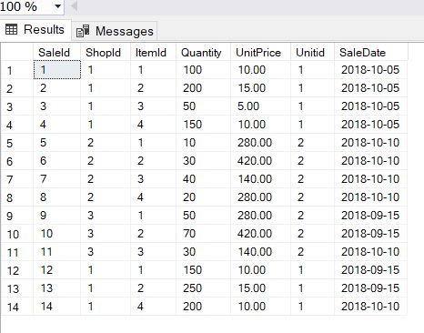

--Q1.2

SELECT top 1 I.ItemName,(SUM(S.Quantity \* S.UnitPrice)) AS Revenue

FROM Sales S,Item I WHERE MONTH(S.SaleDate) = 10

and S.ItemId = I.ItemId

GROUP BY I.ItemName

ORDER BY Revenue DESC

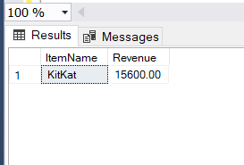

--Q1.3

SELECT top 1 I.ItemName,SUM(S.Quantity) AS TotalQuantity

FROM Sales JOIN Item I ON S.ItemID = I.ItemID

JOIN Shop SH ON S.ShopID = SH.ShopID

WHERE SH.ShopName = 'Amal Stores'

AND MONTH(S.SaleDate) = 10

GROUP BY I.ItemName

ORDER BY TotalQuantity DESC

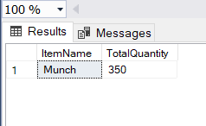

--Q1.4

SELECT I.ItemName, SUM(S.Quantity \* S.UnitPrice) AS Revenue

FROM Sales S

JOIN Item I ON S.ItemID = I.ItemID

WHERE MONTH(S.SaleDate) = 10

GROUP BY I.ItemName

HAVING

SUM(S.Quantity \* S.UnitPrice) > 10000

ORDER BY Revenue DESC

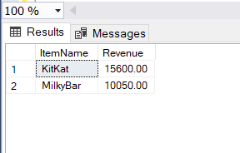

--Q1.5

SELECT top 1 SH.ShopName, SUM(S.Quantity \* S.UnitPrice) AS Revenue

FROM Sales S JOIN Shop SH ON S.ShopID = SH.ShopID

WHERE MONTH(S.SaleDate) = 10

GROUP BY SH.ShopName

ORDER BY Revenue DESC

