Jeffrey Razon

**CPE301 – SPRING 2018**

Since it has 16 bit to store the sum you need to get the 16 bit value. Design Assignment 01

**DO NOT REMOVE THIS PAGE DURING SUBMISSION:**

The student understands that all required components should be submitted in complete for grading of this assignment.

|  |  |  |  |
| --- | --- | --- | --- |
| **NO** | **SUBMISSION ITEM** | **COMPLETED (Y/N)** | **MARKS**  **(/MAX)** |
| 1 | COMPONENTS LIST AND CONNECTION BLOCK DIAGRAM w/ PINS |  |  |
| 2. | INITIAL CODE OF TASK 1/A |  |  |
| 3. | INCREMENTAL / DIFFERENTIAL CODE OF TASK 2/B |  |  |
| 3. | INCREMENTAL / DIFFERENTIAL CODE OF TASK 3/C |  |  |
| 3. | INCREMENTAL / DIFFERENTIAL CODE OF TASK 4/D |  |  |
| 3. | INCREMENTAL / DIFFERENTIAL CODE OF TASK 5/E |  |  |
| 4. | SCHEMATICS |  |  |
| 5. | SCREENSHOTS OF EACH TASK OUTPUT |  |  |
| 5. | SCREENSHOT OF EACH DEMO |  |  |
| 6. | VIDEO LINKS OF EACH DEMO |  |  |
| 7. | GOOGLECODE LINK OF THE DA |  |  |
|  |  |  |  |
|  |  |  |  |

**Task 1/A**: Store 300 numbers starting from the STARTADDS=0x0222 location. Populate the value of the memory location by adding high(STARTADDS) and low(STARTADDS) . Use the X/Y/Z registers as pointers to fill up 300 numbers.

a) Declaring X/Y/Z registers as pointers

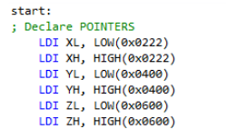

b) Populating 300 numbers and storing them (counter checks for exactly 300 numbers)

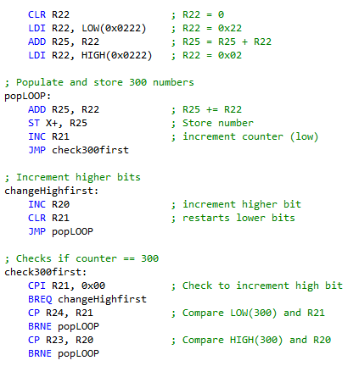

c) Memory spaces

Memory space 0x222, first number placed is 0x24 (36) and last number is 0x7a (122)

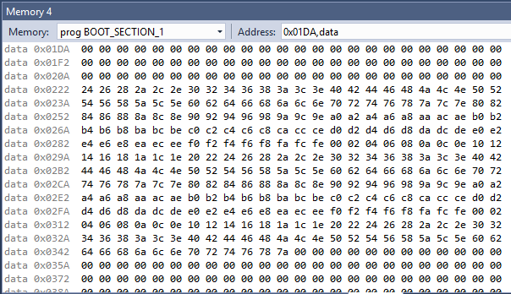

Memory space 0x400, numbers divisible by 5

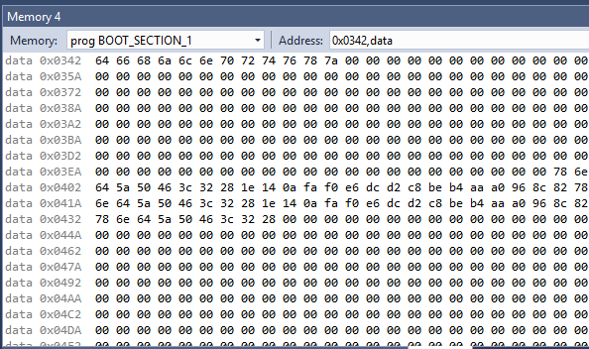

Memory space 0x600, numbers not divisible by 5

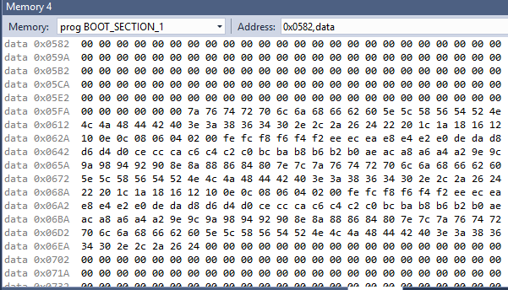

**Task 2/B**: Use X/Y/Z register addressing to parse through the 300 numbers, if the number is divisible by 5 store the number starting from memory location 0x0400, else store at location starting at 0x0600.

**Task 3/C**: Use X/Y/Z register addressing to simultaneously add numbers from memory location 0x0400 and 0x0600 and store the sums at R16:R17 and R18:R19 respectively. Do not worry about the overflow.

a) checking if each number is divisible by 5, goes to registers R16 and R17 if divisible by 5 and goes to registers R18 and R19 if not

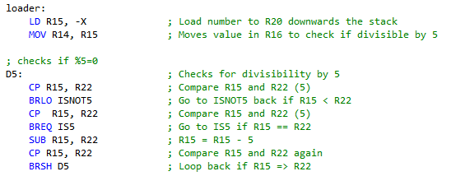

b) running the program, R16:R17 (divisible by 5) is 7220 (0x1C34) and R18:R19 (not divisible by 5) is 28768 (0x7060)

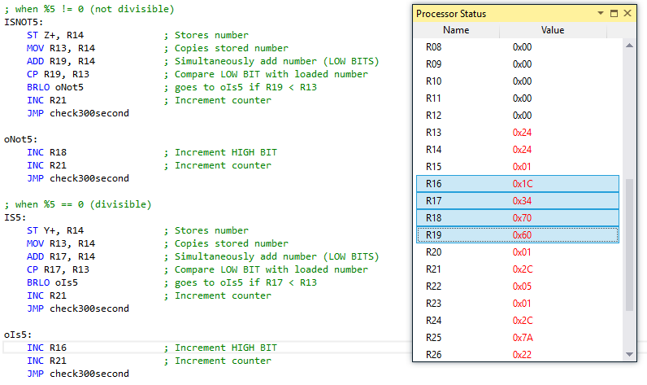

**Task 4/D**: Verify your algorithm and answers using C programming

a) The Code

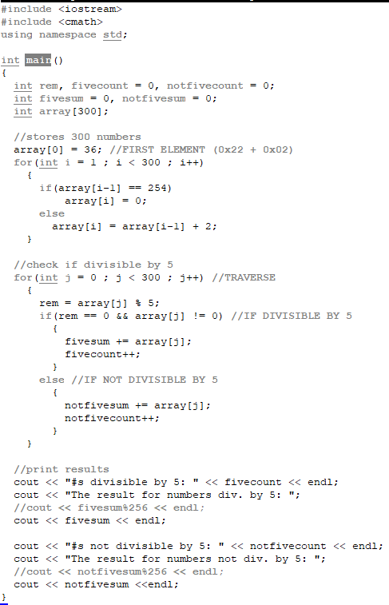

b) running the code, the outputs matches the hexadecimal results from Task 3/C, 7220 being 0x1C34 and 28768 being 0x7060

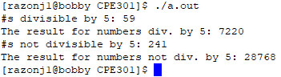

**Task 5/E**:Determine the execution time @ 16MHz/#cycles of your algorithm using the simulation.

Execution time (in microseconds) = # of cycles (65543 cycles) / frequency (16 MHz) = 4096.44 us

a) calculations on online scientific calculator

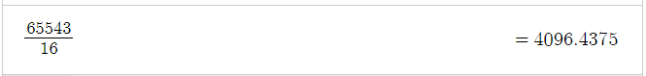

b) by changing the frequency on Atmel Studios, the stop watch’s execution time changed accordingly

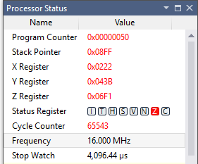

**FULL CODE**

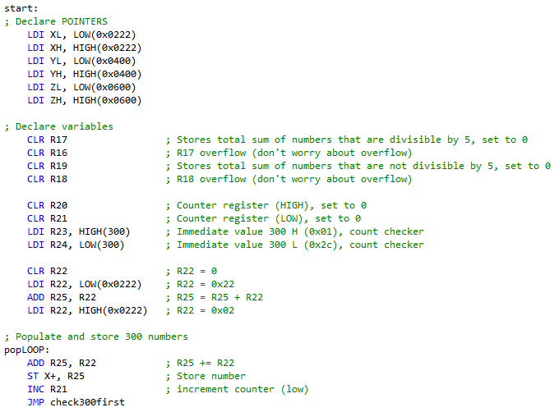

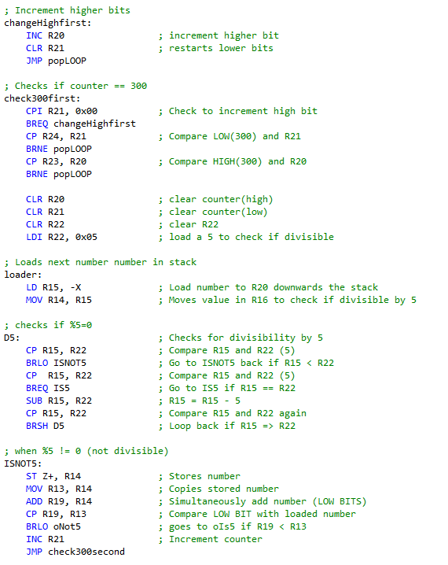

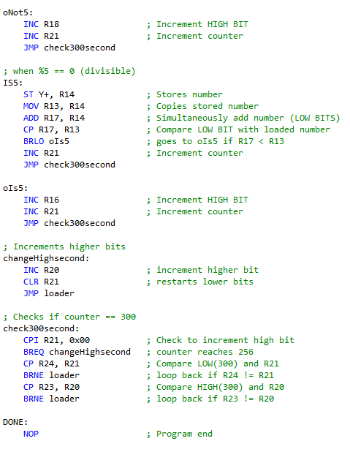

**FLOW CHART**

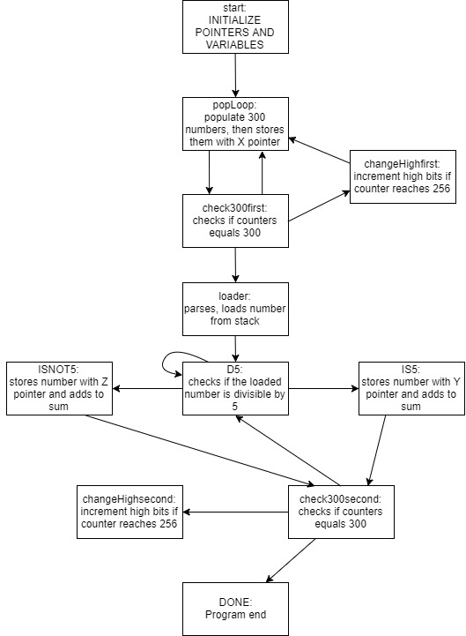

**GITHUB LINK:** https://github.com/JeffinVegas/EmbSys.git

**Student Academic Misconduct Policy**

<http://studentconduct.unlv.edu/misconduct/policy.html>

“*This assignment submission is my own, original work*”.

Jeffrey Razon