Jeffrey Razon

**CPE301 – SPRING 2018**

Design Assignment 03

**DO NOT REMOVE THIS PAGE DURING SUBMISSION:**

The student understands that all required components should be submitted in complete for grading of this assignment.

|  |  |  |  |
| --- | --- | --- | --- |
| **NO** | **SUBMISSION ITEM** | **COMPLETED (Y/N)** | **MARKS**  **(/MAX)** |
| 1 | COMPONENTS LIST AND CONNECTION BLOCK DIAGRAM w/ PINS |  |  |
| 2. | INITIAL CODE OF TASK 1/A |  |  |
| 3. | INCREMENTAL / DIFFERENTIAL CODE OF TASK 2/B |  |  |
| 3. | INCREMENTAL / DIFFERENTIAL CODE OF TASK 3/C |  |  |
| 3. | INCREMENTAL / DIFFERENTIAL CODE OF TASK 4/D |  |  |
| 3. | INCREMENTAL / DIFFERENTIAL CODE OF TASK 5/E |  |  |
| 4. | SCHEMATICS |  |  |
| 5. | SCREENSHOTS OF EACH TASK OUTPUT |  |  |
| 5. | SCREENSHOT OF EACH DEMO |  |  |
| 6. | VIDEO LINKS OF EACH DEMO |  |  |
| 7. | GOOGLECODE LINK OF THE DA |  |  |
|  |  |  |  |
|  |  |  |  |

**Task 1/A**: Write a C AVR program that will monitor the LM34/35 connected to an Analog pin to display the temperature in F on the serial terminal every 1 sec. Use a timer with interrupt for the 1 sec delay. Use a FTDI chip for serial to USB conversion.

a) Full code (in C)

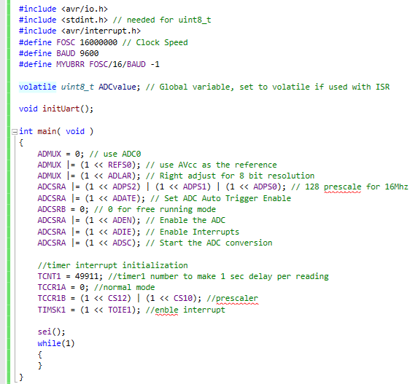

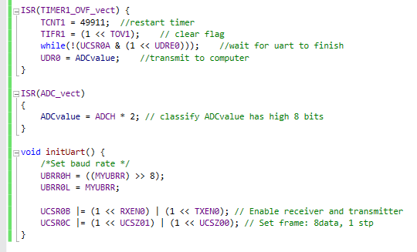

**Task 2/B**: Use the ATMEL Studio Data Visualizer or any Charting program to display the values in time.

- For this assignment, I used ATMEL Studio Data Visualizer to display the ADCvalue, which is assigned the UDR0 register.

a) Constant temperature at 74oF (w/o finger contact to LM34)

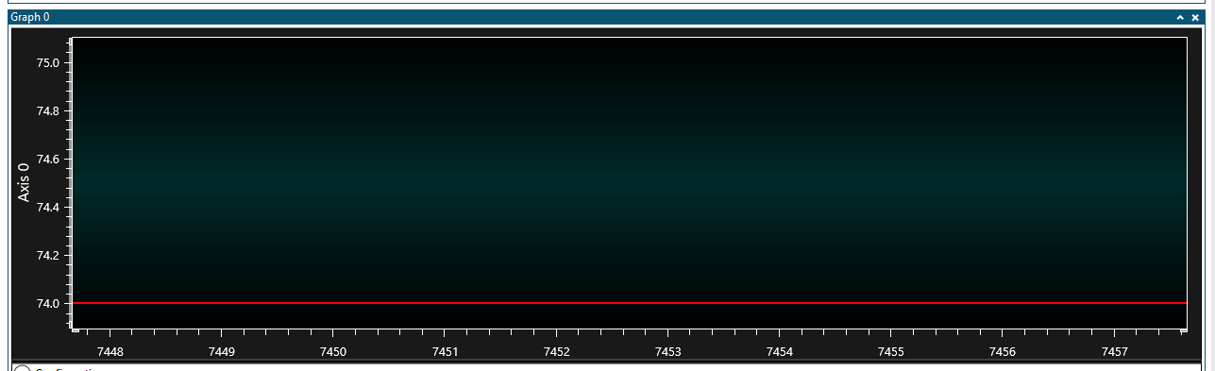

b) Temperature raising to the 80soF (Pinching the LM34)

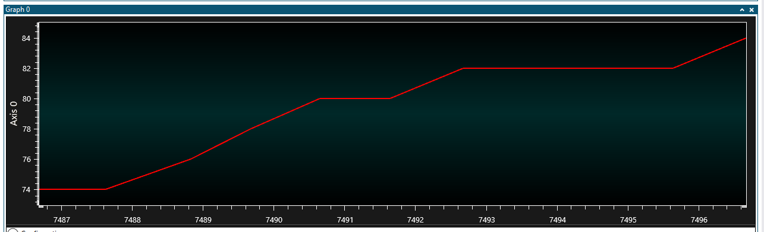

c) Temperature decreasing (no longer

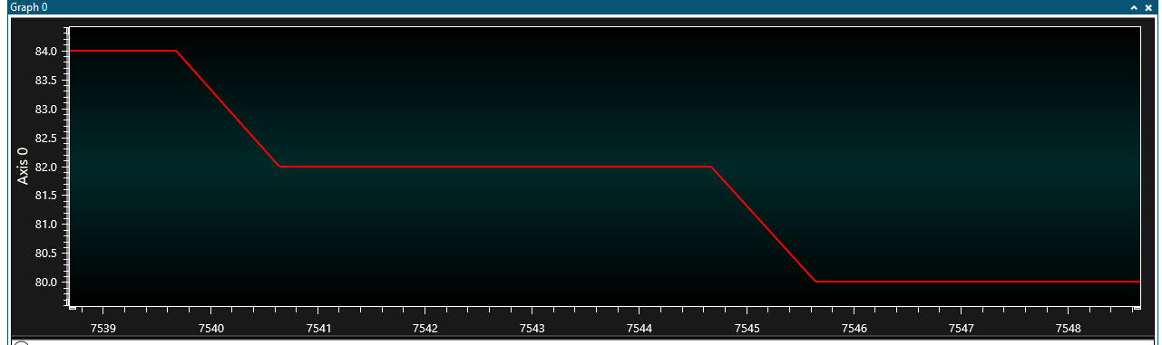

**Flowchart:**

a) Flowchart

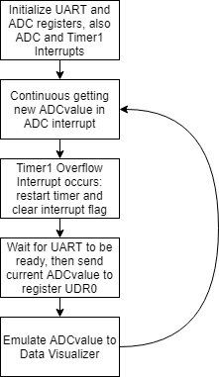

**Schematics**:

a) Fritzing schematics

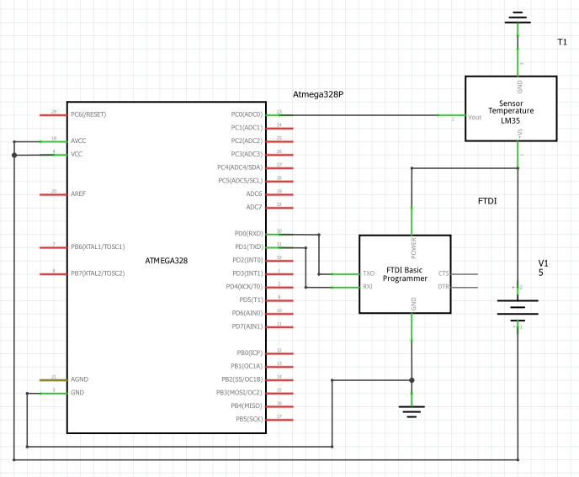

**Physical Set-up:**

a) Breadboard circuit (ATMega328P and FTDI chip)

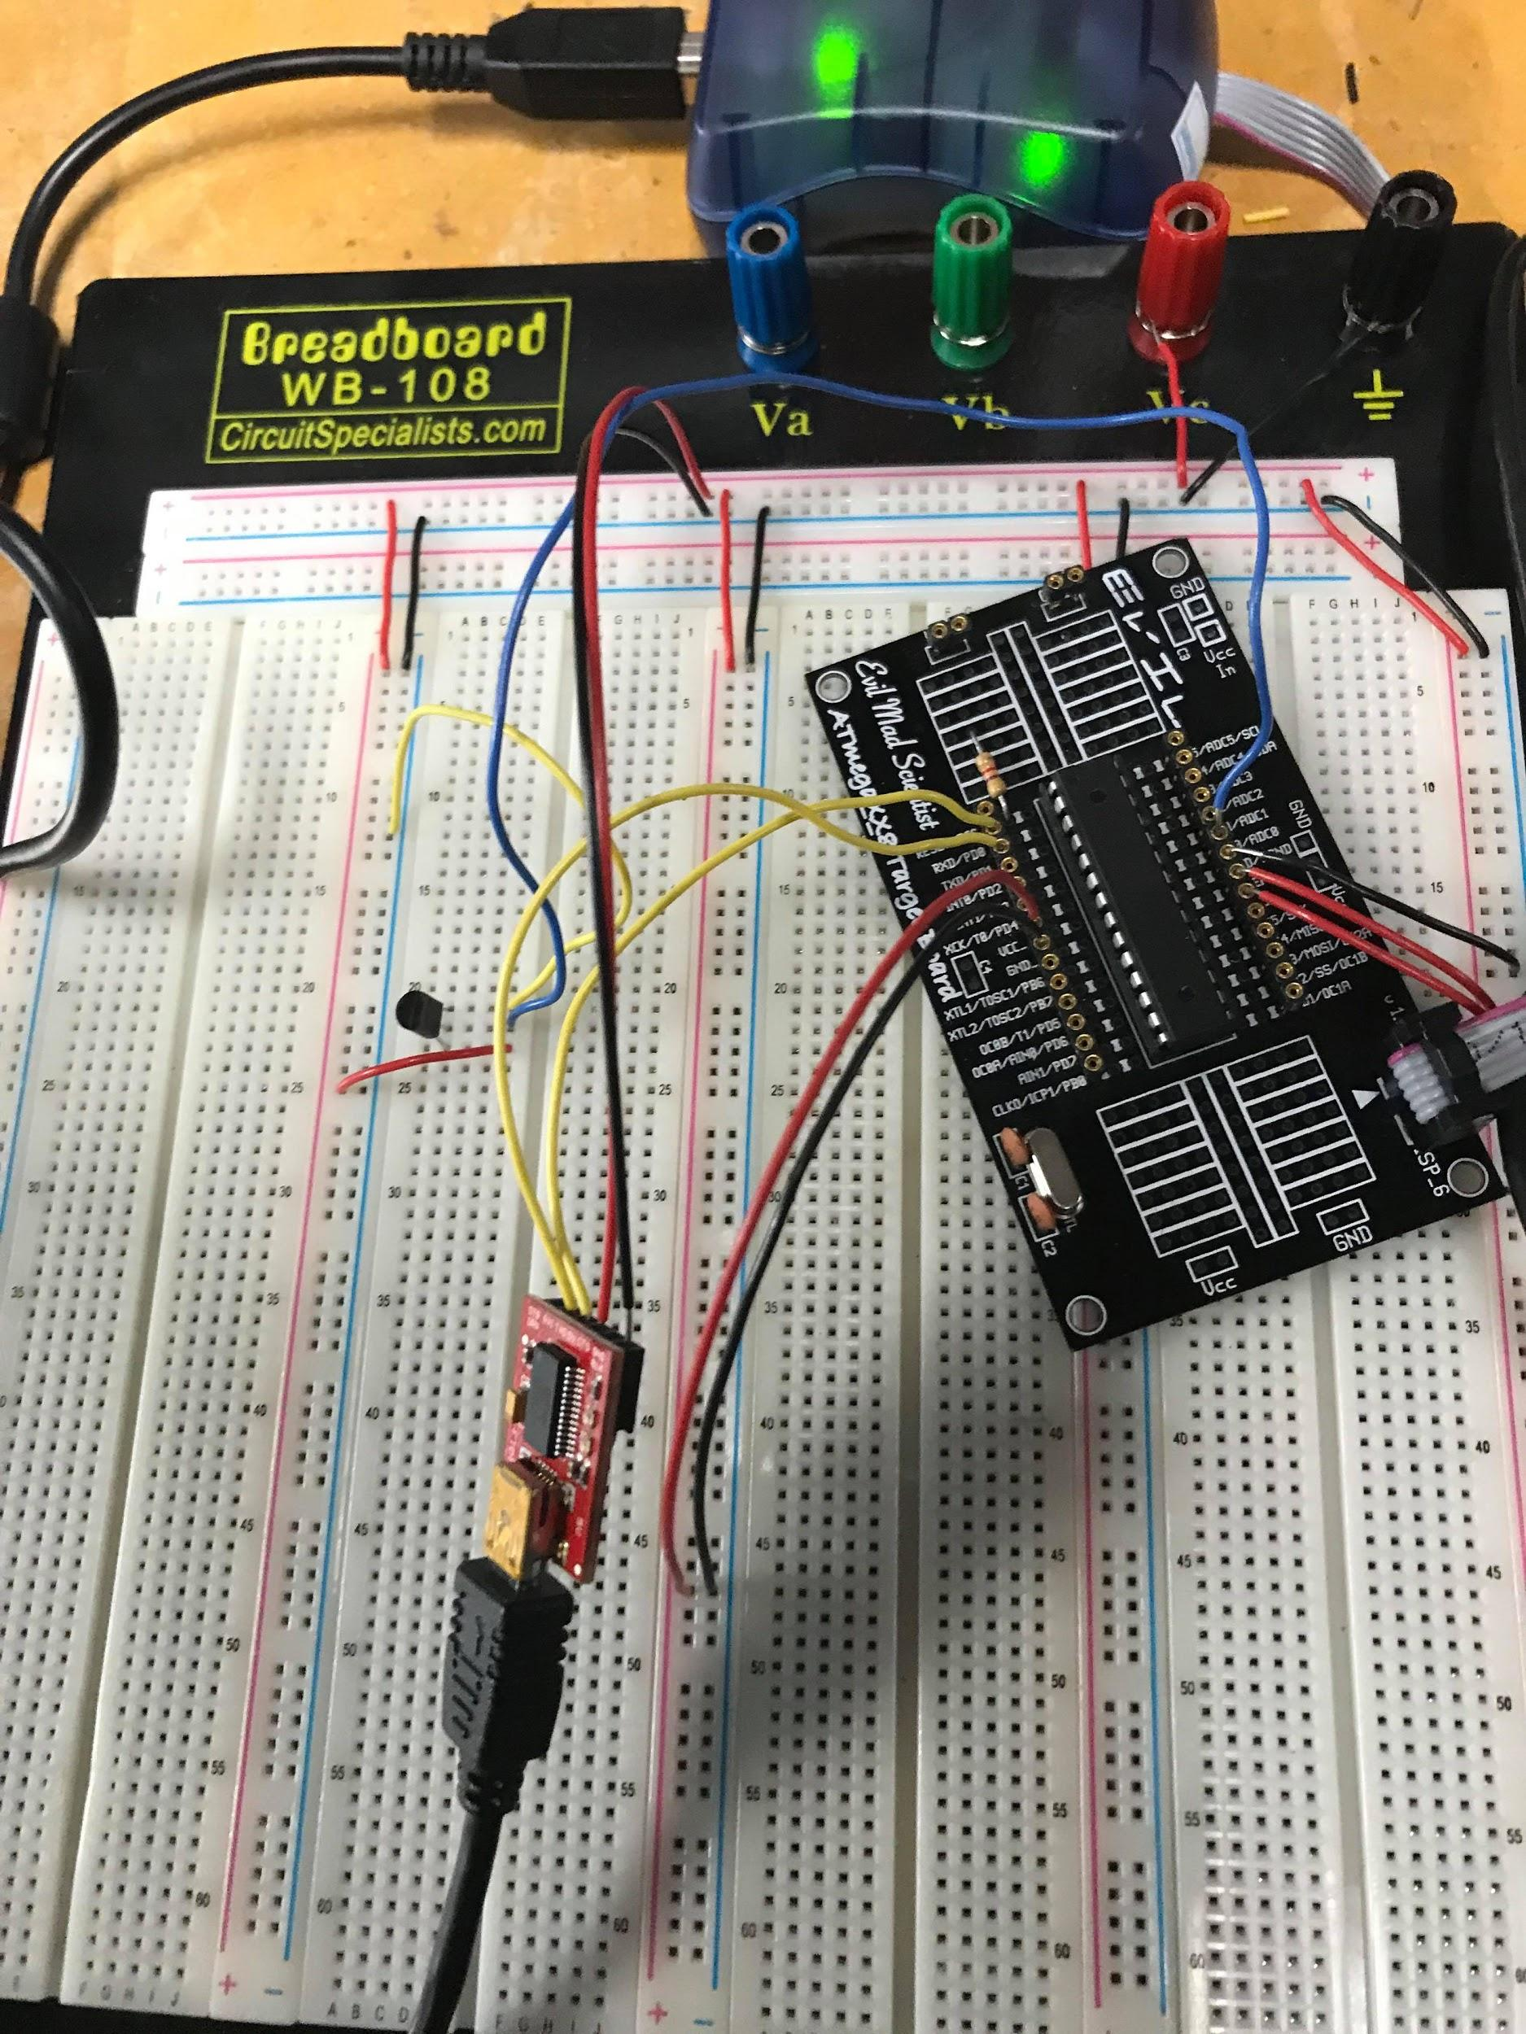

**GITHUB LINK:** https://github.com/JeffinVegas/EmbSys.git

**Student Academic Misconduct Policy**

<http://studentconduct.unlv.edu/misconduct/policy.html>

“*This assignment submission is my own, original work*”.

Jeffrey Razon