Jeffrey Razon

**CPE301 – SPRING 2018**

Design Assignment 04

**DO NOT REMOVE THIS PAGE DURING SUBMISSION:**

The student understands that all required components should be submitted in complete for grading of this assignment.

|  |  |  |  |
| --- | --- | --- | --- |
| **NO** | **SUBMISSION ITEM** | **COMPLETED (Y/N)** | **MARKS**  **(/MAX)** |
| 1 | COMPONENTS LIST AND CONNECTION BLOCK DIAGRAM w/ PINS |  |  |
| 2. | INITIAL CODE OF TASK 1/A |  |  |
| 3. | INCREMENTAL / DIFFERENTIAL CODE OF TASK 2/B |  |  |
| 3. | INCREMENTAL / DIFFERENTIAL CODE OF TASK 3/C |  |  |
| 3. | INCREMENTAL / DIFFERENTIAL CODE OF TASK 4/D |  |  |
| 3. | INCREMENTAL / DIFFERENTIAL CODE OF TASK 5/E |  |  |
| 4. | SCHEMATICS |  |  |
| 5. | SCREENSHOTS OF EACH TASK OUTPUT |  |  |
| 5. | SCREENSHOT OF EACH DEMO |  |  |
| 6. | VIDEO LINKS OF EACH DEMO |  |  |
| 7. | GOOGLECODE LINK OF THE DA |  |  |
|  |  |  |  |
|  |  |  |  |

**Task 1/A**: Write an AVR C program to control the speed of the DC Motor using a potentiometer connected to any of the analog-in port. Use an interrupt on a button to stop and start the motor at each click. The minimum speed of the motor should be 0 when pot is minimum and maximum should be 95% of PWM value.

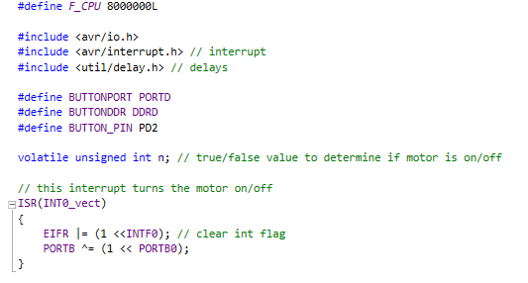

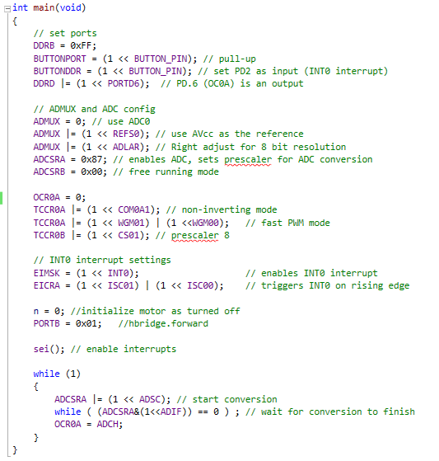

**Flowchart:**

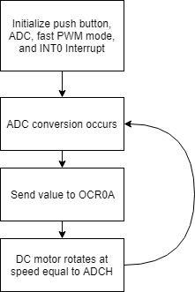

**Schematics**:

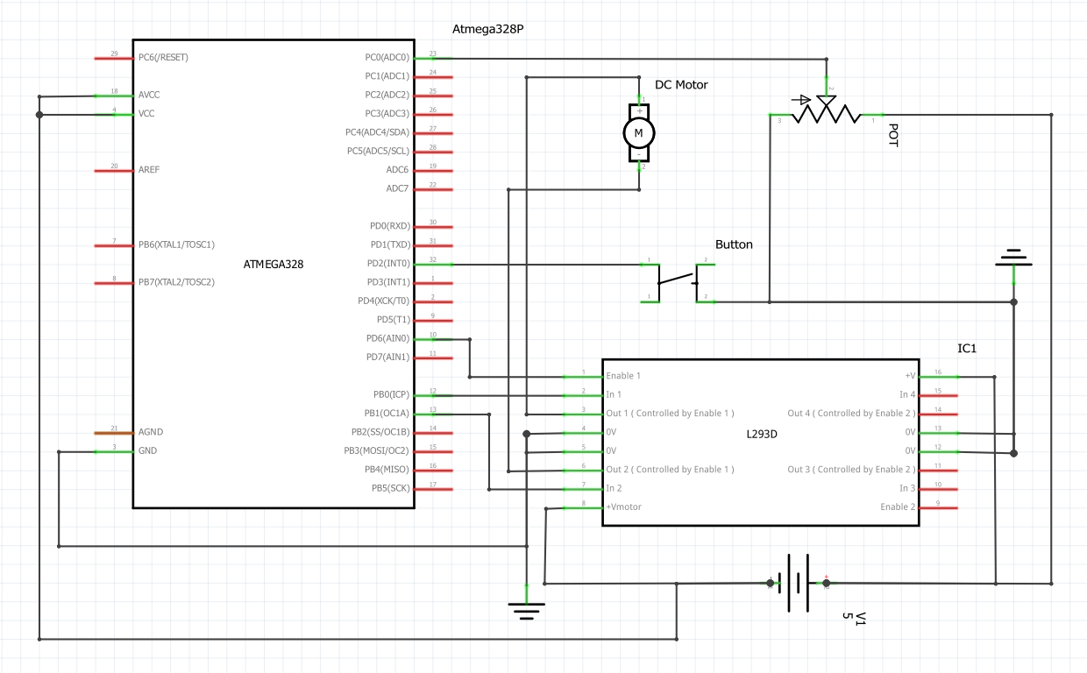

**Breadboard:**

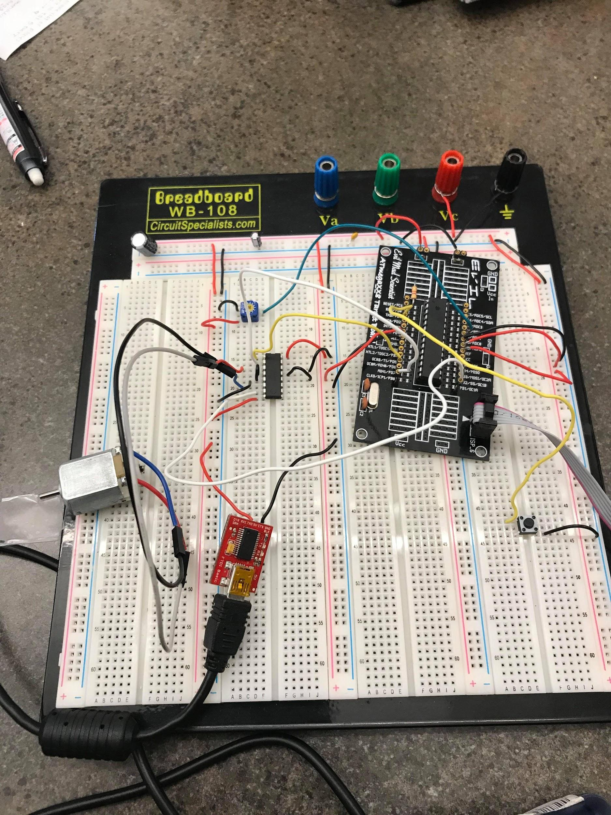

**Task 2/B**: Write an AVR C program to control the speed of the Stepper Motor using a potentiometer connected to any of the analog-in port. Use a timer in CTC mode to control the delay.

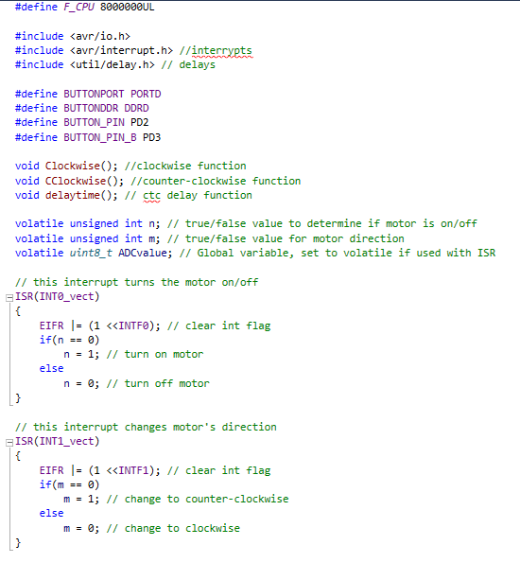

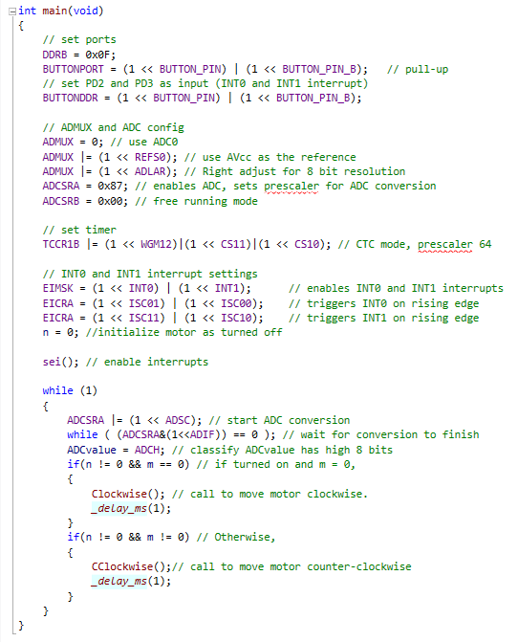



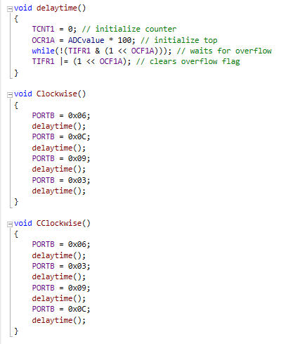

**Flowchart:**

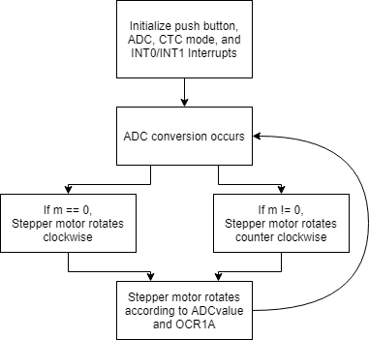

**Schematics**:

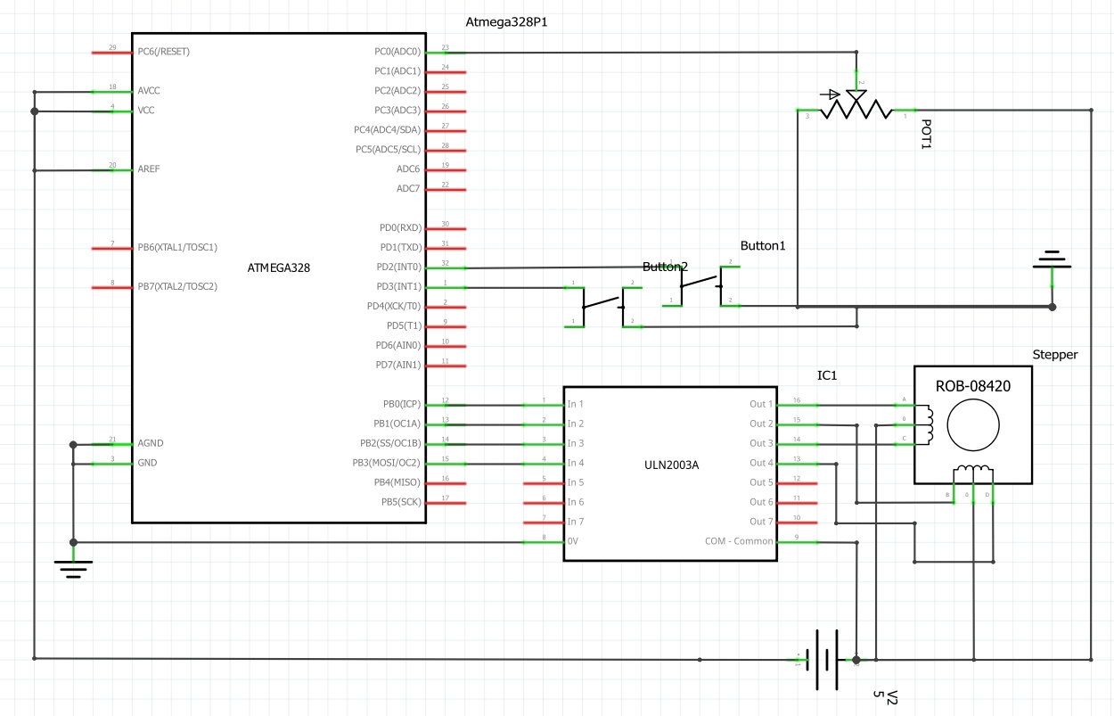

**Breadboard:**

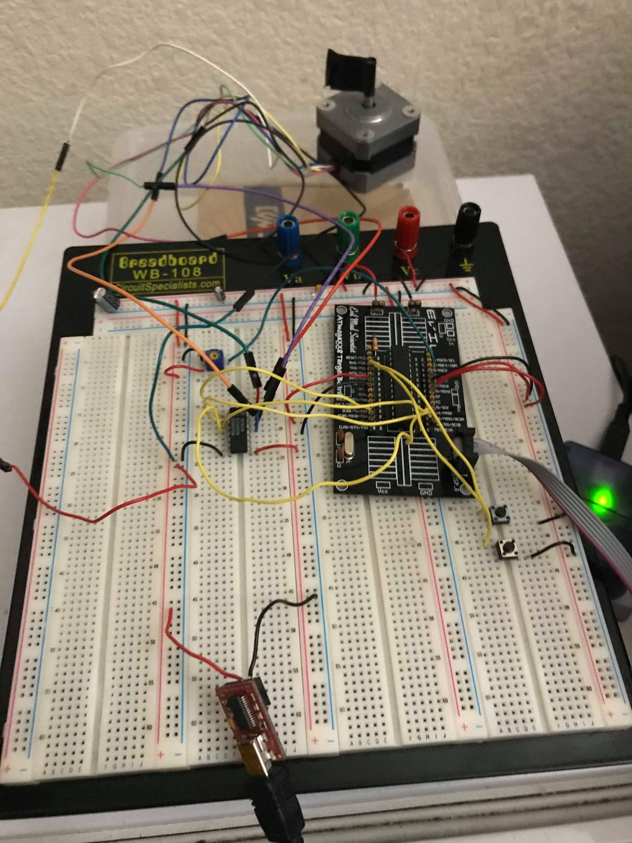

**Task 3/C**: Write an AVR C program to control the position of the Servo Motor using a potentiometer connected to any of the analog-in port. When pot value is 0 the servo is at position 0 deg. and when pot value is max (approx. 5V) the servo is at position 180 deg.

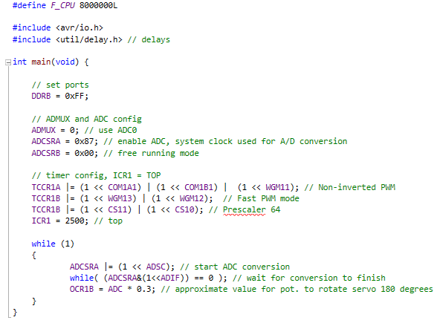

**Flowchart:**

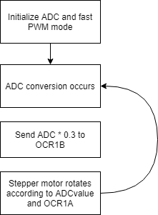

**Schematics**:

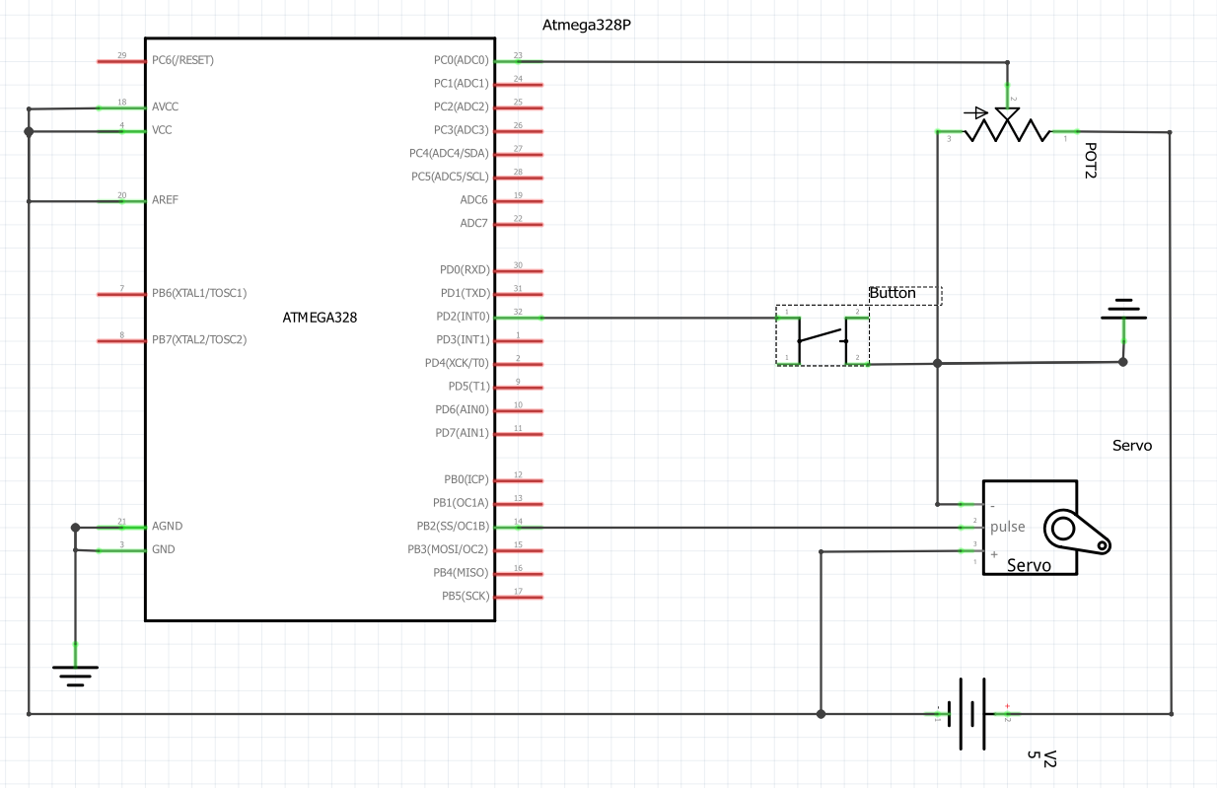

**Breadboard:**

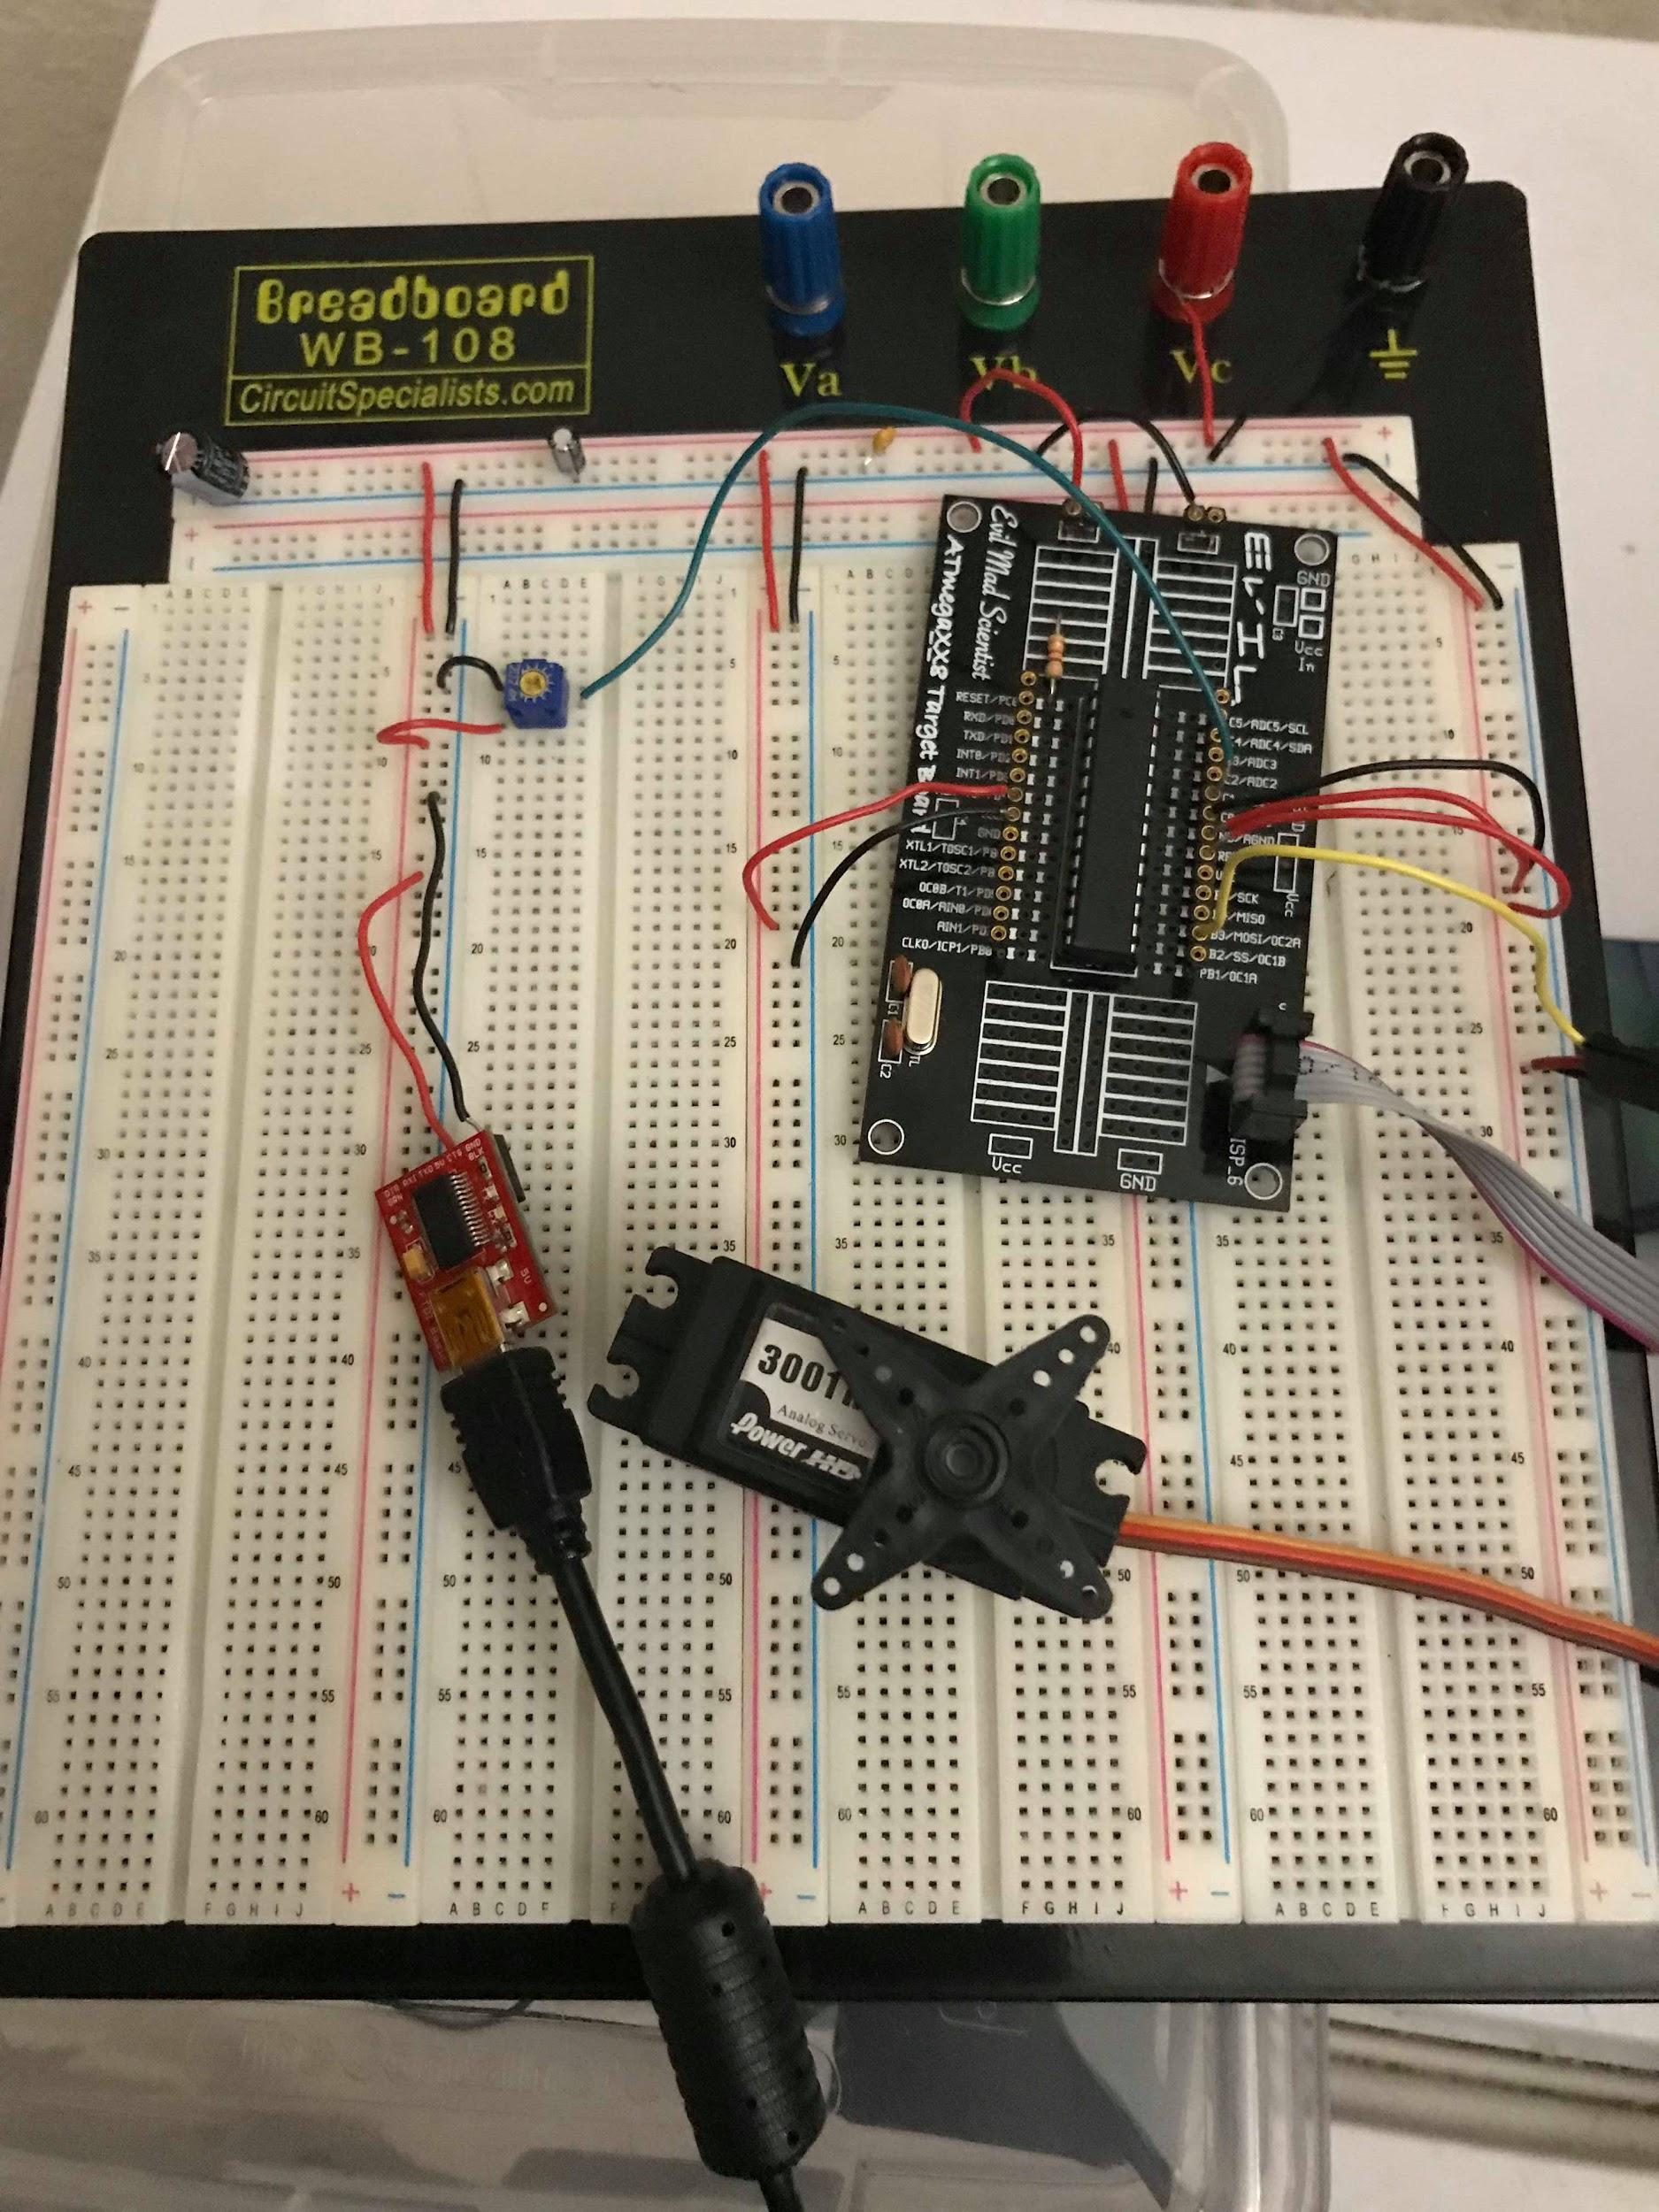

**GITHUB LINK:** <https://github.com/JeffinVegas/EmbSys.git>

**YOUTUBE LINK:** In the videos_DA04.txt file

**Student Academic Misconduct Policy**

<http://studentconduct.unlv.edu/misconduct/policy.html>

“*This assignment submission is my own, original work*”.

Jeffrey Razon