**GROUP: Jeffrey Razon, Argenis Jimenez**

**TITLE: REMOTE CONTROL ROBOT CAR BASED ON ATMEGA328P**

**GOALS:**

* Use FTDI to send commands to ATmega328p using UART
* Have the Pololu Zumo Robot car perform commands sent with UART
* Write to terminal with keyboard commands and print which command is currently being implemented

**DELIVERABLES:**

The project was produced in order to control the robot car by having it move according through UART, along with any additional commands we can implement.

**COMPONENTS:**

**POLOLU ZUMO DC MOTOR CAR**

The Zumo robot is a low-profile tracked robot platform intended for use with an Arduino (or compatible device) as its main controller. It is both small enough (10 cm on each side) and light enough (approximately 300 g) to enter in Mini-Sumo arena competitions. For our project, we made a code and configuration around the ATmega328p, a microcontroller that goes hand in hand with Arduino devices. Our Zumo car was built with 2 DC motors, which is used with the pins of the ATmega328p to move the robot car.

**ATmega328p**

ATMEGA328P is high performance, low power controller from Microchip. ATMEGA328P is an 8-bit microcontroller (by Atmel) based on AVR RISC architecture. It is the most popular of all AVR controllers as it is used in ARDUINO boards. Using its pins (28 in total), our group wired it together with the FTDI chip, the Zumo car, LED lights, and the L293D driver to create a moving car.

**FTDI**

The FTDI USB-to-serial IC chip is a basic breakout board. The pinout of this board matches the FTDI cable to work with official Arduino and cloned 5V Arduino boards. It can also be used for general serial applications. For our project, the FTDI is the medium to transmit and receive instructions between the PuTTY terminal and the ATmega328p.

**SCHEMATICS:**

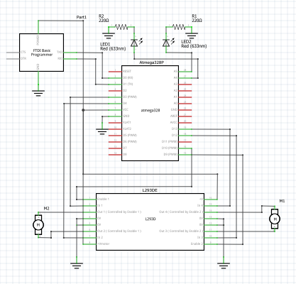

**INITIAL PCB:**

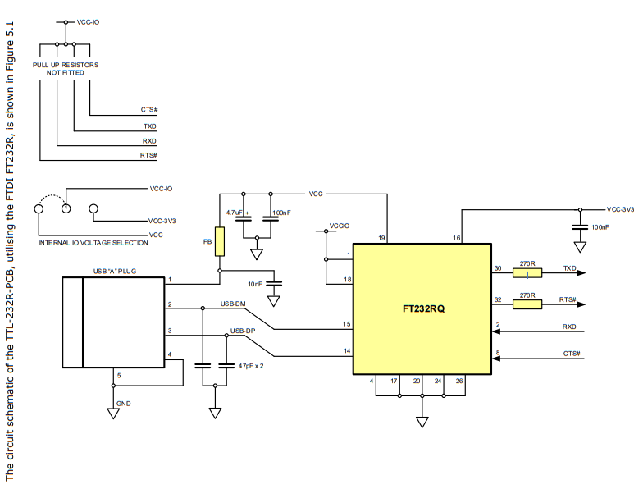

**IMPLEMENTATION:**

* ATmega328p
  + The ATmega328p will manipulate the actions the robot execute using the FTDI and the PuTTY terminal.
* Pololu Zumo Robot Car
  + The robot car will perform the actions the ATmega328p determines for it to do, like moving forward and backwards, speed up/slow down, etc.
* FTDI
  + The FTDI receives the command from the keyboard (controller) and sends the command to the ATmega328p.
  + In our project’s case, the FTDI chip also powered the circuit with a constant 5V.
* PuTTY Terminal
  + We write commands to the PuTTY terminal. This will trigger the USART RX interrupt.
  + Once the command that is being performed is determined, the ATmega328p will send back to the terminal through the FTDI which action was performed.

**SNAPSHOTS/SCREENSHOTS:**

Snapshots: In “Photos” folder of DA_FINAL folder

Remote-Controlled Robot Car Demo: https://youtu.be/O5vhrxH784c

**CODE:** [FIX]

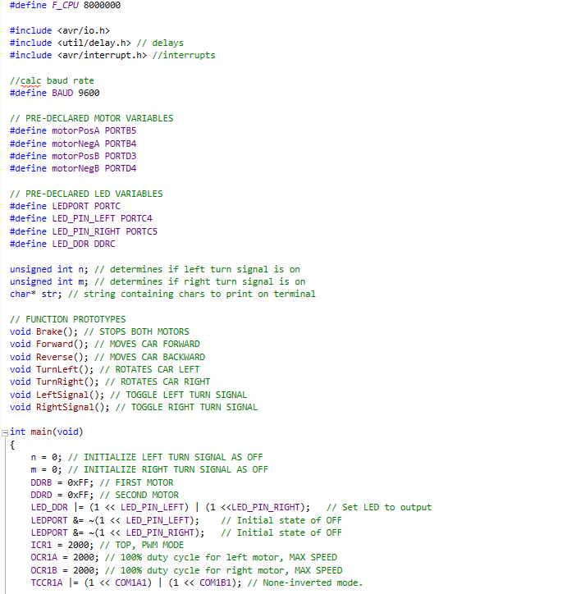

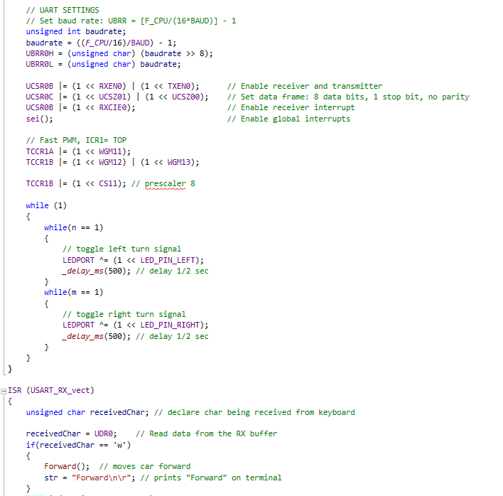

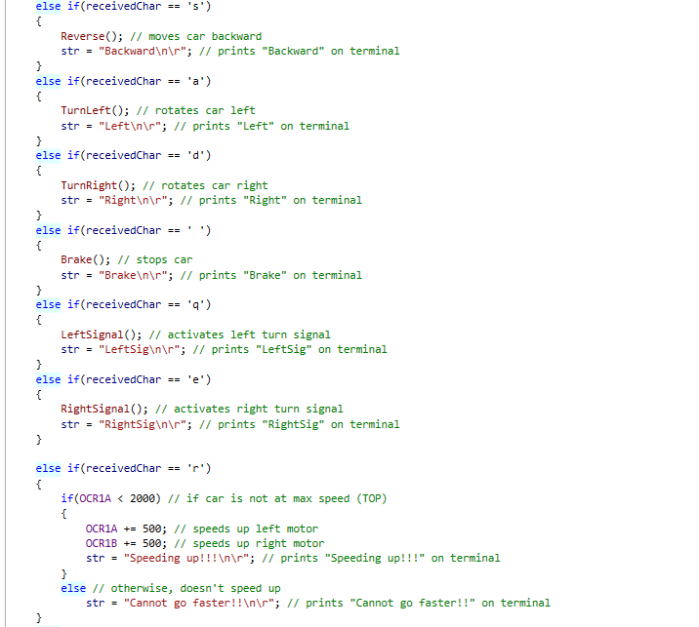



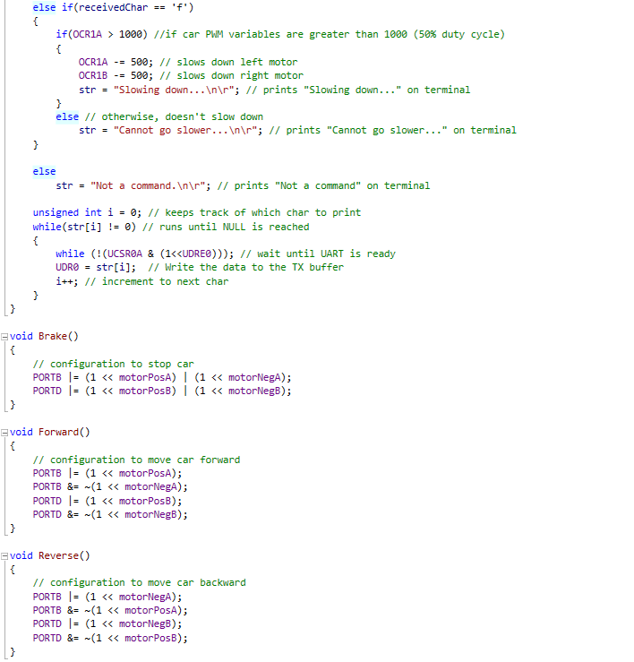

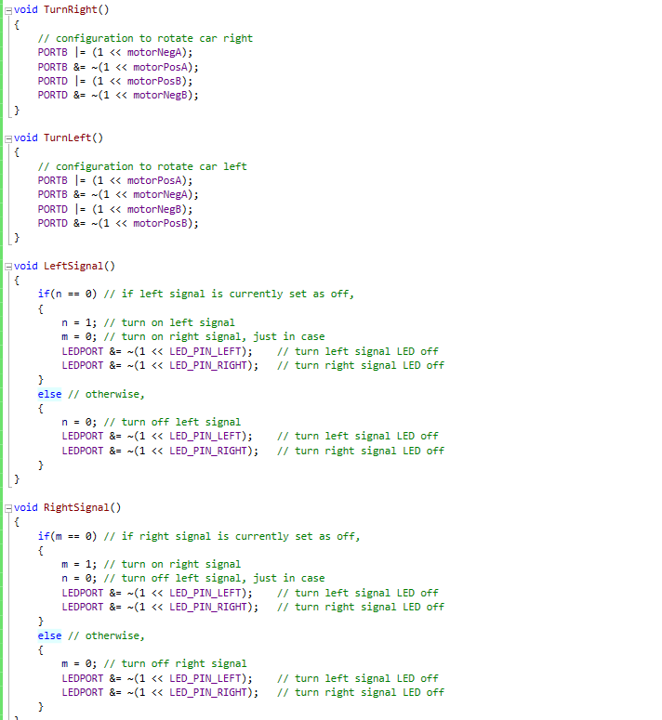

**REFERENCE:**

**ATmega328p Datasheet:**

<http://ww1.microchip.com/downloads/en/DeviceDoc/Atmel-42735-8-bit-AVR-Microcontroller-ATmega328-328P_Datasheet.pdf>

**More About ATmega328p:**

<https://components101.com/microcontrollers/atmega328p-pinout-features-datasheet>

**FTDI Chip Datasheet:** <http://www.ftdichip.com/Support/Documents/DataSheets/Cables/DS_TTL-232R_PCB.pdf>

**More About FTDI:**

<https://www.sparkfun.com/products/9716>

**Github:**

<https://github.com/JeffinVegas/EmbSys>

**Arduino Tutorial - DC Motor Control with L293D Reference Video:**

<https://www.youtube.com/watch?v=d7oFD-zQpuQ>

**PWM Reference:**

<https://sites.google.com/site/qeewiki/books/avr-guide/pwm-on-the-atmega328>

**Pololu Zumo Robot Information:**

<https://www.pololu.com/product/2506>