Jeffrey Razon

**CPE301 – SPRING 2018**

Design Assignment MIDTERM

**DO NOT REMOVE THIS PAGE DURING SUBMISSION:**

The student understands that all required components should be submitted in complete for grading of this assignment.

|  |  |  |  |
| --- | --- | --- | --- |
| **NO** | **SUBMISSION ITEM** | **COMPLETED (Y/N)** | **MARKS**  **(/MAX)** |
| 1 | COMPONENTS LIST AND CONNECTION BLOCK DIAGRAM w/ PINS |  |  |
| 2. | INITIAL CODE OF TASK 1/A |  |  |
| 3. | INCREMENTAL / DIFFERENTIAL CODE OF TASK 2/B |  |  |
| 3. | INCREMENTAL / DIFFERENTIAL CODE OF TASK 3/C |  |  |
| 3. | INCREMENTAL / DIFFERENTIAL CODE OF TASK 4/D |  |  |
| 3. | INCREMENTAL / DIFFERENTIAL CODE OF TASK 5/E |  |  |
| 4. | SCHEMATICS |  |  |
| 5. | SCREENSHOTS OF EACH TASK OUTPUT |  |  |
| 5. | SCREENSHOT OF EACH DEMO |  |  |
| 6. | VIDEO LINKS OF EACH DEMO |  |  |
| 7. | GOOGLECODE LINK OF THE DA |  |  |
|  |  |  |  |
|  |  |  |  |

**Task 1/A**. Program the ADC of ATmega328/p to read the LM34/35 temperature sensor.

FINISHED IN DA03, REFER TO DA03 DOC OR REFER TO FULL CODE LATER IN DOCUMENT

**Task 2/B**. Display the value to UART.

FINISHED IN DA03, REFER TO DA03 DOC

**Task 3/C**. Make sure the AT Firmware is downloaded into the ESP8266-01 module.

a) Proof of successful firmware download (green check bottom-left)

- distorted QR box and AP/STA MAC for safety purposes, FTDI was in COM4

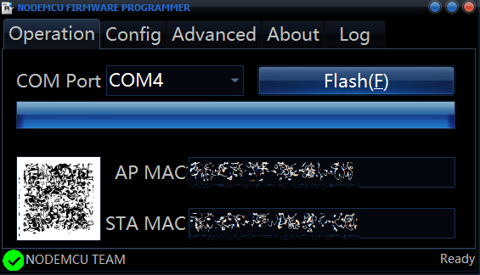

**Task 4/D**. Register for a free Thingspeak account with MATHWORK. Setup and get the channel Key.

a) Proof of ThingSpeak account creation

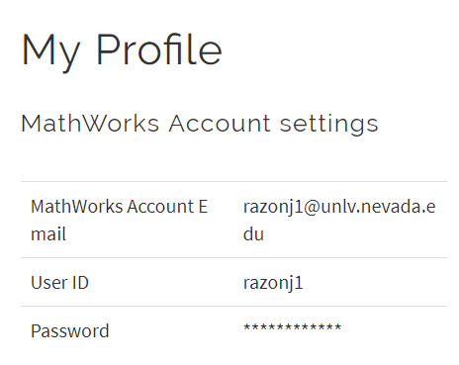

**Task 5/E**. Transmit temperature sensor value to ESP8266-01 through UART port using AT Commands.

REFER TO FULL CODE LATER IN DOCUMENT  
Utilized this site for AT commands: <https://room-15.github.io/blog/2015/03/26/esp8266-at-command-reference/>

**Task 6/F**. Display the temperature sensor value as a graph in Thingspeak

a) Graph on ThingSpeak

Notes:

- Normal temperature was around 78o-80o F.

- Temperature rises when pinching LM34.

- Temperature drops when placed cold object on top of LM34.

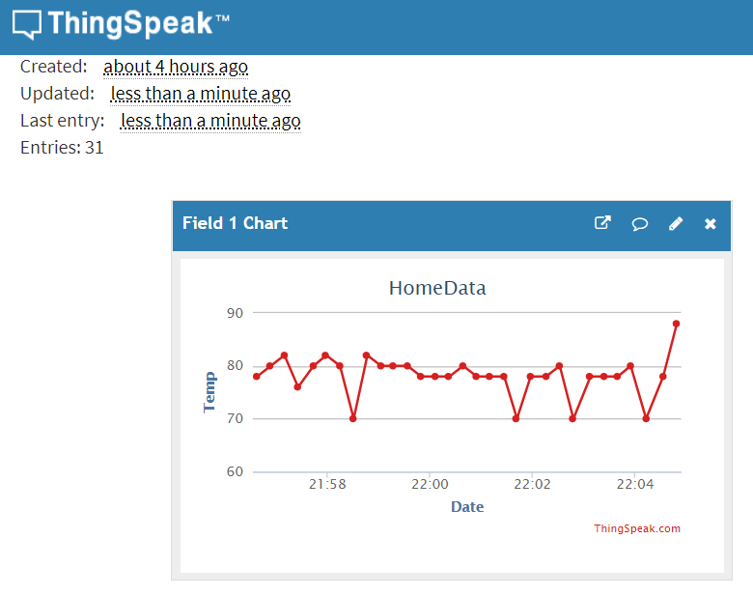

**Full Code:**

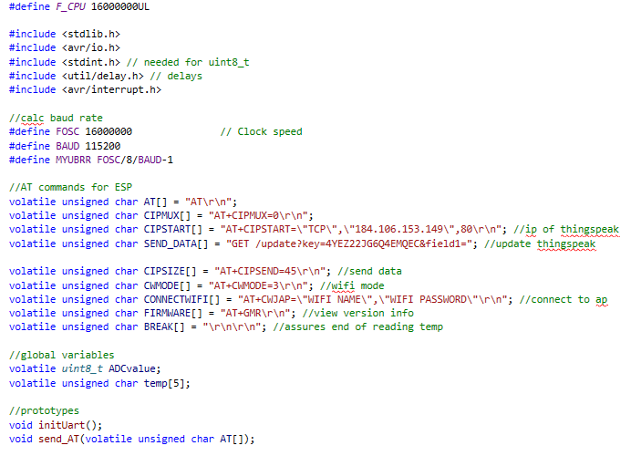

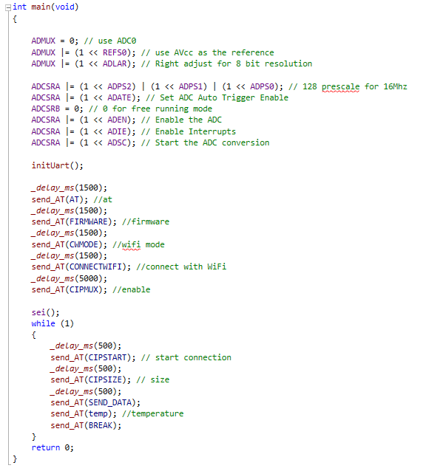

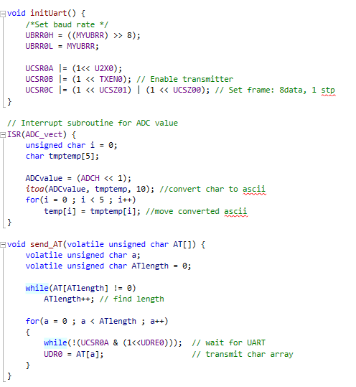

**Flowchart:**

a) Flowchart

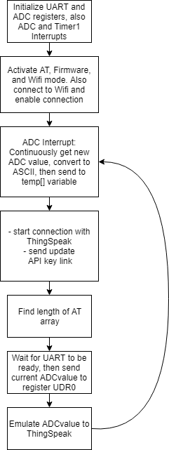

**Physical Set-up:**

a) Circuit to install ESP-01 firmware (FTDI, ESP)

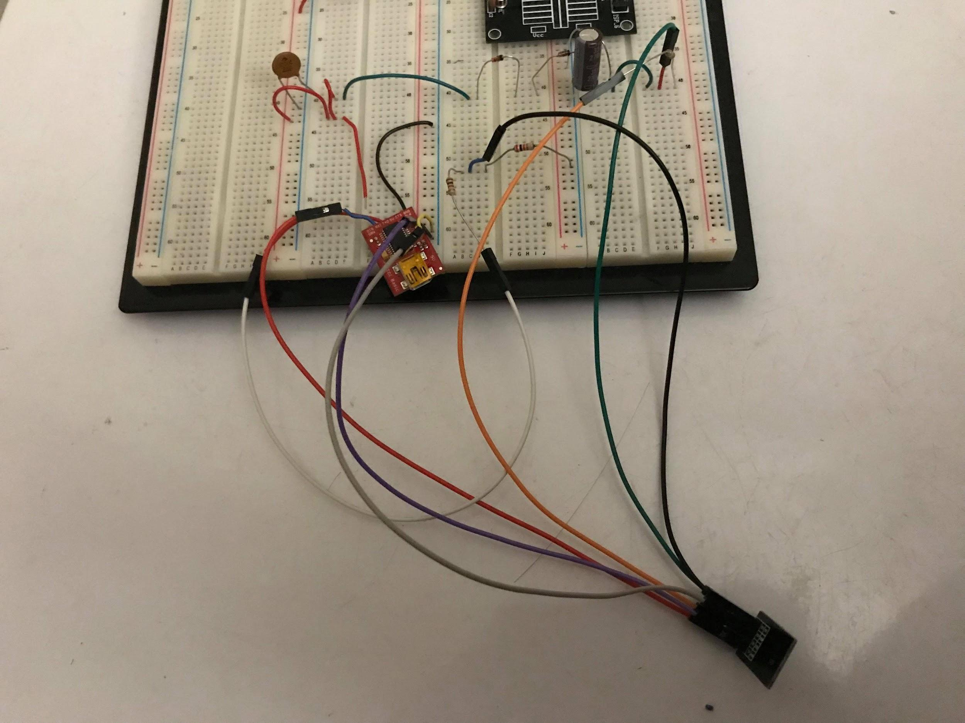

b) Full Breadboard circuit (ATMega328P, FTDI chip, ESP)

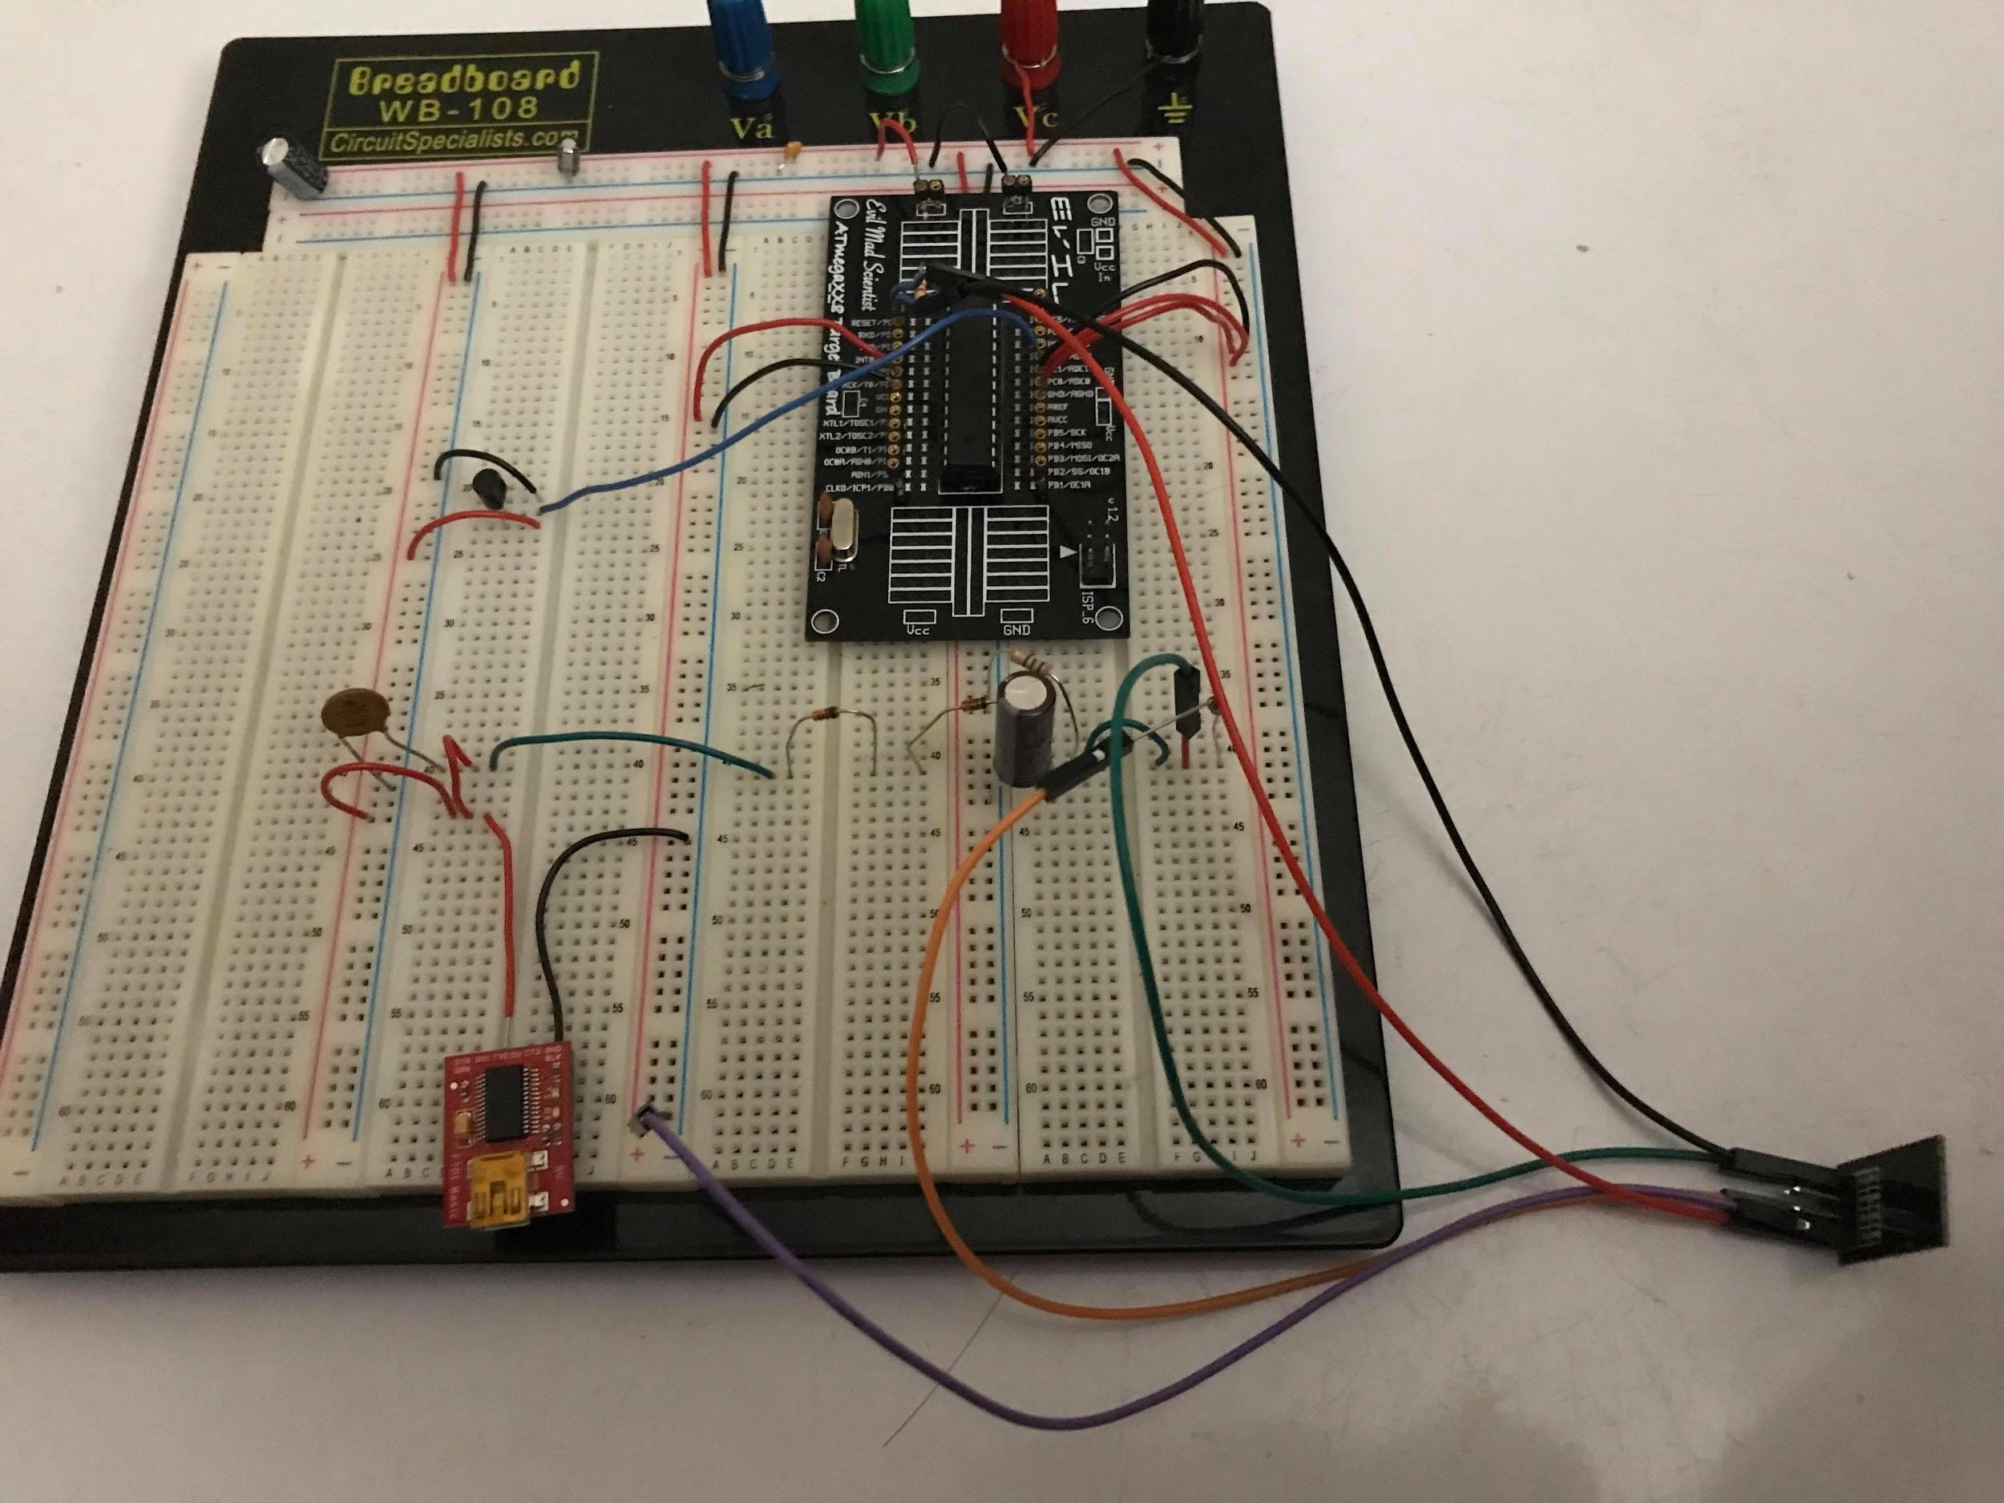

c) FTDI chip

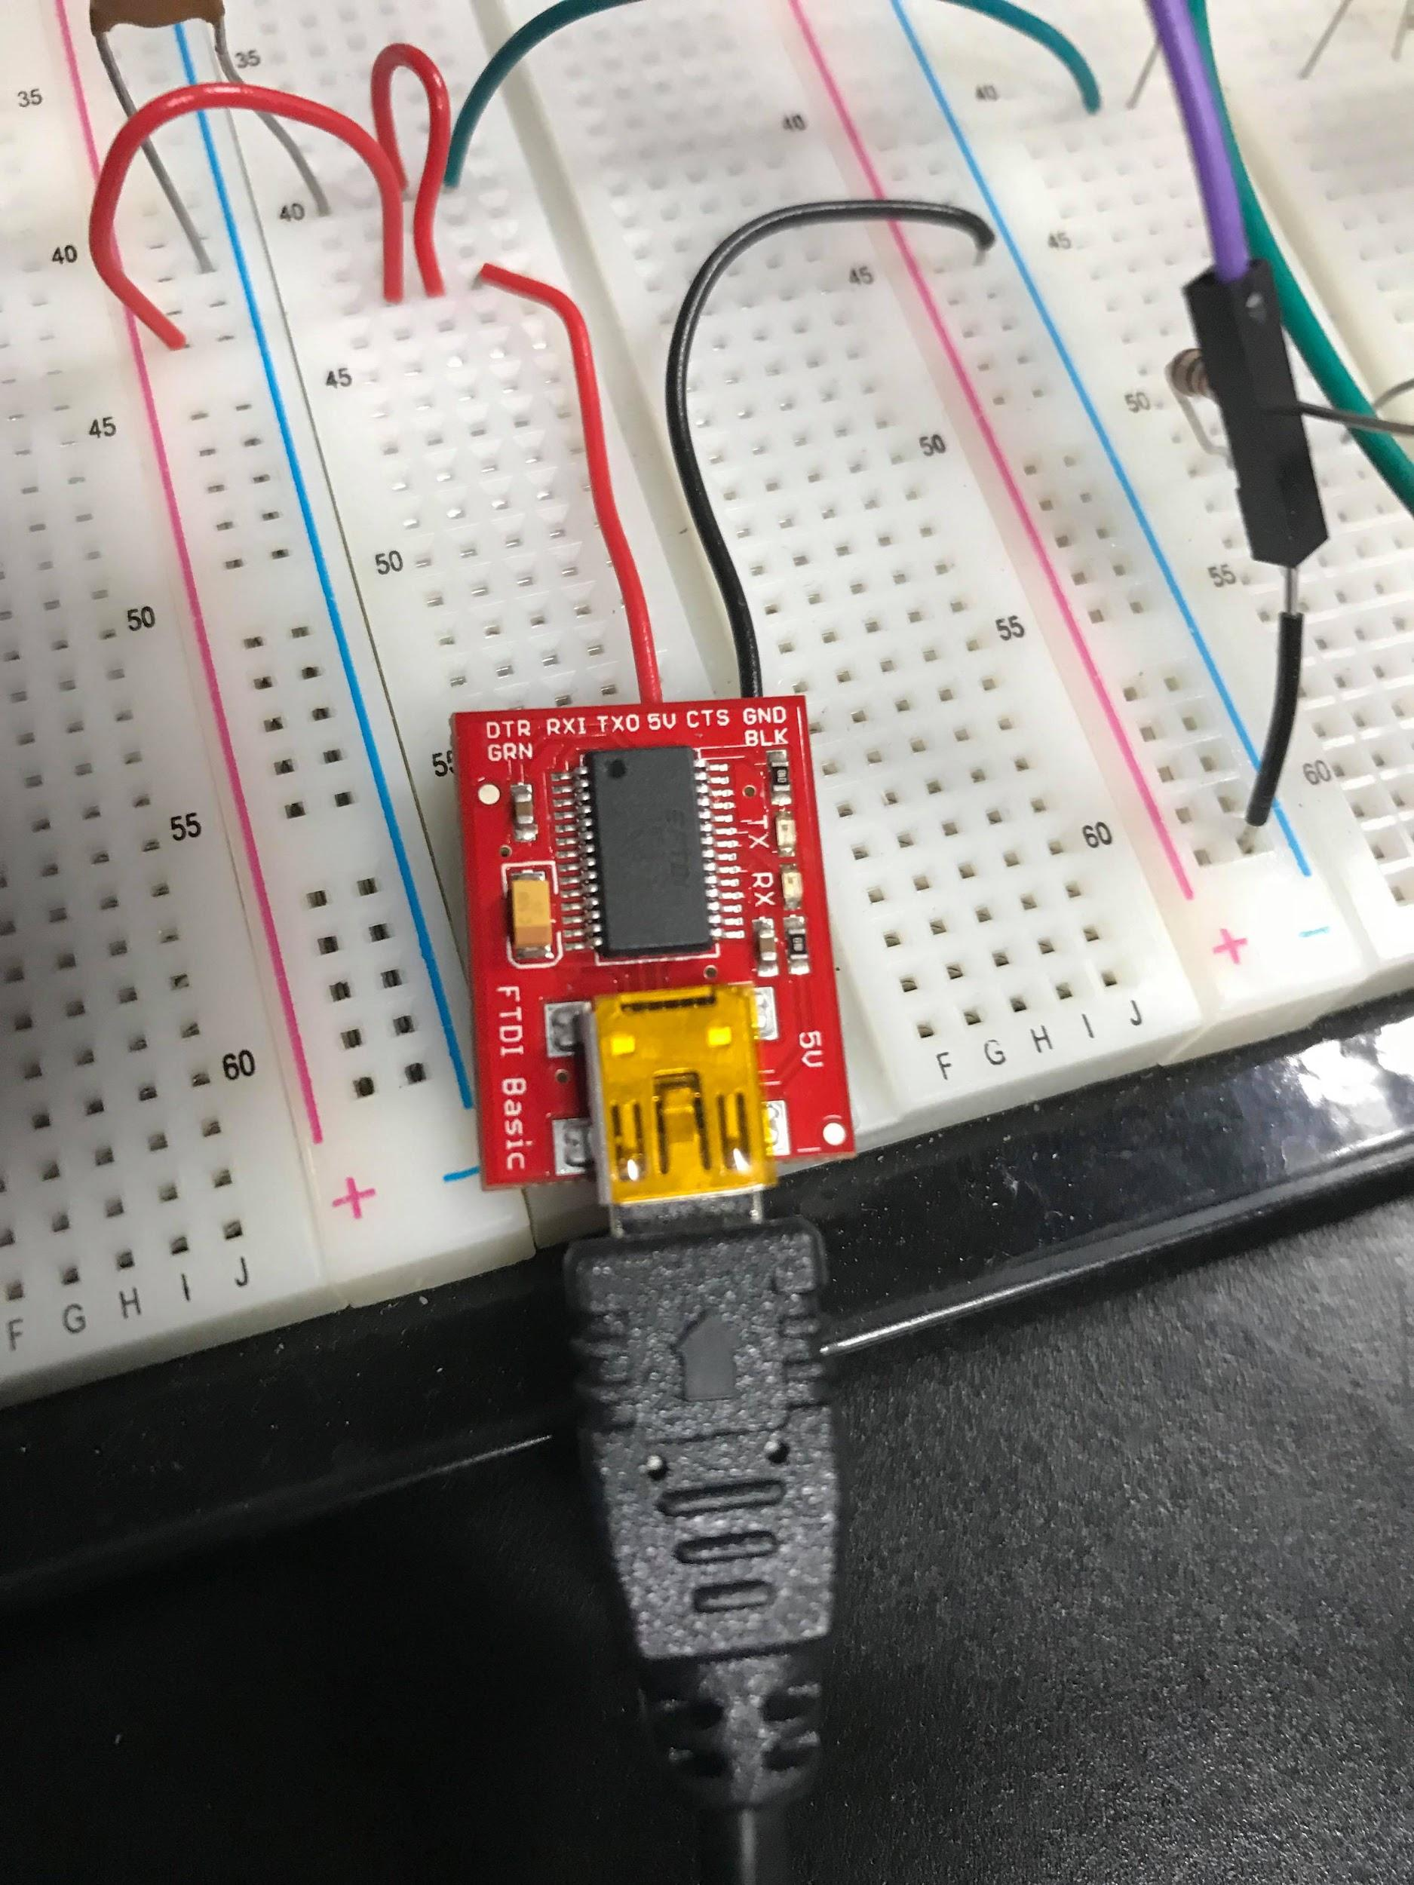

d) ESP01 chip  
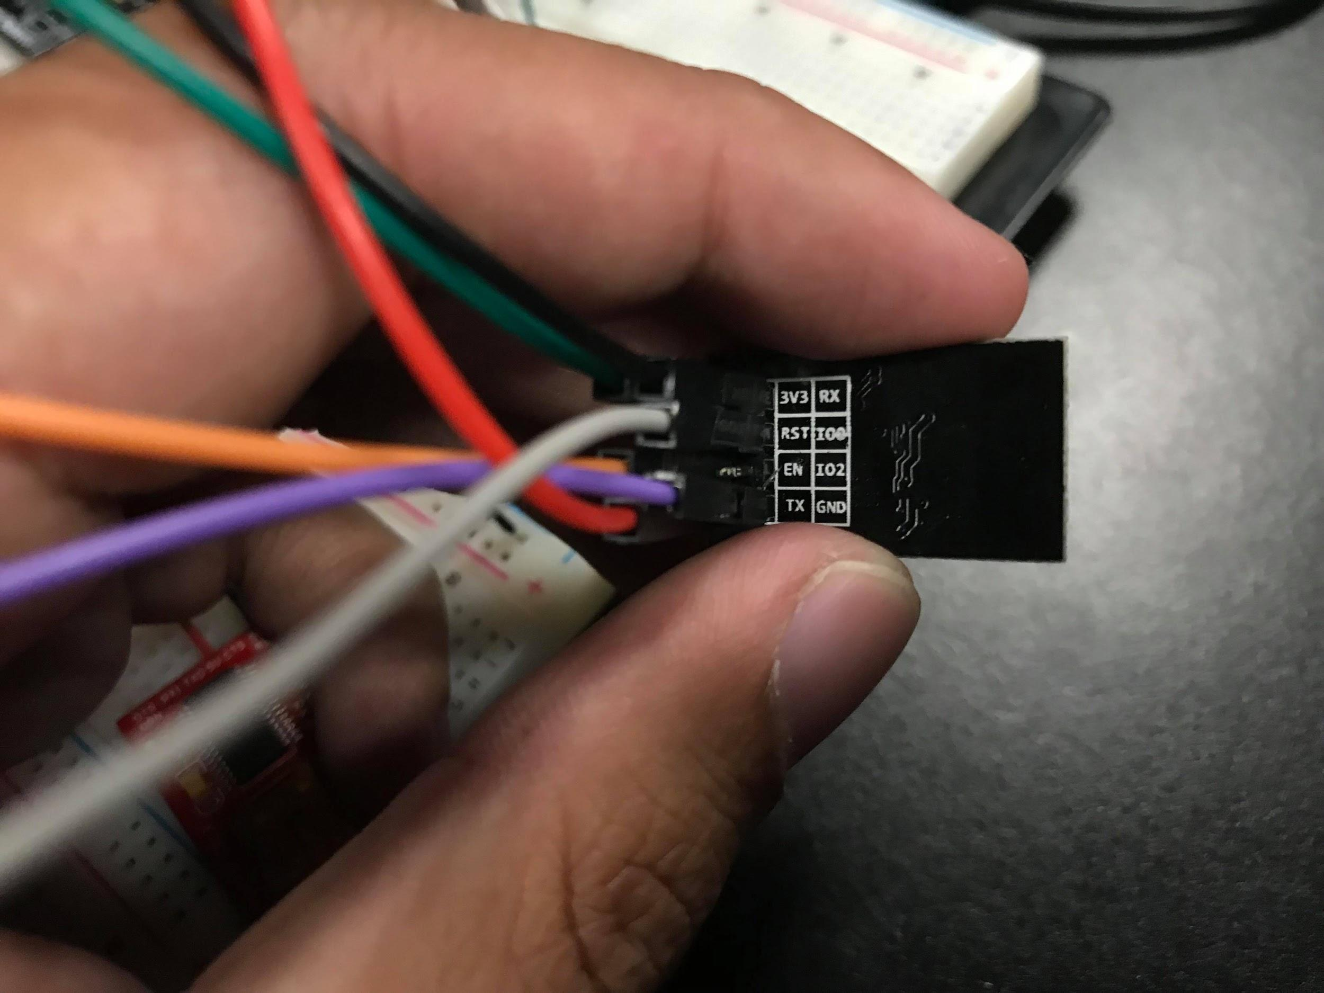

**GITHUB LINK:** <https://github.com/JeffinVegas/EmbSys.git>

**YOUTUBE LINK:** In the videos_DA_MIDTERM.txt file

**Student Academic Misconduct Policy**

<http://studentconduct.unlv.edu/misconduct/policy.html>

“*This assignment submission is my own, original work*”.

Jeffrey Razon