Jeffrey Razon

**CPE301 – SPRING 2018**

Design Assignment MIDTERM 2

**DO NOT REMOVE THIS PAGE DURING SUBMISSION:**

The student understands that all required components should be submitted in complete for grading of this assignment.

|  |  |  |  |
| --- | --- | --- | --- |
| **NO** | **SUBMISSION ITEM** | **COMPLETED (Y/N)** | **MARKS**  **(/MAX)** |
| 1 | COMPONENTS LIST AND CONNECTION BLOCK DIAGRAM w/ PINS |  |  |
| 2. | INITIAL CODE OF TASK 1/A |  |  |
| 3. | INCREMENTAL / DIFFERENTIAL CODE OF TASK 2/B |  |  |
| 3. | INCREMENTAL / DIFFERENTIAL CODE OF TASK 3/C |  |  |
| 3. | INCREMENTAL / DIFFERENTIAL CODE OF TASK 4/D |  |  |
| 3. | INCREMENTAL / DIFFERENTIAL CODE OF TASK 5/E |  |  |
| 4. | SCHEMATICS |  |  |
| 5. | SCREENSHOTS OF EACH TASK OUTPUT |  |  |
| 5. | SCREENSHOT OF EACH DEMO |  |  |
| 6. | VIDEO LINKS OF EACH DEMO |  |  |
| 7. | GOOGLECODE LINK OF THE DA |  |  |
|  |  |  |  |
|  |  |  |  |

**Task 1/A**. Using the nRF24L01/+ transceiver provided establish a receiver and transmitter node using the ATMEGA328p. Communicate to the nRF24L01 using SPI interface.

**Task 2/B**. The temperature data (just the whole number) should transmitter from TX node to the RX node and should be displayed on the UART terminal. Both TX and RX should display the temperature data on the UART terminal to validate the transmission.

**Full Code (Transmit):**

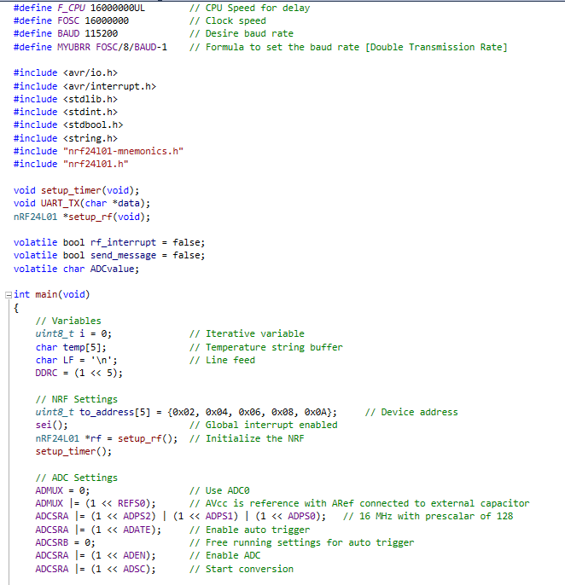

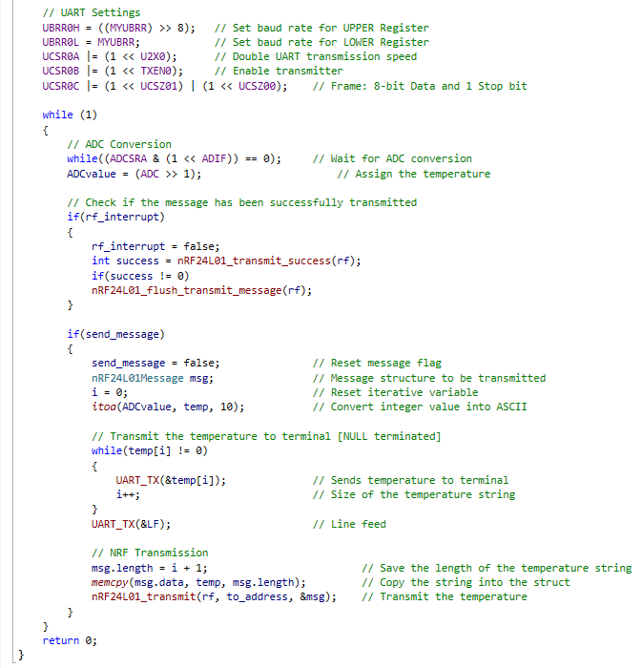



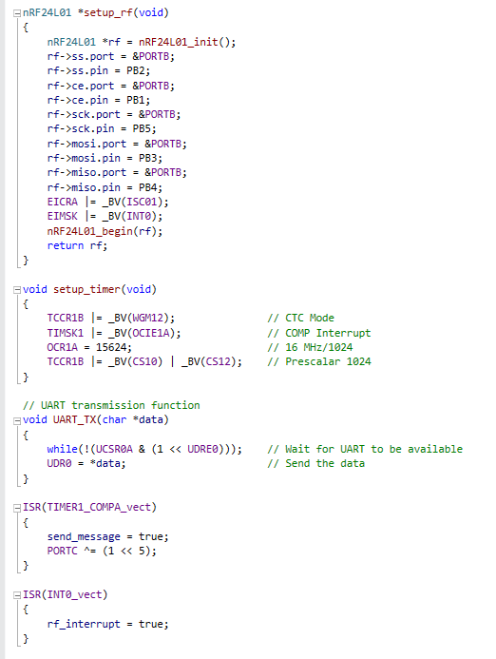



**Full Code (Receive):**

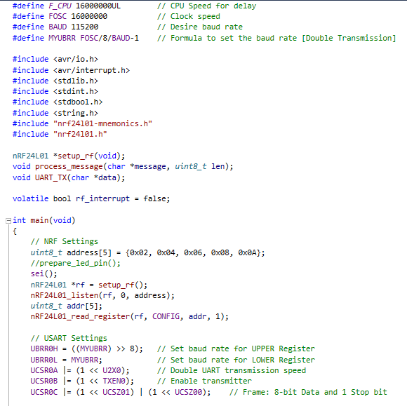

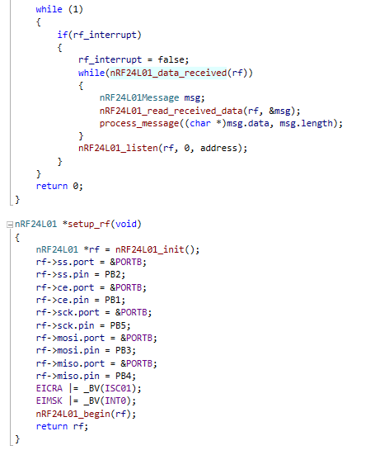

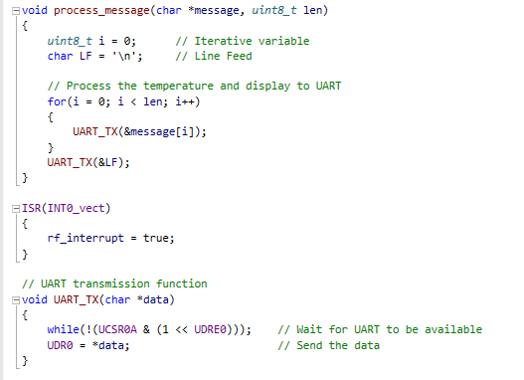

**Flowchart:**

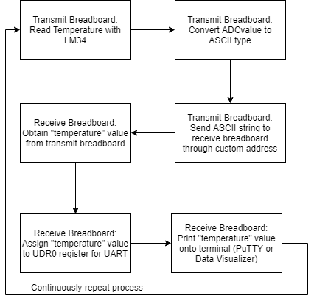

**Schematics (Transmit):**

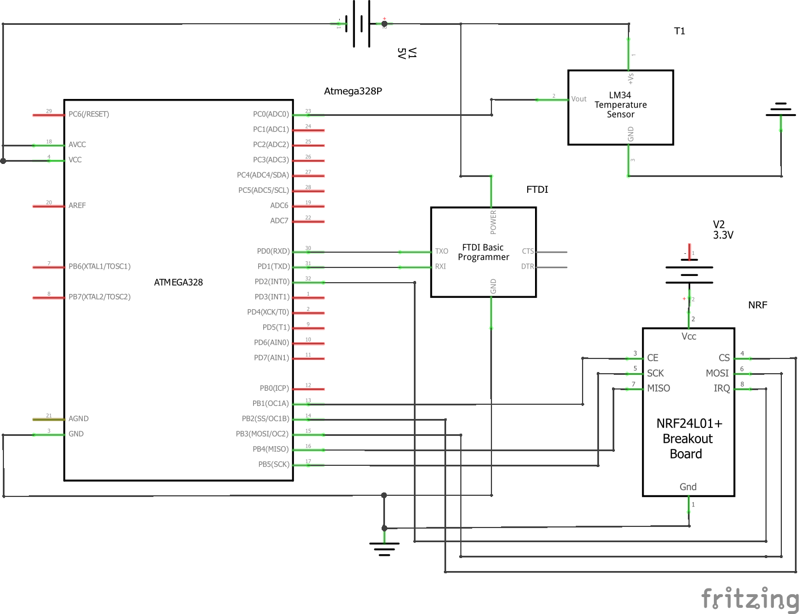

**Schematics (Receive):**

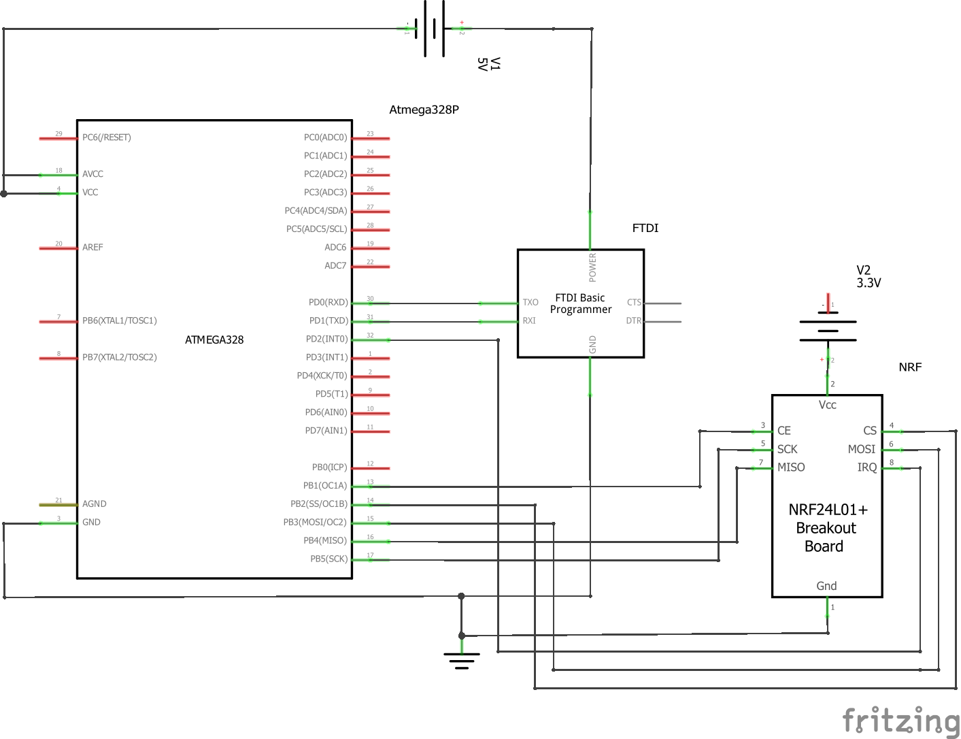

**Physical Set-up:**

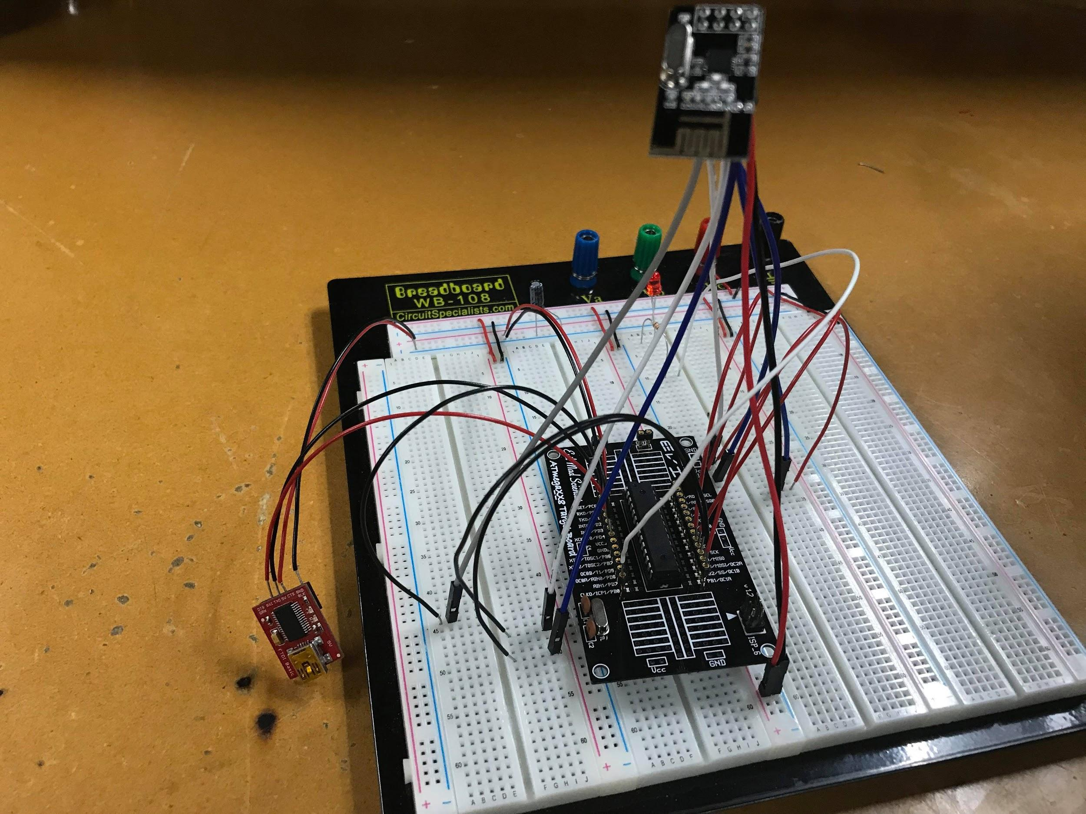

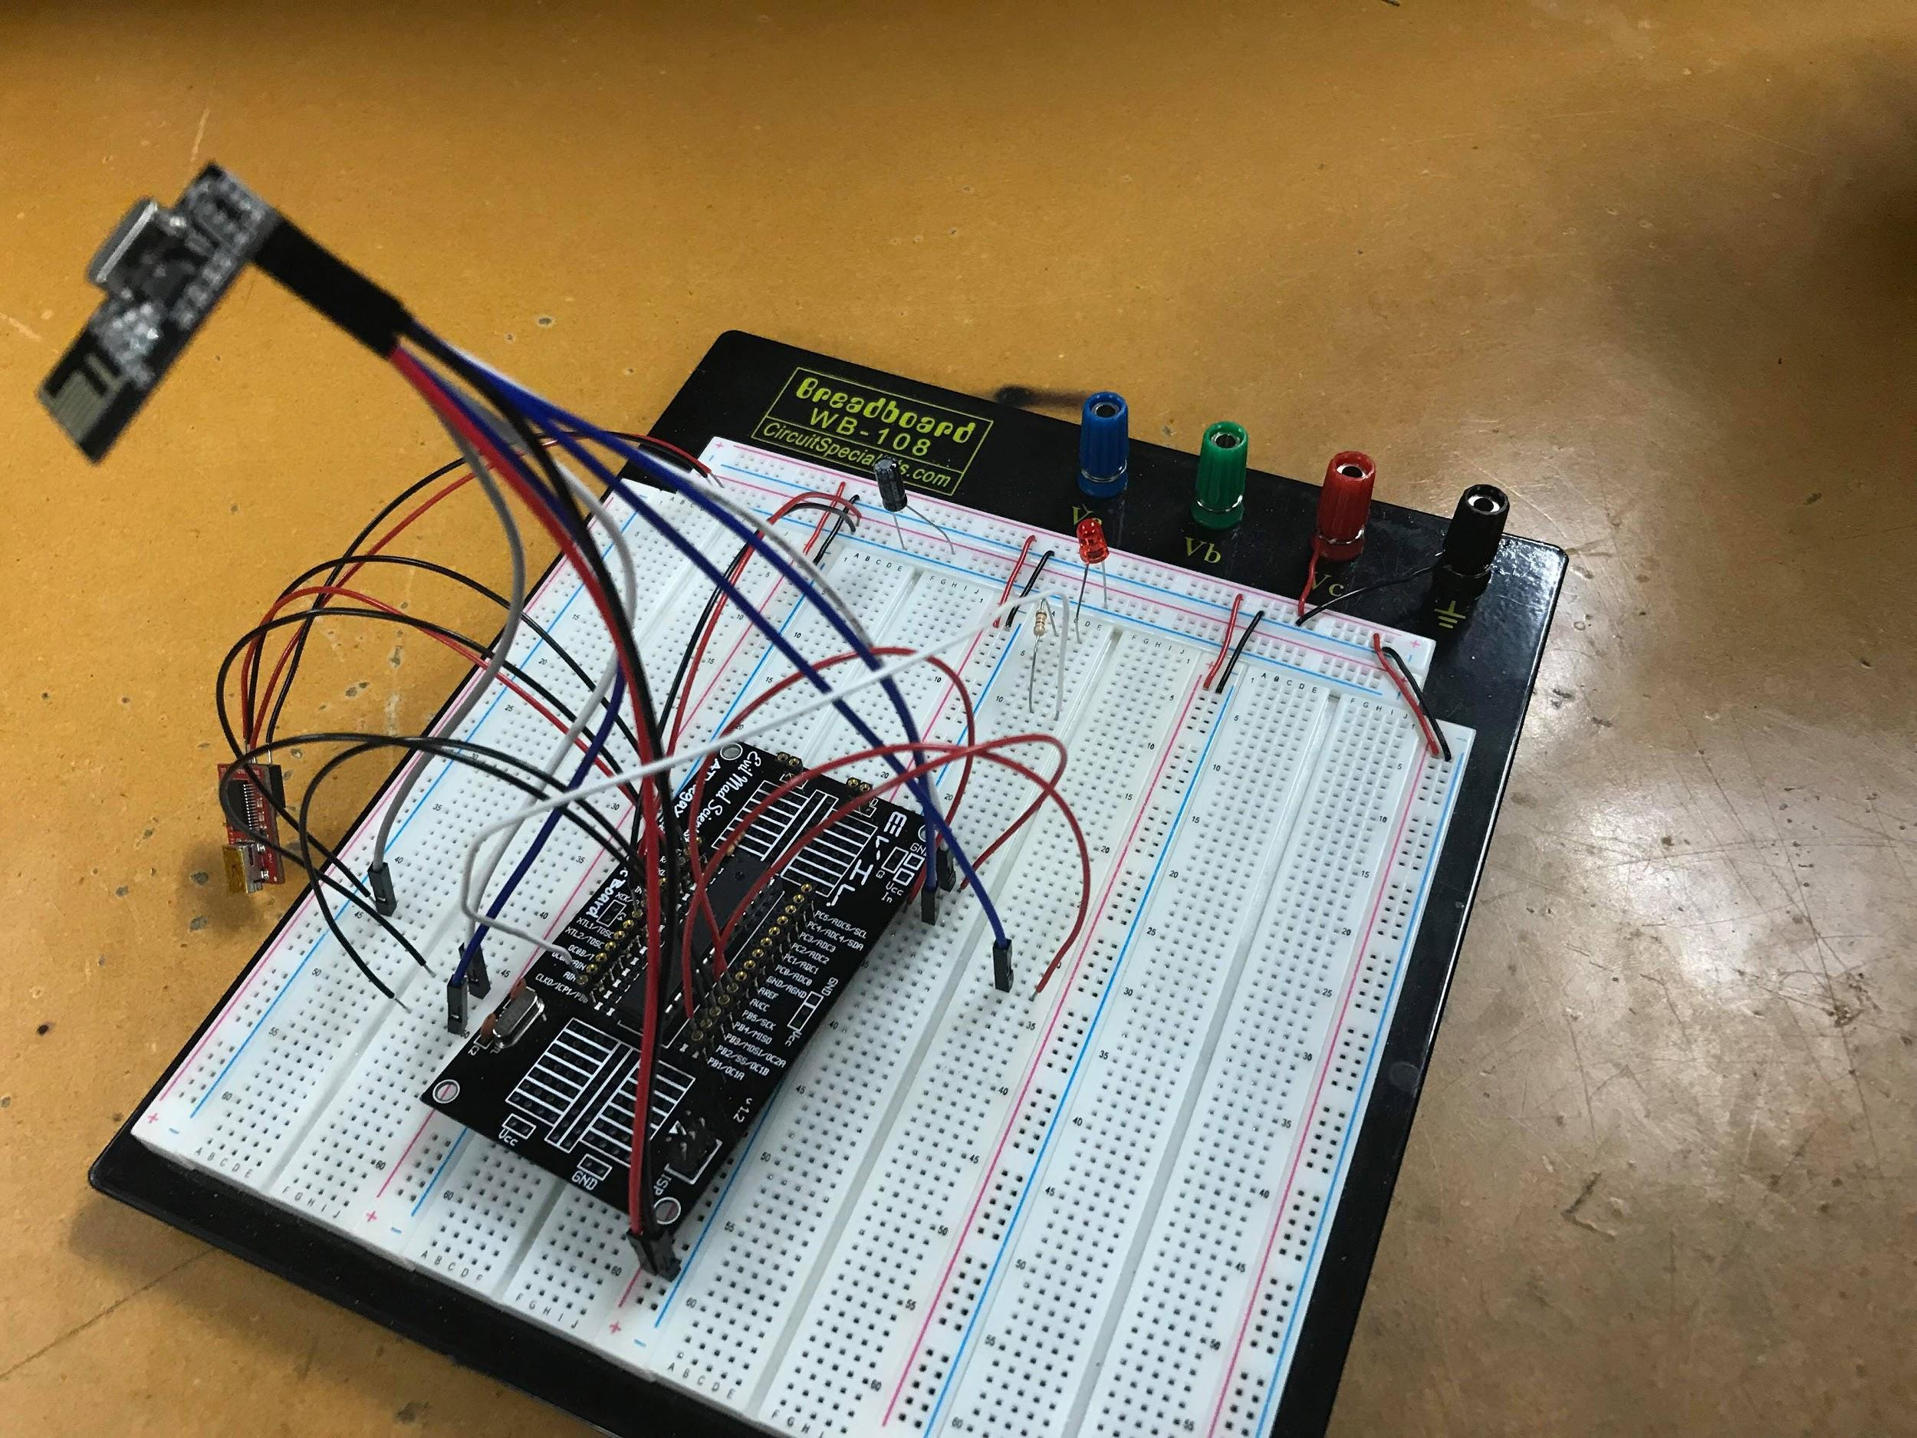

**GITHUB LINK:** <https://github.com/JeffinVegas/EmbSys.git>

**YOUTUBE LINK:** In the videos_DA_MIDTERM2.txt file

**Group**:

Jeffrey R.

Argenis J.

Bryan T.

Tenniel T.

**Student Academic Misconduct Policy**

<http://studentconduct.unlv.edu/misconduct/policy.html>

“*This assignment submission is my own, original work*”.

Jeffrey Razon